MongoDB Assignment 16:
Name: Manas Kelkar
Batch & Roll No: KD1 & 80098
=======================================================================

Q1) Install MongoDB database server.
Query: sudo apt-get install -y mongodb-org

Screenshot:
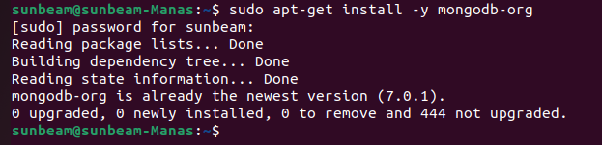

Q2) create a directory/folder to store MongoDB datafiles.
Q3) set necessary path environment variables.

Query: sudo systemctl status mongod

Screenshot:
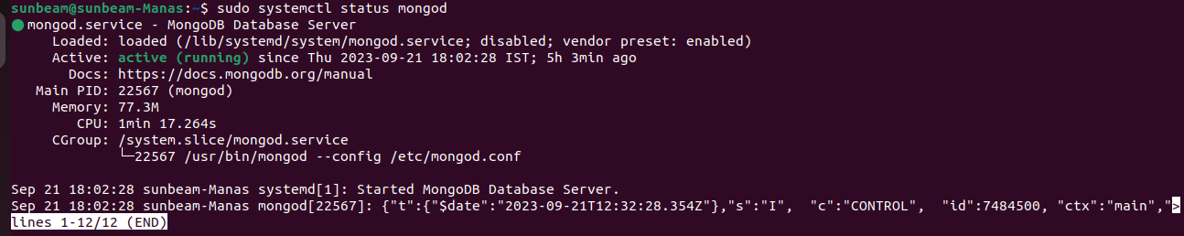

Q4) Startup MongoDB database.

Query: mongosh

Screenshot::
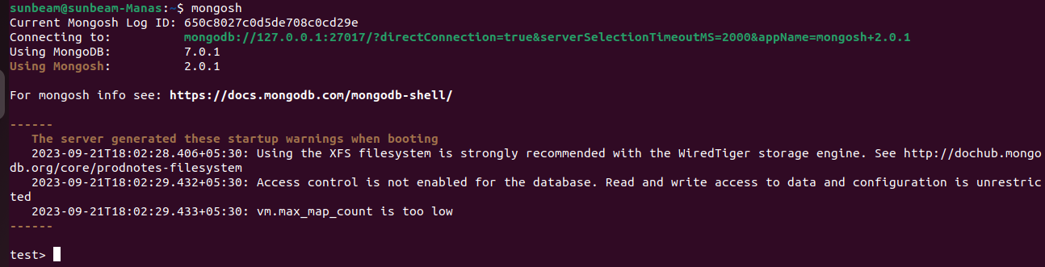
Q5) connect to MongoDB database through the MongoDB shell command line interface.

Query: mongosh

Screenshot:
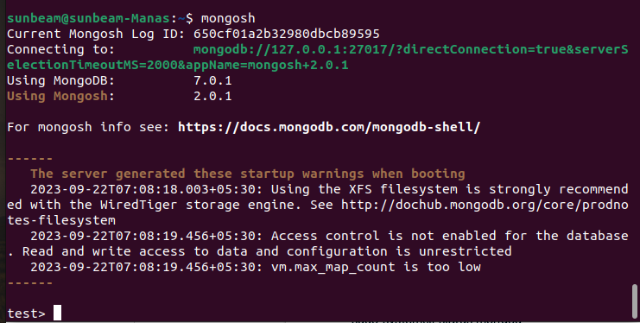
Q6) view list of available databases

Query: show dbs

Screenshot:
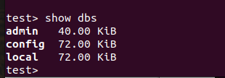

Q7) create a new database CDAC and connect to it.

Query: use CDAC

Screenshot:
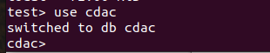

Q8)view list of available collections in database:

Query: show collections

Screenshot:
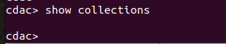

Q9) create a new collection by the name of LIBRARY:

Query: db.createCollection(“LIBARY”)

Screenshot:
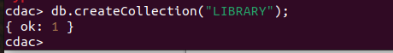

Q10) Insert the following document in the library collection:

Query: db.createCollection("LIBRARY");

Screenshot:
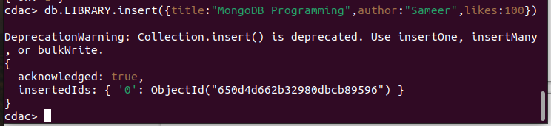

Q11)View the recently inserted document and note the _id field.

Query: db.LIBRARY.find()

Screenshot:
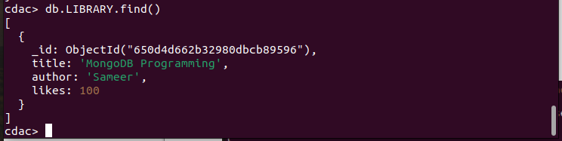

Q12) Insert another document in the library collections as follows :-
title:’MySQL Programming’,
authors:[‘Jack’,’Jill’],likes:200

Query: db.LIBRARY.insert({title:"MySQL Programming",author:["Jack","Jill"], likes:200})

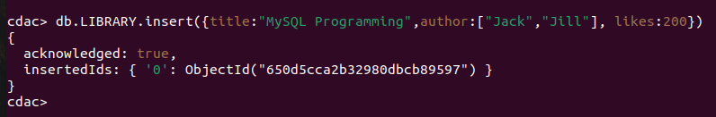
Screenshot:

Q13) View the inserted documents

Query: db.LIBRARY.find()

Screenshot:
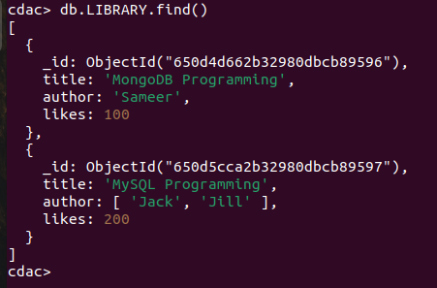

Q14) View only the first inserted document.

Query:.LIBRARY.findOne()

Screenshot:
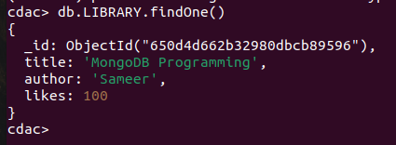

Q15) View the documents using the pretty method.

Query: db.LIBRARY.find().pretty()

Screenshot:
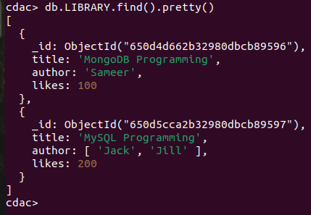

Q16) update the document where author name Sameer and change it to Sameer Dehadri.

Query: db.LIBRARY.update({author:'Sameer'},{$set:{author:'Sameer Dehadrai'}})

Screenshot:
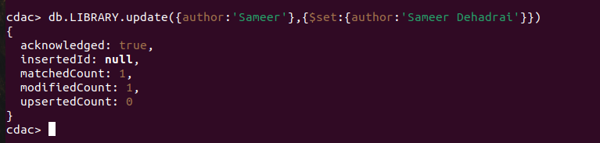

Q17)delete all documents that have 100 likes.

Query: db.LIBRARY.remove({likes:100})

Screenshot:
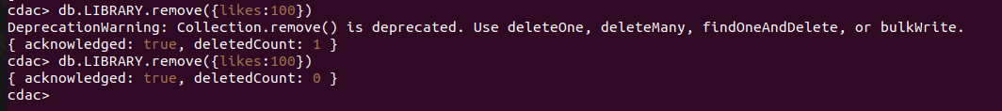

Q18) Drop the library collection:

Query: db.LIBRARY.drop()

Screenshot:
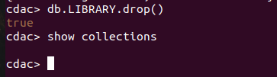

Q19) Drop the CDAC database.

Query: db.dropDatabase

Screenshot:
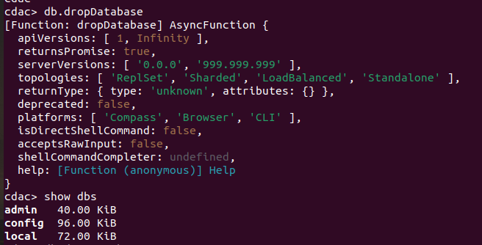

Q20) Exit from MongoDB shell

Query: exit

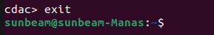
Screenshot:

Q21) Stop MongoDB server

Query: sudo systemctl stop mongod

Screenshot:
