Assignment 7 :
Name : Manas Kelkar
Batch & Roll No: KD1 & 80098
=======================================================================

Summarizing data with Aggregate functions :

Q1) Write a query that counts all orders for October 3.

Ans:
Query: select count(*) Count_Of_Orders from Orders where Odate ='1990-10-03';

Screenshot:
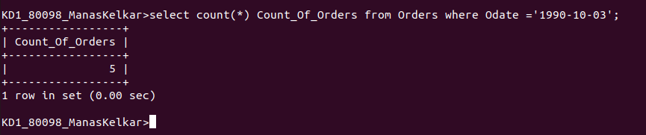

Q2) Write a query that counts the number of different non-NULL city in the Customers table.

Ans:

Query: select count(City) from CUSTOMERS where city is not null;

Screenshot:
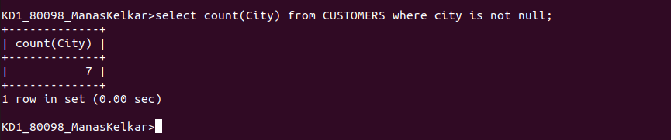

Q3) Write a query that selects each customer’s smallest order

Ans:

Query: select Cnum, min(Amt) from Orders group by Cnum order by 1;

Screenshot:
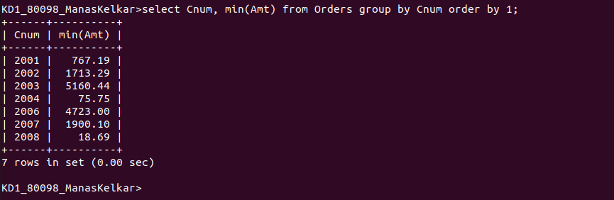

Q4) Write a query that selects the first customer’s in alphabetical order, whose name begins with G.

Ans:
Query: select min(Cname) from CUSTOMERS where Cname like 'G%' order by Cname;

Screenshot:
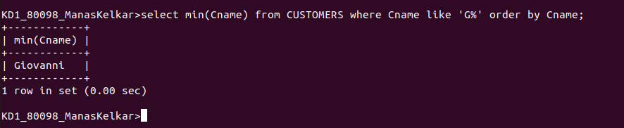

Q5) write a query that selects the highest rating in each city

Ans:
Query: SELECT City,Max(Rating) from CUSTOMERS GROUP BY City;

Screenshot:
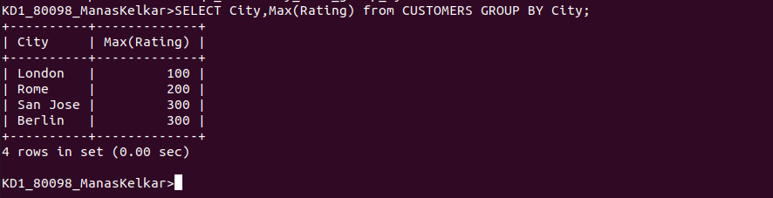

Q6) Write a query that counts the number of salespeople registering order for each day. (If a salesperson has more than one order on a given day then he or she should be counted once.)

Ans:
Query: select odate,count(distinct Snum) from Orders where Odate in('1990-10-03','1990-10-04','1990-10-05','1990-10-06')group by Odate;

Screenshot:
