Assignment 6 :
Name : Manas Kelkar
Batch & Roll No: KD1 & 80098
=======================================================================

Q1) Write two different queries that would produce all orders taken on October 3rd or 4th, 1990.

Ans: Query: select * from Orders where Odate in ('1990-10-04');

Query: select * from Orders where Odate in ('1990-10-03');

Screenshot: 1
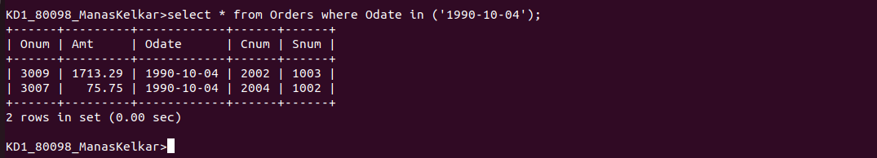
Screenshot: 2
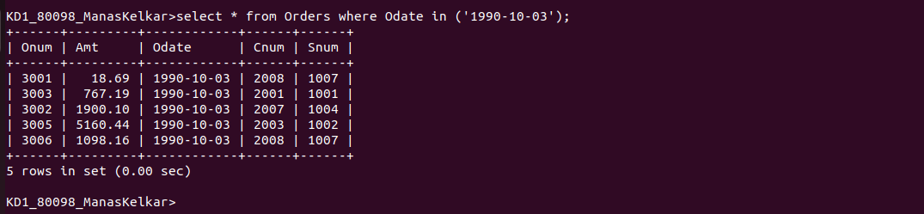
Q2) Write a query that selects all of the customers serviced by Peel or Motika.

Ans: Query: select * from CUSTOMERS where Snum in (1001,1004);

Screenshot:
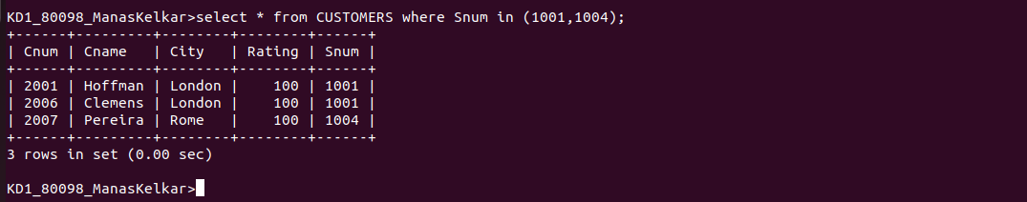

Q3)Write a query that will produce all the Customers whose names begin with a letter from ‘A’ to ‘G’;

Ans: Query: select Cname from CUSTOMERS where substr(Cname,1,1) between 'A' AND 'G';

Screenshot:
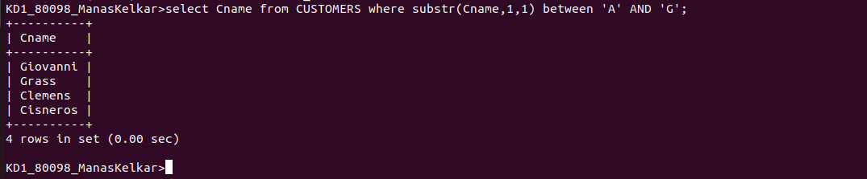

Q4) Write a query that selects all customers whose names begin with the letter ‘C’;

Query: select * from CUSTOMERS where Cname like 'C%';

Screenshot:
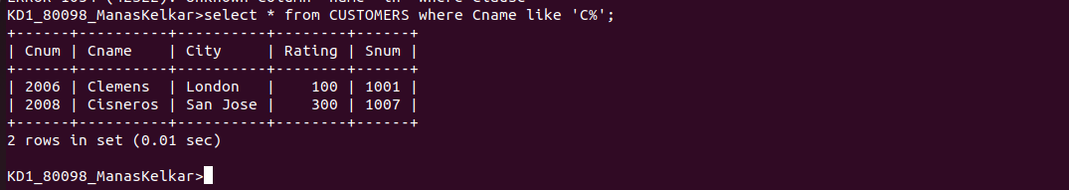

Q5) Write a query that selects all orders except those with zeroes or NULLs in the amt field.

Query: select * from Orders where Amt is not null and Amt !=0;

Screenshot:
