Assignment12:
Name: Manas Kelkar
Batch and Roll No: KD1 & 80098
=======================================================================

Q1) Write a query that selects all customers whose ratings are equal to or greater than any of the serres’.
Query:select Cname,Rating from CUSTOMERS where Rating = any(select Rating from CUSTOMERS where Snum=(select Snum from SALESPEOPLE where Sname='Serres'));

Screenshot:
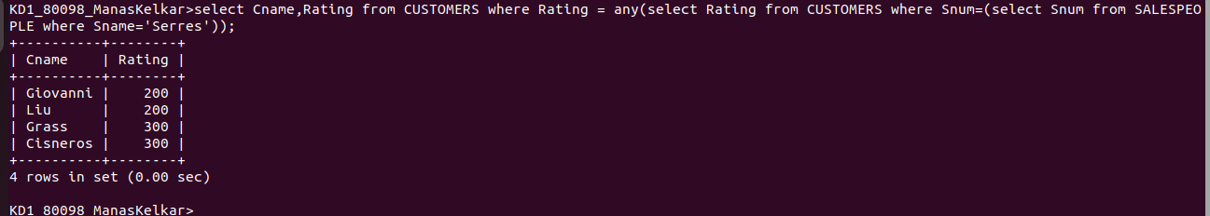
Q2) Write a query using any or all that will find all SALESPEOPLE who have no customers located in the city.

Query: select Sname from SALESPEOPLE where Snum != all (select SALESPEOPLE.Snum from CUSTOMERS,SALESPEOPLE where SALESPEOPLE.Snum=CUSTOMERS.Snum and SALESPEOPLE.City=CUSTOMERS.City );

Screenshot:
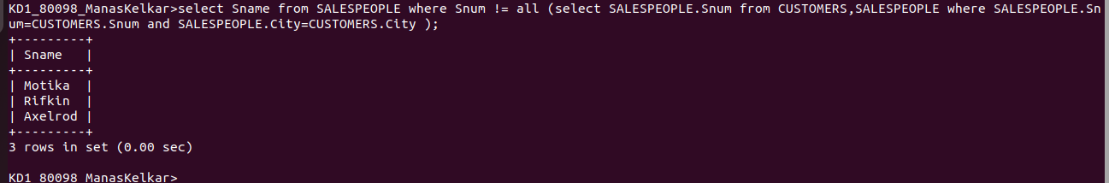

Q3) Write a query that selects all orders for amounts greater than any for the CUSTOMERS in LONDON.

Query:select Onum,Amt from Orders,CUSTOMERS where CUSTOMERS.Cnum=Orders.Cnum and Amt> any(select Amt from Orders where Cnum=any(select Cnum from CUSTOMERS where City ='London'));

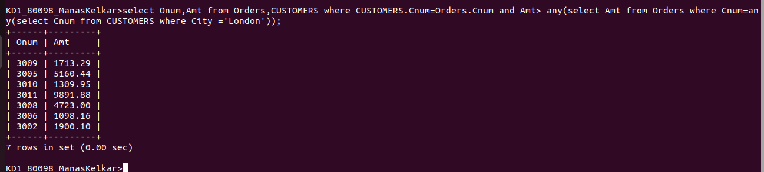
Screenshot:
Q4) Write the above query using Min or Max

Query: select Onum,Amt from Orders,CUSTOMERS where CUSTOMERS.Cnum=Orders.Cnum a nd Amt>(select min(Amt)from Orders where Cnum =any(select Cnum from CUSTOMERS where City ='London'));

Screenshot:
