**Valuation of Brigade Enterprises, Godrej properties ltd and Prestige Estates Projects Through FCFE**

**And FCFF models**

**Assignment 4**

Submitted in partial fulfillment

 of the course of

**ECON F355 Business Analysis And Valuation**

By

**Group No 34**

**2020A4PS2272H Manas Kumar Khandelwal**

**2020A1PS2282H Hemanth Kumar G V**

**2020A3PS0531H Mohit Dhoot**

**2020A4PS2349H Muthukururu Venkata Gowtham Reddy**

Under the supervision of

**Prof. Niranjan Swain**



**BIRLA INSTITUTE OF TECHNOLOGY AND SCIENCE PILANI**

**25 DECEMBER 20**

ACKNOWLEDGEMENT

*We would like to convey our heartfelt appreciation to Dr. Niranjan Swain for providing us with the chance to work under him on this project and for taking the time to assist us with the necessary advice wherever it was needed. His contribution was vital to the assignment. We'd want to thank him for giving us this wonderful opportunity to apply our course knowledge to real-world data and gain hands-on experience. We are grateful for all of his assistance and advice throughout the course and this task.*

ABSTRACT

Real estate in India is being acknowledged as an infrastructural service that is propelling the country's economic growth engine. This assignment compares the dividend discount model and the free cash flow to equity(FCFE) valuation model for determining the intrinsic value of a company. The interpretation aims to determine the accuracy and reliability of each model in predicting stock prices and making investment decisions.

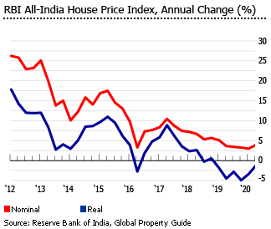 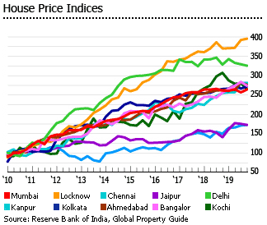

**TABLE OF CONTENTS**

**SECTION 1:** **DIVIDEND DISCOUNT MODEL 5**

1.1 Valuation using dividend discount model 6

1.2 Two stage DDM (Theory and formulas) 7

1.3 Three stage DDM (Theory and formulas) 8

1.4 DDM 2 stage valuation model 15

1.5 DDM 3 stage valuation model 17

**SECTION 2: FCFE, FCFF VALUATION MODEL 21**

2.1 FCFE, FCFF valuation (Theory and formulas) 21

2.2 Valuation model applied on companies22

**SECTION 3 : Summary 28**

**SECTION 4 : References 29**

**SECTION-1**

**1.1 Valuation Using Dividend Discount Model**

* Underlying Principle- Dividends during the holding term and an anticipated price at the conclusion of the holding period are the two main forms of cash flows that investors often anticipate when purchasing shares in publicly listed corporations.
* The value of a stock may be expressed as the present value of dividends in perpetuity since this predicted price is itself set by subsequent dividend payments.

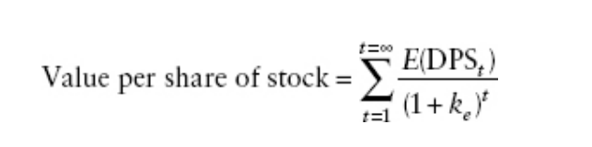

Here DPSt, is expected dividends per share in period t

Ke = Cost of equity

* The basic notion of the model is being derived from the Present Value Concept or the DCF (Discounted Cash Flow ) Basically here we are trying to discount the cash flows with cost of equity to get the present value of the future expected dividend payments

Now There can be Variations in the dividend discount model based on the variation in the number of year of valuation as well as changing the growth period either linearly or sudden would give rise to various models Some of them are-

* + - Gordon Growth Model
    - Two Stage Model
    - H- Model
    - Three Stage Model

**1.2- Two Stage DDM**

* The two-stage growth model permits two stages of growth: an early phase in which the growth rate is not stable and a following steady state in which the growth rate is stable and is anticipated to stay that way for a long time.
* Although the growth rate during the first phase is often larger than the steady growth rate, the model may be modified to assess businesses that are anticipated to have short-term low or even negative growth rates before returning to stable growth.

Value of the Stock would be =PV of dividend during Extraordinary Phase+ PV of terminal Price

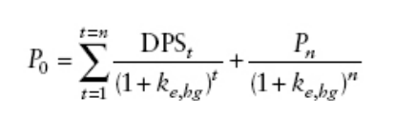

* In case we have growth rate as well as the payout ratio as fixed for the first n years then we can simplify the formula as

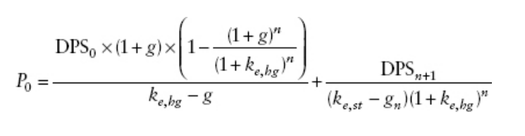

* For stable Period Payout ratio we can calculate it with the help of following formula as-

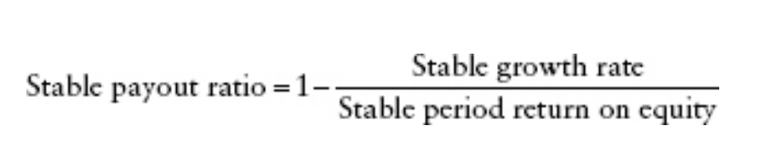

**1.3- Three stage DDM**

* The two-stage model and the H model's characteristics are combined in the three-stage dividend discount model. Assuming an initial period of stable high growth, a second period of decreasing growth, and a third period of steady low growth that lasts forever, it is the most generic of the models since it has no constraints on the payout ratio.

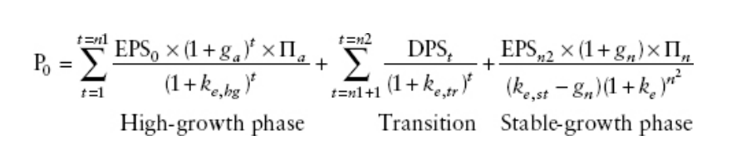

* Because of this model's adaptability, it may be used by any organisation, which is likely to experience changes in growth as well as payment practices and risk over time. In terms of application, this is the model that is better suitable for a company whose earnings are expanding rapidly.

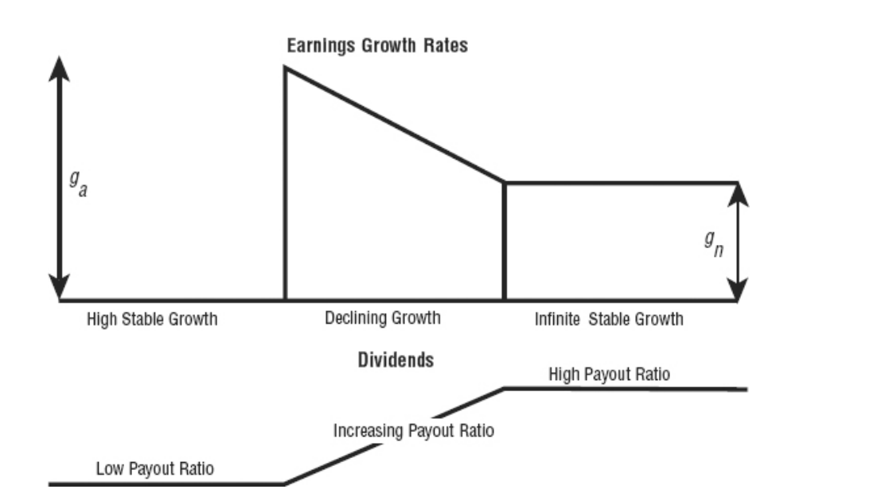

* Now we will be applying 2 stage as well as 3 stage models to our selected organization to determine their Intrinsic value and we will be using the previous assignment’s data for the cost of equity capital as well as the Market Returns and risk premium.

**1.4-DDM 2 Stage Valuation Model**

* Godrej Properties Ltd:
  + Godrej Properties Ltd is a non dividend paying firm hence we can’t
  + directly apply the DDM discounted cash flow method to this firm so to apply DDM method to a non dividend paying firm we have calculated the industry average payout ratio and have used that to estimate the dividend payments of Godrej properties we have used the same firms that we used in assignment 3 to calculate the market index returns and the beta of the firm as well as the cost of equity capital

* Using the statistics we have got the the average payout ratio as 25.833%.



* Now using this Payout we have first evaluated the High growth phase growth rate as 10.27%.

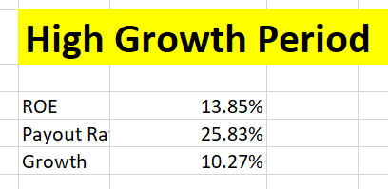

* Then we took cost of equity values from assignment 3 and we also calculated the cost of equity in the stable phase by taking the Beta value as 1 and we also linearly reduced the Market Risk Premium in the stable phase from the notion that Real estate industry will attain a stable phase after some years so risk premium would get reduced too. Hence we got COE in stable phase as 7.88%.

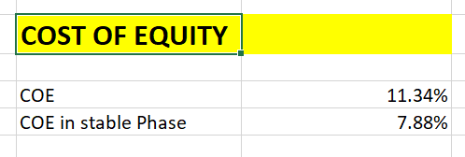

* Then we need to calculate the the payout in the stable period by taking the Growth equal to 5% which would be equal to the growth of Indian economy and then we took the Return on Equity as the Cost of Equity in the Stable Phase That is equal to 7.88%. Here we have made this assumption as the Company’s Return on equity will decline linearly with time and it would atleast get stable at the cost of equity capital for the firm to add value to it’s investors.

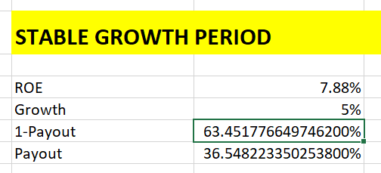

* Then we have calculated the PV of the future dividend cash flows as follows in the following table:

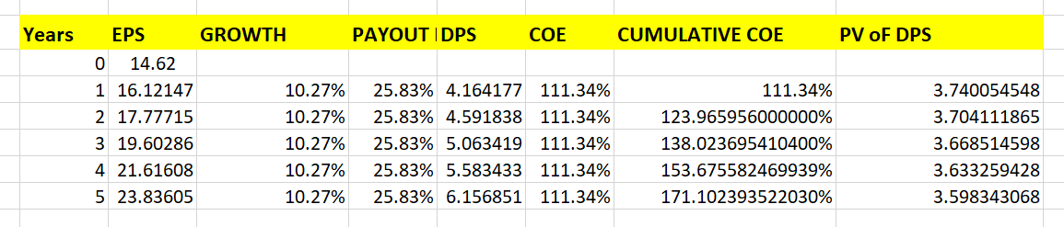

* Next is we have calculated the Terminal Value as by applying stable growth rate on EPS 5 and the stable payout ratio on EPS6 we have got it as follows.

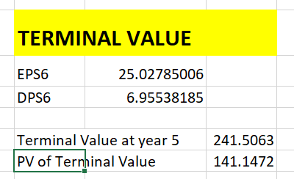

Now to calculate the Value of the firm we need to do the summation of PV’s of all the three cash flows :

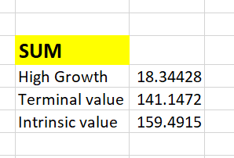

Hence we got the intrinsic value of the firm as **Rs.159.49/Share.**

* Prestige Estate Projects Ltd

Now looking at the valuation stats we can see that Prestige Estate Projects is paying low dividend and has a high return on equity.

Comparing it with industry stats we get the it has a good ROE as

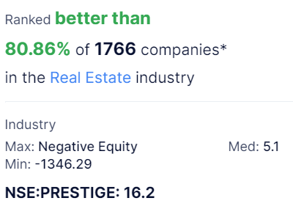

16.2% as Industry average is 5.1% so it is ranked better than 80.86% of the companies in the real estate industry.

By analyzing the past performance of the firm we came to the conclusion that it has been growing since last 10 years at a rapid rate as

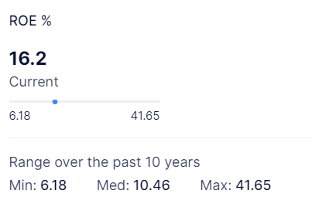

From past 10 years data we can see that it’s minimum hit for ROE was 6.18% which is a good signal for growth prospect.

We have done the valuation and have got the valuation stats as Growth rate equal to 16.88% which declines to 5% in the stable phase and we have got cost of equity capital in stable Phase as 8.88%.

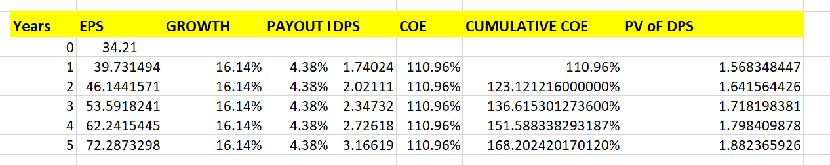

Now Summing up all the values i.e High growth as well as Terminal value we Got The Intrinsic value equal to Rs.516.776/share

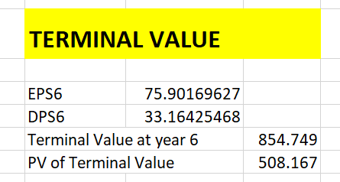 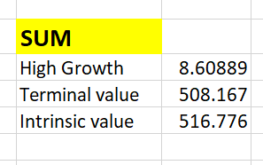

Now Prestige estate share price in market is trading at around 450/share. which is coming close to our Intrinsic value Now since it’s I.V. is Higher than the market value so Hence this share is currently undervalued in the market.

Brigade Enterprises Ltd:-

We have applied 2 stage DDM to Brigade Enterprises and have used cost of equity capital from the Assignment 3 as

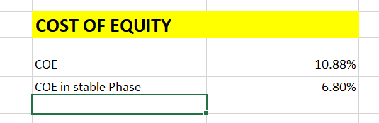

Now in High Growth period we have got the growth rate as 9.81% which declines to 5% in stable growth period

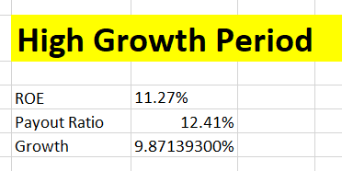 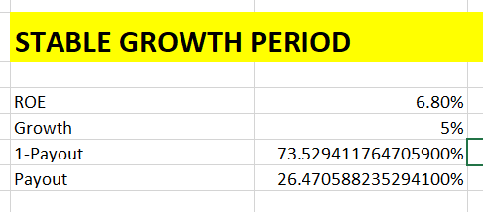

We have taken the ROE in the stable phase as equal to the cost of equity capital in the stable phase we have calculated the cost of equity capital in the stable phase by taking the Beta to be equal to 1.

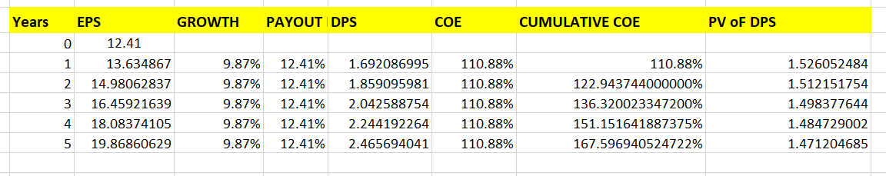

Then using the Discount rates as COE we calculated the Cumulative COE and from Cumulative COE we have calculated the Present value of the Dividends.

Now for Terminal value we calculated EPS6 and DPS6 from stable period payout and stable period growth rate

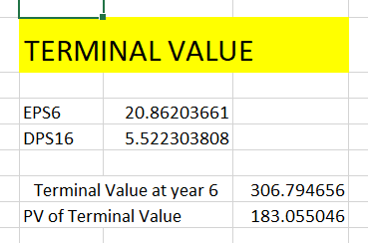 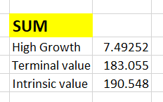

So finally we got the Total Intrinsic value of the firm as equal to 190.584/share.

**1.5- 3 Stage DDM Model**

Now we will be applying 3 stage DDM model to our selected firms as:

* Godrej Properties Ltd:

Now as we saw in DDM 2 stage model that it is a non dividend paying firm hence we need to take the average payout ratio in the industry and then we need to calculate the payout ratio for further calculation.

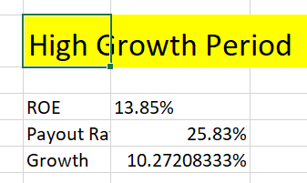 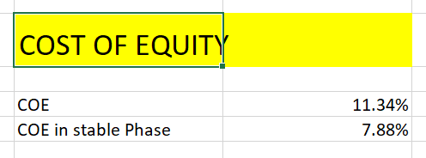

As we can see that In High growth phase we are Having the Growth as equal to 10.272% and COE in the stable phase we took Beta as 1 and then calculated it which is coming equal to 7.88%.

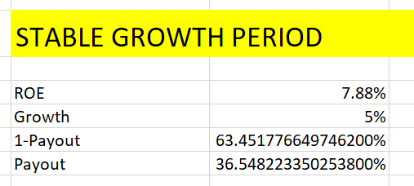 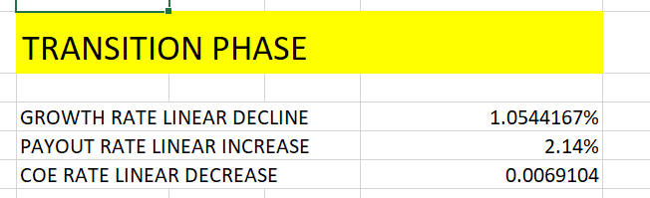

In transition Phase we have done linear Decline to Growth rate, Payout rate as well as the Cost of equity. We got the Growth rate Decline factor to be 1.0544%, Payout Rate Linear Decline Factor to be equal to 2.14% and COE Rate Linear Decline factor to be equal to .69%.

We have assumed that the firm would grow at a stable rate starting from the 10th year.

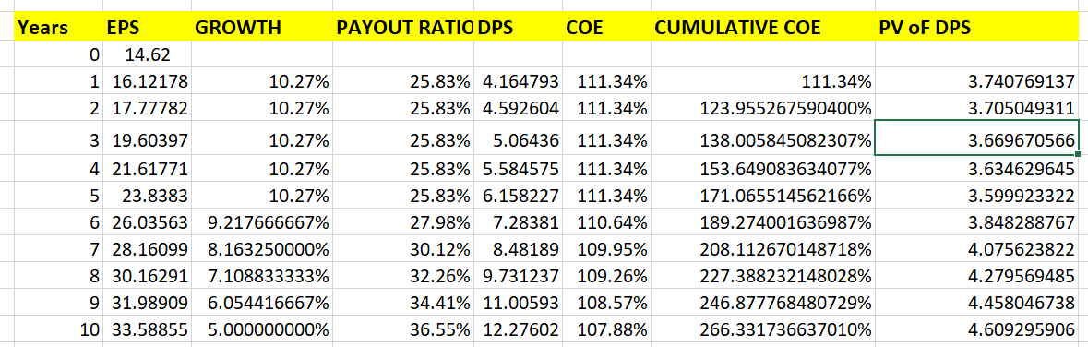

Here in the table shown above we have calculated the PV’s of Dividend in Both Transition as well as the Growth phase and have used Cumulative COE for discounting them.

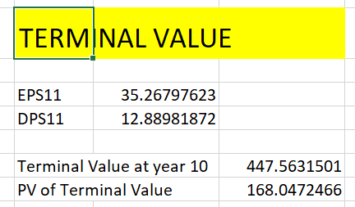 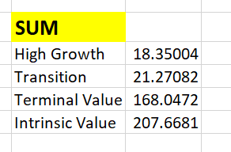

Hence we are getting the Total Intrinsic value of the firm as equal to Rs.207.66/share.

Prestige Estate Projects Ltd:

* We know that prestige is already growing at a high rate with a very high return of equity and hence if we would apply 3 stage DDM to it we might get a good value closer to near the actual share price.

So First analyzing the High growth period as well as in the stable growth period we have-

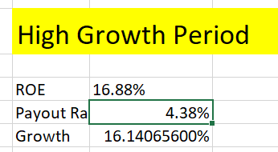 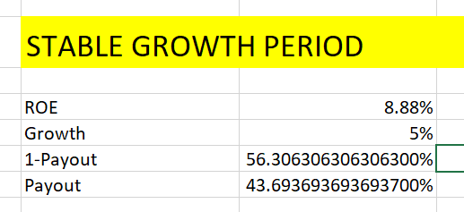

We have Growth rate in the High growth period equal to 16.14%. and from the stable period we are getting the Payout ratio equal to 43.69% as we took the growth rate equal to Growth in Indian Economy as well as the ROE is taken as equal to the COE in the stable phase where we have calculated the COE in the stable phase by taking the Beta to be equal to 1.

Now in Transition phase we have calculated the Decline as well as incline factors as

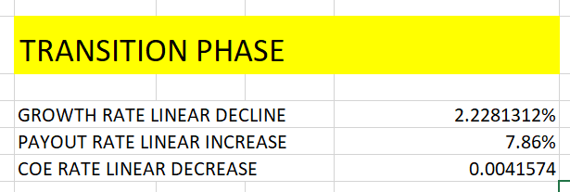

Here we are Getting the Growth rate factor as 2.22%, payout factor as 7.86% as Prestige has a low initial payout ratio equal to 4%. Which would scale up to 43.69% in the 10th year which is a high as it’s initial ROE is also High. So then we have calculated the PV’s of the dividends(expected) in the near future.

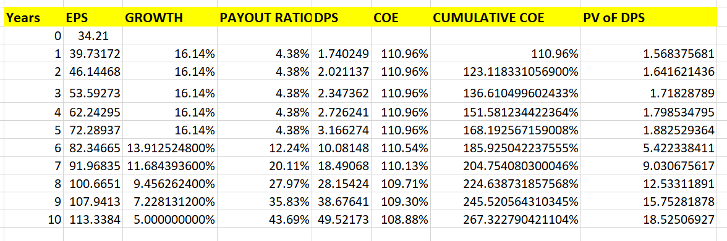

Here we have discounted using the Cumulative COE for each period as we are having different Cost of Equity capital in the Transition Phase (unlike the 2 stage Model) where we have the same cost of equity all over.

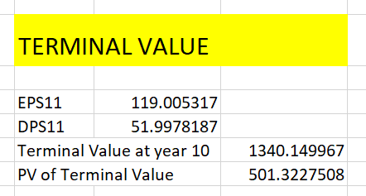 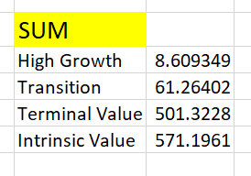

Now we have calculated the terminal value by using EPS11 we have growth rate equal to 5% and DPS11 is calculated by using the stable period payout then for calculating the sum we have simply summed up High Growth, Transition as well as terminal value to get the Intrinsic value of the firm. As **Rs.571.1961/share.**

Brigade Enterprises Ltd:

Brigade is having a lower EPS of Rs.12.41/Share so we are expecting it to grow at a rapid rate in near future and then decline linearly to a stable rate in near future

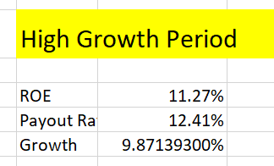 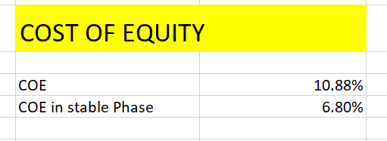

Here in the Stable phase we are getting a growth of 9.87% and for COE in stable phase we have assumed the Beta to be equal to be 1 and then evaluated it.

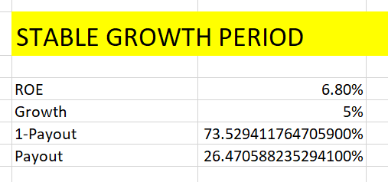

For stable period growth we are getting the values of payout to be equal to 26.47% which matches to the fact that the firm has a lower EPS. Now we have the Transition Phase stats as follows:

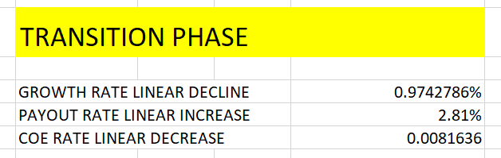

Here we can observe that Growth rate will decline as .97% which would scale down to 5% and the payout ratio would upscale to 26% and COE would also decline at a rate of .8% as Beta would decrease to 1 and market risk premium would also decrease in the stable phase.

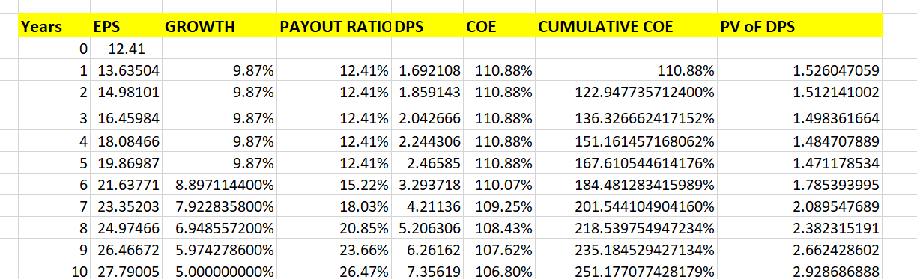

Now we have finally evaluated the PV’s of the expected dividend cash flows and we have discounted using Cumulative COE. Declining from 10.88% to 6.88%.

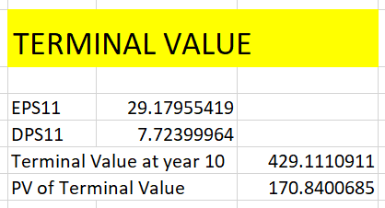 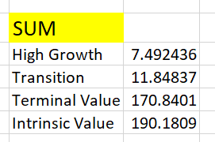

We are getting a terminal value of Rs.429 which we have discounted by Cumulative COE@10 and getting it equal to Rs.170 Now for Intrinsic value we are getting the Value as equal to Rs190.18/share. which is the minimum of last month market share price.

**SECTION -2**

**2.1** **FCFE FCFF Valuation**

When we use FCFE to evaluate stock instead of dividends, we are doing more than just switching one cash flow for another. We assume that the FCFE will be distributed to investors. There are two results:

1. Since the company pays out cash to investors each month after paying debt and meeting reinvestment needs, there won't be any future cash accumulation in the business.
2. Instead of revenue from increases in marketable securities, the predicted rise in FCFE will include growth in income from operational assets. The previous point directly leads to this.

Now Inputs the FCFE model Includes :



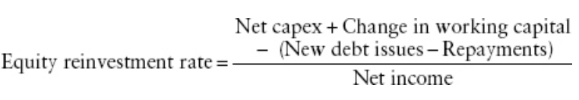

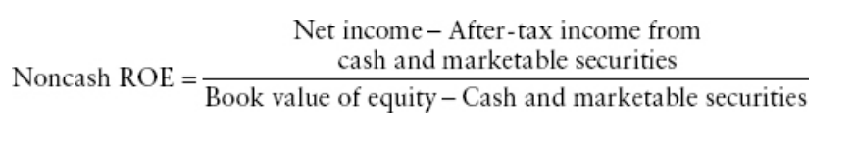

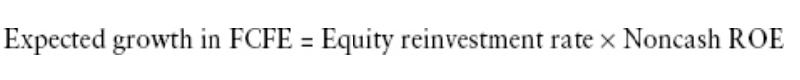

Now applying the underlying principles we will be doing the valuation using the FCFE model.

**2.2- FCFE & FCFF Valuation models applied on companies**

GODREJPROP LTD-

Since we know that for FCFE calculation we would be requiring the Reinvestment rate which would be calculated by using the formulas given above we have created a python code which would extract the financial reports of given firms and would calculate the Reinvestment Rates.

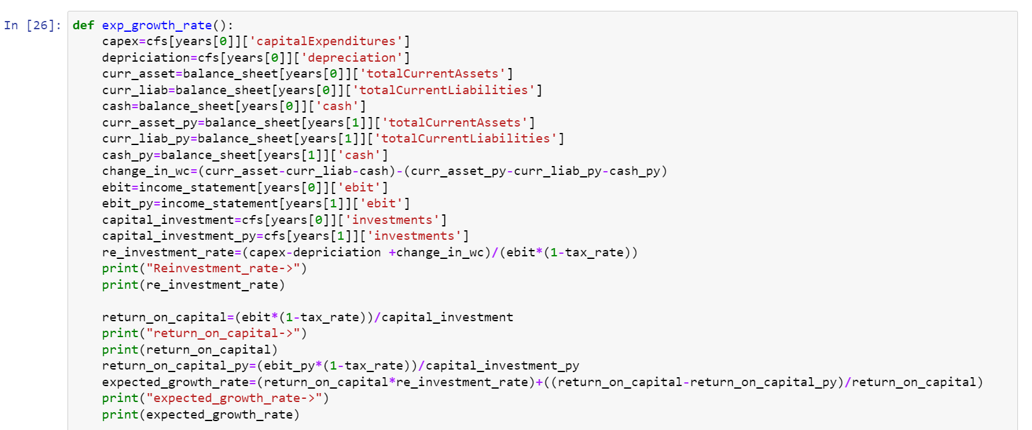

Above is the copy of the function which we wrote to evaluate the Reinvestment rates of our 3 firms and for Godrej we have got it around 13.55%. Now to analyze the growth rate in EBIT and Revenue we plotted graphs of last 10 years data and with the help of average trendline we calculated the growth rate.

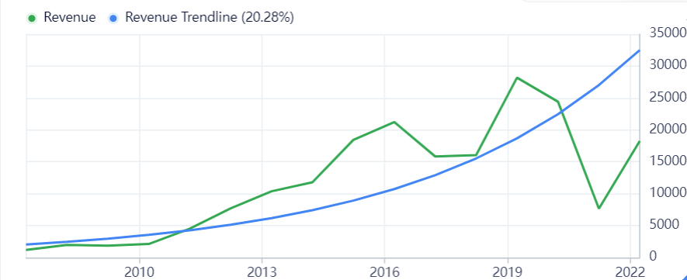

Here we can see a decline in revenues during the covid phase but we can clearly see in the graph that after the lockdown period is over the actual revenue line is slowly approaching towards the trendline. Now analyzing the Net income

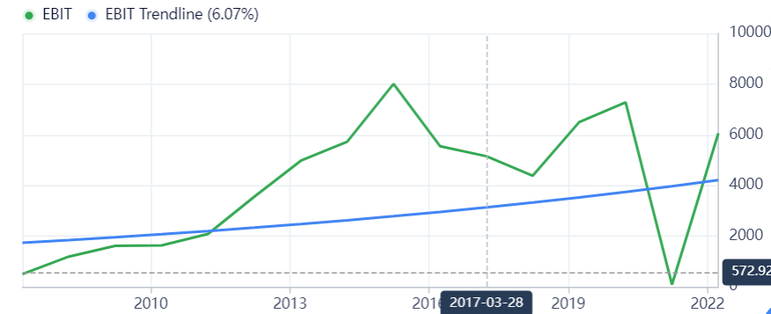

Here also net income is approaching the trendline hence it’s approaching towards actual line so our approximations are correct hence growth rate in net income would be (6.07%) here we would only be considering Net noncash income.

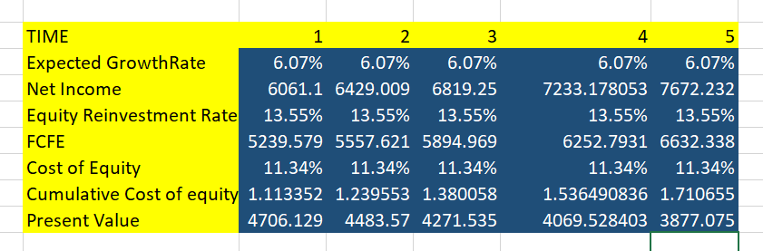

These are all the calculations associated with the FCFE model we calculated it in excel. Then for Terminal value calculation we would be requiring stable phase equity reinvestment rate

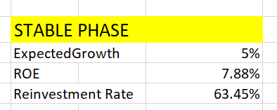 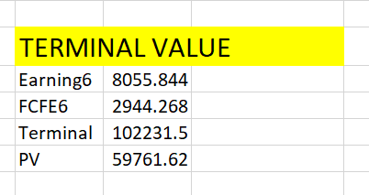

We can see that the Reinvestment Rate was coming close to 63.15% in the Stable Phase.

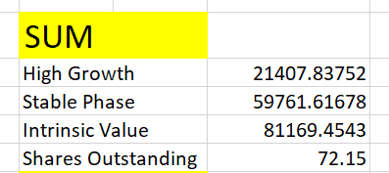 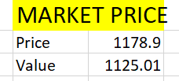

Summing up all the values of High Growth phase as well as the stable phase we are getting the intrinsic value of the firm to be equal to Rs.81169.4543 Cr. Dividing that by number of shares outstanding we are getting the Intrinsic value per share equal to **Rs.1125.01**/share since market price is **Rs.1178.9** Hence this share is coming **Overvalued**.

Prestige Estate Projects Ltd:

Now using the same python code we have found that the reinvestment rate of Prestige Estate Projects Ltd. was coming out to be 12.65%.Now for calculating the expected growth rate in income we have analyzed past 10 years data on revenue as well as EBIT

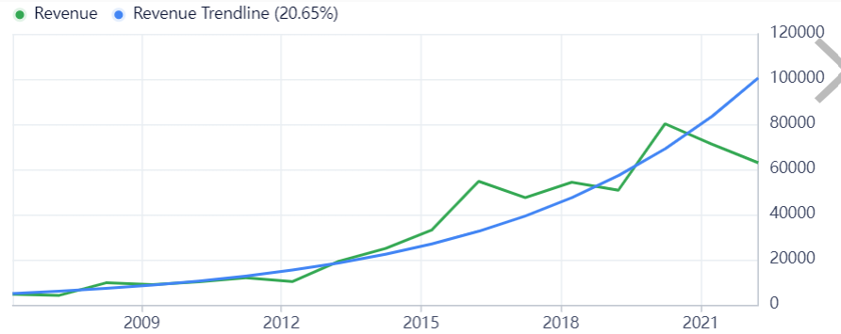

Herer we can see that the revenue is just approaching to the trend line hence we can make the assumption for sure that it would be growing at the rate of 20.65%.

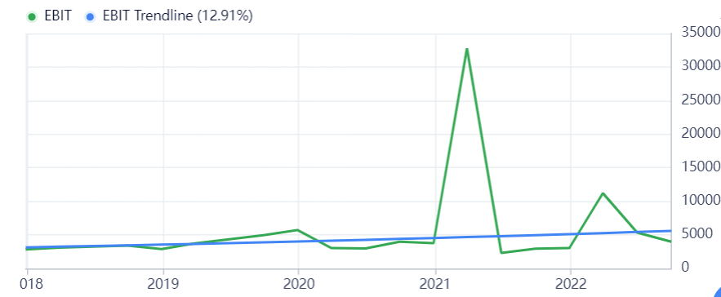

Here we can see that the Ebit figures were coming negative for some time period so we have used smoothing constants to adjust for that and then we have plotted graph and then got the value of 12.91 % as the growth rate in EBIT. As we can also see the spike just after the lockdown as operating income would just have increased to a good amount just after the lockdown period was over.

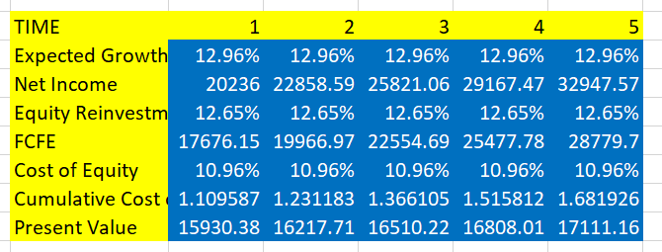

Now we have done the FCFE calculations using the same formula as it was given above in the introduction we have subtracted the Reinvested equity from the Net income for FCFE and have calculated the present values as follows Now we will be evaluating the Terminal Values.

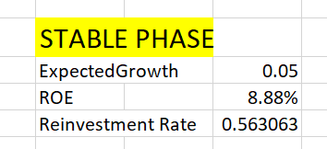 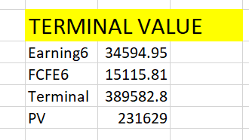

As we can see from the table above that we are getting the Reinvestment Rate to be equal to 56.3% for the stable period then for terminal value calculation we are getting the PV as Rs.231626 Cr.

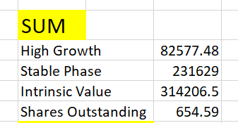 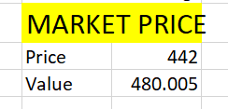

Hence now we are getting the Intrinsic value to be equal to Rs.480.005 /share Since it is greater than that of Rs.442/share which is the market price hence we can conclude that the share is Undervalued in the market.

Brigade Enterprises Ltd:

Using the same python code whose copy is attached above we calculated the reinvestment rate for the firm and it was coming about 17.82%.Now to analyze the profits, revenues as well as the net income we have plotted some of the graphs which we do need to analyze as

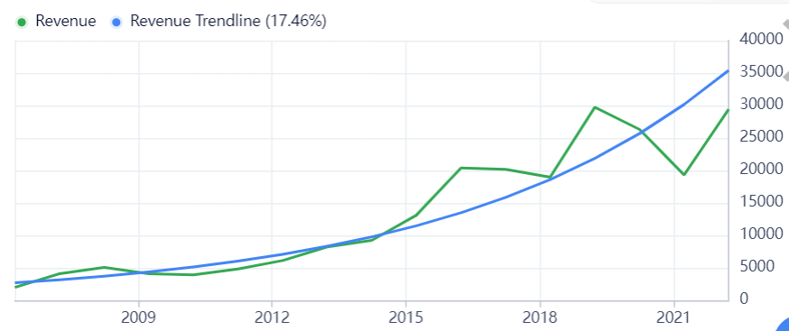

Here we can see that the revenue is slowly approaching towards the trendline and hence we can use the Revenue growth rate as 17.46%

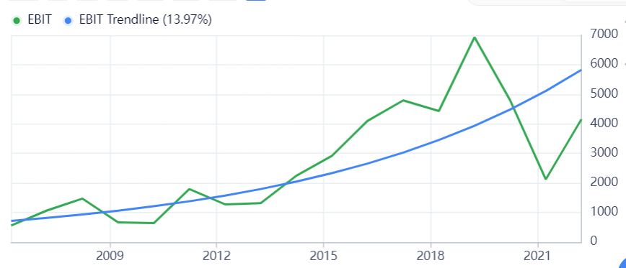

Ebit is also growing at an average rate of 13.97% hence we can use this value as we can see that the revenue is just approaching towards the trendline so this would be the appropriate growth rate so we can move further with the valuation as follows

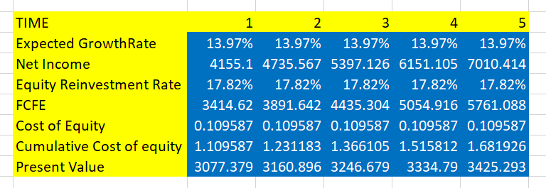

Here we have computed the present values of FCFE using Excel and have used cumulative cost of equity to discount it further.

Now for the stable phase we are having the data as follows:

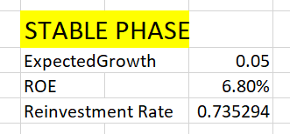 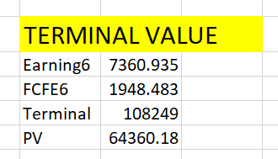

Now we have got the Terminal value from the 6th year component as Rs.64360.18 Cr.

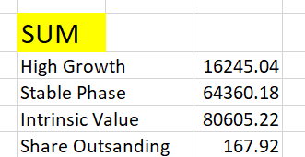 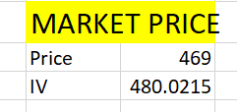

As we can see from the above table that the Intrinsic value of the stock is coming as Rs.480/share Since it is coming slightly greater than the market price hence we can conclude from here that the share is **undervalued.**

SUMMARY

* Prestige Estate Projects ltd- Since it is having a high growth using ROE so DDM model works best for it and we are getting a very close value to the actual price of share in the market DDM model in fact works best for Prestige.
* Godrej Properties Ltd- Now since it is not paying dividends and just recently started paying dividends so DDM model did not worked well for it’s valuation as we have calculated it’d dividend by using the average payout and FCFE model works Best for it.
* Brigade – FCFE model works best for it as it’s growth is less so dividend 2 stage and 3 stage model are not giving us the appropriate results rather FCFE model is helping in predicting the intrinsic value of this firm.

REFERENCES

* <https://finance.yahoo.com/>
* <https://www.moneycontrol.com/financials/godrejproperties/balance-sheetVI/GP11>
* Ashwath Damodaran business analysis and valuation book