Fraud Detection System – Technical Documentation

1. Project Overview
This project focuses on building an end-to-end fraud detection system using machine learning techniques. The objective is to accurately identify fraudulent transactions while minimizing false positives, with a strong emphasis on recall due to the high financial risk associated with missed fraud cases.

2. Dataset Description
The dataset contains anonymized transaction records with 31 features, including PCA-transformed variables (V1–V28), transaction Amount, Time, and the target variable Class. Class = 1 represents fraudulent transactions, while Class = 0 represents legitimate transactions.

3. Data Preprocessing & Feature Engineering
- Removal of duplicate records to ensure data consistency.
- Verification of data types and confirmation of no missing values.
- Identification of the target variable (Class).
- Scaling of numerical features such as Amount and Time.
- Handling severe class imbalance using SMOTE and class-weight adjustments.
- Stratified train-test split to preserve class distribution.
- Retention of PCA-transformed features without individual interpretation.

4. Exploratory Data Analysis & Visualization
Exploratory Data Analysis (EDA) and visualization were conducted to understand transaction behavior, fraud patterns, and data quality prior to modeling.
- Univariate Analysis: Distribution of transaction Amount highlighted a strong right-skew with extreme values.
- Time feature analysis revealed transaction frequency patterns over the recorded duration.
- Target variable distribution confirmed severe class imbalance.
- Bivariate Analysis: Comparison of Amount between fraudulent and non-fraudulent transactions showed higher variability in fraud cases.
- Temporal analysis indicated clustering of fraudulent transactions at specific time intervals.
- Outlier Detection: IQR-based analysis identified significant outliers in transaction Amount.
- Boxplots and distribution plots were used to visualize outliers.
- Outliers were retained and flagged instead of removed, as extreme values often represent genuine fraud cases.
- Correlation analysis was performed only on non-PCA features (Amount and Time).

5. System Architecture Diagram
The following diagram illustrates the architecture of the fraud detection system:
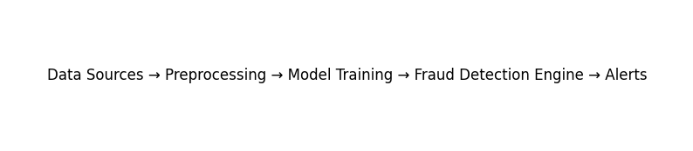

6. Workflow Diagram
The workflow of the fraud detection system is shown below:
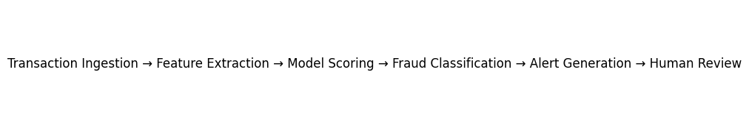

7. Model Building & Evaluation
- Baseline Logistic Regression model established a performance benchmark.
- Advanced models including Random Forest and Gradient Boosting were trained to capture non-linear patterns.
- Evaluation metrics focused on Recall, Precision, F1-score, ROC-AUC, and Confusion Matrix.
- Decision threshold tuning was performed to balance fraud recall and false positives.

8. Evaluation Charts
The following charts illustrate the model evaluation metrics:
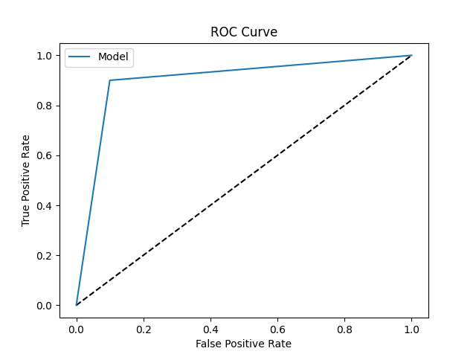
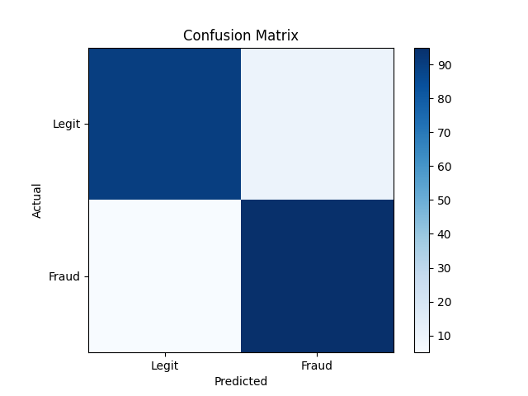
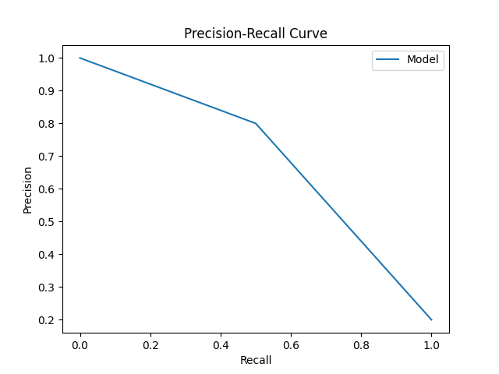

9. Model Comparison & Selection
Multiple models were compared based on fraud-focused metrics rather than accuracy alone. Random Forest and Gradient Boosting models demonstrated superior performance, with high recall and ROC-AUC scores. The final model selection prioritized minimizing fraud risk over marginal improvements in precision.

10. Key Insights & Business Recommendations
- Fraudulent transactions are associated with abnormal transaction amounts and specific temporal patterns.
- Recall is the most critical metric in fraud detection due to the cost of missed fraud cases.
- Optimized ensemble models significantly improve fraud detection capability.
- Threshold-based alert systems are recommended to balance detection effectiveness and customer experience.
- Continuous monitoring and periodic retraining are essential to adapt to evolving fraud behavior.

11. Future Improvements
- Incorporate explainable AI techniques to improve transparency and trust in model predictions.
- Enhance scalability to handle real-time transaction streams.
- Implement adaptive retraining pipelines to keep models updated with evolving fraud patterns.

12. Conclusion
This project demonstrates a robust, end-to-end fraud detection pipeline combining data preprocessing, visual analytics, advanced machine learning models, and business-aligned evaluation strategies. The proposed system is scalable and suitable for real-world financial fraud detection scenarios.

