Project 3 – Part B: Alteryx Workflow Report

1. Alteryx Workflow Screenshot
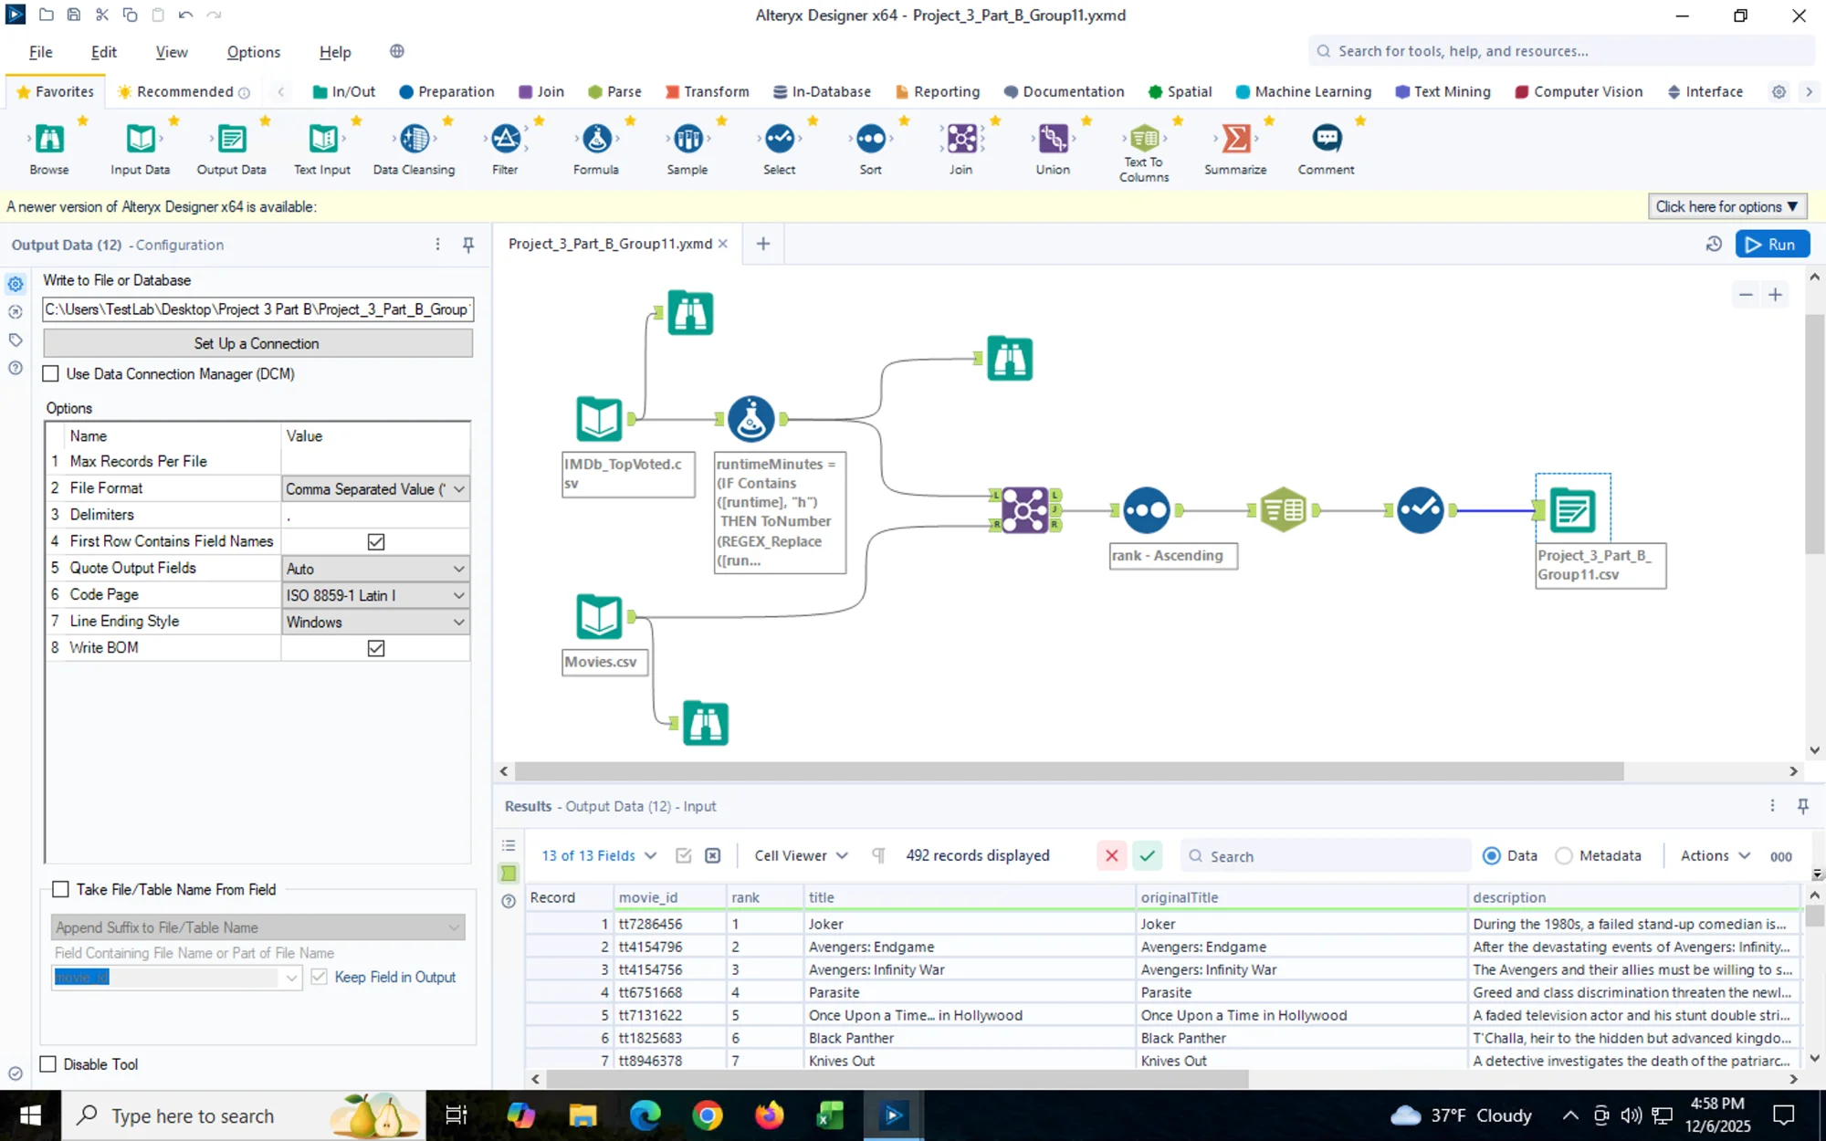
Figure 1: Alteryx workflow for data cleaning, transformation, and integration of IMDb movie data.
The workflow consists of the following key components:
- Input Data Tools: Two input data tools load the IMDb_TopVoted.csv and Movies.csv datasets.
- Formula Tool: Converts the runtime field from text format (e.g., "2h 2m") to numerical minutes using conditional logic to extract hours and minutes components.
- Join Tool: Performs an inner join on the movie_id field to merge both datasets, retaining only matching records.
- Text to Columns Tool: Splits the comma-separated genres field into three separate columns (genre01, genre02, genre03).
- Select Tool: Removes the original genres column and reorders columns for optimal data organization.
- Sort Tool: Sorts the dataset by rank in ascending order (1 to 500).
- Output Data Tool: Exports the final enriched dataset as Project_3_Part_B_Group11.csv.

2. Data Used for Enrichment

2.1 Source Datasets
Two datasets were used in this data enrichment process:
Primary Dataset: Movies.csv
The client's original dataset contained 500 movie records with the following attributes:
Field | Description
movie_id | Unique identifier for each movie (e.g., tt7286456)
originalTitle | The original title of the movie
description | A brief synopsis or plot summary of the movie
ratingCategory | Content rating classification (e.g., R, PG-13, PG)
genres | Comma-separated list of genres associated with the movie
Secondary Dataset: IMDb_TopVoted.csv
This dataset was scraped from the IMDb website and contains the top 500 movies released between 2018 and 2020, sorted by the number of user votes in descending order. The scraped data includes:
Field | Description
movie_id | Unique identifier matching the primary dataset
rank | Position in the top-voted list (1-500)
title | Display title of the movie
runtime | Duration of the movie (e.g., "2h 2m")
year | Year of release
rating | Average user rating on a scale of 1-10
votes | Total number of user votes (e.g., "1.7M", "936K")

2.2 Enrichment Value
The enrichment process added significant analytical value to the client's data by incorporating:
- Popularity Metrics: The rank and votes fields provide insight into audience engagement and movie popularity, enabling analysis of which movies resonated most with viewers.
- Quality Indicators: The rating field offers a quantitative measure of perceived movie quality based on aggregated user opinions.
- Temporal Context: The year field allows for trend analysis across the 2018-2020 time period.
- Duration Information: The runtime (converted to runtimeMinutes) enables analysis of movie length patterns and their relationship to ratings or popularity.

3. Data Cleaning and Transformation

3.1 Overview
The data cleaning and transformation process was essential to ensure data quality, consistency, and compatibility between the two datasets before merging. The following transformations were implemented using Alteryx:

3.2 Data Type Conversions
Several fields required data type changes to enable proper analysis and calculations:
Field | Original Type | Converted Type | Reason
rank | String | Integer (Int32) | Enable numerical sorting and ranking operations
year | String | Integer (Int16) | Enable temporal analysis and filtering
rating | String | Double | Enable statistical calculations and comparisons
votes | String | Integer (Int64) | Enable numerical aggregation and sorting

3.3 Votes Transformation
The votes field presented a unique cleaning challenge as IMDb displays vote counts in abbreviated format for readability. The transformation logic applied was:
- Values containing "M" (millions): Multiplied by 1,000,000
Example: "1.7M" → 1,700,000
- Values containing "K" (thousands): Multiplied by 1,000
Example: "936K" → 936,000
- Values with commas: Removed commas and converted to integer
Example: "45,678" → 45678
This transformation ensures consistent numerical representation for accurate sorting and statistical analysis.

3.4 Runtime Transformation
The runtime field required conversion from a text-based duration format to a numerical value representing total minutes:
Transformation Logic:
- Extract hours component (if present) and multiply by 60
- Extract minutes component (if present)
- Sum both values to get total runtime in minutes
Examples:
Original Value | Transformed Value (runtimeMinutes)
"2h 2m" | 122
"1h 57m" | 117
The column was also renamed from "runtime" to "runtimeMinutes" to clearly indicate the unit of measurement.

3.5 Data Integration (Join Operation)
The two datasets were merged using an inner join operation:
- Join Key: movie_id (common identifier in both datasets)
- Join Type: Inner join (retains only matching records)
- Result: Combined dataset containing all fields from both sources for movies that exist in both datasets

3.5.1 Join Results and Non-Matching Records
An inner join was performed to ensure only movies existing in both datasets were retained. This process resulted in 492 matching records out of the original 500 movies in each dataset. The join produced three outputs:
- Join (J): 492 records that matched on movie_id in both datasets
- Left (L): 8 records from IMDb_TopVoted.csv that did not have a match in Movies.csv
- Right (R): 8 records from Movies.csv that did not have a match in IMDb_TopVoted.csv
Non-Matching Records from IMDb_TopVoted.csv (Left Output):
The following 8 movies from the scraped IMDb data were not found in the client's Movies.csv dataset:
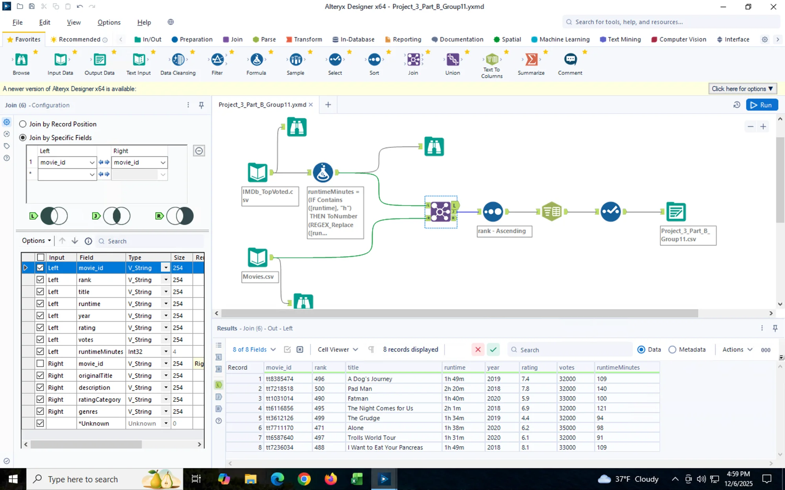
Figure 2: Left output showing 8 non-matching records from IMDb_TopVoted.csv
Sample non-matching movies from IMDb data include:
- A Dog's Journey (tt8385474) - Rank 496
- Pal Alto (tt7218526) - Rank 500
- Fatman (tt1031014) - Rank 490
- The Night Comes for Us (tt6116856) - Rank 495
Non-Matching Records from Movies.csv (Right Output):
The following 8 movies from the client's Movies.csv dataset were not found in the scraped IMDb_TopVoted.csv data:
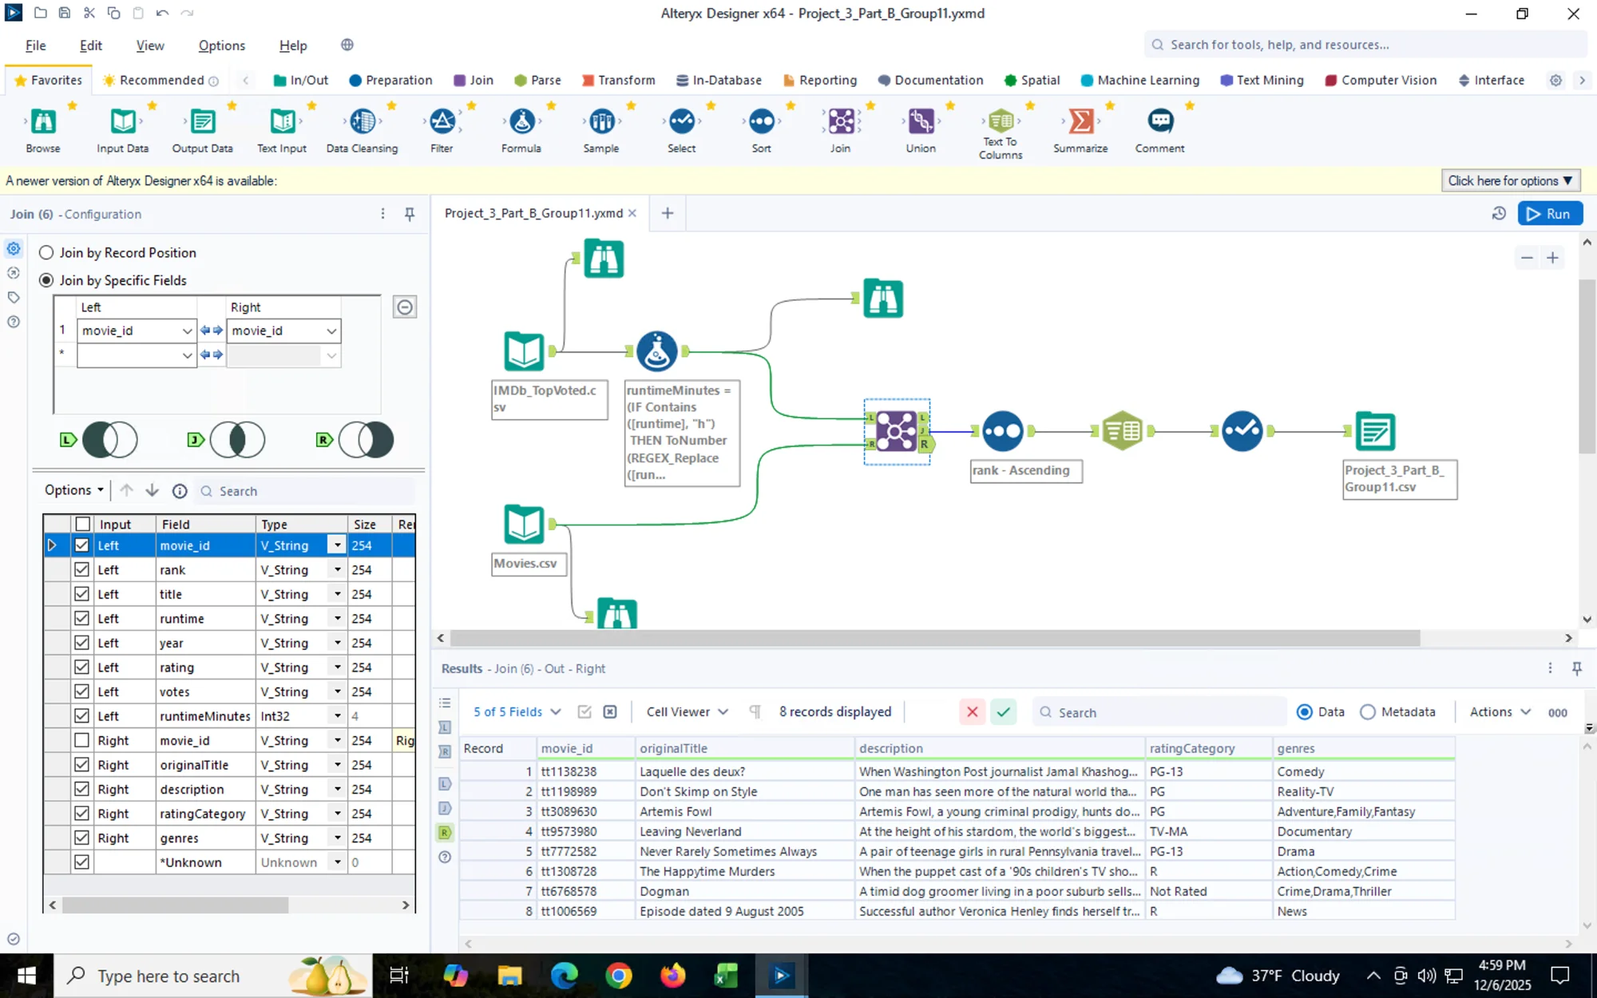
Figure 3: Right output showing 8 non-matching records from Movies.csv
Sample non-matching movies from client data include:
- Laquelle des deux? (tt1158238)
- Don't Say a Word (tt0198989)
- Artemis Fowl (tt3089630)
- Leaving Neverland (tt9573980)
Explanation of Discrepancies:
The 8 non-matching records in each dataset can be attributed to several factors:
- Different selection criteria: The IMDb data was scraped based on vote counts, while the client's data may have been collected using different criteria or time periods.
- Data collection timing: Movies may have been added or removed from the top 500 list between when the client collected their data and when the IMDb scraping occurred.
- Regional variations: Some movies may have different popularity rankings or availability in different regions.

3.6 Sorting
The enriched dataset was sorted by the rank field in ascending order (1 to 492), organizing movies from most popular to least popular based on user vote counts.

3.7 Column Reorganization
The dataset columns were rearranged into a logical order that groups related information together:
- movie_id – Primary identifier
- rank – Popularity ranking
- title – Display title
- originalTitle – Original title
- description – Plot summary
- year – Release year
- votes – Vote count
- rating – User rating
- runtimeMinutes – Duration in minutes
- ratingCategory – Content rating
- genre01 – Primary genre
- genre02 – Secondary genre
- genre03 – Tertiary genre

3.8 Genre Splitting and Column Removal
The genres field originally contained multiple genre values in a comma-separated format (e.g., "Action, Drama, Thriller"). This field was split into three separate columns to enable easier filtering and analysis by individual genres:
Original Field | New Fields
genres | genre01, genre02, genre03
Example Transformation:
Original genres | genre01 | genre02 | genre03
"Crime, Drama, Thriller" | Crime | Drama | Thriller
"Comedy, Drama" | Comedy | Drama | (empty)
"Horror" | Horror | (empty) | (empty)
After the genre splitting operation, the original genres column was removed from the final dataset using the Select tool. This decision was made to:
- Eliminate data redundancy, as the information is preserved in the three individual genre columns
- Simplify the dataset structure for easier querying and analysis
- Enable more efficient filtering and grouping operations by individual genre values

4. Final Output
The enriched, cleaned, and transformed dataset was exported as:
Filename: Project_3_Part_B_Group11.csv
Total Records: 492 movies (from the 492 matched records in the inner join)
Final Schema:
Column | Data Type | Description
movie_id | String | Unique movie identifier
rank | Integer | Popularity rank (1-492)
title | String | Movie display title
originalTitle | String | Original movie title
description | String | Plot summary
year | Integer | Release year (2018-2020)
votes | Integer | Total user votes
rating | Double | Average user rating (1-10)
runtimeMinutes | Integer | Movie duration in minutes
ratingCategory | String | Content rating (R, PG-13, etc.)
genre01 | String | Primary genre
genre02 | String | Secondary genre (if applicable)
genre03 | String | Tertiary genre (if applicable)

5. Conclusion
The Alteryx workflow successfully automated the data cleaning, transformation, and integration process that was initially performed manually in Python (Part A). The workflow provides a repeatable, visual solution that can be easily modified and executed to process similar datasets in the future.
Key achievements of this workflow include:
- Data Integration: Successfully merged 492 matching records from two independent datasets using movie_id as the common key.
- Data Quality: Implemented comprehensive data type conversions and transformations to ensure analytical readiness.
- Data Structure: Optimized the dataset structure by splitting genres into separate columns and removing redundant fields.
- Transparency: Documented non-matching records to provide complete visibility into data discrepancies and integration results.
The enriched dataset now contains comprehensive movie information combining the client's original data with valuable IMDb metrics, enabling deeper analysis of movie popularity, quality, and characteristics. The 492-record dataset represents movies that exist in both data sources and can be confidently used for further analysis and business intelligence applications.

