APPLIED MACHINE LEARNING | PROJECT T036
Traffic Flow Prediction and Signal Control via Graph Attention Networks and Flow Models
Project report: the AML phase (Phases 0 to 4)
Author: Manas Saxena
Contributors: Harsh Raj (project setup, data loading and exploratory analysis, Phases 0 and 1); Sumit (GitHub: sumit316-glitch; interactive Streamlit dashboard)
Date: 26 October 2026
Repository: https://github.com/ManasSaxena14/TrafficFlowControl_AIML-DL_T036
Report generated from commit: 101ec90 (23 commits at that point)

Scope and integrity note. This report covers work completed to date: the data, a leak-free preprocessing pipeline, six forecasting baselines, and four experiments that measure what independent per-sensor models miss. Every number, table and figure is generated from files in the repository (results/, reports/figures/, data/processed/ and git history) by scripts/report/collect_data.py, so each claim can be traced to its source (Appendix C). Graph deep-learning models (Phase 5) are not yet built and no results are claimed for them.

Contents
1 Executive summary
2 Objectives and scope
3 Data: METR-LA
4 Methodology
5 Results: forecasting baselines (Phase 3)
6 Results: identifying the gap (Phase 4)
7 Engineering and reproducibility
8 Limitations and threats to validity
9 Conclusions and next steps
Appendix A Test MAE at every horizon
Appendix B Validation scores
Appendix C Provenance: result to source file
Appendix D Commit history

1 Executive summary
The project asks whether a model that sees the road network forecasts traffic speed better than strong per-sensor models, and where any gain comes from. The AML phase builds and tests the per-sensor side of that question using METR-LA, 207 freeway sensors in Los Angeles sampled every 5 minutes over four months, with forecasts 5 to 60 minutes ahead. Signal control is a simulation-only extension and is not claimed anywhere in this work.
What was done. A chronological, leak-free preprocessing pipeline with outage masking; a 46-column feature table; six baselines (persistence, historical average, Ridge, XGBoost, Random Forest, and an LSTM without a graph) scored with one shared evaluation path (masked MAE, RMSE and MAPE by horizon, plus peak and off-peak); and four experiments that measure where independent per-sensor models fail.
Table 1. Headline results (test block, MAE in mph; lower is better)
Model | 15 min | 30 min | 60 min | Pooled MAE
Persistence | 3.49 | 4.20 | 5.37 | 4.23
Historical average | 4.42 | 4.42 | 4.42 | 4.42
Ridge per sensor | 3.31 | 4.08 | 5.17 | 4.08
Random Forest | 3.08 | 3.68 | 4.45 | 3.64
LSTM (no graph) | 2.97 | 3.55 | 4.35 | 3.54
XGBoost | 3.02 | 3.51 | 4.01 | 3.44
XGBoost + neighbour speeds (both directions) | 2.91 | 3.42 | 3.95 | not computed

Key findings
- XGBoost is the strongest independent baseline. Test MAE 3.02, 3.51 and 4.01 mph at 15, 30 and 60 minutes: 14% lower than persistence at 15 minutes and 25% lower at 60 minutes. The LSTM is marginally better at 15 minutes (2.97) and worse from 30 minutes on.
- Rush hour is hardest. Every model's weekday-peak error is 1.4 to 1.95 times its off-peak error (XGBoost at 30 minutes: 5.22 vs 3.01 mph).
- The per-sensor model fails where congestion propagates. In the 30 minutes after a congestion onset XGBoost's MAE is 16.2 mph at 15 minutes against 2.7 mph at other times (5.9 times worse; 3,911 onsets in the test period). Errors of directly linked sensors correlate (0.20 at 60 minutes) while errors of unconnected sensors do not (0.00).
- Neighbour information helps, but not enough. Adding hand-made upstream and downstream speed features lowers test MAE at every horizon (both directions: 3.5%, 2.6% and 1.4% at 15, 30 and 60 minutes; 11% right after onsets at 15 minutes). Linked errors stay correlated, which is the case for a model that learns which neighbours matter over several hops (Section 6.4).
- Reproducible. 23 commits, 39 automated tests (12 of them leakage tests), make targets for every stage, and an interactive dashboard.

2 Objectives and scope
The project brief defines a hybrid logic: start with segment-level machine learning, identify what it cannot represent, then test a network-aware deep-learning model. Table 2 maps the brief to the work in this repository.
Table 2. Brief requirements and status
Requirement from the brief | Where addressed | Status
AML baseline on lagged speed, time of day and road-segment features | 46-column feature table (Section 4.2) | Done
Flow and occupancy features | Not available in METR-LA (speed only); PeMS planned for Phase 9 | Data limit
XGBoost per segment or multi-output Random Forest | Both implemented (Section 4.3) | Done
Identify the gap: independent models cannot represent upstream and downstream propagation | Four experiments (Section 6) | Done
Fair comparison: chronological splits; MAE, RMSE, MAPE by horizon; equal history; peak vs off-peak | Applied to all baselines (Sections 4 and 5); final comparison with graph models in Phase 6 | Baselines done
Mask sensor outages; fit scaling on training data only; cyclic time features; no random splits | Preprocessing pipeline with 12 leakage tests (Section 4.1) | Done
Deep-learning model: graph attention or diffusion model over the road graph | Phase 5 | Not started
Congestion maps; optional simulated signal-control experiment | Phases 7 and 8; signal control is simulation only | Not started

3 Data: METR-LA
METR-LA contains speed readings (mph) from 207 loop detectors on Los Angeles freeways, one reading every 5 minutes from 2012-03-01 to 2012-06-27: 34,272 timestamps per sensor with no gaps. The sensor graph is the one distributed with the DCRNN reference implementation: a directed Gaussian-kernel adjacency matrix built from road-network distances. Column order of the speed matrix was verified against the adjacency order, and this is enforced in code and in tests.
Table 3. Dataset facts (results/phase1_findings.json)
Property | Value
Sensors; timestamps per sensor | 207; 34,272
Period | 2012-03-01 to 2012-06-27 (training period for exploration ends 2012-05-23 07:05)
Readings equal to 0 mph (sensor down) | 8.11% (whole-network outages 6.27 points; isolated sensor outages 1.84 points)
Whole-network outages | 2,148 timestamps; longest 31.8 hours
Worst single sensor | 718076, down 20.1% of the time
Weekday free-flow speed; weekend minimum | 63.2 mph; 56.7 mph
Weekday dips below 90% of free flow | 07:05 to 10:45 (low 49 mph); 14:30 to 19:15 (low 45.7 mph)
Speed distribution | median 63.22 mph; 66.36% of readings at least 60 mph; 10.5% below 40 mph; 2.75% below 20 mph
Graph | 207 nodes, 1,515 directed links, mean degree 7.32, 26.67% of links two-way, 1 isolated sensor, 2 weak components

3.1 Missing data
8.11% of all readings are 0 mph, which means the sensor was down, not that traffic stopped. Of this, 6.27 percentage points are whole-network outages (all 207 sensors at once, i.e. logging failures) and only 1.84 points are single-sensor failures. Treating zeros as traffic would teach a model that roads randomly stop; all later stages therefore mask them.
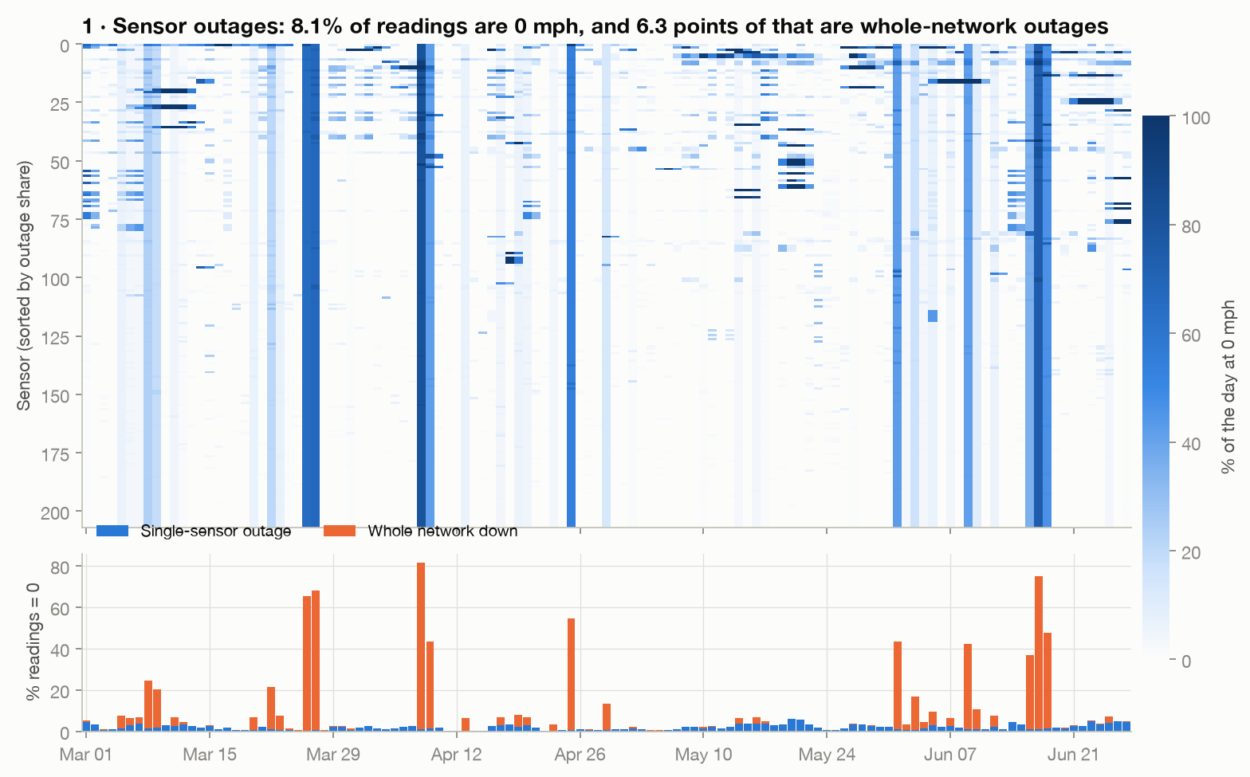
Figure 1. Missing data by sensor and day, and the share explained by whole-network outages.

3.2 Daily rhythm and the need for time features
Weekday speeds dip in the morning and, more deeply, in the afternoon; weekend speeds stay above 56.7 mph. Detected dips (below 90% of free flow for over 30 minutes) are 07:05 to 10:45 and 14:30 to 19:15; the brief's fixed peak definition (weekdays 07:00 to 09:59 and 16:00 to 19:59) lies inside them and is used for all peak results. Because 66.36% of readings are free-flowing, an average error is dominated by easy periods, which is why peak and congestion-onset results are reported separately.
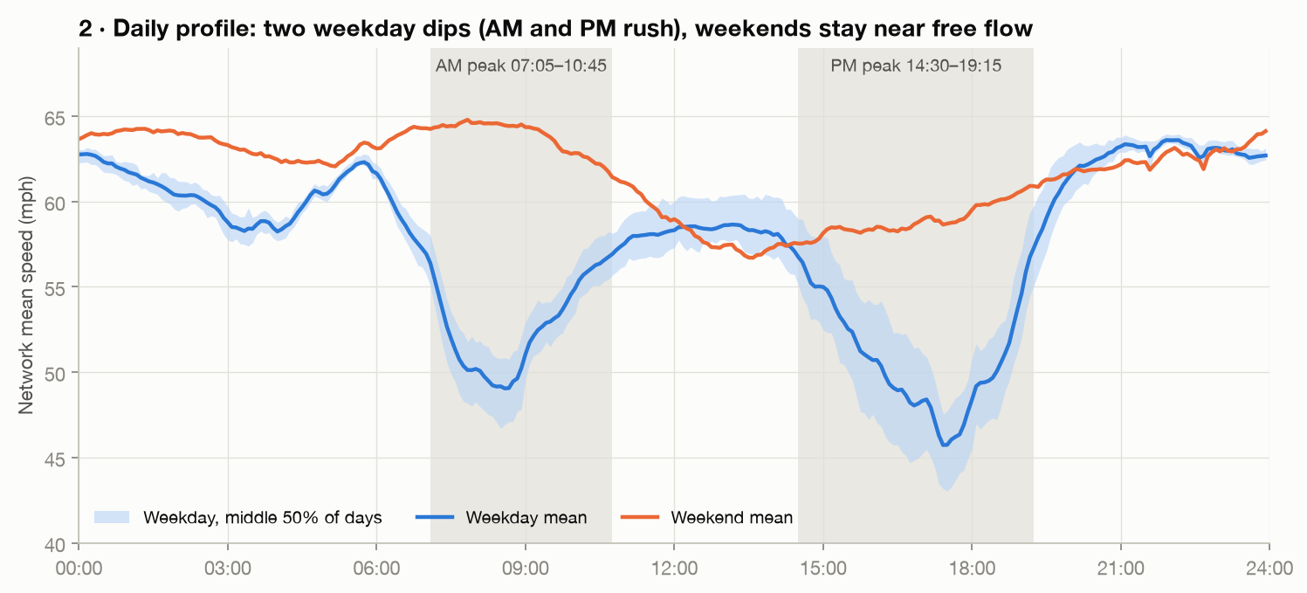
Figure 2. Network-mean speed by time of day, weekday versus weekend (training period only).

3.3 Congestion propagates backwards along the graph
To test whether neighbouring sensors carry information, each sensor's typical daily pattern was subtracted and the remaining disturbance was cross-correlated along every directed link (training period only). 62.2% of the 1,515 links are weak (peak correlation below 0.3). Of the 499 links with a clear peak, 60.5% co-move within one 5-minute step, the downstream sensor moves first on 156 links and the upstream sensor first on 41. The implied backward wave speed is about 16 km/h. A jam therefore shows up at the downstream neighbour before the upstream sensor, which a model that sees only its own history cannot anticipate.
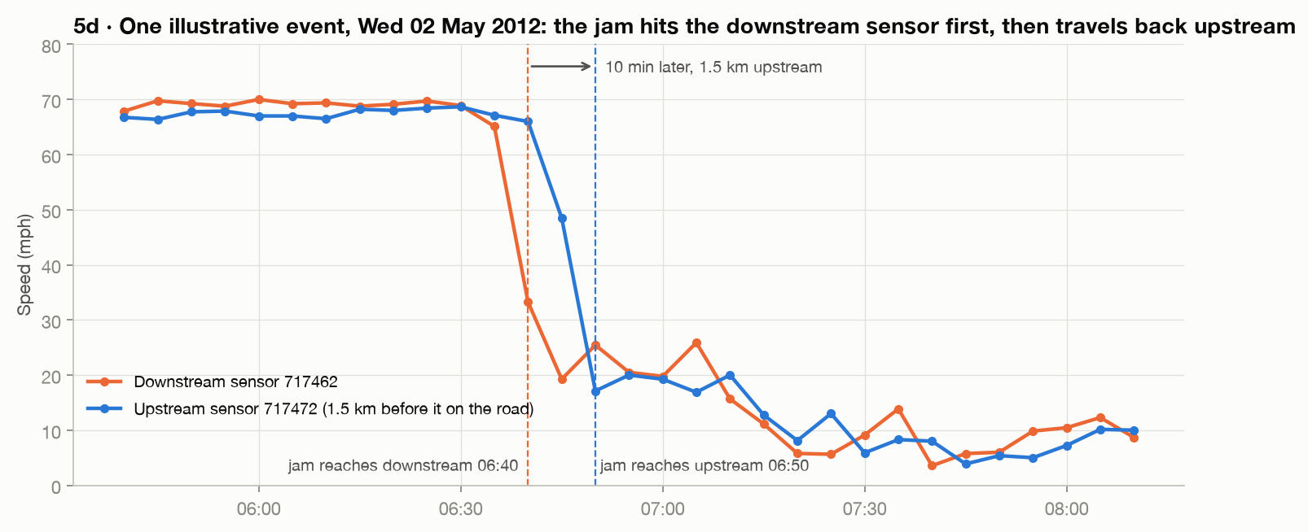
Figure 3. Worked example (2 May 2012): the downstream sensor drops to about 20 mph at 06:40 while the upstream sensor is still at about 66 mph. An illustration chosen by a rule; the evidence is the all-link statistics above.

4 Methodology

4.1 Leak-free preprocessing (Phase 2)
One shared pipeline feeds every model, so the comparison is fair by construction.
- Chronological split with a purge gap. Timestamps are split 70, 10 and 20 percent into train, validation and test blocks; a window is kept only if all 12 of its target timestamps lie inside one block. Windows whose targets straddle a boundary are purged (11 per boundary), so no target timestamp appears in two splits. Inputs may look back into earlier data, which is the past and not a label.
- Outage masking. 0 mph becomes missing. Input gaps are forward-filled from the last real reading inside the same 12-step window, otherwise from the training mean of that sensor and time-of-day slot, and a mask channel marks imputed values. Targets stay missing (NaN); every loss and metric ignores them. Training windows whose targets are over 90% masked (mostly whole-network outages) are dropped; validation and test keep every window.
- Scaling on training data only. Mean 58.58 mph and standard deviation 12.82 mph over training timestamps, ignoring outages. All errors are reported in mph after inverse scaling.
- Cyclic time features. Sine and cosine of time of day and of day of week, plus a weekend flag, so 23:55 and 00:05 are neighbours.
- Adjacency. Rebuilt from the road-distance file (Gaussian kernel, sigma equal to the standard deviation of finite distances, threshold 0.1) and asserted equal to the supplied matrix; it stays directed and fixed.
- Windows. Input: the last 12 steps (60 minutes). Output: the next 12 steps (5 to 60 minutes). Every model, including the tree models, uses this same history.
Table 4. Strict split: windows, target periods and masked targets (data/processed/strict)
Split | Windows | Rows (windows x 207) | First target | Last target | Masked targets
train | 22,933 | 4,747,131 | 2012-03-01 01:00 | 2012-05-23 07:05 | 2.96%
val | 3,417 | 707,319 | 2012-05-23 07:10 | 2012-06-04 04:45 | 6.98%
test | 6,843 | 1,416,501 | 2012-06-04 04:50 | 2012-06-27 23:55 | 12.12%
The training block excludes 1,034 windows dropped by the 90% masking rule. The test block has a much higher share of masked targets (12.12%) than training (2.96%) because the test period contains more outages; metrics ignore masked points, but this is one reason test errors are not directly comparable with validation errors.
Table 5. Why the purge matters: strict split versus the DCRNN reference split
 | Strict (used) | DCRNN reference (comparison only)
Split unit | Timestamps, then windows | Windows
Last train target | 2012-05-23 07:05 | 2012-05-23 07:40
First validation target | 2012-05-23 07:10 | 2012-05-23 06:50 (before last train target)
Scaler mean / std (mph) | 58.58 / 12.82 (outages excluded) | 54.41 / 19.49 (0 mph outages included)
Both protocols are implemented so published numbers can be compared later. The reference split lets train and validation targets overlap by 50 minutes; the strict split does not, and a test proves this.

4.2 Feature table for the per-sensor models (Phase 3)
One row is one sensor at one forecast origin; there are 4,747,131 training rows, 707,319 validation rows and 1,416,501 test rows. All 46 columns come from the Phase 2 windows.
Table 6. Feature groups
Group | Columns | Count
Lagged speed | speed at t, t-1, ..., t-11 (imputed where the sensor was down) | 12
Rolling statistics | mean, standard deviation and minimum over the last 3, 6 and 12 steps | 9
Change | speed(t) minus speed(t-1); speed(t) minus speed(t-3) | 2
Missing flags | real-reading flag for each of the 12 lags; number of imputed lags | 13
Time | sin and cos of time of day and of day of week; weekend flag | 5
Segment (training data only) | sensor id, mean speed, free-flow speed (85th percentile), in-degree, out-degree | 5
Flow and occupancy, which the brief lists, are not recorded in METR-LA; adding them requires PeMS data (Phase 9). This is a data limitation, not omitted work.

4.3 Models
Table 7. The six baselines and how each was configured (all selection on validation only)
Rung | Model | Configuration
0 | Persistence | Repeats the last (imputed) speed for all 12 horizons.
1 | Historical average | Training mean per sensor, weekday-or-weekend and 5-minute slot.
2 | Ridge per sensor | One linear model per sensor and horizon (207 x 12) on the 41 time-varying features, standardised per sensor. Regularisation chosen from 1, 10, 100, 1000 on validation: 1000 (validation MAE 3.859 to 3.858, so the choice barely matters).
3 | XGBoost per horizon | One regressor per horizon trained on all sensors stacked, sensor id as a feature, masked targets given weight 0. Maximum depth searched on the 30-minute horizon: 10 gives 3.291, 8 gives 3.342, 6 gives 3.413 validation MAE; depth 10 chosen. Learning rate 0.05, subsample and column sample 0.8, up to 600 rounds with early stopping (50) on validation. Every 2nd window used for training.
4 | Multi-output Random Forest | One forest predicting all 12 horizons: 100 trees, depth 20, minimum leaf 10, 30% bootstrap samples, 50% of features per split. Trained on every 6th window, keeping only rows whose 12 targets are all observed (742,613 rows); evaluated on every test row with the mask.
5 | LSTM, no graph | Two LSTM layers of 64 units with dropout 0.1; one set of weights shared by all 207 sensors; input is each sensor's own 12 x 7 window, output 12 horizons. Masked MAE in mph, Adam (learning rate 0.002, halved on plateau), gradient clipping 5, at most 12 epochs. It ran all 12 epochs; best validation MAE 3.208.
XGBoost and the Random Forest are independent models: a row contains only one sensor's own history, time and static descriptors and never a neighbour's speed. The LSTM shares weights across sensors but also sees no neighbour, so it separates the effect of deep learning from the effect of the graph: if a later graph model beats it, the gain comes from the graph.

4.4 Evaluation protocol
- Metrics. Masked MAE and RMSE in mph and MAPE in percent, computed only where the target is a real reading. MAPE guards against a near-zero denominator with a 1 mph floor.
- Horizons. All 12 horizons (5 to 60 minutes) are stored; headline numbers are step 3, 6 and 12, i.e. 15, 30 and 60 minutes. The pooled column averages over all 12.
- Peak definition. Weekdays 07:00 to 09:59 and 16:00 to 19:59, judged on the timestamp being predicted; other weekday times are off-peak and weekends are reported separately.
- Test discipline. Test numbers are written to results but never used to choose anything; hyper-parameters and early stopping use the validation block only.

5 Results: forecasting baselines (Phase 3)

5.1 Scores on the test block
Table 8. Test scores at 15, 30 and 60 minutes (best in each column in green)
Model | MAE 15 | MAE 30 | MAE 60 | RMSE 15 | RMSE 30 | RMSE 60 | MAPE 15 | MAPE 30 | MAPE 60
Persistence | 3.49 | 4.20 | 5.37 | 6.39 | 8.01 | 10.29 | 8.6 | 10.8 | 14.5
Historical average | 4.42 | 4.42 | 4.42 | 8.08 | 8.08 | 8.08 | 13.9 | 13.9 | 13.9
Ridge per sensor | 3.31 | 4.08 | 5.17 | 5.88 | 7.19 | 8.67 | 8.9 | 11.7 | 15.5
Random Forest | 3.08 | 3.68 | 4.45 | 5.62 | 6.71 | 7.85 | 8.3 | 10.6 | 13.5
LSTM (no graph) | 2.97 | 3.55 | 4.35 | 5.84 | 7.20 | 8.84 | 8.0 | 10.3 | 13.5
XGBoost | 3.02 | 3.51 | 4.01 | 5.47 | 6.41 | 7.28 | 8.2 | 10.1 | 12.0
MAE and RMSE in mph; MAPE in percent. Forecast horizons are in minutes. The pooled averages over all 12 horizons are in Appendix B.
XGBoost has the lowest RMSE at 15, 30 and 60 minutes and the lowest MAE and MAPE at 30 and 60 minutes. The LSTM has the lowest MAE and MAPE at 15 minutes (2.97 against 3.02 mph), a difference of 0.04 mph from a single training run, which should not be over-interpreted. Persistence is a strong floor at 15 minutes, but its MAE grows from 3.49 to 5.37 mph by 60 minutes. The historical average ignores the present, so its error is flat (4.42 mph at every horizon); it beats persistence and Ridge at 60 minutes but not the tree models. Ridge is competitive at 15 minutes but its MAPE at 60 minutes (15.5%) is the worst, because a linear model extrapolates the recent trend too far.
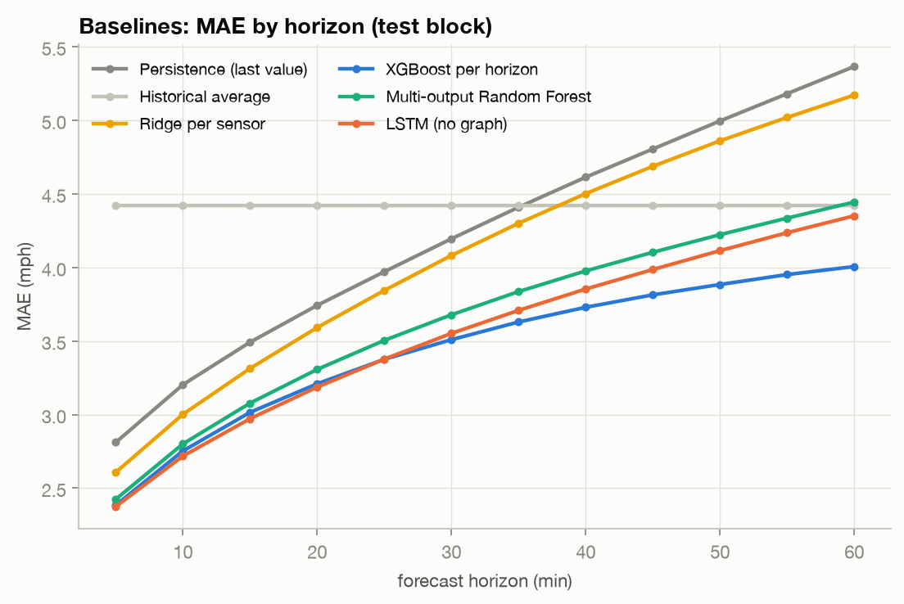
Figure 4. Test MAE by forecast horizon for all six baselines.

5.2 Peak versus off-peak
Table 9. Test MAE (mph) by period at 15 / 30 / 60 minutes
Model | Weekday peak | Weekday off-peak | Weekend
Persistence | 4.61 / 6.05 / 8.32 | 3.25 / 3.74 / 4.62 | 2.86 / 3.31 / 3.98
Historical average | 6.82 / 6.82 / 6.82 | 3.58 / 3.58 / 3.58 | 3.94 / 3.94 / 3.94
Ridge per sensor | 4.58 / 6.02 / 7.93 | 3.00 / 3.56 / 4.40 | 2.71 / 3.27 / 4.10
Random Forest | 4.31 / 5.51 / 7.08 | 2.75 / 3.15 / 3.63 | 2.56 / 3.02 / 3.65
LSTM (no graph) | 4.16 / 5.34 / 6.96 | 2.69 / 3.09 / 3.66 | 2.39 / 2.75 / 3.23
XGBoost | 4.22 / 5.22 / 6.23 | 2.69 / 3.01 / 3.32 | 2.50 / 2.90 / 3.34
Peak-hour error is 1.42 to 1.95 times off-peak error across all models and horizons, and the penalty grows with the horizon. XGBoost's weekday-peak MAE rises from 4.22 to 6.23 mph while its off-peak MAE rises from 2.69 to 3.32 mph. Rush hour is when congestion forms and travels, so this is where a network-aware model has the most to gain. The full table with RMSE, MAPE and sample counts is results/baselines_peak.csv.

5.3 What XGBoost relies on
Table 10. Share of total gain by feature (top 8 per horizon; results/baselines/xgb_importance.csv)
Feature | 15 min | 30 min | 60 min
speed_t | 54.0% | 47.4% | 36.2%
mean_3 | 29.7% | 26.9% | 21.9%
speed_t-1 | 3.8% | 3.4% | 2.5%
mean_6 | 2.6% | 3.0% | 2.7%
cos_tod | 1.3% | 3.0% | 7.1%
sensor_mean | 1.1% | 2.7% | 6.6%
mean_12 | 0.9% | below top 8 | below top 8
sin_tod | 0.9% | 2.1% | 4.9%
free_flow_p85 | below top 8 | 1.2% | 2.5%
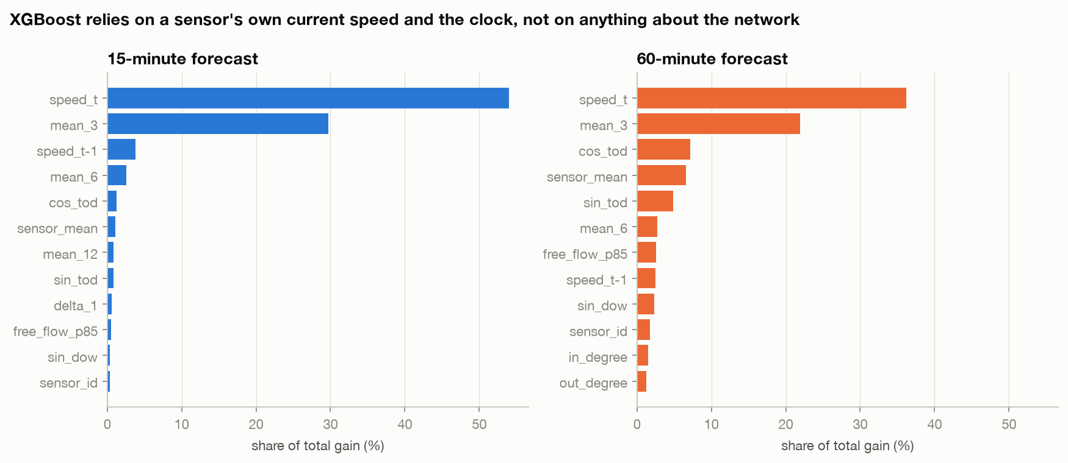
Figure 5. XGBoost feature importance at 15 and 60 minutes.
The model leans on the current speed and its short-term mean at every horizon (current speed 54.0% of gain at 15 minutes, 36.2% at 60), and as the horizon grows the clock and the sensor's typical speed gain weight. Nothing in the feature set describes what is happening elsewhere on the network.

6 Results: identifying the gap (Phase 4)
Phase 1 showed that congestion propagates between sensors. Phase 4 tests whether the best independent model, XGBoost, fails exactly where that propagation matters. All results use the test block and the saved XGBoost predictions.

6.1 Error grows steadily with horizon
XGBoost's MAE rises from 3.02 to 3.51 to 4.01 mph and its RMSE from 5.47 to 6.41 to 7.28 mph at 15, 30 and 60 minutes. Beyond about 15 minutes the jam that will arrive is not yet visible in the sensor's own history; it is at a neighbour.
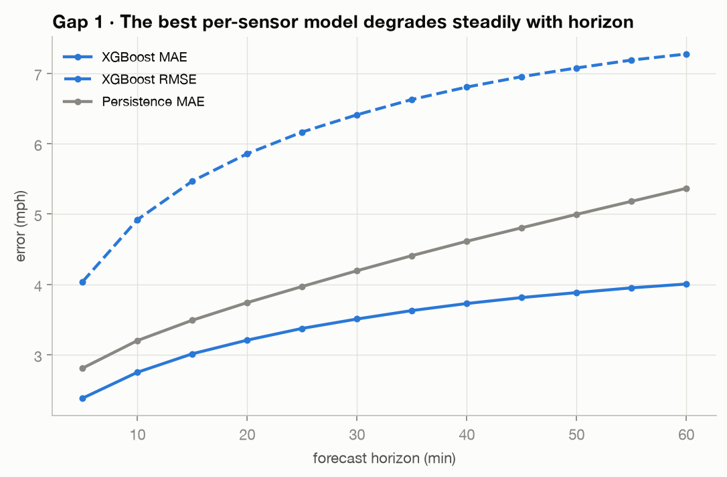
Figure 6. XGBoost error against horizon, with persistence for reference (test block).

6.2 Error at congestion onset
A congestion onset is a speed drop of more than 20 mph within 15 minutes starting from at least 50 mph (3-step rolling median, the Phase 1 definition). A target counts as "after an onset" if it lies within 30 minutes after one at that sensor. The test period contains 3,911 onsets; the affected targets are 2.17% of all real targets.
Table 11. Test MAE (mph) in the 30 minutes after an onset versus other times
Model | Horizon | After onset | Other times | Ratio
XGBoost | 15 min | 16.20 | 2.72 | 5.9x
XGBoost | 30 min | 20.12 | 3.14 | 6.4x
XGBoost | 60 min | 19.09 | 3.67 | 5.2x
Persistence | 15 min | 17.90 | 3.17 | 5.6x
Persistence | 30 min | 25.35 | 3.73 | 6.8x
Persistence | 60 min | 27.15 | 4.88 | 5.6x
XGBoost + neighbours | 15 min | 14.42 | 2.65 | 5.4x
XGBoost + neighbours | 30 min | 18.77 | 3.08 | 6.1x
XGBoost + neighbours | 60 min | 18.89 | 3.62 | 5.2x
XGBoost's error right after an onset is 5.9 to 6.4 times its error at other times. The model keeps forecasting free flow until the slowdown appears in its own lags. Persistence fails the same way and worse, so the cause is the information available, not the learner.
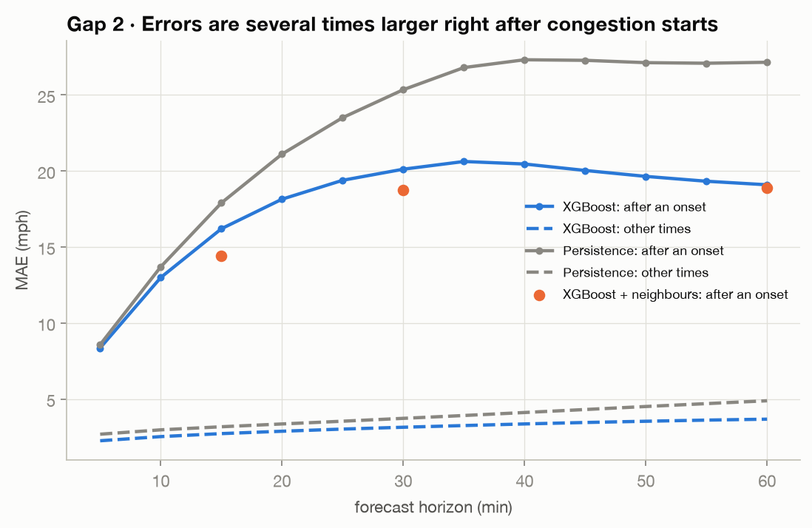
Figure 7. MAE in the 30 minutes after a congestion onset versus other times, by horizon.

6.3 Errors of linked sensors move together
For every pair of sensors, the correlation of their XGBoost residual series (using only timestamps where both are real) was grouped by the number of road links between them.
Table 12. Mean residual correlation by road-graph distance
Pair distance | XGBoost 15 min | XGBoost 30 min | XGBoost 60 min | XGBoost + neighbours 60 min
1 link | 0.115 | 0.158 | 0.200 | 0.197
2 links | 0.019 | 0.031 | 0.050 | 0.044
3 links | 0.010 | 0.014 | 0.025 | 0.020
4+ links | 0.007 | 0.010 | 0.017 | 0.014
not connected | 0.003 | 0.005 | -0.002 | 0.000
Errors are correlated along the road graph and the correlation decays with every link (0.200 for one link, 0.050 for two, about zero for unconnected pairs at 60 minutes). A network-wide cause such as time of day would also correlate unconnected pairs; it does not. Correlation grows with horizon, as expected if the missing information is congestion travelling between sensors. This is an association, not proof of causation.
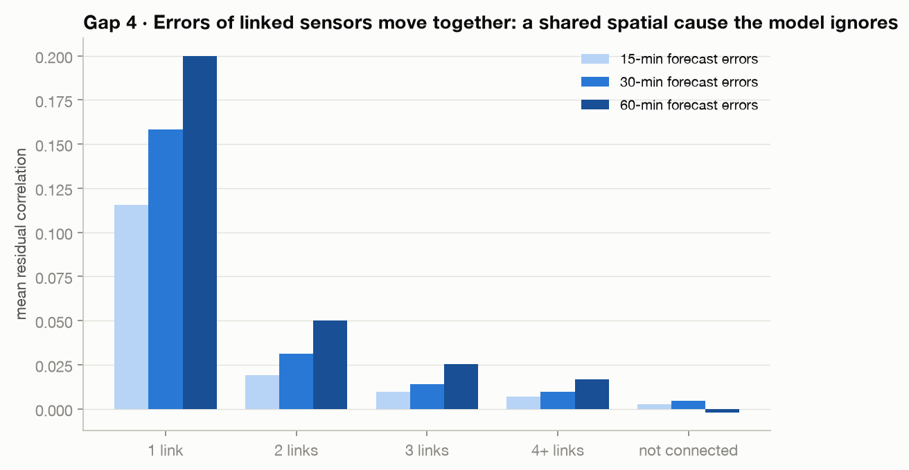
Figure 8. Mean correlation of XGBoost errors between sensor pairs, by road-graph distance.

6.4 Neighbour-information test
The key experiment hands XGBoost hand-made summaries of each sensor's road neighbours: the weighted mean neighbour speed now and 5, 15 and 30 minutes ago, the slowest neighbour now, and the largest 15-minute drop among neighbours. Upstream only (6 features), downstream only (6) and both directions (12) were tested with the same depth, row thinning and early stopping as the base model, without extra tuning. Because of training cost, each variant was trained for the 15, 30 and 60 minute horizons only.
Table 13. Test MAE (mph) and change versus own-history XGBoost
Model | 15 min | 30 min | 60 min | RMSE 15 | MAPE 15 (%)
XGBoost, own history only | 3.015 | 3.510 | 4.006 | 5.47 | 8.2
+ upstream neighbours | 2.971 (-1.5%) | 3.472 (-1.1%) | 3.978 (-0.7%) | 5.37 | 8.0
+ downstream neighbours | 2.945 (-2.3%) | 3.461 (-1.4%) | 3.971 (-0.9%) | 5.26 | 7.8
+ both directions | 2.908 (-3.5%) | 3.418 (-2.6%) | 3.949 (-1.4%) | 5.17 | 7.7
Every variant beats the independent model at every horizon, and the validation block shows the same ordering (both directions: -4.2%, -3.8%, -2.5%). Downstream neighbours help more than upstream ones, consistent with the Phase 1 finding that congestion is seen first downstream. Right after congestion onsets, MAE at 15 minutes falls from 16.20 to 14.42 mph (11%) and at 30 minutes from 20.12 to 18.77 mph (7%), a far larger relative gain than the average.
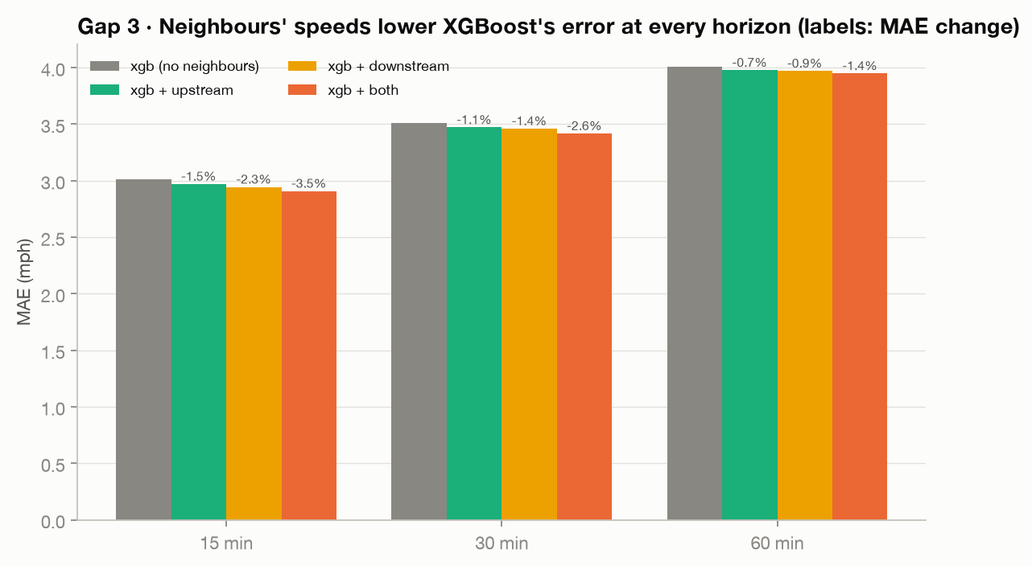
Figure 9. Test MAE of XGBoost with no, upstream, downstream and both-direction neighbour features.
Why this is not enough. The 12 neighbour features together receive only 4.5%, 6.3% and 7.8% of the model's total gain at 15, 30 and 60 minutes. The gain shrinks at 60 minutes, residual correlation between linked sensors barely moves (0.200 to 0.197 at 60 minutes), and the error after onsets is still about 5.4 times normal at 15 minutes. A tree model with one-hop summaries cannot learn which neighbour matters when, nor look several links away. That is what attention over the road graph and multi-hop diffusion are designed to learn.

6.5 Gap statement
Independent segment models forecast each sensor from its own history. Congestion forms at bottlenecks and travels backwards along road links at about 16 km/h, so at longer horizons the most predictive information sits at neighbouring sensors. We observe this as error rising steadily with horizon, errors 5 to 6 times larger in the 30 minutes after a congestion onset, and residuals correlated only between road-linked sensors. Handing XGBoost one-hop neighbour summaries lowers error at every horizon but leaves linked residuals correlated and onset errors several times normal. A graph model that learns which neighbours matter, over several hops, should close this gap.

7 Engineering and reproducibility
The repository (https://github.com/ManasSaxena14/TrafficFlowControl_AIML-DL_T036) holds 1,988 lines of source in src/, 450 lines of tests, and a 808-line dashboard. Large intermediate data (data/processed, about 2.5 GB per protocol) is git-ignored and rebuilt by the make targets.
Table 14. Repository map
Path | Contents
src/data | Loading (HDF5, graph, locations); leak-free preprocessing; split and scaler readers
src/features | 46-column per-sensor feature table, cached as memory-mapped arrays
src/models | Simple baselines, XGBoost and Random Forest, shared-weight LSTM
src/eval | Masked metrics; per-horizon and peak/off-peak evaluation
src/analysis | Exploratory analysis (Phase 1) and gap analysis (Phase 4)
src/train | Runners: baselines (Phase 3) and gap experiments (Phase 4)
src/viz | Figure code with one shared visual style
tests | Automated tests (see below)
results, reports/figures | All result tables and the figures used in this report
docs | Project guide, phase reports 1 to 4, this report, the slide deck
app.py | Interactive Streamlit dashboard over the saved results

Table 15. Automated tests
Test file | Tests | What it guards
test_data.py | 9 | Shapes, five-minute clock, sensor order equals graph order, adjacency properties, outage masking
test_leakage.py | 12 | Chronological target order, no target in two splits, train-only scaler, no future inputs, masked metrics, adjacency rebuild
test_baselines.py | 12 | Feature alignment, train-only statistics, baselines, tree models, peak labelling
test_gap.py | 6 | Neighbour direction and features, onset labelling, residual correlation
Total | 39 | All pass; the code also passes the project linter
Reproduce. make setup, data, eda, preprocess, features, baselines, gap and test rebuild everything from the raw download; make dashboard opens the dashboard. Appendix D lists the commit history. Team: Manas Saxena (Phases 2 to 4, this report and the slide deck), Harsh Raj (Phases 0 and 1), Sumit (dashboard).

8 Limitations and threats to validity
- Speed only. METR-LA has no flow or occupancy, so the brief's flow and occupancy features are not used; PeMS would supply them.
- One city, one season. Freeway data from Los Angeles in 2012; results may not transfer to other networks or to signalised urban streets.
- Single runs, no significance tests. Each model was trained once (seed 42). Small differences, such as the LSTM versus XGBoost at 15 minutes, should not be over-interpreted; significance testing is planned for Phase 6.
- Limited tuning budgets. XGBoost used at least 580 of its 600 allowed rounds at 9 of 12 horizons, so a larger budget might help slightly. The LSTM used all 12 epochs with validation error still improving slowly. XGBoost and the Random Forest were trained on thinned windows (every 2nd and every 6th). The neighbour experiment covers three horizons.
- Validation and test differ. The test period has 12.12% masked targets against 6.98% on validation, so test and validation errors are not directly comparable. The test block is used for reporting only.
- Definitions drive the gap analysis. Congestion onsets use one threshold definition; residual correlation shows association, not causation.
- No published-number comparison yet. The DCRNN reference results are not yet reproduced; that is a gate in Phase 5.
- Simulation only. Signal control, if added, will be evaluated only in a simulator and will not be presented as live traffic control.

9 Conclusions and next steps
The AML phase is complete. A leak-free pipeline and six baselines establish that XGBoost is the strongest independent model (test MAE 3.02, 3.51, 4.01 mph at 15, 30, 60 minutes), and four experiments show that its remaining error is concentrated right after congestion starts, at rush hour, and in a form shared between road-linked sensors. Giving it its neighbours' speeds helps at every horizon, which shows the missing information is spatial, but hand-made one-hop features capture only a small part of it.

Next steps
- Phase 5, graph models. A spatio-temporal graph attention network (STGAT) and a diffusion convolutional recurrent network (DCRNN) over the fixed directed road graph, with the DCRNN required to reproduce the published reference within about 5% before it is trusted, and ablations (graph versus no graph, directed versus undirected).
- Phase 6, fair comparison. All models on the same splits, windows, masks and metrics, with peak and off-peak breakdowns and significance tests. The targets to beat are XGBoost's 3.02, 3.51 and 4.01 mph.
- Phases 7 to 9. Congestion maps, an optional simulated signal-control experiment, and extensions (PeMS flow and occupancy, packaging).

Appendix A Test MAE at every horizon
Test MAE in mph for horizons 1 to 12 (5 to 60 minutes). Source: results/baselines/<model>.csv, split = test.
Model | 5 | 10 | 15 | 20 | 25 | 30 | 35 | 40 | 45 | 50 | 55 | 60
Persistence | 2.81 | 3.20 | 3.49 | 3.74 | 3.97 | 4.20 | 4.41 | 4.61 | 4.81 | 5.00 | 5.18 | 5.37
Historical average | 4.42 | 4.42 | 4.42 | 4.42 | 4.42 | 4.42 | 4.42 | 4.42 | 4.42 | 4.42 | 4.42 | 4.42
Ridge per sensor | 2.61 | 3.00 | 3.31 | 3.59 | 3.84 | 4.08 | 4.30 | 4.50 | 4.69 | 4.86 | 5.02 | 5.17
Random Forest | 2.43 | 2.80 | 3.08 | 3.31 | 3.51 | 3.68 | 3.84 | 3.98 | 4.10 | 4.22 | 4.34 | 4.45
LSTM (no graph) | 2.38 | 2.72 | 2.97 | 3.19 | 3.38 | 3.55 | 3.71 | 3.85 | 3.99 | 4.12 | 4.24 | 4.35
XGBoost | 2.39 | 2.75 | 3.02 | 3.21 | 3.38 | 3.51 | 3.63 | 3.73 | 3.81 | 3.89 | 3.95 | 4.01
Column headings are forecast horizons in minutes.

Appendix B Validation scores
Validation-block scores, used only to choose settings and for early stopping. Pooled columns average over all 12 horizons.
Model | MAE 15 | MAE 30 | MAE 60 | RMSE 15 | RMSE 60 | MAPE 15 | MAPE 60 | Pooled MAE val | Pooled MAE test
Persistence | 3.22 | 3.82 | 4.79 | 6.02 | 9.59 | 7.8 | 13.0 | 3.85 | 4.23
Historical average | 4.74 | 4.74 | 4.73 | 8.75 | 8.73 | 14.5 | 14.4 | 4.74 | 4.42
Ridge per sensor | 3.11 | 3.85 | 4.91 | 5.58 | 8.26 | 8.4 | 14.6 | 3.86 | 4.08
Random Forest | 2.86 | 3.42 | 4.14 | 5.31 | 7.46 | 7.7 | 12.5 | 3.39 | 3.64
LSTM (no graph) | 2.73 | 3.23 | 3.89 | 5.49 | 8.22 | 7.3 | 12.1 | 3.21 | 3.54
XGBoost | 2.82 | 3.29 | 3.78 | 5.19 | 6.95 | 7.5 | 11.1 | 3.23 | 3.44

XGBoost with neighbour features: validation MAE (mph)
Model | 15 min | 30 min | 60 min
XGBoost, own history only | 2.816 | 3.291 | 3.777
+ upstream neighbours | 2.772 | 3.241 | 3.741
+ downstream neighbours | 2.731 | 3.207 | 3.697
+ both directions | 2.697 | 3.165 | 3.684

Appendix C Provenance: result to source file
Every number in this report is generated by scripts/report/collect_data.py from the files below; rerun it and scripts/report/build_report.js to regenerate the report.
Report content | Source in the repository
Dataset facts, missingness, graph, propagation (Section 3) | results/phase1_findings.json; reports/figures/fig01, fig02, fig05d
Split sizes, target periods, masked share, scalers (Section 4.1) | data/processed/strict and dcrnn (rebuilt by make preprocess); configs/data/metr_la.yaml
Model configuration (Section 4.3) | results/baselines/{xgb,rf,ridge,lstm}.json; src/models
Test and validation scores (Sections 1, 5; Appendices A and B) | results/baselines.csv; results/baselines/<model>.csv
Peak versus off-peak (Section 5.2) | results/baselines_peak.csv
XGBoost feature importance (Section 5.3) | results/baselines/xgb_importance.csv
Onset errors, residual correlation (Sections 6.2, 6.3) | results/gap/onset_vs_normal.csv; results/gap/residual_correlation.csv; results/phase4_findings.json
Neighbour experiment (Section 6.4) | results/gap_results.csv; results/gap/xgb_neighbours.csv; results/gap/xgb_neighbours_importance.csv
Figures 1 to 9 | reports/figures/*.png (generated by src/viz)
Tests, lines of code, commit history (Section 7, Appendix D) | pytest collection; git log

Appendix D Commit history
23 commits at the time of generation (commit 101ec90). Source: git log.
Hash | Author | Date | Subject
f902e0f | harsh raj | 2026-10-09 | Phase 0 + 1: project setup, METR-LA data loading and EDA
4960487 | Manas Saxena | 2026-10-26 | Phase 2: leak-free preprocessing, masked metrics and leakage tests
1cfda92 | Manas Saxena | 2026-10-26 | Phase 3 (1/3): feature table, evaluation harness and simple baselines
f2e3813 | Manas Saxena | 2026-10-26 | Phase 3: XGBoost per horizon and multi-output Random Forest
8a54f6d | Manas Saxena | 2026-10-26 | Phase 3: shared-weight LSTM baseline without a graph
a3bdd65 | Manas Saxena | 2026-10-26 | Phase 4: gap analysis toolkit
0eafca4 | Manas Saxena | 2026-10-26 | Phase 4: experiment runner and baseline figures
608e853 | Manas Saxena | 2026-10-26 | Phase 4: gap figures and LSTM epoch budget
f5ef040 | Manas Saxena | 2026-10-26 | Add make targets for Phase 3 features, baselines and Phase 4 gap analysis
b65d3fe | Manas Saxena | 2026-10-26 | Phase 3: XGBoost and Random Forest results
b901341 | Manas Saxena | 2026-10-26 | Phase 4: error vs horizon and error at congestion onset
76168fc | Manas Saxena | 2026-10-26 | Phase 4: residual correlation along road links
63b8547 | Manas Saxena | 2026-10-26 | Phase 3 report: baseline ladder results and analysis
02f692d | Manas Saxena | 2026-10-26 | Phase 4 report draft and project status update
c7ac2fd | Manas Saxena | 2026-10-26 | Phase 3: LSTM results, final baselines table, Phase 3 complete
22e045c | Manas Saxena | 2026-10-26 | Phase 3 report: correct the 15-minute comparison with the LSTM
abec77b | Manas Saxena | 2026-10-26 | Phase 4: XGB + neighbours experiment results
5075a58 | Manas Saxena | 2026-10-26 | Phase 4 complete: final report, gap statement and AML results summary
4127d46 | Manas Saxena | 2026-10-26 | Phase 3: peak vs off-peak evaluation of the baselines
f276415 | Manas Saxena | 2026-10-26 | Project documentation cleanup and AML part (Phases 2-4) completion
266c55a | sumit316-glitch | 2026-10-26 | Add interactive Streamlit dashboard for METR-LA traffic flow results
55e46dd | Manas Saxena | 2026-10-26 | Add project presentation for the AML part
101ec90 | Manas Saxena | 2026-10-26 | Integrate the Streamlit dashboard and fix the peak-ratio range

