**TESTING**

1. **LOGIN UI**

* Login details i.e. **Email** and **Password** should be correct so as to login successfully.

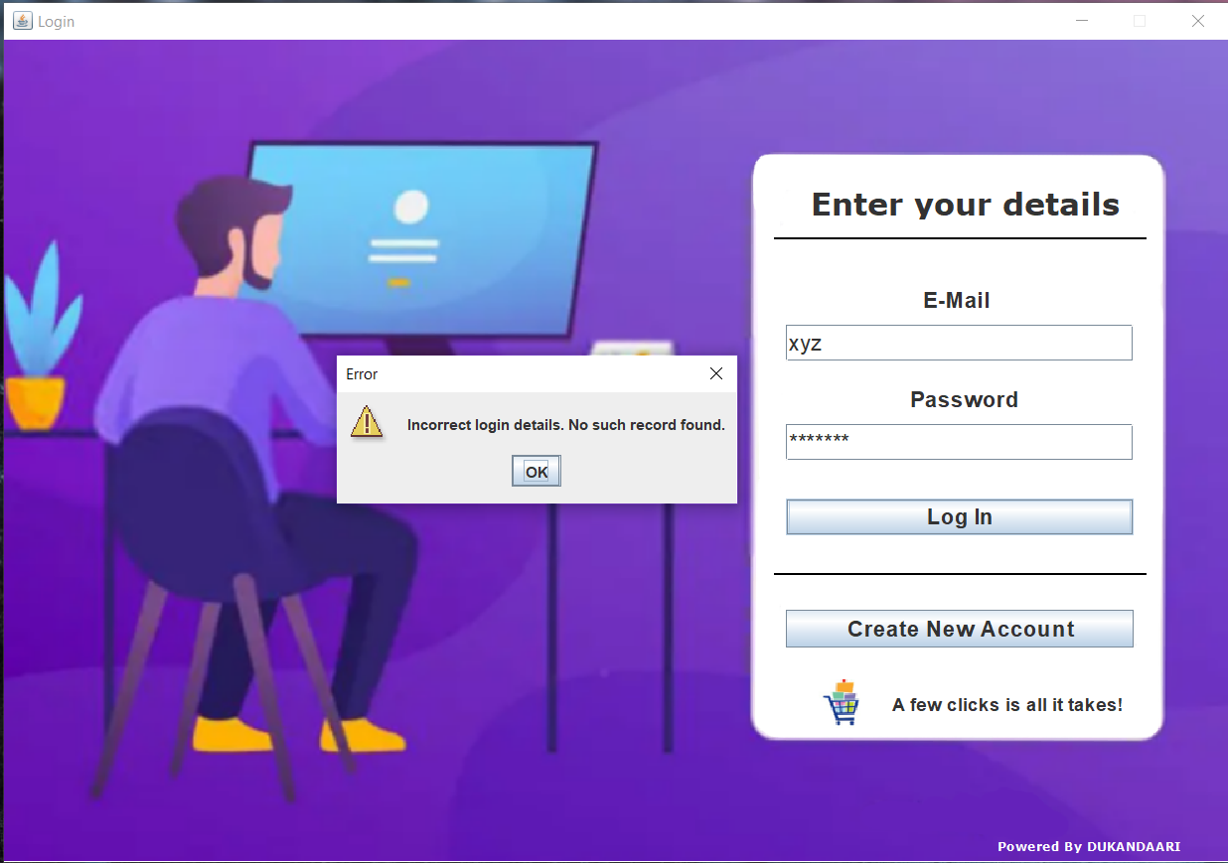

1. **REGISTRATION UI**

* **Full Name** is a mandatory field so, it can’t be kept blank.

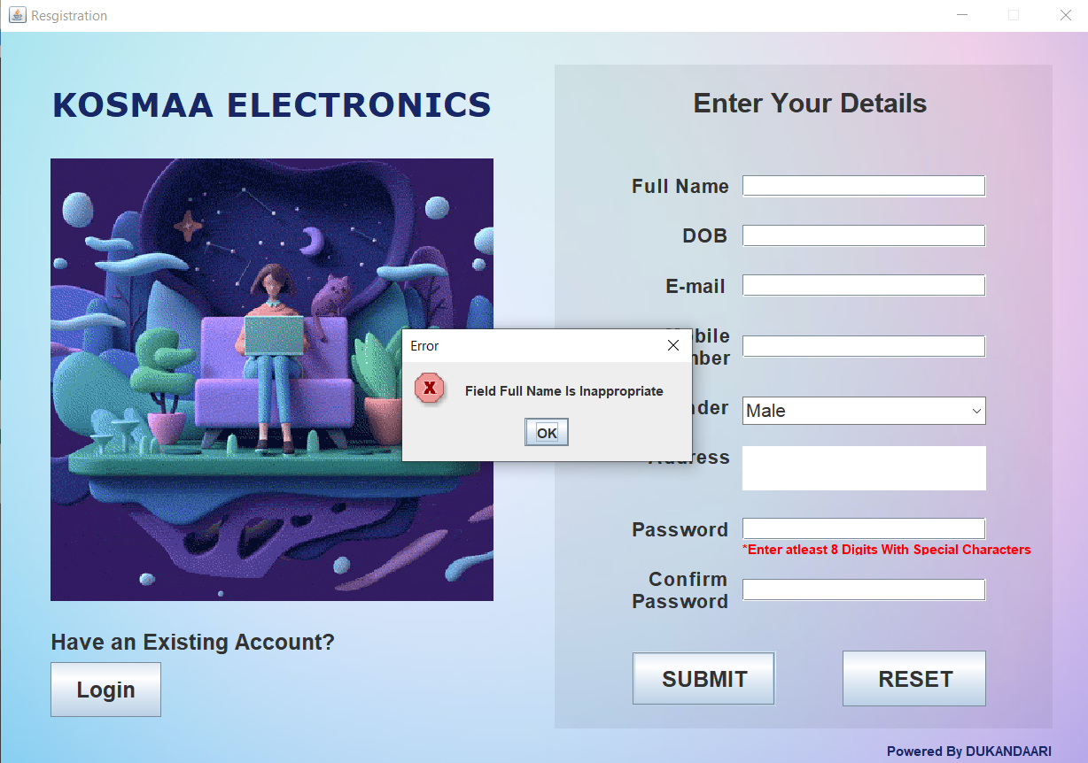

.

* **E-mail** entered should be **Valid.**

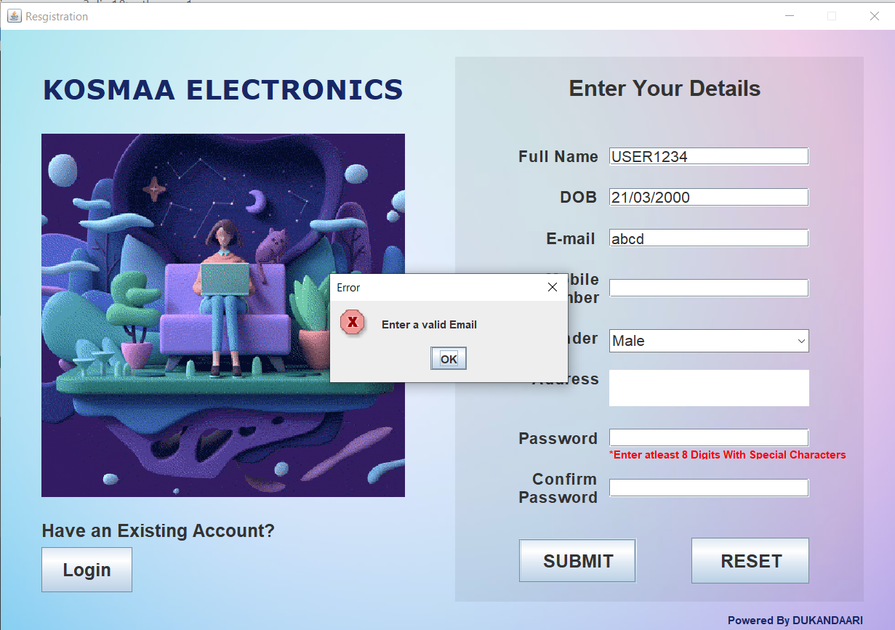

* The entered **Mobile Number** should be of 10 digits.

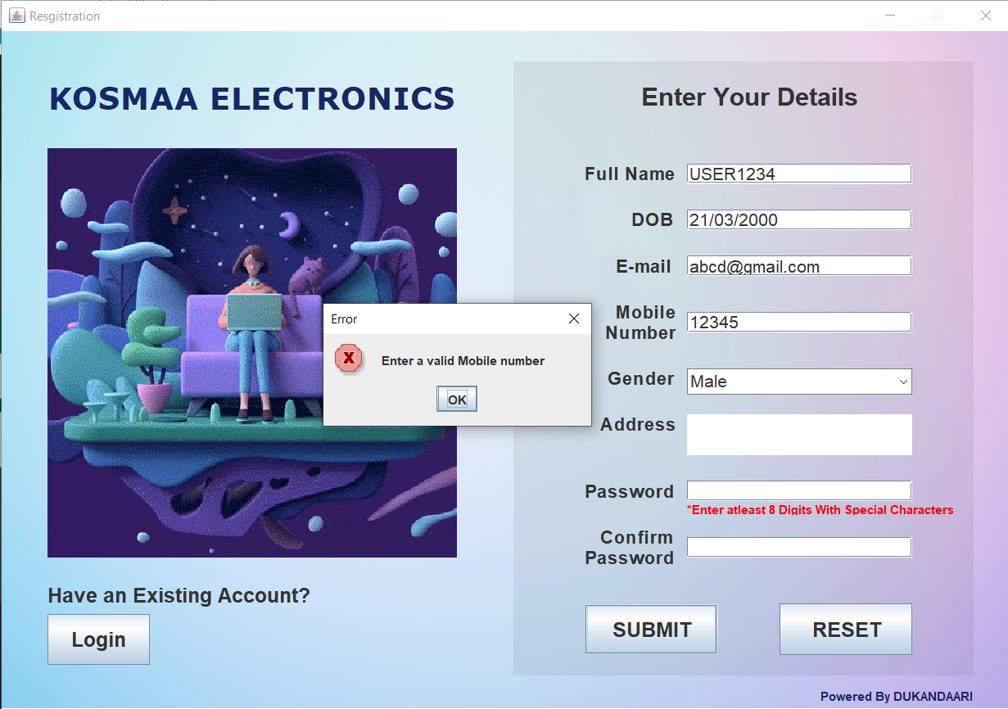

* The entered **Password** should be valid and must contain at least 8 characters/digits with special characters (ie at least 1 Uppercase , 1 Lowercase , 1 Special Character and 1 number ).

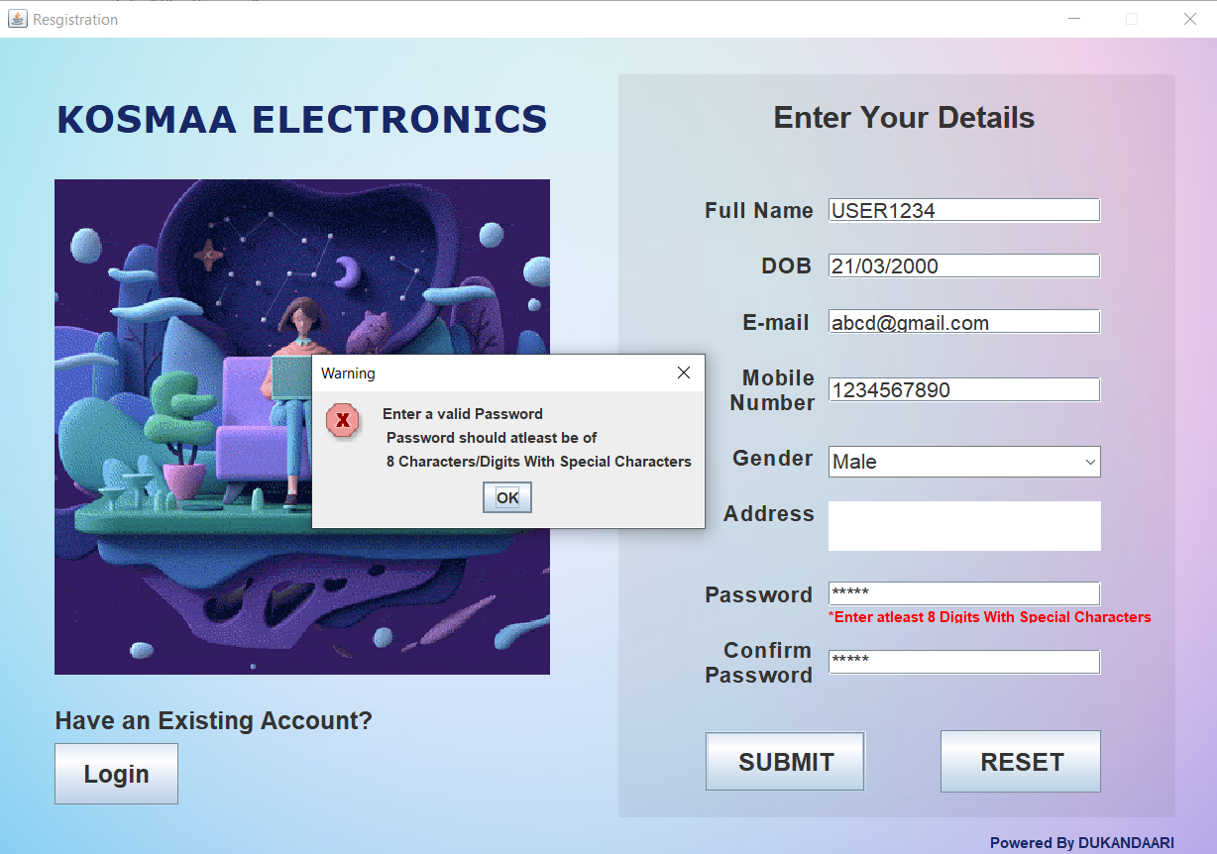

* **Password** and **confirm password** field should match.

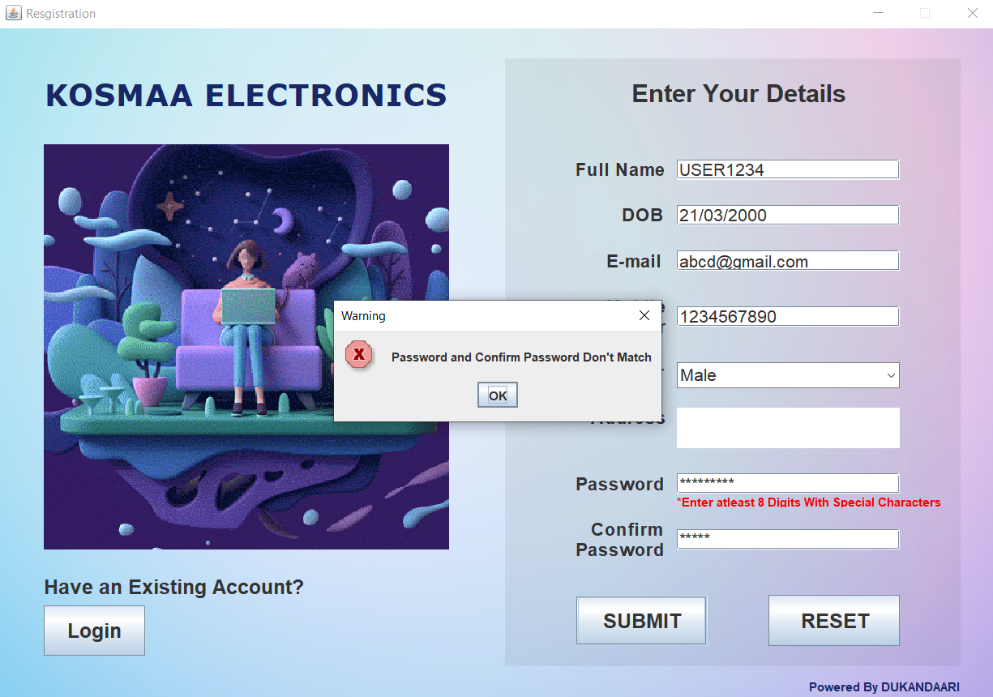

1. **SHOP DETAILS UI**

* **Shop Name** is mandatory field so, it cannot be kept Blank.

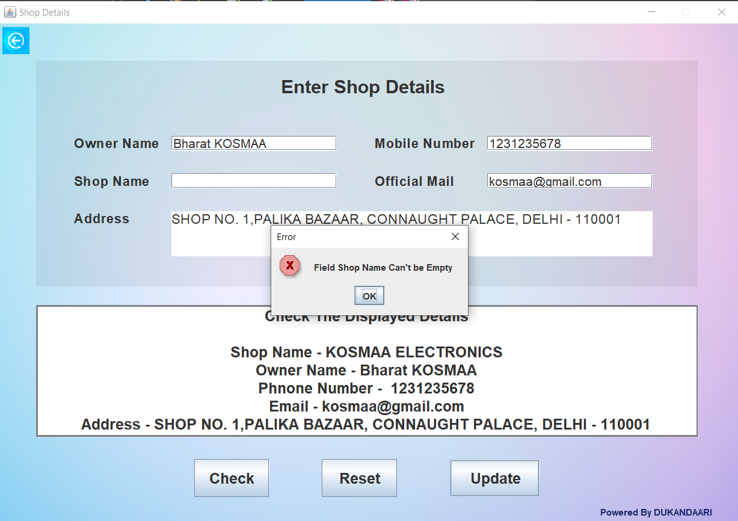

* **Owner Name** is mandatory field so, it cannot be kept Blank.

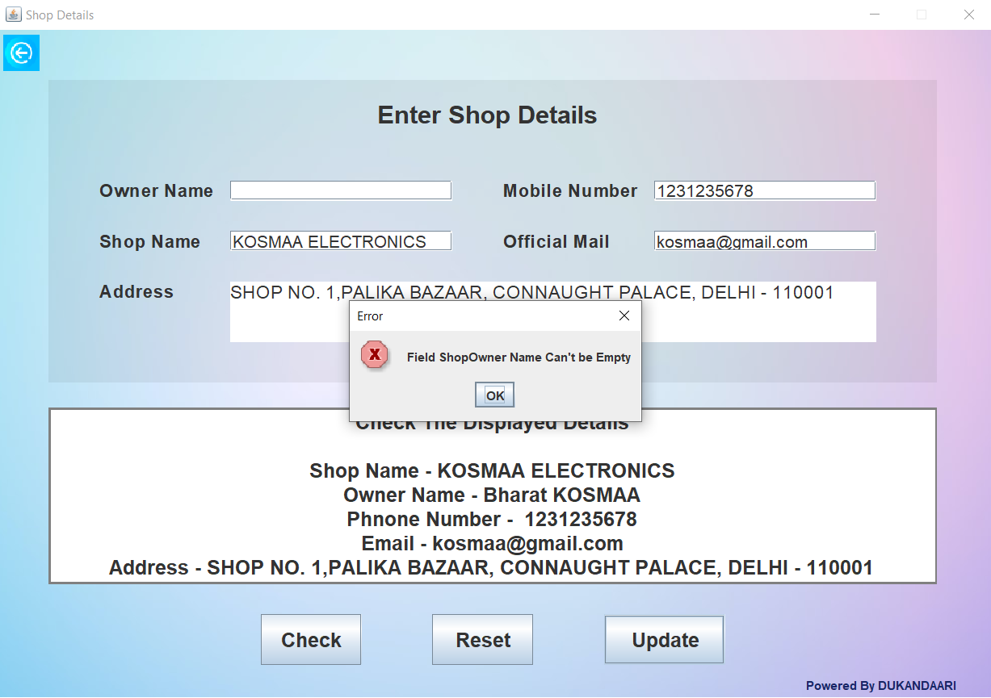

1. **PRODUCT DETAILS UI**

* The field **Product SU** is **Unique ,** another product with the same **Product SU** can’t be added.

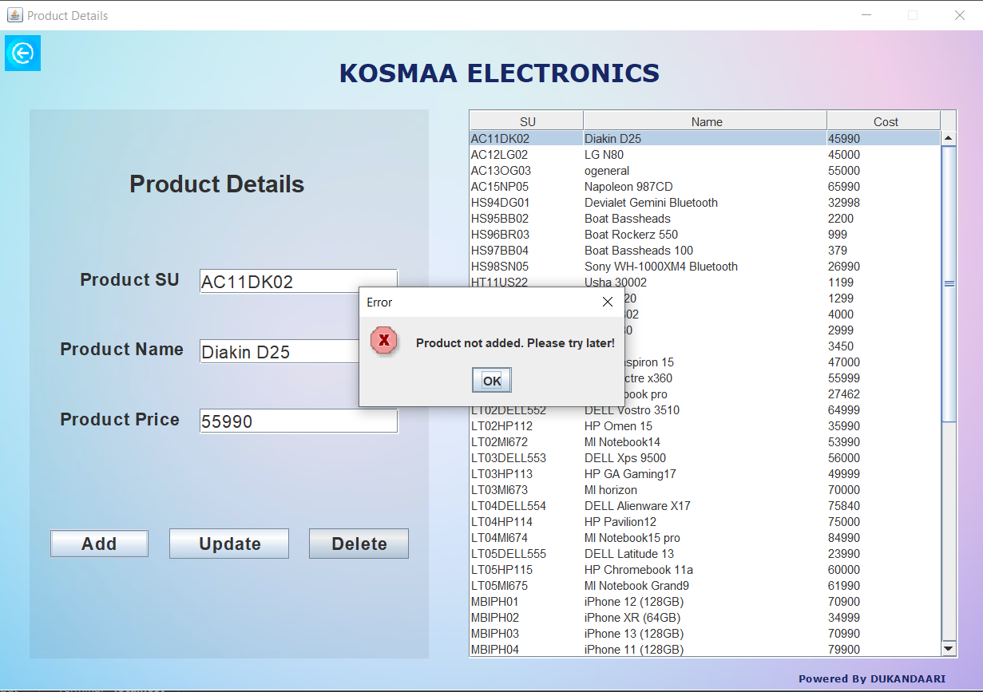

1. **CUSTOMER DETAILS UI**

* The **SU Code** enter should be **Valid** and must match with the data present in the Database.

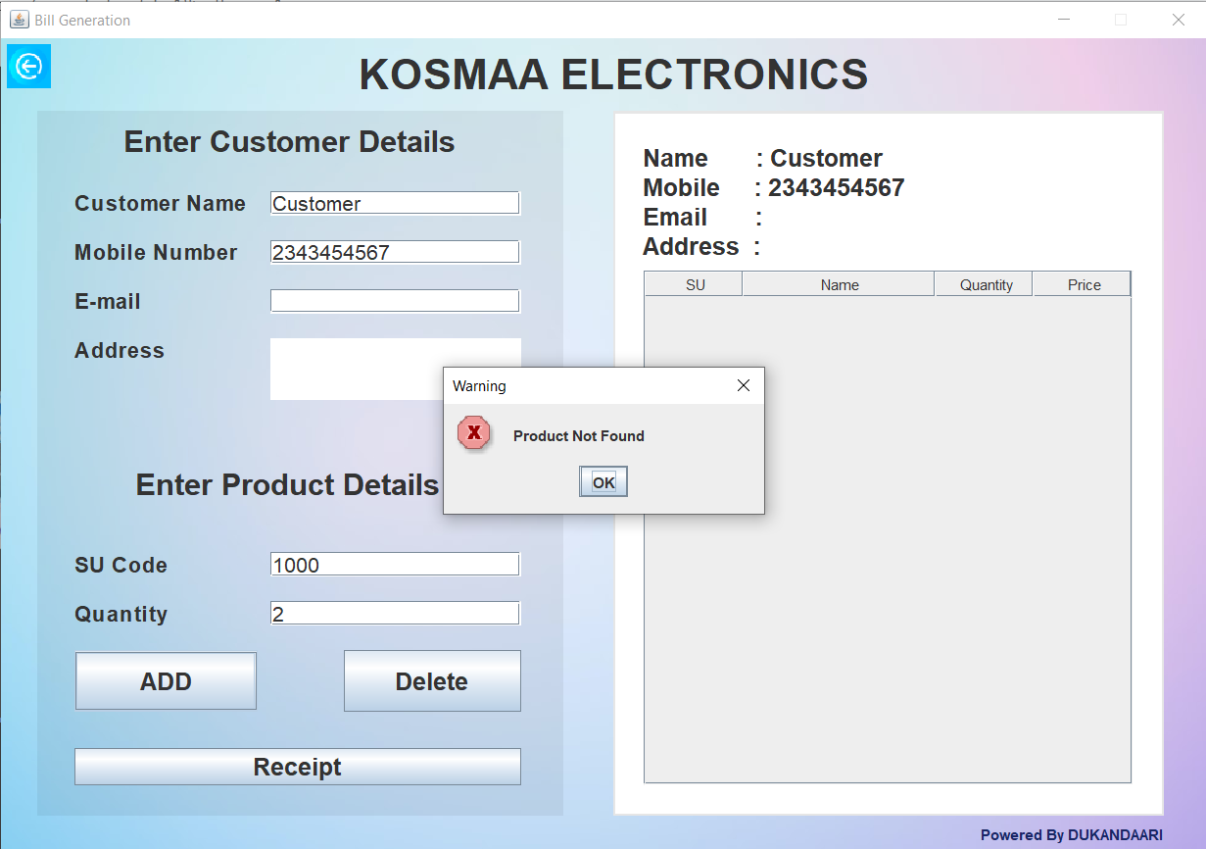

* **Customer Name** is a mandatory field so it cannot be kept **Blank**.

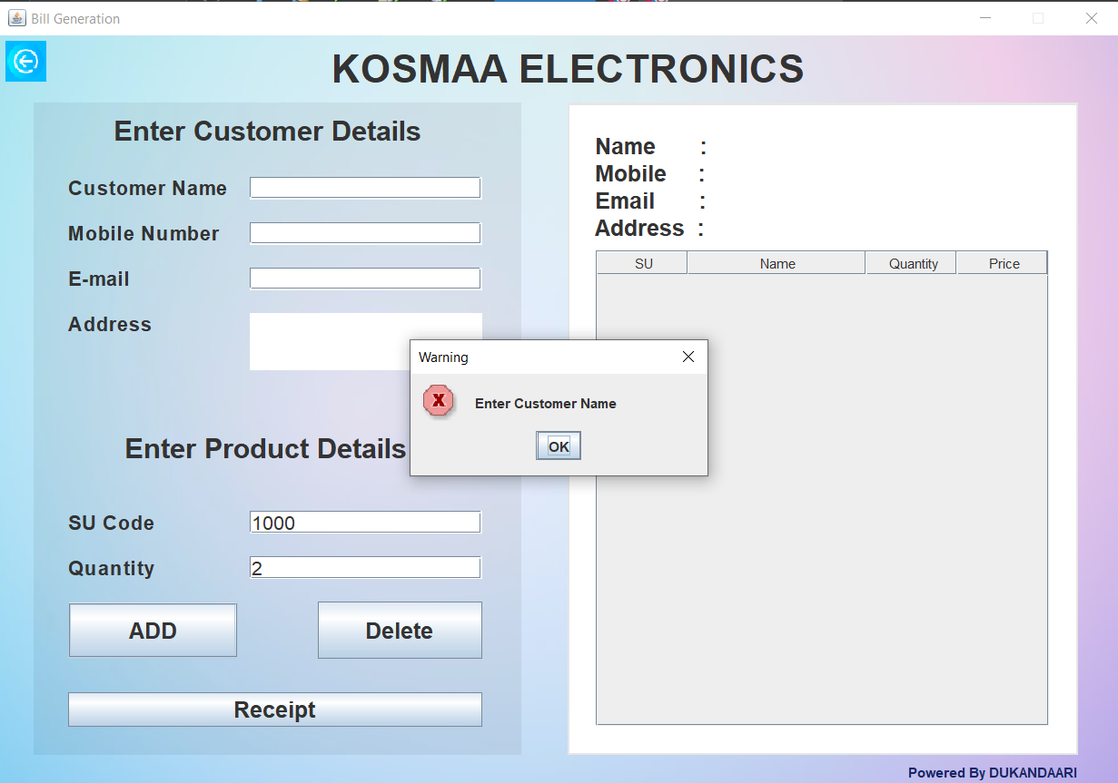

* **Mobile number** added should be **Valid** and must contain **10 digits**.

