Trader Performance vs. Bitcoin Market Sentiment
An analysis of Hyperliquid trader data against the Fear & Greed Index

1. Executive Summary
This report examines 211,224 trades across 32 Hyperliquid accounts (Feb 2023 – May 2025), merged with the Bitcoin Fear & Greed Index by date (99.997% match rate). The goal is to identify how trader profitability, risk behavior, and positioning shift across market sentiment regimes.
Key takeaways:
- Traders are most profitable in absolute terms during “Fear” and “Extreme Greed” days — total realized PnL of $3.36M and $2.72M respectively — but “Extreme Greed” delivers the highest average PnL per trade ($130) and the highest win rate (89.2%).
- “Extreme Fear” is the weakest regime: lowest win rate (76.2%) and lowest profit factor (2.16), suggesting panic-driven trading is the least reliable.
- Average position sizes are largest during Fear ($7,375) and smallest during Greed ($4,234) — traders appear to size up when the market is fearful, possibly viewing dips as opportunities or being forced into larger defensive trades.
- Short positions are opened proportionally more often during Greed (21.4% of opens vs 16.9% during Fear), consistent with contrarian/short-the-rally behavior; long positions dominate during Fear (29.8% of opens).
- Overall, Greed days produced the highest total PnL ($4.87M) and best profit factor (4.66), while Fear days were close behind ($4.10M total PnL, profit factor 4.33). Neutral days were the weakest broad regime (profit factor 4.32, total PnL $1.29M).

2. Dataset Overview

2.1 Data Sources
- Hyperliquid Historical Trader Data: 211,224 trade/order records across 32 accounts and 246 traded assets, with execution price, size (tokens & USD), side, direction, closed PnL, fees, and timestamps.
- Bitcoin Fear & Greed Index: daily classification (Extreme Fear, Fear, Neutral, Greed, Extreme Greed), covering Feb 2018 – May 2025.

2.2 Methodology
- Trade timestamps (IST) were converted to dates and joined to the daily Fear & Greed classification.
- “Closed trades” are rows where Closed PnL ≠ 0 (i.e., realized PnL events) — used for profitability, win-rate, and profit-factor metrics. All 211,224 rows are used for position-sizing and directional analysis.
- Broad sentiment groups combine Extreme Fear + Fear → “Fear”, and Extreme Greed + Greed → “Greed”, with Neutral standing alone.

3. Performance by Sentiment Classification
Classification | Trades | Total PnL ($) | Avg PnL ($) | Median PnL ($) | Win Rate | Profit Factor
Extreme Fear | 10,406 | 739,110 | 71.03 | 6.39 | 76.2% | 2.16
Fear | 29,808 | 3,357,155 | 112.63 | 6.35 | 87.3% | 6.66
Neutral | 18,159 | 1,292,921 | 71.20 | 4.58 | 82.4% | 4.32
Greed | 25,176 | 2,150,129 | 85.40 | 4.93 | 76.9% | 3.03
Extreme Greed | 20,853 | 2,715,171 | 130.21 | 8.53 | 89.2% | 11.02

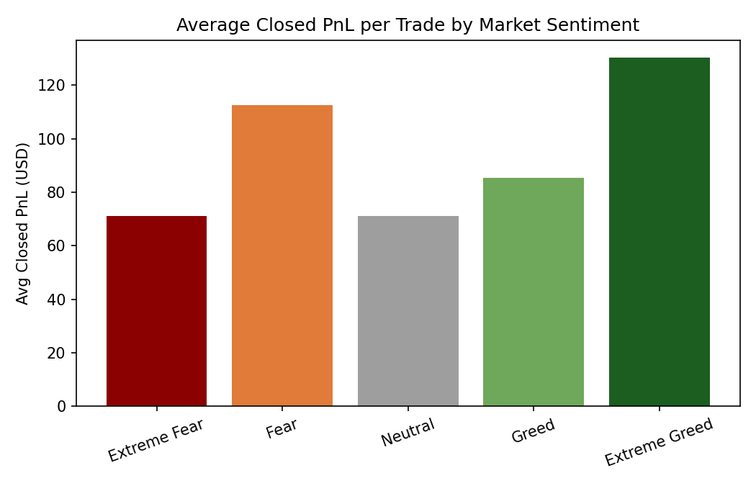
Average PnL per trade is U-shaped-ish across the sentiment spectrum: it dips during ordinary Fear/Neutral/Greed but spikes sharply at “Extreme Greed” ($130.21) — likely reflecting strong trending markets where momentum trades pay off well. “Extreme Fear” trades are profitable on average but far less so ($71.03).
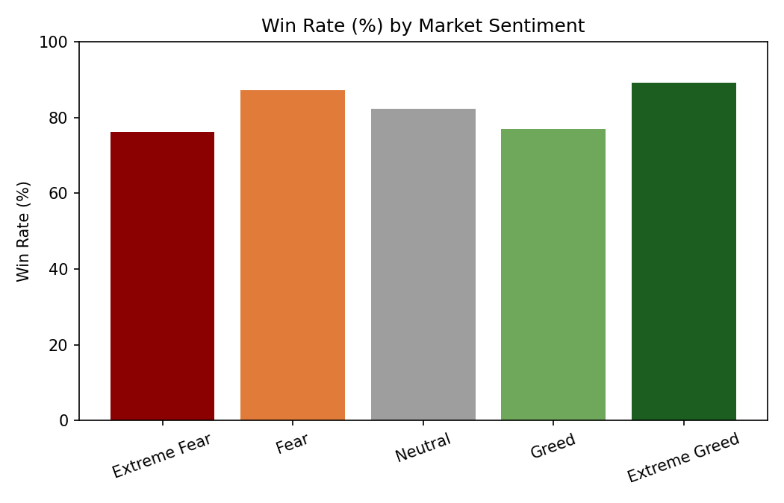
Win rates follow a similar pattern: Extreme Greed (89.2%) and Fear (87.3%) are the most favorable regimes for closing winning trades, while Extreme Fear (76.2%) and Greed (76.9%) are noticeably weaker.
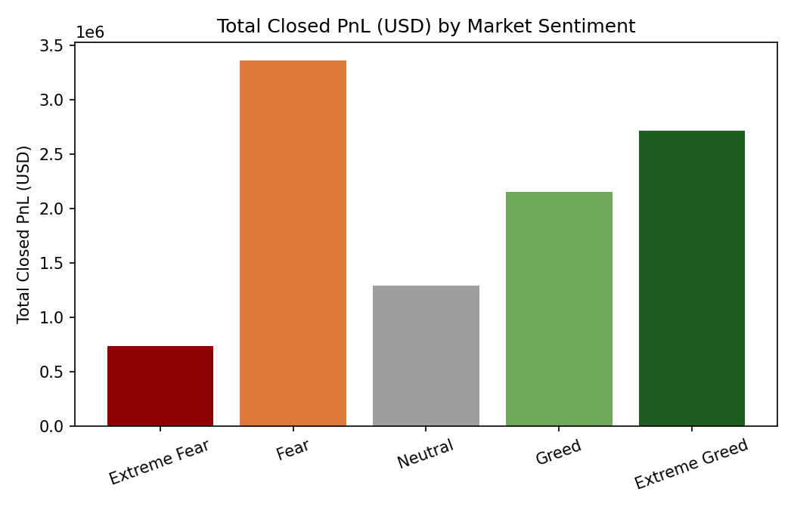
In aggregate dollar terms, “Fear” days generated the largest pool of realized profit ($3.36M), followed by “Extreme Greed” ($2.72M) and “Greed” ($2.15M). “Extreme Fear” contributed the least ($739K), consistent with both lower trade volume and weaker per-trade economics in that regime.

4. Position Sizing and Risk Behavior
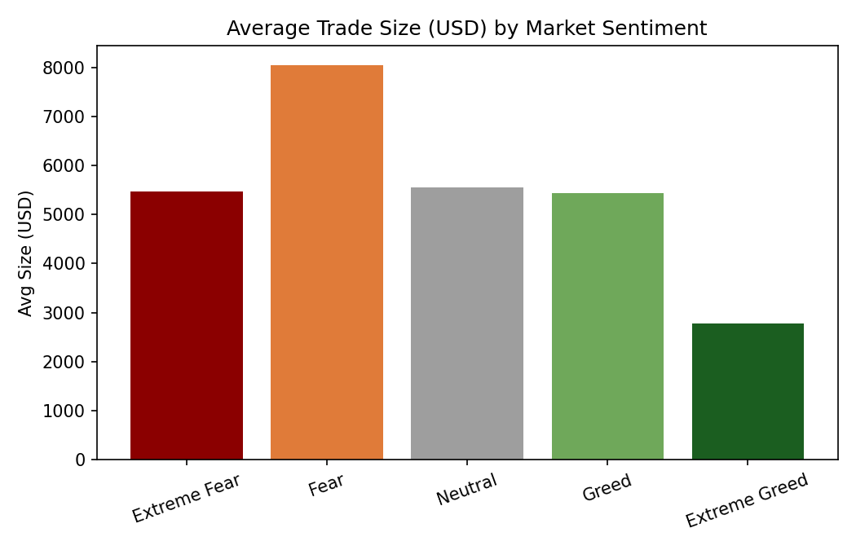
Average trade size (USD) is highest during Fear ($7,375) and Extreme Fear ($5,350 — see classification-level data), and lowest during Greed ($4,234). This suggests traders commit larger notional positions when sentiment is fearful — either viewing fear-driven dips as buying opportunities, or because volatility-driven price swings inflate position values.

5. Long/Short Positioning by Sentiment
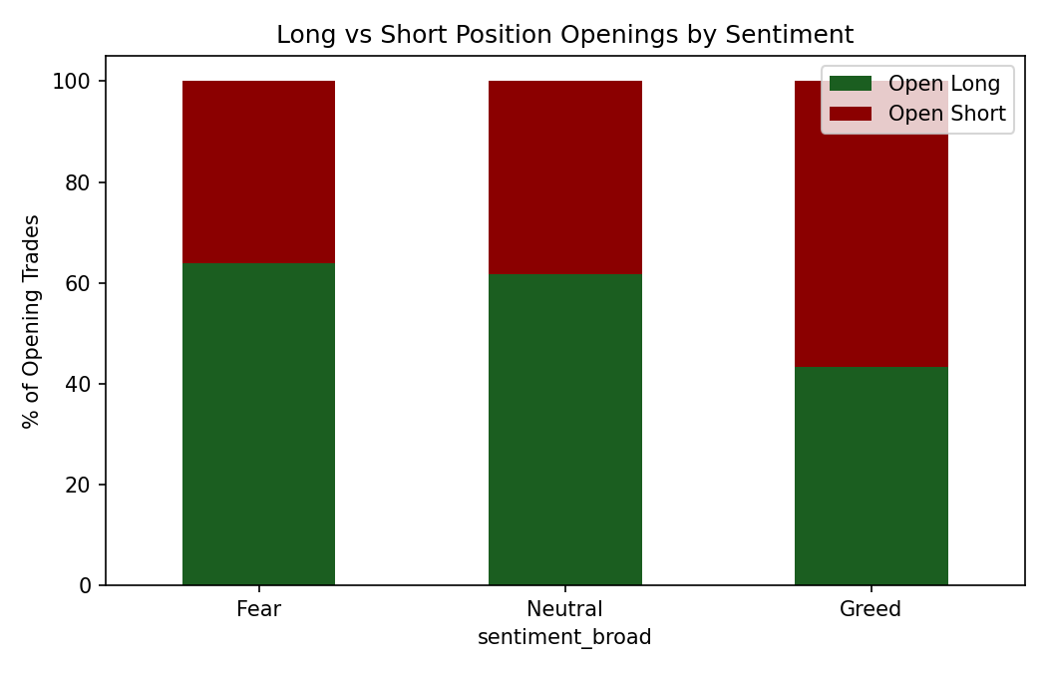
During Fear, 63.9% of new directional positions opened are Longs vs 36.1% Shorts — a clear “buy the fear” tilt. During Greed, the split narrows to 43.4% Long / 56.6% Short, indicating traders increasingly position for reversals or fade rallies as greed intensifies. Neutral days sit closer to the Fear pattern (61.6% Long / 38.4% Short).

6. Broad Sentiment Comparison (Fear vs Neutral vs Greed)
Sentiment | Trades | Total PnL ($) | Avg PnL ($) | Profit Factor
Fear | 83,237 | 4,096,266 | 49.21 | 4.33
Neutral | 37,686 | 1,292,921 | 34.31 | 4.32
Greed | 90,295 | 4,865,301 | 53.88 | 4.66

At the broad level, Greed days are marginally the most efficient (profit factor 4.66, avg PnL/trade $53.88), with Fear close behind (4.33 / $49.21). Neutral days are the laggard on both total and per-trade profitability — markets with no strong sentiment signal appear to offer the least edge.

7. Recommendations for Trading Strategy
- Favor momentum / trend-following setups during Extreme Greed: this regime shows the highest win rate (89.2%) and profit factor (11.02), suggesting strong directional follow-through is more reliable here than in any other regime.
- Treat Extreme Fear with caution or use it for smaller, higher-conviction entries: it has the lowest win rate (76.2%) and profit factor (2.16) despite traders sizing up ($5,350 avg) — larger bets in the worst-performing regime is a risk-management red flag worth investigating per-account.
- Consider contrarian short bias during Greed and long bias during Fear, consistent with observed trader behavior (56.6% shorts in Greed vs 63.9% longs in Fear), which appears to align with the better-than-average profit factors in both regimes.
- Investigate position sizing discipline: the gap between average size in Fear ($7,375) vs Greed ($4,234) is large. If this is driven by a few accounts, individual risk limits may need review to avoid concentration risk during volatile, low-win-rate periods.
- Use Neutral-sentiment days as a baseline / lower-conviction trading window — both total and per-trade PnL are weakest here, implying fewer high-quality setups when sentiment lacks a clear extreme.

8. Appendix: Data Notes
- 211,218 of 211,224 trades (99.997%) matched a Fear & Greed Index date; 6 unmatched records were excluded from sentiment-based analysis.
- “Closed PnL = 0” rows (order placements without a realization event) were excluded from PnL, win-rate, and profit-factor calculations but included in position-sizing and directional analysis.
- Profit Factor = Gross Profit ÷ Gross Loss across closed trades.
- Full summary tables are provided in the accompanying Excel workbook (trader_sentiment_analysis.xlsx).

