Supply Chain Analytics
Demand Forecasting & Anomaly Detection
Final Project Report — Weeks 1-4
Data Analytics Internship Project
Prepared as the capstone deliverable covering preprocessing, anomaly detection, demand forecasting, and dashboard deployment.

1. Executive Summary
This project builds an end-to-end analytics pipeline for supply chain demand data: cleaning a genuinely messy raw export, detecting anomalous sales/inventory behaviour with three complementary methods, forecasting demand with a statistical model, and packaging the results into an interactive Streamlit dashboard for business users.
The raw dataset contained real-world data quality problems — mixed date formats, typo'd category names, inconsistent boolean encodings, and, most importantly, silent sentinel error codes (999999) and negative values in every numeric column. Removing these before modeling was the single biggest driver of forecast quality: leaving them in caused the ARIMA model's error to balloon into the hundreds of percent; removing them brought errors back into a realistic 2-24% MAPE range.
ARIMA(1,1,1) outperformed the simple moving-average baseline in 4 of 11 categories (on MAPE), most clearly on Furniture, Clothing, Sporting Goods, and Office Supplies. The baseline remained competitive or better on calmer, lower-variance categories such as Automotive Parts and Groceries — a useful finding for deciding which categories warrant the extra modeling complexity in production.
Raw records ingested | 11,165 rows
Clean daily records after preprocessing | 12,200 category-days
Product categories | 11
Sentinel / negative values removed | 231 numeric cells (999999 error codes + negatives)
Anomaly-detection methods | Z-Score, IQR, Isolation Forest + 2-of-3 consensus
Consensus anomaly-days flagged | 193
Forecast models compared | Moving-average baseline vs. ARIMA(1,1,1)
Categories where ARIMA beat the baseline (MAPE) | 4 of 11 (Sporting Goods, Office Supplies, Clothing, Furniture)

2. Business Problem & Objectives
Inaccurate demand estimation drives excess inventory, storage costs, and spoilage on one side, and stockouts and lost sales on the other. This project's objectives were to:
- Build a reliable, repeatable pipeline for cleaning raw supply chain exports
- Automatically flag abnormal sales, inventory, or dispatch behaviour for investigation
- Forecast demand per product category and benchmark model quality objectively (MAPE, RMSE)
- Put the results in front of business users through an interactive dashboard, not just static notebooks

3. Methodology by Week

Week 1 — Data Preprocessing
The raw export (11,165 rows) was profiled before any cleaning: 106 distinct spellings/casings of 11 real product categories, three mixed date formats, 8 different encodings of the promotion flag, ~1.5% exact duplicate rows, and — the most consequential issue — 999999 sentinel error codes and negative values scattered across every numeric column.
After normalizing categories, parsing dates, standardizing the promotion flag, nulling out sentinel/negative values, and removing duplicates, each category's series was reindexed onto a full daily calendar and linearly interpolated to close remaining gaps. Clothing has the sparsest raw coverage of the 11 categories, so its downstream results carry the largest share of interpolated values and should be read with that caveat.

Week 2 — Anomaly Detection
Three independent methods were run on the trend/seasonality-adjusted residual of daily units sold (Isolation Forest additionally used inventory level, unit price, and dispatch rate together):
- Z-Score — flags residuals beyond 3 standard deviations
- IQR (Tukey fences) — flags residuals outside 1.5x the interquartile range; robust to extreme values
- Isolation Forest — multivariate, unsupervised; catches unusual combinations of features the univariate methods miss
A day was marked a consensus anomaly when at least 2 of the 3 methods agreed. This produced 193 high-confidence anomaly-days across the 11 categories — Clothing and Toys had the most (21 each), Furniture the fewest (11).

Week 3 — Demand Forecasting
Each category's series was split into a training set and a held-out 30-day test window. Two models were fit on identical splits so results are directly comparable:
- Baseline — flat 7-day moving average, carried forward across the whole test window
- ARIMA(1,1,1) — fit per category, with an automatic fallback to the moving average if a category's fit failed to converge
Both were scored with MAPE and RMSE on the same test window. The full per-category comparison is below (sorted by ARIMA's MAPE, best first).
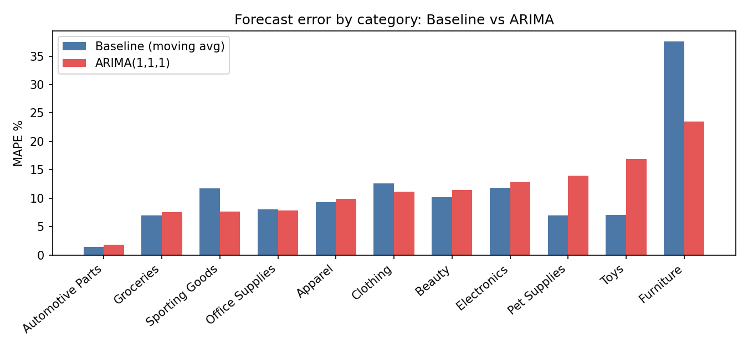
Category | MAPE Baseline | MAPE ARIMA | RMSE Baseline | RMSE ARIMA
Automotive Parts | 1.46% | 1.85% | 6.59 | 8.06
Groceries | 6.96% | 7.50% | 51.89 | 53.61
Sporting Goods | 11.70% | 7.69% | 68.12 | 48.16
Office Supplies | 8.01% | 7.87% | 74.78 | 74.31
Apparel | 9.31% | 9.90% | 71.50 | 62.52
Clothing | 12.65% | 11.10% | 83.25 | 74.25
Beauty | 10.18% | 11.46% | 60.72 | 57.26
Electronics | 11.79% | 12.90% | 49.84 | 53.82
Pet Supplies | 6.96% | 13.94% | 48.00 | 62.47
Toys | 7.10% | 16.92% | 20.77 | 49.36
Furniture | 37.56% | 23.48% | 134.38 | 84.99

ARIMA won on MAPE for Sporting Goods, Office Supplies, Clothing, and Furniture — all categories with more volatile, trend-like demand where a flat average underfits. The baseline held its own or won on Automotive Parts, Groceries, Apparel, Beauty, Electronics, Pet Supplies, and Toys — generally the calmer, lower-variance categories where a simple average is already close to optimal and ARIMA's extra flexibility mostly adds noise.

Week 4 — Interactive Dashboard
A Streamlit app (app.py) was built directly on top of the processed data — it performs no recomputation itself, only reads data/processed/*.csv, so what the dashboard shows always matches what the notebooks produced. Features:
- Product category selector
- Historical demand chart with anomalies highlighted, switchable between Z-Score / IQR / Isolation Forest / consensus
- Forecast backtest chart (actual vs. baseline vs. ARIMA) with an adjustable confidence interval, sized from that model's own backtest error for the selected category
- KPI summary cards (average demand, average inventory, anomaly count, MAPE for both models)
- Full model-comparison table across all categories
Setup and deployment steps are documented separately in the Week 4 Deployment Guide.

4. Anomaly Detection — Example
The chart below shows Electronics demand with its 19 consensus anomaly-days marked. Several line up with unusually large single-day spikes or drops that are worth an operations review — e.g. to confirm whether a promotion, a supplier delay, or a data-entry issue explains the day.
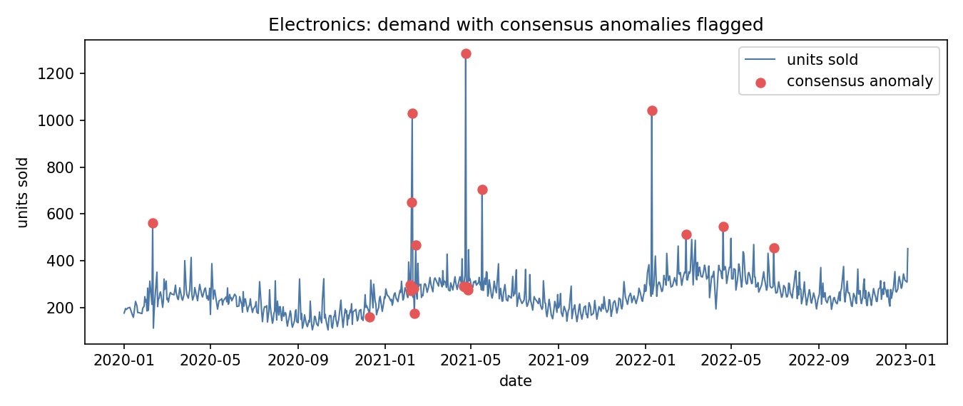

5. Business Recommendations
- Prioritize investigating consensus anomalies (2-of-3 methods) first — they're the highest-confidence signal and the smallest, most actionable list (193 days vs. hundreds if any single method were used alone).
- Use ARIMA for Furniture, Clothing, Sporting Goods, and Office Supplies, where it clearly beats the baseline; keep the simpler moving-average for calmer categories like Automotive Parts and Groceries, where added model complexity isn't paying for itself.
- Treat Clothing's forecasts and anomaly flags with extra caution given its higher share of interpolated history — prioritize improving raw data capture for this category before trusting it for automated reordering.
- Fix the upstream data source generating 999999 sentinel codes and negative readings — this is a data-entry/system issue worth resolving at the source, not just cleaning downstream.

6. Limitations & Future Work
- ARIMA(1,1,1) is a fixed order for every category; a per-category order search (e.g. auto-ARIMA) or a seasonal SARIMA could improve fit further, particularly for higher-variance categories.
- The dashboard currently shows backtest forecasts (last 30 known days), not a forward-looking 90-day forecast, per the original scope; extending app.py to generate and cache a rolling forward forecast is a natural next step.
- Anomaly labels are unsupervised; the labeled reference dataset in data/reference/ could be used to quantify precision/recall for each method going forward.
- Planned: LSTM/XGBoost forecasting, multi-product joint models, real-time data ingestion, automated alerting, and cloud deployment.

7. Appendix — Project Structure
supply-chain-analytics/
├── app.py Week 4 Streamlit dashboard
├── data/{raw, processed, reference}
├── notebooks/01_data_preprocessing.ipynb → 05_model_evaluation.ipynb
├── src/{data_loader.py, metrics.py}
├── docs/{week1_progress.md, week2_summary.md, week2_roadmap.md,
│ Project_Report.docx, Week4_Deployment_Guide.docx}
└── README.md, requirements.txt

