UNDER WATER IMAGE ENHANCEMENT USING PSO ALGORITHM

PROJECT REPORT
Submitted by

BLESSEENA YERRA(B192121) RENUKA THANNIRU (B191002) HARSHITHA VALLABUDASU(B191476)

Of
Bachelor of Technology

Under the guidance of

Dr.B. VENKAT RAMAN HOD CSE, RGUKT BASAR


DEPARTMENT OF COMPUTER SCIENCE AND ENGINEERING RAJIV GANDHI UNIVERSITY OF KNOWLEDGE TECHNOLOGIES BASAR, NIRMAL (DIST.),
TELANGANA – 504107

UNDER WATER IMAGE ENHANCEMENT USING PSO ALGORITHM

Project Report submitted to
Rajiv Gandhi University of Knowledge Technologies, Basar for the partial fulfillment of the requirements
for the award of the degree of

Bachelor of Technology in
Computer Science & Engineering
by

BLESSEENA YERRA(B192121) RENUKA THANNIRU (B191002) HARSHITHA VALLABUDASU(B191476)

Under the Guidance of

Mr. B .VENKAT RAMAN
HOD CSE, RGUKT BASAR

DEPARTMENT OF COMPUTER SCIENCE AND ENGINEERING RAJIV GANDHI UNIVERSITY OF KNOWLEDGE TECHNOLOGIES, BASAR
MAY 2025

DEPARTMENT OF COMPUTER SCIENCE AND ENGINEERING RAJIV GANDHI UNIVERSITY OF KNOWLEDGE TECHNOLOGIES, BASAR

CERTIFICATE

This is to certify that the Project Report entitled ‘UNDERWATER IMAGE ENHANCEMENT USING PSO ALGORITHM’ submitted by Blesseena Yerra - B192121, Harshitha Vallabudasu – B191476, Renuka Thanniru-B192121 Department of Computer Science and Engineering, Rajiv Gandhi University Of Knowledge Technologies, Basar, for partial fulfillment of the requirements for the degree of Bachelor of Technology in Computer Science and Engineering; is a bonafide record of the work and investigations carried out by them under my supervision and guidance.

PROJECT SUPERVISOR : HEAD OF DEPARTMENT :

Dr. B.VENKAT RAMAN Mr. B .VENKAT RAMAN HOD CSE HOD CSE

PROJECT COORDINATOR : EXTERNAL EXAMINER :

Mr. LAXMI NARAYANA
Assistant Professor


DEPARTMENT OF COMPUTER SCIENCE AND ENGINEERING RAJIV GANDHI UNIVERSITY OF KNOWLEDGE TECHNOLOGIES, BASAR

DECLARATION

We hereby declare that the work which is being presented in this project entitled, "UNDERWATER IMAGE ENHANCEMENT USING PSO ALGORITHM" submitted to RAJIV GANDHI UNIVERSITY OF KNOWLEDGE TECHNOLOGIES, BASAR in the partial fulfillment of the requirements for the award of the degree of BACHELOR OF TECHNOLOGY in COMPUTER SCIENCE AND ENGINEERING, is an authentic record of our own work carried out under the supervision of “Mr. B. VENKAT RAMAN”, HOD of Department of Computer Science And Engineering, RGUKT, Basar.
The matter embodied in this project report has not been submitted by us for the award of any other degree.

Place: Basar BLESSEENA YERRA(B192121)

Date:09-05-2025 RENUKA THANNIRU(B191002) HARSHITHA VALLABUDASU(B191476)

ACKNOWLEDGEMENT

We would like to express our deep gratitude to our project guide Mr. B. VENKAT RAMAN, Head of the Department, Computer Science and Engineering, RGUKT BASAR, for his guidance with unsurpassed knowledge and immense encouragement and also for providing us with the required facilities for the completion of the project work.

We are very much thankful to the Director and Administration, RGUKT, BASAR for their encouragement and cooperation to carry out this work.

We express our thanks to all teaching faculty of Department of CSE, whose suggestions during reviews helped us in accomplishment of our project.

We would like to thank all non-teaching staff of the Department of CSE, RGUKT BASAR for providing great assistance in accomplishment of our project.

We would like to thank our parents, friends, and classmates for their encouragement throughout our project period. At last but not the least, we thank everyone for supporting us directly or indirectly in completing this project successfully.

PROJECT STUDENTS :

BLESSEENA YERRA(B192121) RENUKA THANNIRU(B191002)
HARSHITHA VALLABUDASU(B191476)

ABSTRACT

This article presents a framework for enhancing underwater images using the Particle Swarm Optimization
(PSO) algorithm. A pre-processing step is applied to mitigate the absorption and scattering effects of water
before applying a PSO-based filter for enhancement. Underwater images typically suffer from strong
absorption, low contrast, noise, and poor visibility, which limits their quality and affects vision tasks. To
address this, the paper also explores various enhancement techniques such as Histogram Equalization,
Adaptive Histogram Equalization (AHE), CLAHE, Histogram Slicing, Contrast Stretching, and Dark
Channel Prior. However, many traditional methods introduce distortion in the output. The proposed
natural-based underwater image color enhancement (NUCE) method involves four main steps:
- neutralizing color cast by enhancing inferior color channels using gain factors derived from differences
- with superior channels; dual-intensity image fusion using mean and median-based histogram
- stretching to improve contrast;
- swarm intelligence-based mean equalization to adjust channel means toward natural balance
using PSO; and
- applying unsharp masking to sharpen the final image. Experimental results on diverse underwater
images show that this integrated PSO and NUCE approach significantly enhances image quality
over existing methods.

vi

LIST OF FIGURES

Figure 1.1 Flowchart 6
Figure 2.1 PSO Chart 9
Figure 3.1 Command Prompt Terminal 11
Figure 3.2 Input image 12
Figure 3.3 Output Image 12
Figure 3.4 Input image 12
Figure 3.5 Output Image 12

LIST OF TABLES
Table 5.1 Work plan 24

vii

Table of Contents

Certificate iii
Declaration iv
Acknowledgement v
Abstract vi
Contents vii
CHAPTER 1 1
INTRODUCTION
  - Project Objective 1
  - Background 2
  - Problem Statement 3
  - Aims and Objectives 4
  - Scope of the Project 5
  - Flowchart 6
CHAPTER 2 7
REVIEW OF LITERATURE
  - Literature Review on Underwater image enhancement using PSO 7
  - Existing Techniques for Underwater Image Enhancement 7
- Contrast stretching 7
- Homomorphic filtering 7
- Anisotropic filtering 8
- Histogram equalization 8
- Contrast Limited Adaptive Histogram Equalization(CLAHE)……………………………….8
  - Applications 10

CHAPTER 3 10
MODEL IMPLEMENTATION AND ANALYSIS
  - Introduction 11
  - Design Requirements 11
    - Libraries Installation 11
    - Command Prompt Terminal 11
  - Experimental Results 12

CHAPTER 4 13
CODE IMPLEMENTATION
  - Code Implementation 13
    - Main.py 13
    - utility.py 14
    - pso.py……………………………………………………………….…………………..20
CHAPTER 5 24
WORK PLAN
  - Introduction 24
  - Work Break Down Structure 24
CHAPTER 6 25
CONCLUSION AND FUTURE WORK 25
REFERENCES 26
CHAPTER - 1 INTRODUCTION

Project Objective:

The primary objective of underwater image enhancement is to recover the quality that has been degraded
due to scatters and amalgamation within the underwater environment. These images suffer from strong
absorption, low contrast, noise, and poor visibility. Underwater image enhancement technique is a simple
method but has a great effect on improving the quality of underwater imagery. It improves image
quality by manipulating red–green–blue (RGB) color channels intensity values according to certain rules.
proposed a color correction method based on automatic color equalization (ACE) model. Their method is designed to solve strong and non uniform color cast of underwater images. PSO is a stochastic optimization technique based on the movement and intelligence of swarms. In PSO, the concept of social interaction is used
for solving a problem. It uses a number of particles (agents) that constitute a swarm moving around
in the search space, looking for the best solution. Each particle in the swarm looks for its positional coordinates
in the solution space, which are associated with the best solution that has been achieved so far by that particle.
It is known as pbest or personal best. Another best value known as gbest or global best is tracked by the PSO.
This is the best possible value obtained so far by any particle in the neighbourhood of that particle

Background

Underwater images often suffer from poor visibility, low contrast, and color distortion due to light absorption and scattering in water. The dominance of blue and green wavelengths results in a loss
of red-channel intensity, causing color imbalance. Additionally, uneven illumination, haze effects, and reduced contrast make it challenging to extract meaningful details from underwater images. Traditional image enhancement techniques, such as histogram equalization and simple contrast adjustments,
often fail to restore natural colors and fine details effectively. To address these challenges, this project leverages a Natural-based Underwater Image Color Enhancement (NUCE) technique and PSO Algorithm which balances color channels by identifying superior and inferior components and applying gain factor adjustments. Furthermore, a contrast-stretching method enhances image brightness and visibility by adjusting pixel intensity distributions. This approach aims to improve the quality of underwater images, making them more suitable for applications in marine exploration, underwater photography, and scientific analysis,where clarity and accurate color representation are crucial.

Problem Statement

Due to light absorption and scattering in an underwater environment, the underwater images generally have
the following problems: low contrast and brightness, blurry details, colour distortion, and bright specks. In
addition, the dark environment is also encountered in the period of deep-sea exploration and complex
environmental detection. The camera flash also can be used to increase light in the environment; however, it is
still necessary that the restoration algorithms are highly capable in an underwater dark environment when the
flash is not available. The case can be divided into three primary factors: (1) The flash is not allowed on certain
occasions such as the detection of certain sea creatures or passive detection of underwater intrusion.
(2) The flash could be ineffective in complex surroundings. For example, the light from the flash could be
blocked by the complicated structure of bridge bases, ports, and sea wrecks. (3) The battery‟s power limits
the flash exposure range. Even when the flash is turned on, there are larger areas away from the areas
illuminated by flash. The above issues mentioned in a special submerged scene are urgently needed to
be addressed. In this paper, we mainly focus on restoring the dark and blurred underwater images.
.

Aims and Objectives

The aim of this project is to develop an automated underwater image enhancement technique Using Natural-based Underwater Image Color Enhancement (NUCE) and PSO Algorithm to improve the visibility, color balance, and contrast of underwater images affected by light scattering, absorption, and turbidity. This technique aims to restore natural colors and enhance image details, making underwater visuals clearer and more suitable for applications in marine exploration, underwater photography, and scientific analysis.
- To analyze underwater image degradation by identifying dominant and inferior color channels affected by water absorption and scattering.
- To apply color neutralization by adjusting the weaker channels using gain factor calculations, thereby restoring a balanced color representation.
- To enhance image contrast using a stretching technique that adjusts intensity distributions to improve brightness and visibility.
- To develop an automated image processing pipeline that can efficiently enhance multiple underwater images with minimal manual intervention.
- To compare and evaluate the performance of the enhanced images using histograms and visual comparisons to ensure improved clarity.
- To make the enhanced images suitable for real-world applications, such as underwater object detection, marine biodiversity studies, and deep-sea exploration.
This approach aims to provide a robust and effective underwater image enhancement technique that improves color fidelity, contrast, and overall visual quality, enabling better analysis and interpretation of underwater scenes.

Scope of the Project

The image pairs (the dark and blurred underwater images and the corresponding normal exposure and clear
images) are collected and provided to a neural network. We use a new method to collect the image pairs
(the dark and blurred underwater images and the corresponding normal exposure and clear images). In
particular, the objects are placed in the air, and the light passes through both air and water to the camera to
simulate the underwater environment. The collecting method is proved to be effective to generate the
underwater images in theory and practice. The proposed algorithm restores the images captured in the extremely dark and blurred underwater environment. The restoration results are beyond most underwater enhancement and restoration methods

Flowchart:

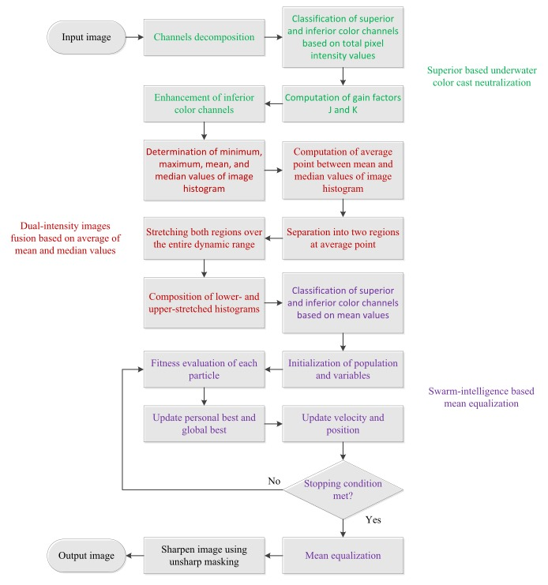

Figure 1.1

CHAPTER – 2

REVIEW OF LITERATURE

2.1 Literature Review on Underwater Image Enhancement Using PSO

The PSO evolutionary algorithm has been used in the literature to enhance gray-level images and colored images . Gorai and Ghosh and Braik and Sheta use the PSO algorithm for ordinary image enhancement; in the former, the enhanced images were better when compared with hue-preserving color image enhancement without the gamut problem and GA color image enhancement .
The resulting images from the latter approach have been compared with GA-based enhancement technique . The PSO-based enhancement method is better in terms of time, number of pixels on edges, and the objective scores obtained.

2.2 Existing Techniques for Underwater Image Enhancement

1. Contrast stretching- Contrast stretching is a straight forward image enhancement method that is used to
improve, enhance the image contrast by `stretching' the series of intensity values. A measure of images
dynamic range or the "broaden" of image‟s histogram is the contrast of an image. Whole range of intensity
value present within the image, or in a easier way, the minimum pixel value subtracted from the maximum
pixel value is called dynamic range of image. It differs from the more complicated histogram equalization in
a way that it can only concern a linear scaling function to the image pixel values.

2. Homomorphic filtering : The homomorphic filtering is utilized to fix non-uniform lighting to reinforce
contrast from the impression. This is a frequencyfiltering technique. It is the most utilized system on
the grounds that it redresses11function of image detected by device, I(x, y) the illumination function and
r(x, y) the reflectance function. By multiplying these components filter can reduce the non uniform
illumination present in the image.
3. Anisotropic filtering: Anisotropic filtering disentangles picture components to enhance picture division.
This channel smoothes the picture in homogeneous rang however conserve edges and upgrades them. It is
utilized to smooth compositions and diminishes relics by erasing little edges enhanced by
homomorphic filtering.

4. Histogram equalization: Histogram equalization is a method for modifying image intensities and contrast
p- ISSN: 2395-0072 the true color and for dealing with the issue of uneven illumination. of image in image
the image 's histogram processing using . Histogram equalization is helpful in pictures with backgrounds
and frontal areas that are both bright or both dim. This is a simple and straightforward technique. But it has
a disadvantage also that is it also amplifies the background noise present in the image and lead to decrease in the useful signal. So it produces unrealistic effects in the output images. The basic idea lying behind this method is mapping the gray levels depending upon the probability distribution of the input gray levels.

5. Contrast Limited Adaptive Histogram Equalization (CLAHE): It is generalization of adaptive
histogram equalization. With this technique the image is broken up into tiles. The gray scale is calculated
for each of these tiles, based upon its histogram and transform function, which is derived from the
interpolation between the manipulated histograms of the neighbouring sub-regions. The transformation
function is relative to the cumulative distribution function (CDF) of pixel values in the area. CLAHE
contrasts from AHE in contrast limiting. CLAHE limits the noise enhancement by cut-out the histogram at
a client characterized worth. A. CLAHE on RGB color model RGB color is an additive color model which
depicts hues regarding the measure of red (R), green (G) and blue (B) present. It depicts what sort of light
needs to be transmitted to create a given hues present in the image. CLAHE can be applicable to all the three
parts i.e.red, greenand blue separately. The effect of full-color RGB can beacquired by combining the
individual components of model. B. CLAHE on HSV color model HSV color model defines colors in terms
of the Hue (H), Saturation (S), and Value (V). HSV color model is cylindrical coordinate illustration of points
in an RGB color model. Hue is the characteristic of a visual sensation as indicated by which a territory seems
to be related to one of the color seen. The hue and saturation level don't have any kind of effect when value is
at max or min intensity level. CLAHE is applied on V and S components.
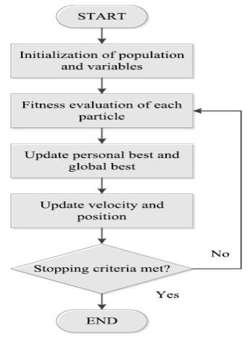
Figure 2.1
PSO Chart
2.3 Applications
Under water image enhancement finds a lot of application in multiple number of diversified fields. It finds use in inspection of underwater infrastructure and detection of any man-made objects.it is also used to understand marine biology research, for environmental evaluation, for the research of monuments submerged in water and for underwater navigational monitoring in submarines. Underwater image enhancement is also crucial in the control system of underwater vehicles and to determine the cultural heritage of archaeological sites submerged under water. Also, study of underwater formations like coral reefs depends heavily on underwater image enhancement.
1. Marine biology: Enhance the underwater images captured for the study of marine life, coral reefs, and aquatic ecosystems.
2. Oceanography: Improve the visual quality of images captured for the study of ocean currents, wave patterns, and ocean floor topography.
3. Underwater archaeology: Enhance images of shipwrecks and underwater ruins to gather more information about these sites.
4. Underwater photography: Enhance the quality of underwater images captured by scuba divers and underwater photographers to produce more vivid and appealing pictures.
5. Robotics and Autonomous Systems: Enhance the images captured by underwater robots and autonomous systems to help improve their navigation and perception capabilities.
6. Oil and Gas Exploration: Enhance the images captured during oil and gas exploration activities to gather more accurate information about the underwater environment.

CHAPTER – 3

MODEL IMPLEMENTATION AND ANALYSIS

Introduction
This section provides an overview of the model implementation and analysis. It explains the purpose, scope, and significance of the study, along with a brief summary of the methods used.

Design Requirements
This section details the essential components and specifications necessary for the model's implementation. It outlines the hardware and software prerequisites and other functional requirements.

Libraries Installation
The libraries used in the code are:
• NumPy: A library for numerical computing in Python.
• os: A module that provides a way of interacting with the operating system.
• Matplotlib: A plotting library for Python.
• Python: A high-level programming language used for computer vision and image processing tasks.
• OpenCV: An open-source computer vision library that provides tools for image and video analysis.
• Here are the installation instructions for libraries that are not included in the standard Python distribution:
• Matplotlib: You can install Matplotlib using pip by running the following command in a terminal
or command prompt.

Command Prompt Terminal
This subsection describes the role of the command prompt or terminal in the implementation. It includes instructions on running scripts, executing commands, and debugging processes.
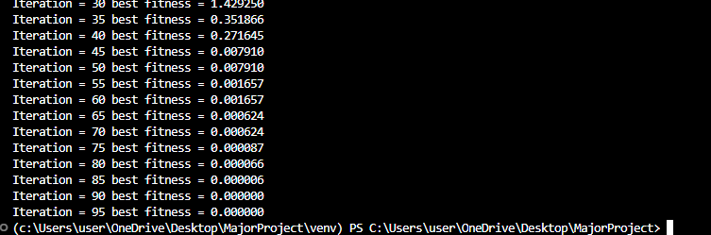
Figure 3.1

Experimental Results

This section presents the results obtained from testing the model. It includes performance metrics, accuracy comparisons, error analysis, and other statistical evaluations.

Input image : Output Image:
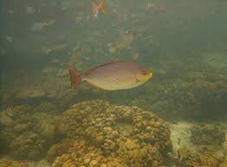
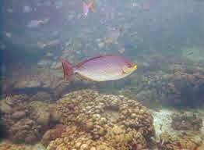
Figure 3.2 Figure 3.3

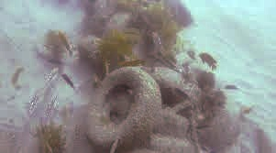
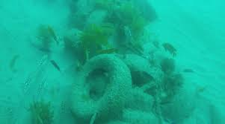
Figure 3.4 Figure 3.5

CHAPTER – 4 CODE IMPLEMENTATION

4.1 Code Implementation

Main.py:

import os
import numpy as np
import cv2 as cv
import matplotlib.pyplot as plt
from utility import *

dir_path = "./images/"

original_images =[]
NUCE_images =[]

img_w = 350 #image width
img_h = 350 #image height

for im in os.listdir(dir_path):

img = cv.imread(dir_path+im,1)
# img = cv.resize(img,(img_w,img_h))
original_images.append(img)

nuce_img = NUCE(img)
NUCE_images.append(nuce_img)

cv.imwrite("./results/"+im.split('/')[-1], nuce_img)

fig, ax = plt.subplots(4,2,figsize=(6, 9), constrained_layout = False)
ax[0][0].set_title("Original Image")
ax[0][1].set_title("NUCE Image")

for i in range(4):

ax[i][0].imshow(cv.cvtColor(original_images[i], cv.COLOR_BGR2RGB),cmap='gray')
ax[i][0].axis('off')

ax[i][1].imshow(cv.cvtColor(NUCE_images[i], cv.COLOR_BGR2RGB), cmap='gray')
ax[i][1].axis('off')

fig.tight_layout()
plt.savefig("./results/output.jpg")
# plt.show()

utility.py:
import numpy as np
import cv2 as cv
import matplotlib.pyplot as plt
from PSO import *

# shows histogram of all 3 channels
def color_hist(img):

y = np.linspace(0 ,256)
fig , ax = plt.subplots(3,1)
ax[0].hist(img[:,:,0].flatten().ravel(),color='blue',bins = 256)
ax[1].hist(img[:,:,1].flatten().ravel(),color='green',bins = 256)
ax[2].hist(img[:,:,2].flatten().ravel(),color='red',bins = 256)

plt.show()

def plot_hist(img):

plt.hist(img.flatten(),bins = 150)
plt.show()

# stacking BGR channels in order after computation
def image(input):
val = list(input)

for p in range(len(val)):
if val[p][1]=="B":
b = val[p][0]
elif val[p][1]=="G":
g = val[p][0]
if val[p][1]=="R":
r = val[p][0]
img = np.dstack([b,g,r])
img = np.array(img,dtype=np.uint8)

return img

# Indicating superior, inferior and intermediate channels based on mean of pixels in channel
def superior_inferior_split(img):

B, G, R = cv.split(img)

pixel = {"B":np.mean(B) ,"G":np.mean(G),"R":np.mean(R)}
pixel_ordered = dict(sorted(pixel.items(), key=lambda x: x[1], reverse=True))

# Classifying Maximum, Minimum and Intermediate channels of image
label =["Pmax","Pint","Pmin"]
chanel={}

for i,j in zip(range(len(label)),pixel_ordered.keys()):
if j=="B":
chanel[label[i]]=list([B,j])

elif j=="G":
chanel[label[i]]=list([G,j])

else:
chanel[label[i]]=list([R,j])

return chanel

def neutralize_image(img):

track = superior_inferior_split(img)

Pmax = track["Pmax"][0]
Pint = track["Pint"][0]
Pmin = track["Pmin"][0]

#gain_factor Pint
J = (np.sum(Pmax) - np.sum(Pint))/(np.sum(Pmax) + np.sum(Pint))

#gain_factor Pmin
K = (np.sum(Pmax) - np.sum(Pmin))/(np.sum(Pmax) + np.sum(Pmin))

track["Pint"][0] = Pint + (J * Pmax)
track["Pmin"][0] = Pmin + (K * Pmax)

#neutralised image
neu_img = image(track.values())

return neu_img

def Stretching(image):

LSR_img = [] # for lower stretched image
USR_img = [] # for upper stretched image
height, width = image.shape[:2]

for i in range(image.shape[2]):
img_hist = image[:,:,i]
max_P = np.max(img_hist)
min_P = np.min(img_hist)

mean_P = np.mean(img_hist)
median_P = np.median(img_hist)

avg_point = (mean_P + median_P)/2

LS_img = np.zeros((height, width))
US_img = np.zeros((height, width))

for i in range(0, height):
for j in range(0, width):
if img_hist[i][j] < avg_point:
LS_img[i][j] = int((( img_hist[i][j] - min_P) * ((255 - min_P) / (avg_point - min_P)) + min_P))
US_img[i][j] = 0
#array_upper_histogram_stretching[i][j] = p_out
else:
LS_img[i][j] = 255
US_img[i][j] = int((( img_hist[i][j] - avg_point) * ((255) / (max_P - avg_point))))

LSR_img.append(LS_img)
USR_img.append(US_img)

LS = np.array(np.dstack(LSR_img),dtype=np.uint8)
US = np.array(np.dstack(USR_img),dtype=np.uint8)

return LS,US

def enhanced_image(img1, img2):

#integration of dual intensity images to get Enhanced-constrast output image
b1,g1,r1 = cv.split(img1)
b2,g2,r2 = cv.split(img2)

height, width = img1.shape[:2]
dual_img=np.zeros((height, width,3),dtype=np.uint8)

dual_img[:,:,0] = np.array(np.add(b1/2, b2/2),dtype = np.uint8)
dual_img[:,:,1] = np.array(np.add(g1/2, g2/2),dtype = np.uint8)
dual_img[:,:,2] = np.array(np.add(r1/2, r2/2),dtype = np.uint8)

return dual_img

def pso_image(img):

group = superior_inferior_split(img)

maxi = np.mean(group["Pmax"][0])
inte = np.mean(group["Pint"][0])
mini = np.mean(group["Pmin"][0])

# Defining hyperparameters
n = 50 # number of particles
params = {"wmax" : 0.9, "wmin" : 0.4, "c1" : 2 , "c2" : 2}
max_iteration = 100

x = np.array([inte, mini])

def func(X,P_sup = maxi):
return np.square(P_sup - X[0])+np.square(P_sup - X[1])

nVar= 2 # number of variables to optimize
VarMin = 0 # lower bound of variables , you can use np.array() for different variables
VarMax = 255 # upper bound of variables, you can use np.array() for different variables

gbest = pso(func, max_iter=max_iteration, num_particles = n, dim = 2, vmin = VarMin, vmax = VarMax, params = params)

#gamma correction for inferior color channels
mean_colors = gbest['position']
gamma = np.log(mean_colors/255)/np.log(x/255)

group["Pint"][0] = np.array(255*np.power(group["Pint"][0]/255 , gamma[0]))
group["Pmin"][0] = np.array(255*np.power(group["Pmin"][0]/255 , gamma[1]))

pso_res = image(group.values())

return pso_res

def unsharp_masking(img):

alpha = 0.2
beta = 1 -alpha
img_blur = cv.GaussianBlur(img, (1,1),sigmaX=1)
unsharp_img = cv.addWeighted(img, alpha, img_blur, beta, 0.0)

return unsharp_img

def NUCE(img):

#superior based underwater color cast neutralization
neu_img = neutralize_image(img)

#Dual-intensity images fusion based on average of mean and median values
img1, img2 = Stretching(neu_img)
dual_img = enhanced_image(img1, img2)

#Swarm-intelligence based mean equalization
pso_res = pso_image(dual_img)

#Unsharp masking
nuce_img = unsharp_masking(pso_res)

return nuce_img

pso.py:
import numpy as np
#particle class

class Particle:
def _init_(self, func, dim, vmin, vmax, seed):
self.rnd = np.random.seed(seed)

# initialize position, velocity, local_best_particle of the particle with 0.0 value
self.velocity = np.zeros(dim)
self.best_part_pos = np.zeros(dim)

self.position = np.random.uniform(vmin, vmax, dim)

# compute fitness of particle
self.fitness = func(self.position) # curr fitness

# initialize best position and fitness of this particle
self.best_part_pos = np.copy(self.position)
self.best_part_fitness = self.fitness # best fitness

def pso(func, max_iter, num_particles, dim, vmin, vmax, params):

# hyper parameters
wmax = params["wmax"] # maximum inertia
wmin = params["wmin"] #minimum inertia
c1 = params["c1"] # cognitive (particle)
c2 = params["c2"] # social (swarm)

rnd = np.random.seed()

# create num_particles
swarm = [Particle(func, dim, vmin, vmax, i) for i in range(num_particles)]

# compute the value of best_position and best_fitness in swarm
best_swarm_pos = np.zeros(dim)
best_swarm_fitness = np.inf # swarm best

# computer best particle of swarm and it's fitness
for i in range(num_particles): # check each particle
if swarm[i].fitness < best_swarm_fitness:
best_swarm_fitness = swarm[i].fitness
best_swarm_pos = np.copy(swarm[i].position)

# main loop of pso
it = 0
while it < max_iter:

# For every 5 iterations print iteration number and best fitness value
if it % 5 == 0:
print("Iteration = " + str(it) + " best fitness = %f" % best_swarm_fitness)

w = wmax - ((wmax - wmin)/max_iter)*it

for i in range(num_particles):

# compute new velocity of current particle
swarm[i].velocity = (
(w * swarm[i].velocity) +
(c1 * np.random.rand(dim) * (swarm[i].best_part_pos - swarm[i].position)) +
(c2 * np.random.rand(dim) * (best_swarm_pos -swarm[i].position)))

# compute new position using new velocity
for k in range(dim):
swarm[i].position[k] += swarm[i].velocity[k]
swarm[i].position[k] = np.maximum(swarm[i].position[k], vmin)
swarm[i].position[k] = np.minimum(swarm[i].position[k], vmax)

# compute fitness of new position
swarm[i].fitness = func(swarm[i].position)

# check for local best particle
if swarm[i].fitness < swarm[i].best_part_fitness:
swarm[i].best_part_fitness = swarm[i].fitness
swarm[i].best_part_pos = np.copy(swarm[i].position)

# check for global best particle
if swarm[i].fitness < best_swarm_fitness:
best_swarm_fitness = swarm[i].fitness
best_swarm_pos = np.copy(swarm[i].position)

it += 1

gbest ={}
gbest["position"] = best_swarm_pos
gbest["cost"] = best_swarm_fitness

return gbest

Introduction

CHAPTER – 5 WORK PLAN

A project work plan allows you to outline the requirements of a project, project planning steps, goals, and team members involved in the project.Within each goal, you're going to outline the necessary Key Action Steps in project planning, the requirements, and who's involved in each action step.

Work Breakdown Structure
In order to develop this system, we gave enormous importance to scheduling because we believed if we want to provide the best of quality in a given period of time then we must give due importance to scheduling which also helped us to achieve a better results. we observe the entire work structure, meaning how the scheduling was maintained throughout the developmental phase.

Month | Activity | Status
February | Selection of project area and Study of related  works | Completed
March | Study on Software Implementation works.  Python and Image Processing | Completed
April | Study of packages/tools and installation of  packages and Implementation of working platform | Completed
May | Implementation of code and User Interface  Design | Completed

Table 5.1 Work Plan

CHAPTER -6

CONCLUSION AND FUTURE WORK

In this article, a PSO algorithm-based underwater image enhancement framework has been proposed. The implementation and testing are realized to prove the efficiency of this algorithm. The main goal of this technique is to enhance the image as much as possible by testing some parameters and comparing the results with another technique used.One of the most important parameters that must be checked is
the number of edges, which helps in the observation of more details in the image, and the goal is always to maximize it without human intervention. To achieve the best results, an appropriate fitness function that combines the parameters intensity, number of edges, entropy measure, standard deviation, and mean value of pixels has been chosen, implemented, and tested. In the state of the art, each fitness function concentrates on some parameters and ignores others. For example, the function chosen by the EEMD and GA does not take into consideration the number of edges.The proposed algorithm, along with the fitness function, efficiently improves the underwater images, i.e., the illumination and true colors. The technique is tested on four selected underwater images using seven evaluation methods. The results obtained are tabulated and histograms are plotted, indicating that the proposed technique enhances underwater images based on the obtained results themselves and by comparing the results with the most recently proposed algorithm (EEMD and GA). In this paper, the proposed NUCE method is successfully implemented to enhance the quality of underwater images. Motivated from natural landscape image, the proposed method integrates four major steps which involves swarm-intelligence algorithm to equalize mean values of all color channel histograms. results, the proposed method is able to enhance various
underwater scenes with high visibility, and being able to reduce underwater color cast significantly.

REFERENCES

- https://www.sciencedirect.com/science/article/pii/S0952197623016299

- https://www.researchgate.net/publication/336113052_Natural-based_underwater_image_color_enhancement_through_fusion_of_swarmintelligence_algorithm

