Input 1: Artificial Intelligence
Original Input:
Recent advances in artificial intelligence (AI) are transforming healthcare delivery, diagnosis, and research. Machine learning models now assist physicians by analyzing medical images such as X-rays and MRIs, detecting anomalies often at or above human-level accuracy. Natural language processing helps extract useful information from electronic health records (EHRs), making long patient histories searchable and enabling clinical decision support.
AI-driven drug discovery pipelines speed up candidate screening by predicting molecular properties and potential toxicity, lowering time-to-discovery and cost. Personalized medicine benefits from predictive models that combine genomic, lifestyle, and clinical data to recommend tailored therapies. Telemedicine adoption — accelerated by the COVID-19 pandemic — relies on AI for remote monitoring and triage.
However, challenges remain. Data privacy and patient consent are critical when using sensitive health records. Models trained on limited or biased datasets may perform poorly for underrepresented populations, exacerbating health disparities. Explainability is another concern: clinicians need interpretable model outputs to trust recommendations. Regulatory frameworks and robust validation are required before clinical deployment.
As research continues, interdisciplinary collaboration among clinicians, data scientists, regulators, and ethicists will be essential to ensure AI tools are safe, effective, and equitable.

Input 2: Renewable Energy
Original Input:
Countries worldwide are ramping up investments in renewable energy as a response to climate change and the need for energy security. Solar photovoltaic and onshore wind are among the fastest-growing electricity generation sources due to rapidly falling costs and favorable policy incentives. Many governments set ambitious targets to reach net-zero emissions by mid-century, driving accelerated deployment of renewables.
Energy storage technologies, primarily lithium-ion batteries, are critical for handling the variable nature of solar and wind power. Improved grid infrastructure, including smart grids and demand response, helps integrate intermittency while maintaining reliability. Large-scale adoption of renewables also increases jobs in manufacturing, construction, and maintenance, providing economic co-benefits.

Summarization Input 1 (Artificial Intelligence):

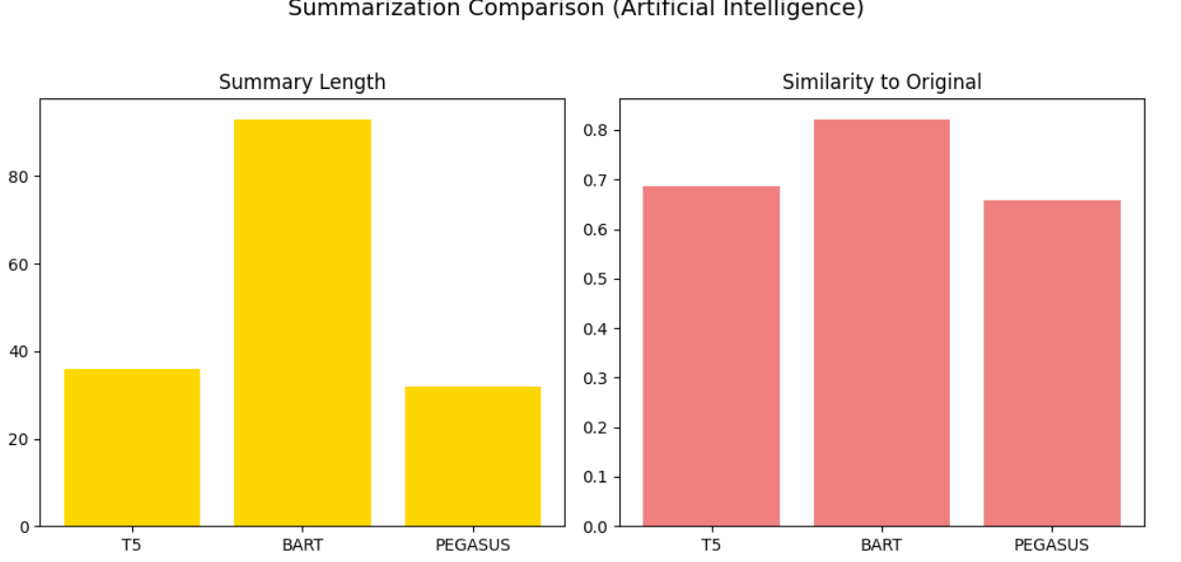

Summarization of Input 2 (Renewable Energy):
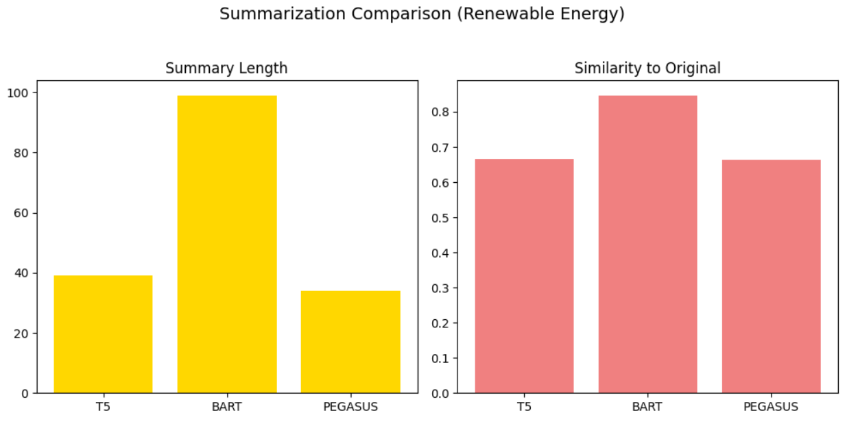

Paraphrasing :
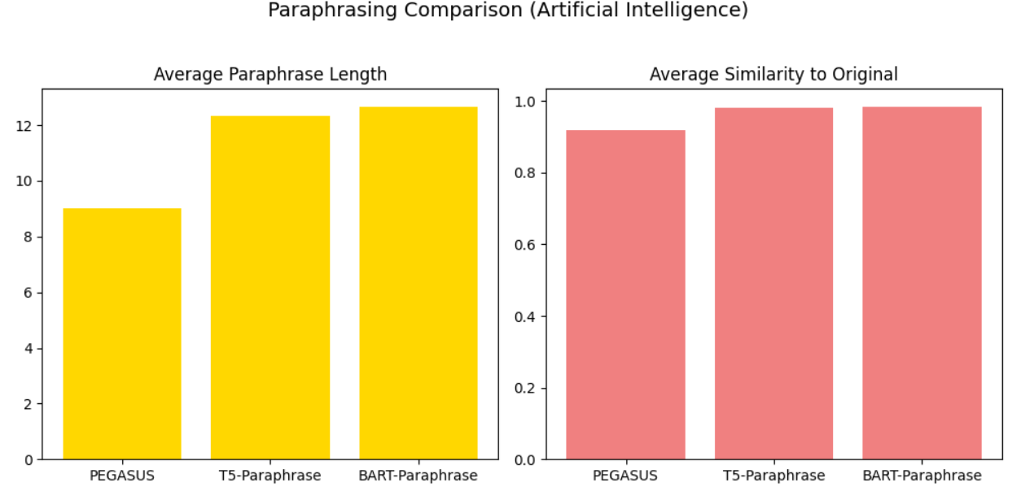

Bigram Visualization:
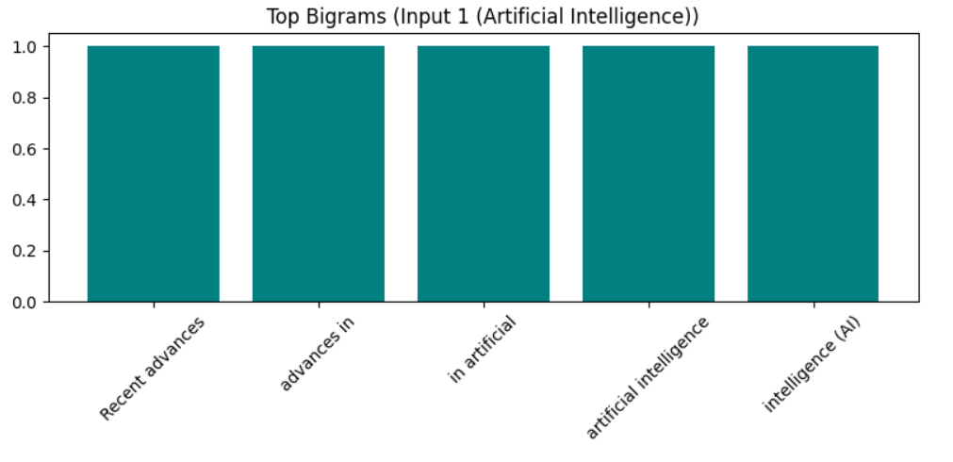
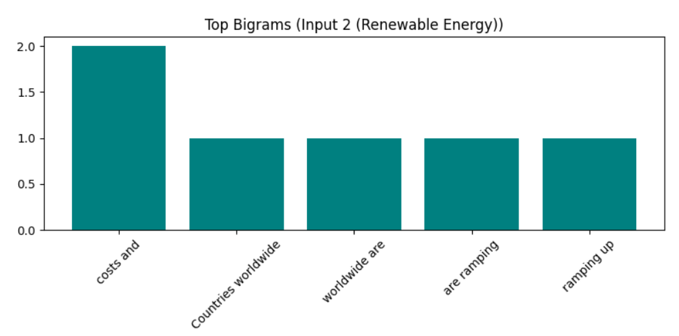

Best Model for Summarization
Among the summarization models I used (T5, BART, PEGASUS):
PEGASUS is typically the best for abstractive summarization, especially for factual or academic texts like “Artificial Intelligence” and “Renewable Energy.”
It produces concise, human-like summaries due to its pre-training on large summarization datasets (C4, HugeNews).
T5 and BART are strong too — T5 is good for factual precision, while BART generates fluent summaries but sometimes repeats phrases.

