Results/Outputs:

Summarization from different models with comparision and visualization.

Summarization(Abstractive) with TinyLlama, Phi-1.5, BART-Large-CNN, Gemma-2B-IT for Input about Technology:

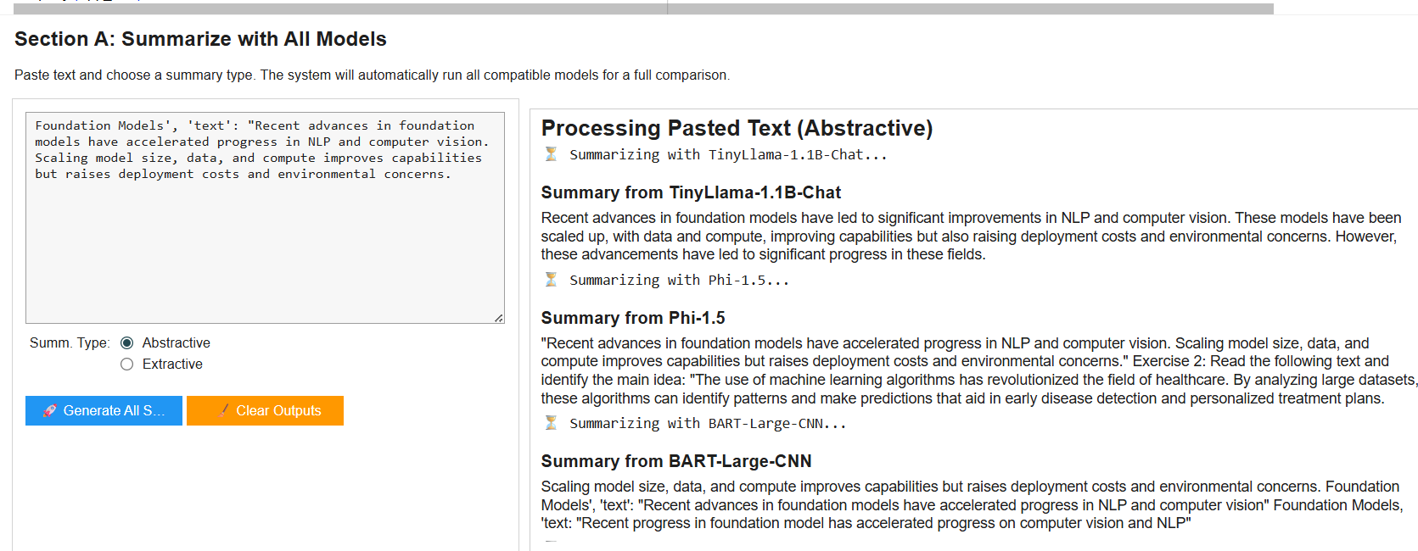

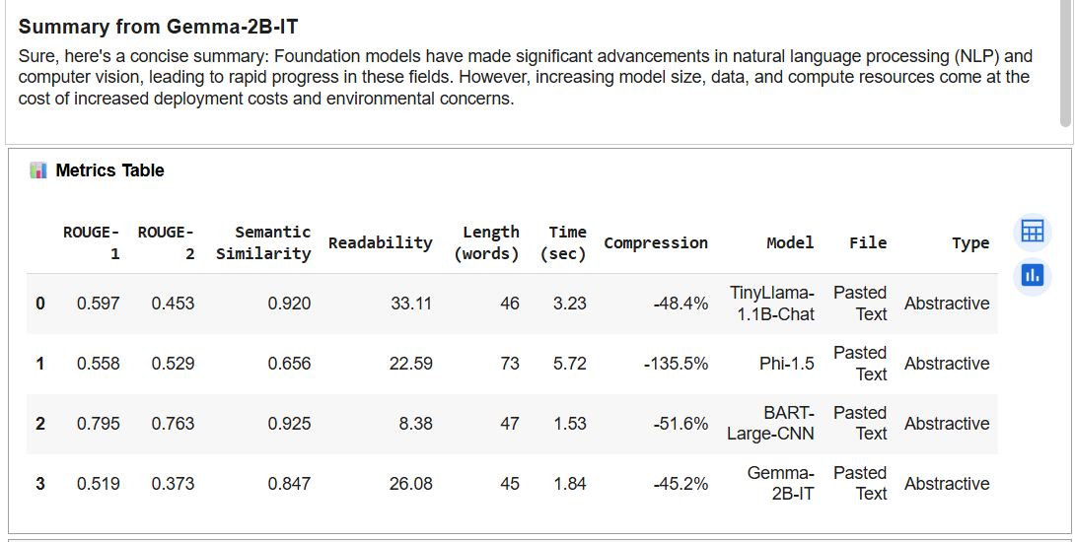
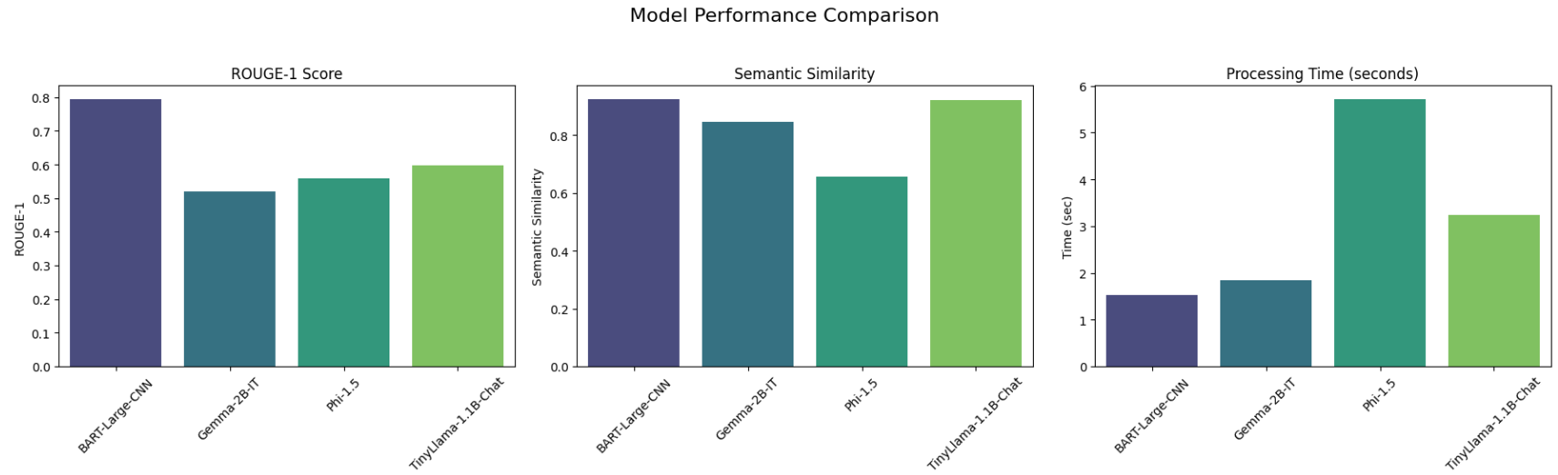
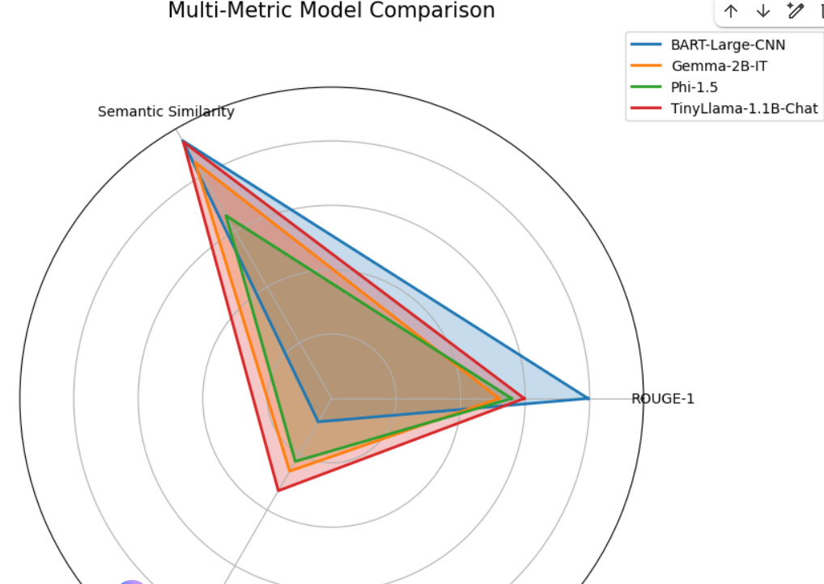

Summarization(Extractive) with TinyLlama, Phi-1.5, BART-Large-CNN, Gemma-2B-IT for Input about Technology:

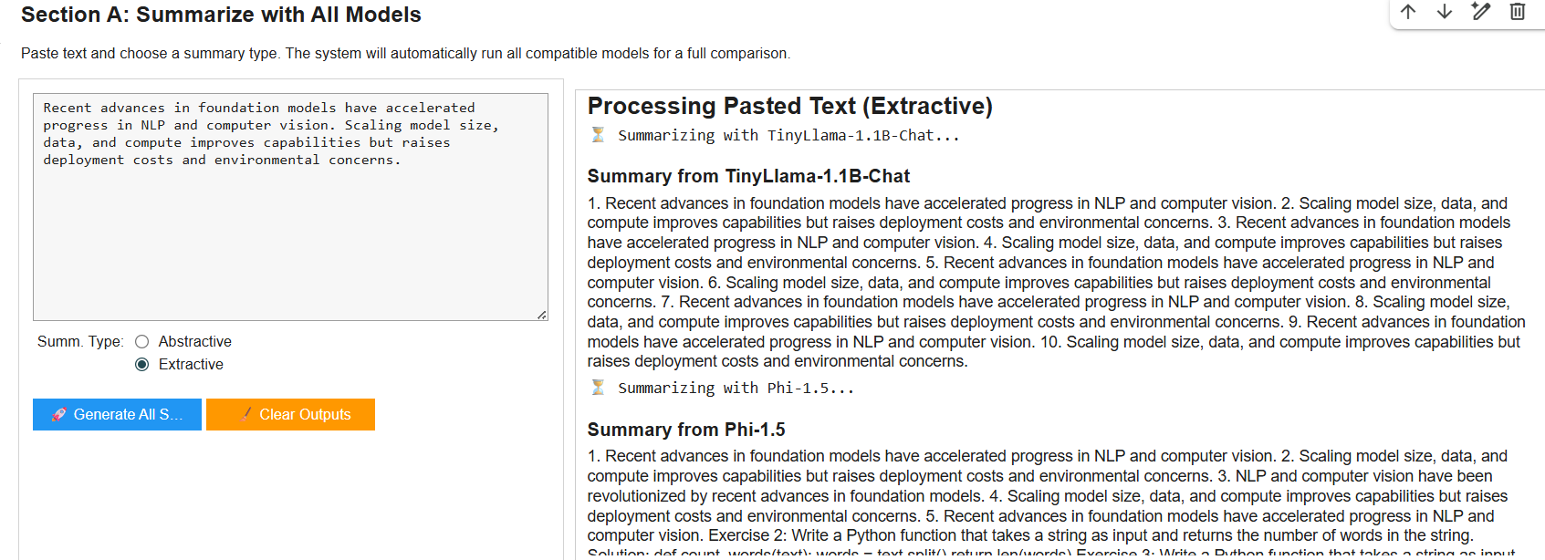
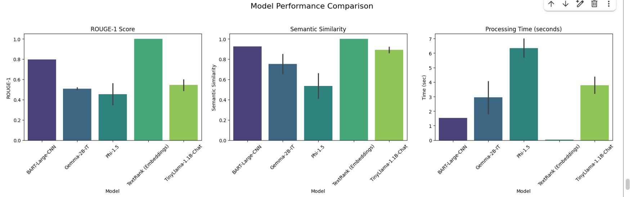
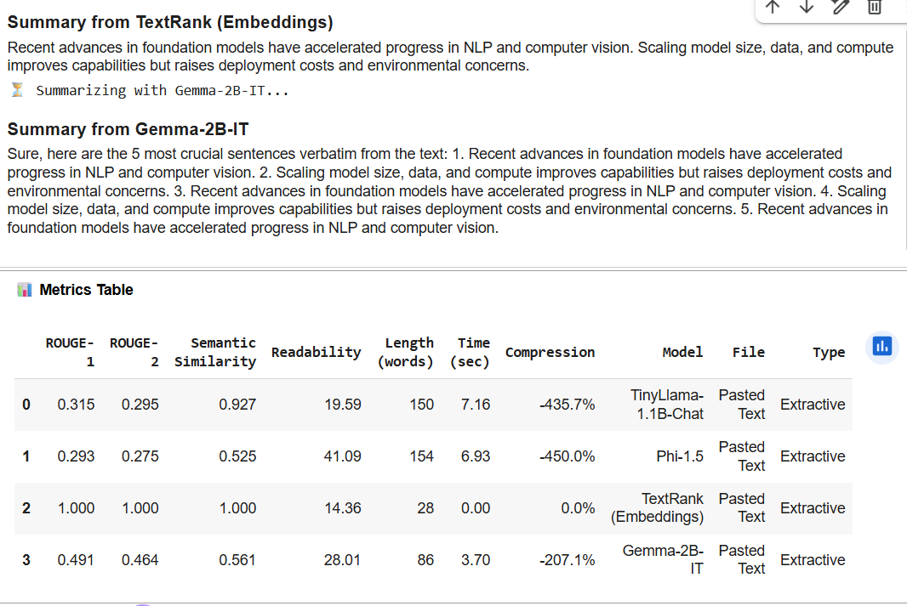
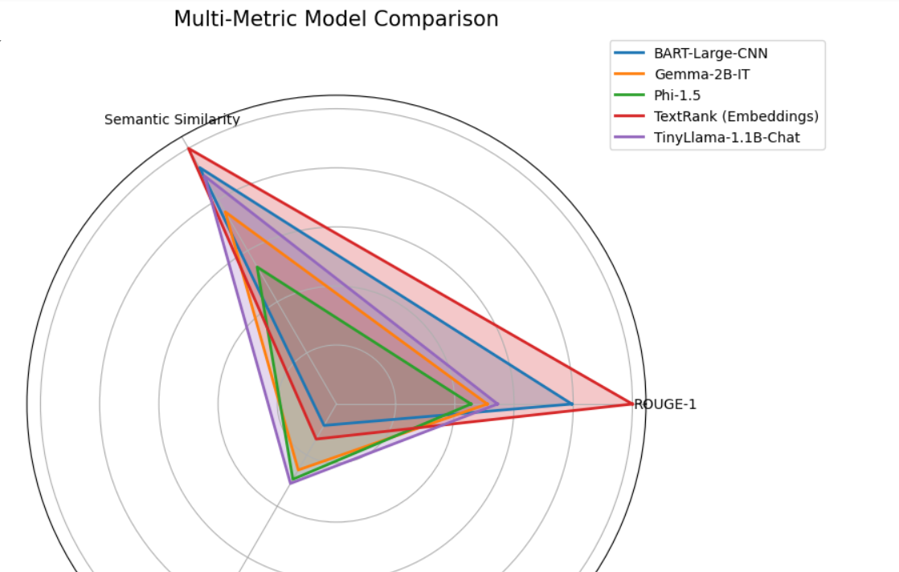

Summarization(Extractive) with TinyLlama, Phi-1.5, BART-Large-CNN, Gemma-2B-IT for Input about Health:

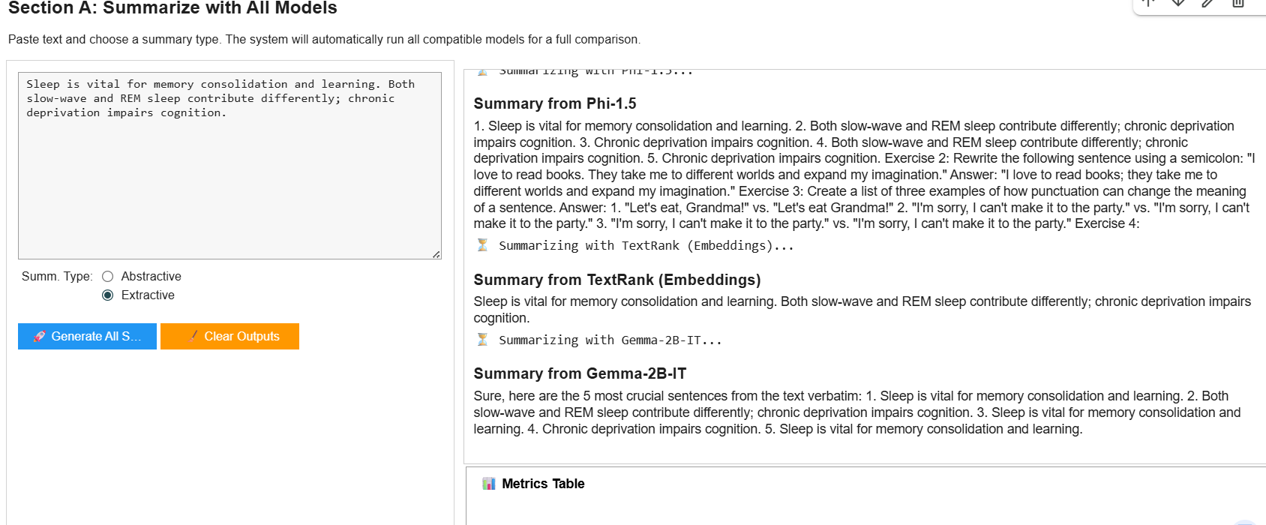
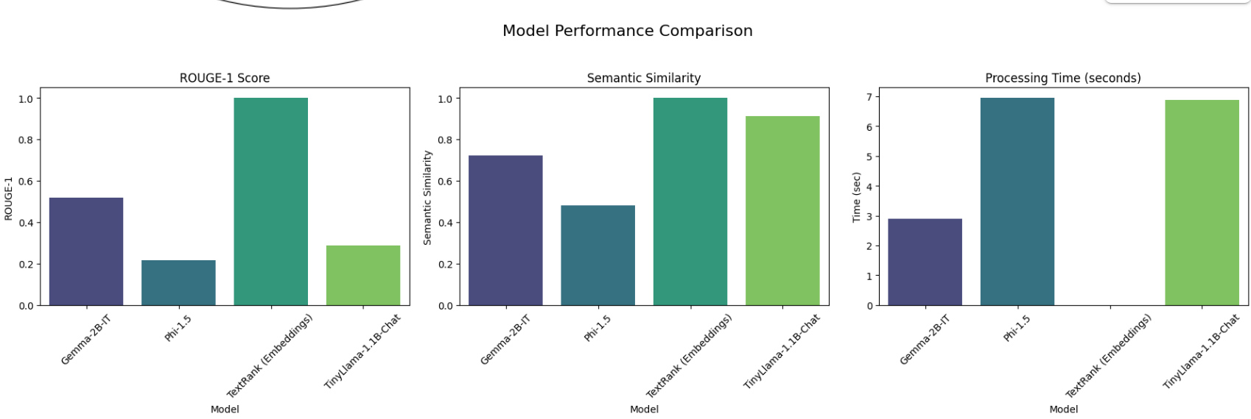
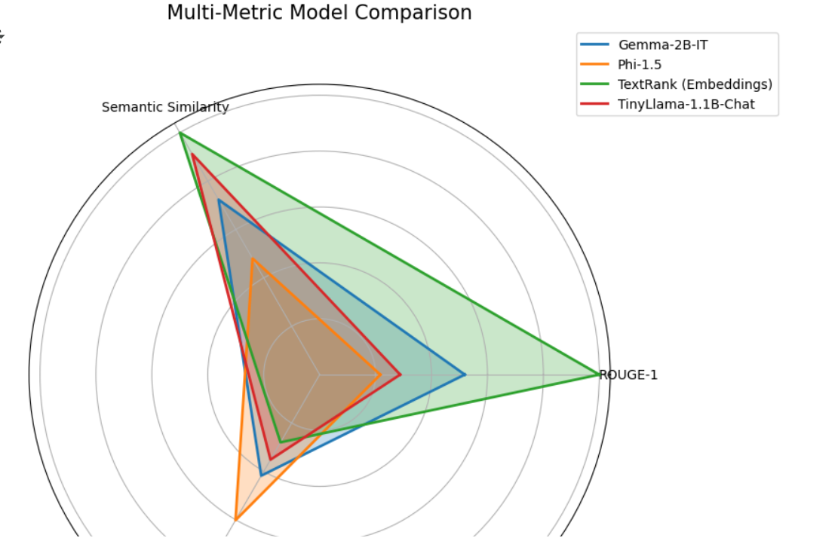

Summarization(Absractive) with Specific Models- I choosed BART_Large-CNN, Gemma-2B-IT for input about business.

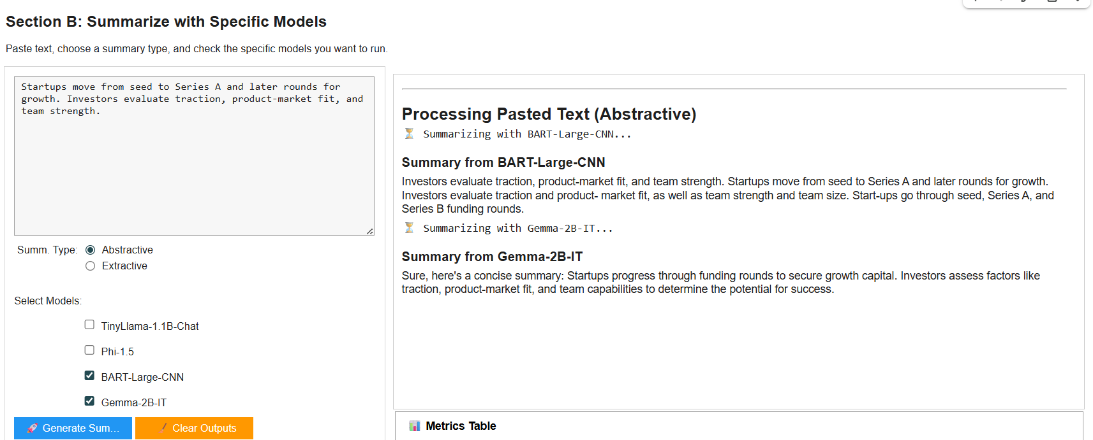
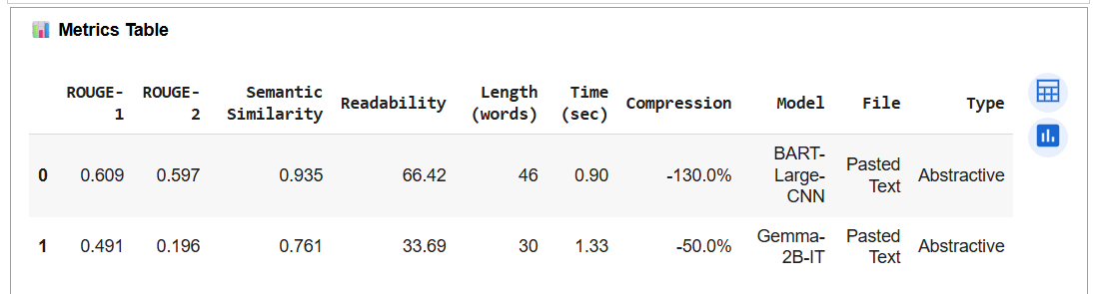
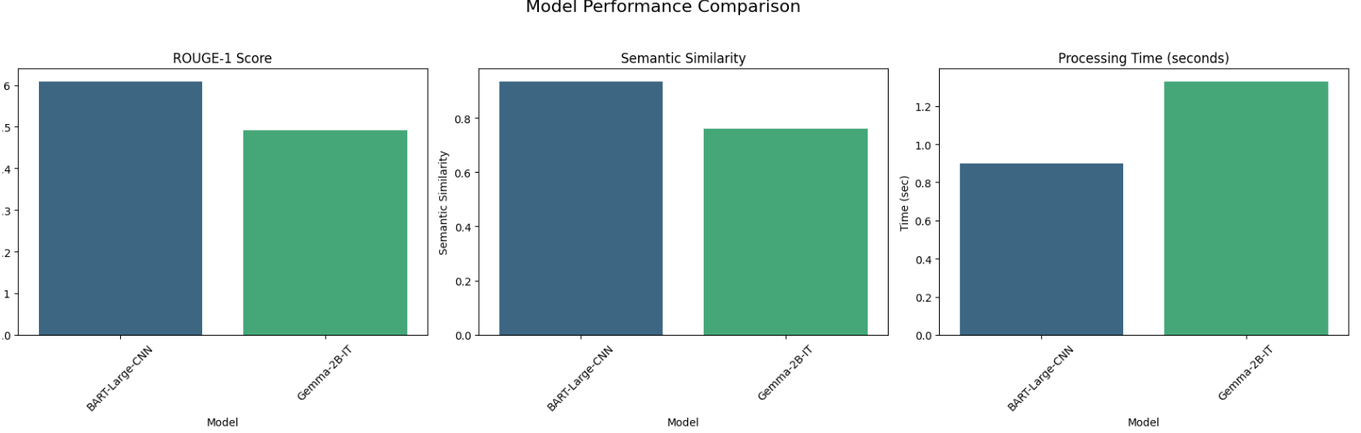
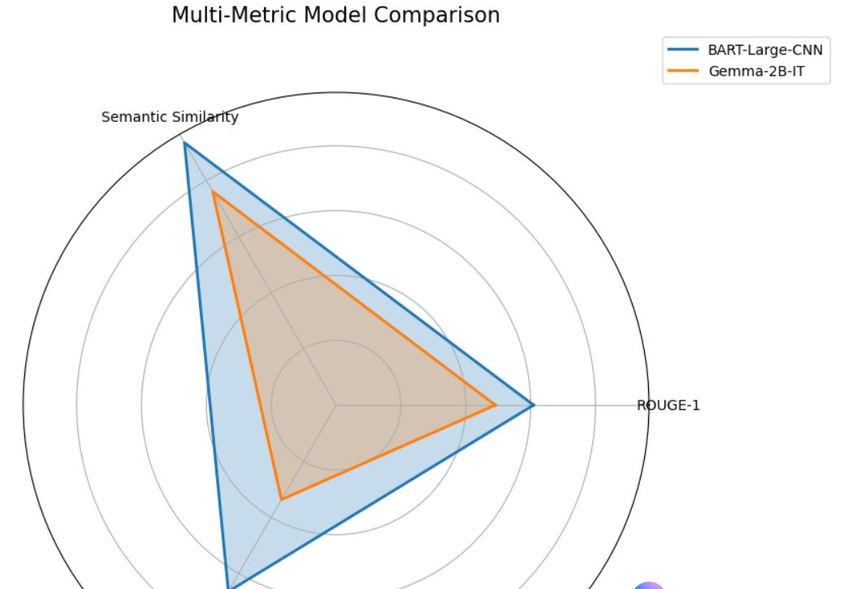

Summarization(Extractive) with Specific Models- I choosed BART_Large-CNN, Gemma-2B-IT for input about business.
