<https://github.com/Manasa-NC/.NetCoreApplication> ,This is my GitHub repository path which contains .NetCore Sample Application code with dependency injection and repository pattern along with database.

This is the sample project with **CRUD** operations in Asp.Net Core Web API using Entity Framework Core, with dependency injection, this published in azure portal along with the database and created CI/CD pipeline.

Below is the screenshot provided for deployment process azure portal.

1.Application pushed to Azure DevOps repository.

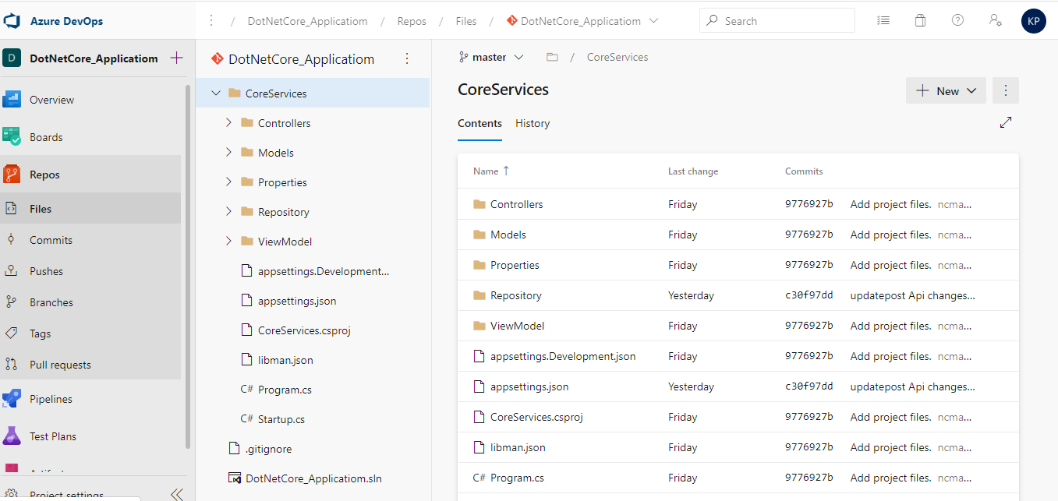

2. hosted in azure portal, below is the URL and Screenshot.

<https://coreservices20200116024508.azurewebsites.net/api/values>

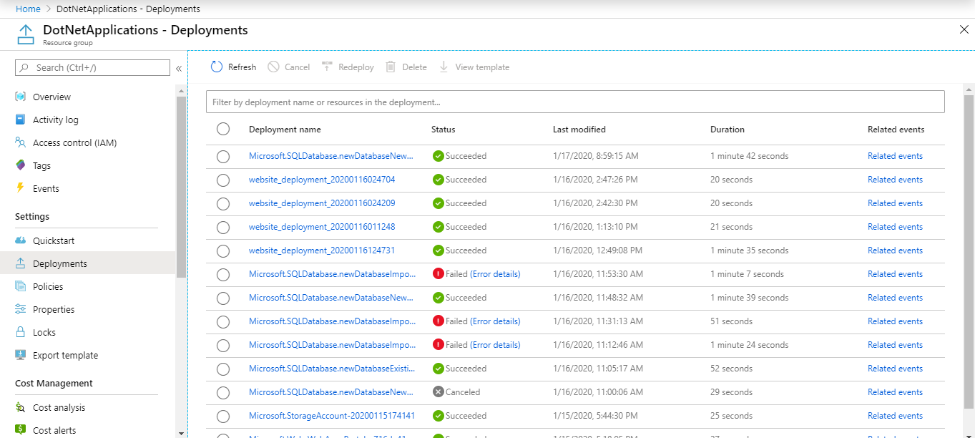

Created Azure SQL Database:

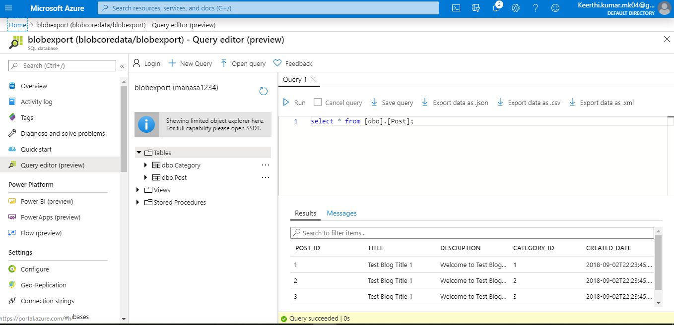

Connected local sql server management studio from azure remote sql server :

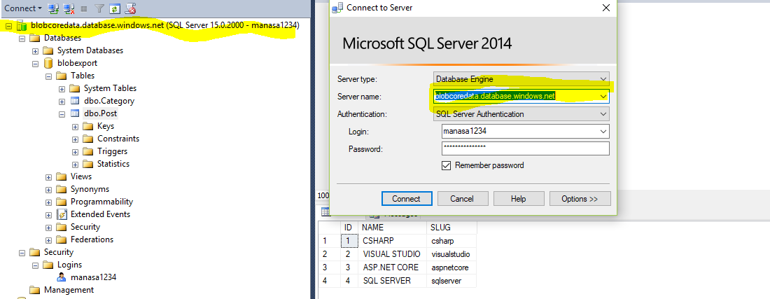

3. Testing our API End Points, header as**'Content-Type': 'application/json'**and click to Send button. It will return the list of available category.

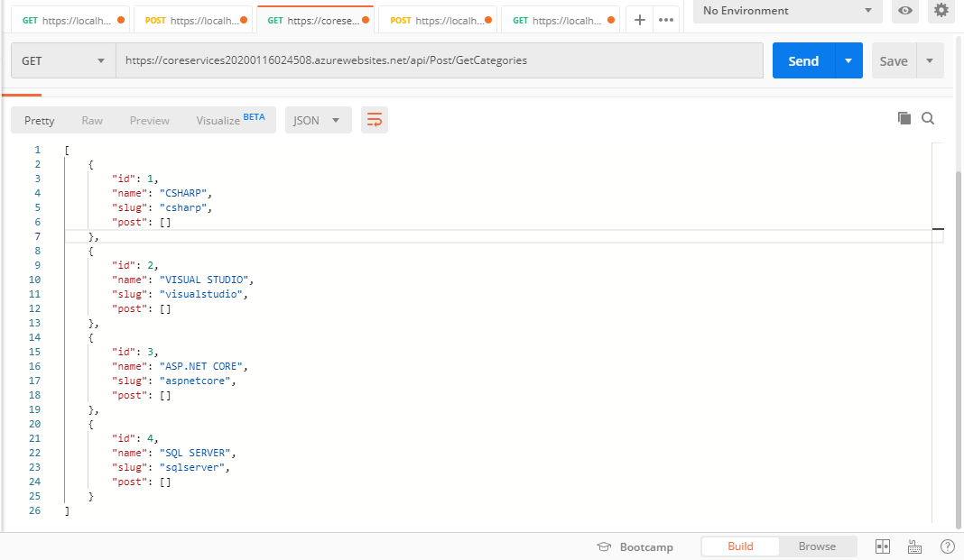

Below are the sample outputs

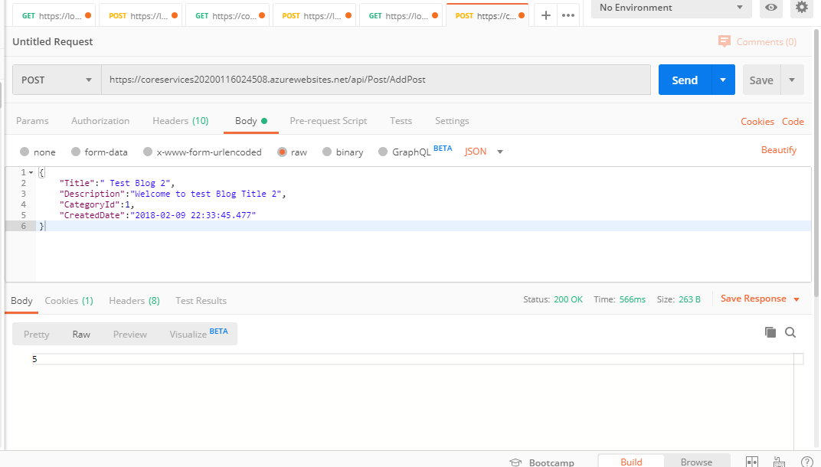

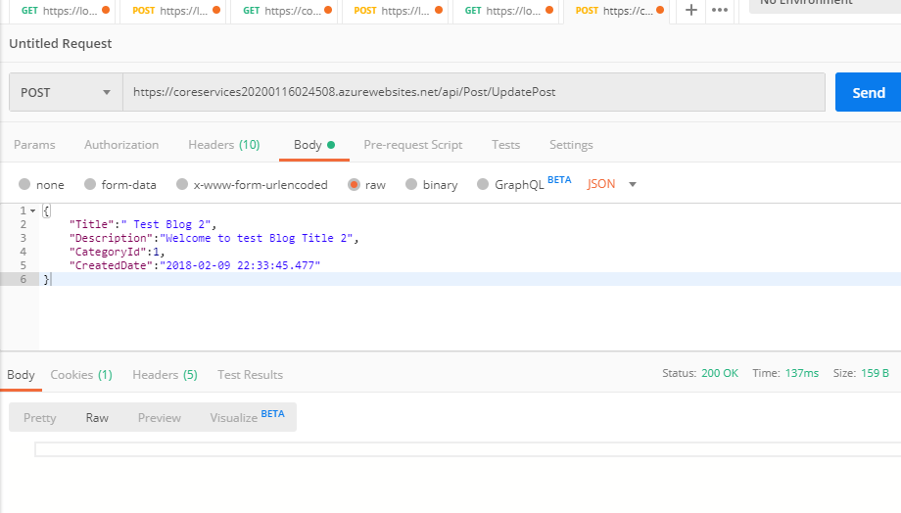

4.Created CI/CD Pipeline.

Build Pipeline:

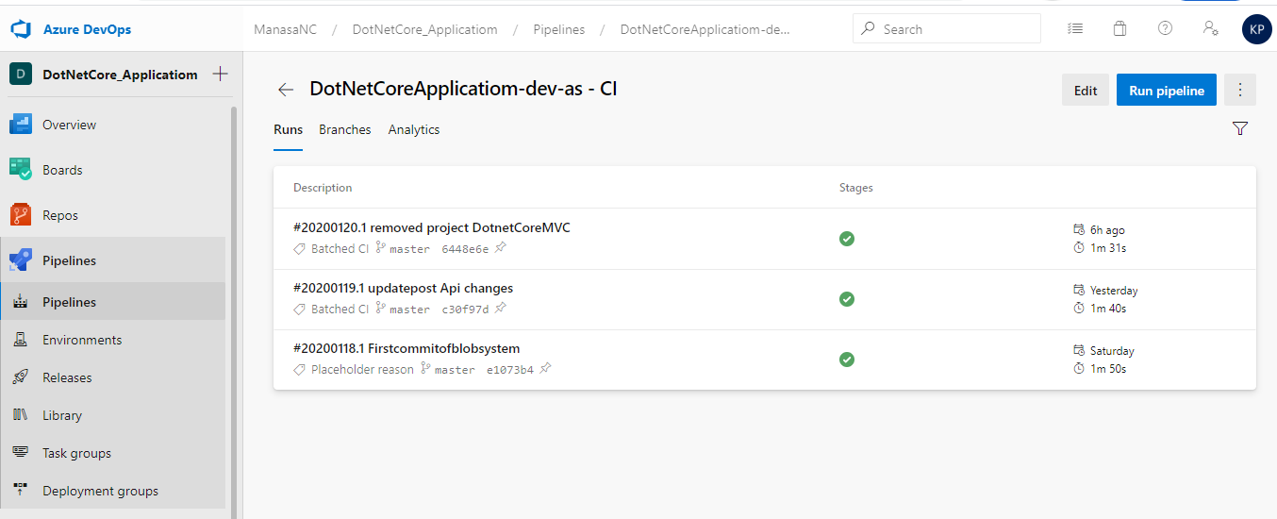

Release Pipeline:

