**[REST](https://www.soapui.org/rest-testing/getting-started.html)**

* REST stands for Representational State Transfer.
* It is a software **architecture** style that relies on a stateless communications protocol, most commonly, HTTP.
* REST structures data in XML, YAML, or any other format that is machine-readable, but usually JSON is most widely used.
* REST follows the object-oriented programming paradigm
* basic REST HTTP requests are: POST, GET, PUT, and DELETE
* You can import your REST service in SoapUI by using WADL files.
* When testing a REST API we should give the URL as request to the test case as well as we can get an XML doc or JSON as response.
* HTTP requests:

|  |  |
| --- | --- |
| **GET** | Read or retrieve data |
| **POST** | Add new data |
| **PUT** | Update data that already exists |
| **DELETE** | Remove data |

REST Testing

### **Create REST Request**

Start by creating a new REST project with a single request:

1. Сlick REst on the main toolbar or select **File > New Rest Project**.

In the dialog box, enter the following URL and click **OK**:

https://petstore.swagger.io/v2/pet/findByStatus?status=available

* SoapUI creates the project complete with a Service, Resource, Method and the actual Request and opens the Request editor.

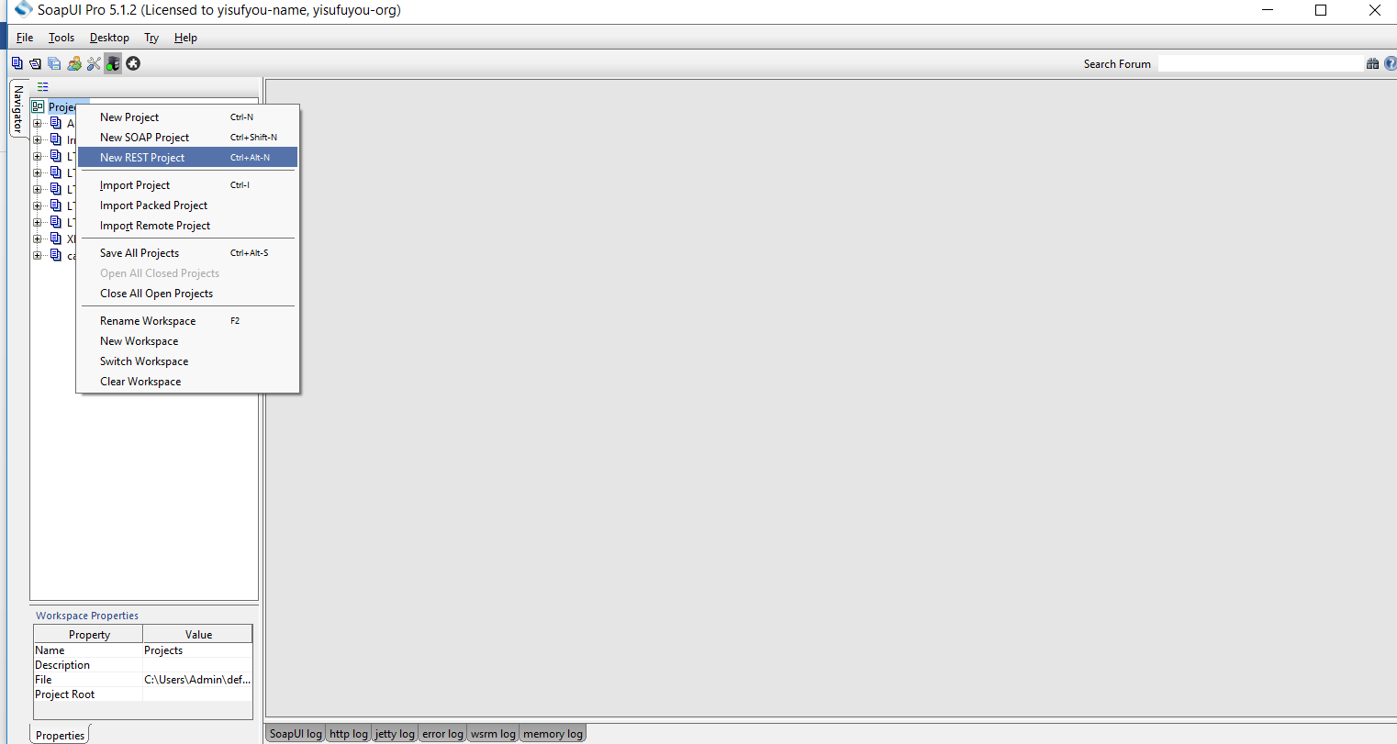

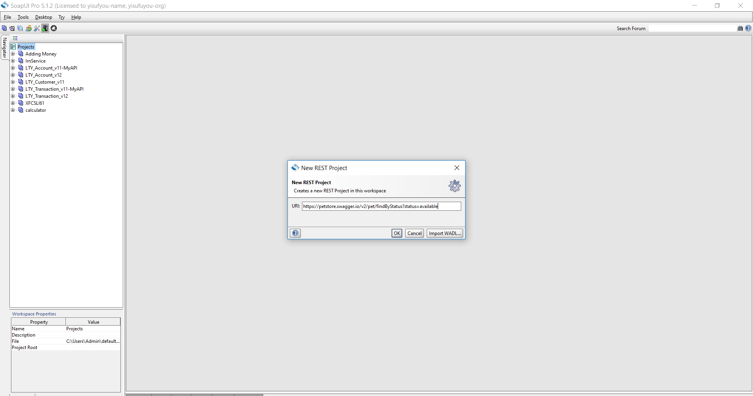

2.Click run on the Request toolbar and you will see the XML output returned by the service:

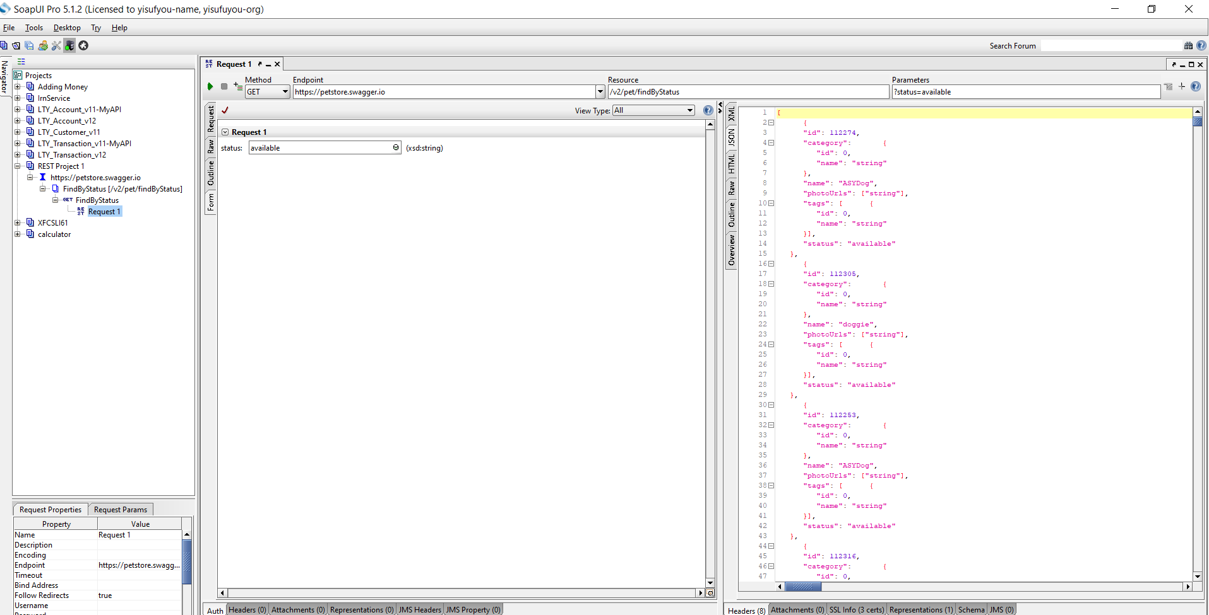

3.Let us create a testsuite. Specify a name for the test suite, test case and for the REST Request test step:

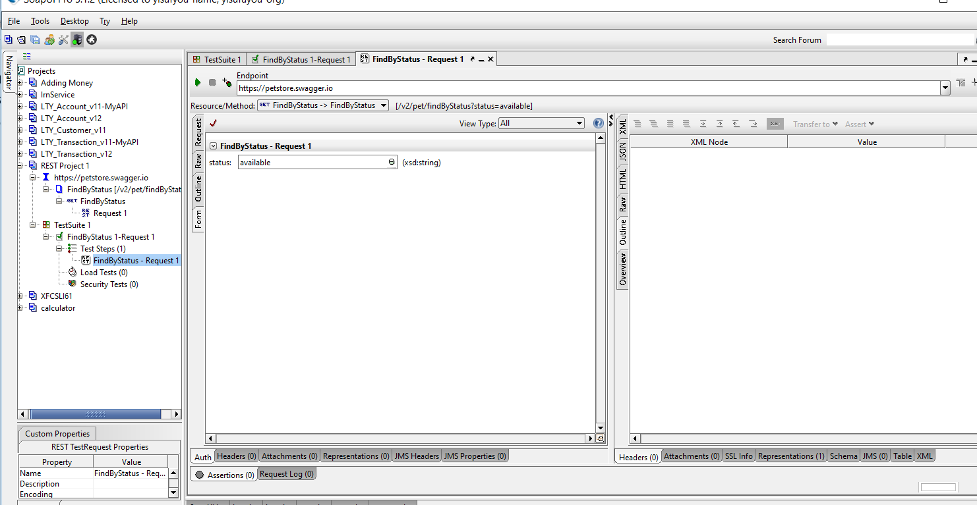

### **Adding Assertion**

* Assertion is to validate the content of the response
* Open the REST Request test step and click run to send the request.
* Click plus to add assertion:

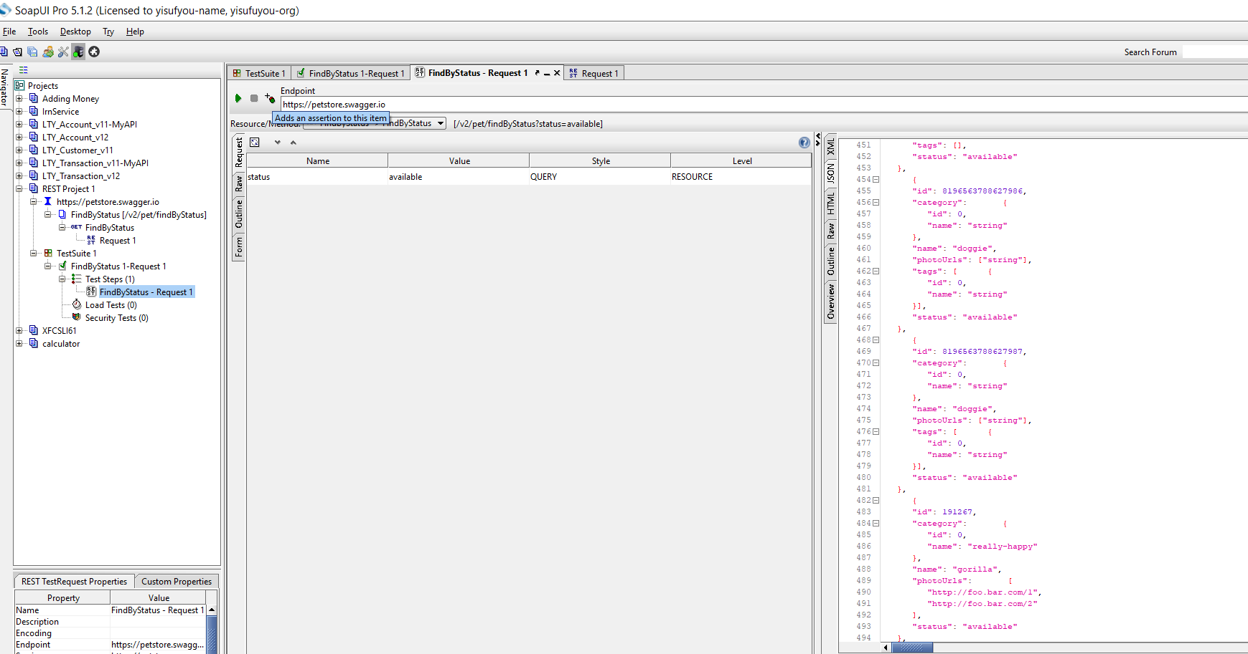

* Select **Property Content > JSONPath Count** and click **Add**:

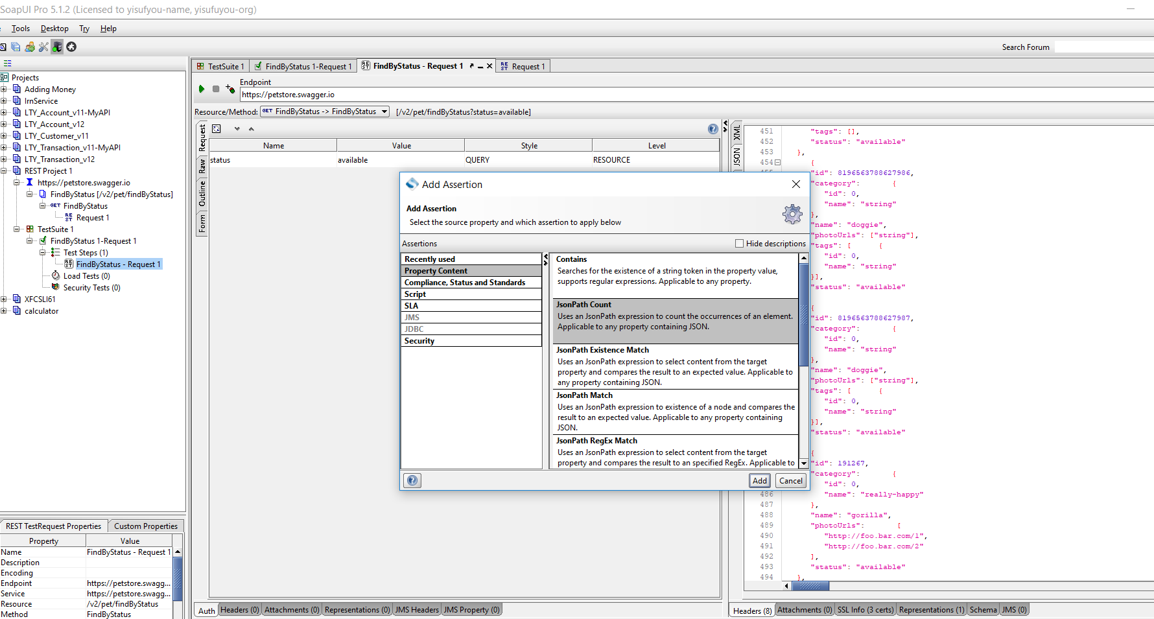

* In the dialog box, specify the following JSONPath expression:

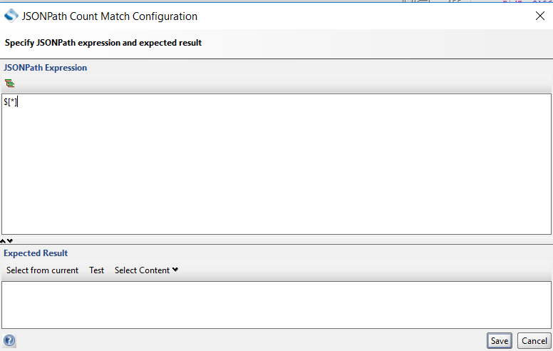

* Click **Select from current** to obtain the value from the current response and Click **Save** to create the assertion :

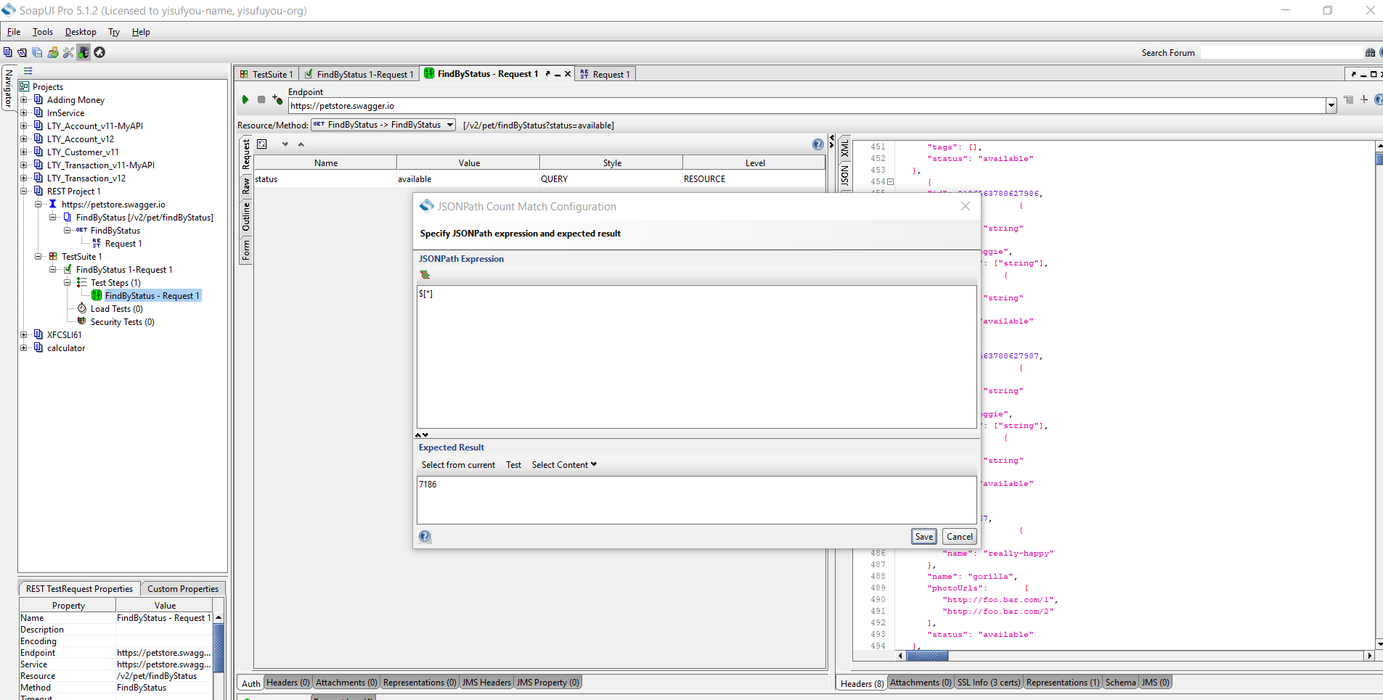

* Run the test case and check that the assertion passes:

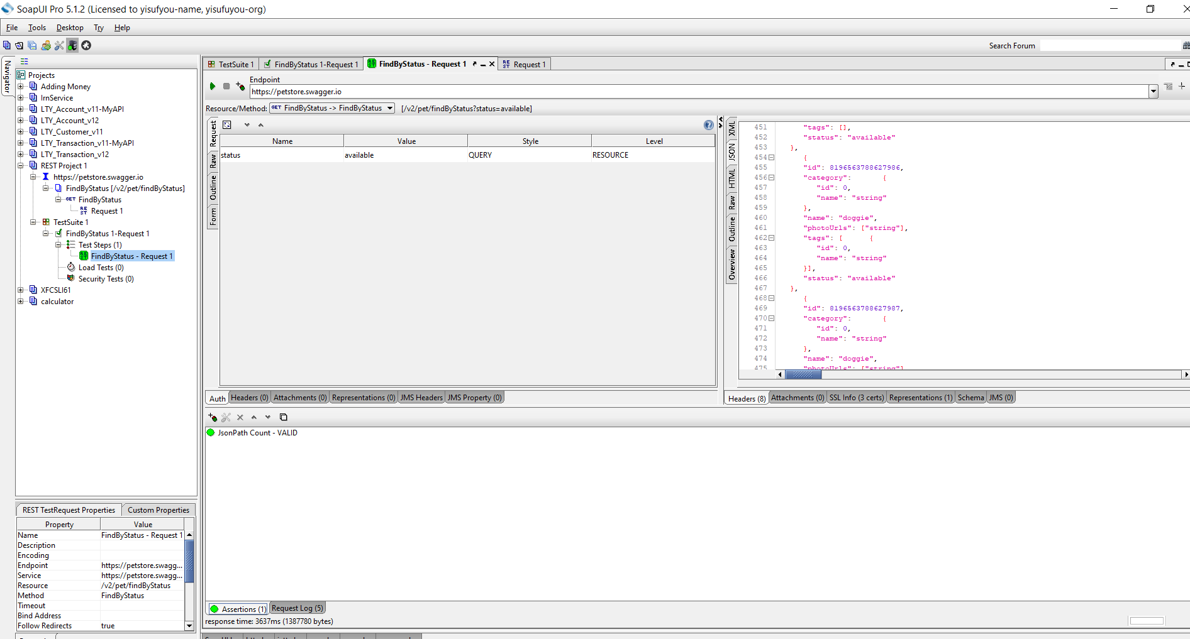

-A webservice that communicates/exchange information between 2 applications using REST architecture/principles is called as RESTful Webservice.

**Principles of Rest Webservice:**

* **UNIFORM INTERFACE:**
* **RESOURCE**: In Rest Everything is a resource:Every module can be defined as resource.

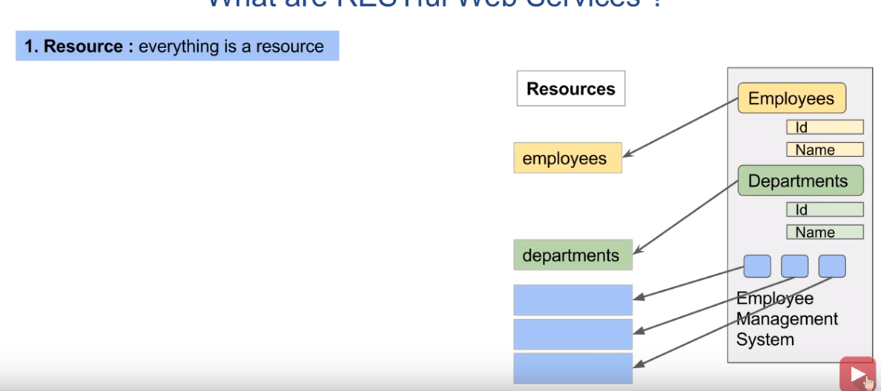

* **URI:**Uniform Resource Identifier:Any Resource or data can be accessed by URI

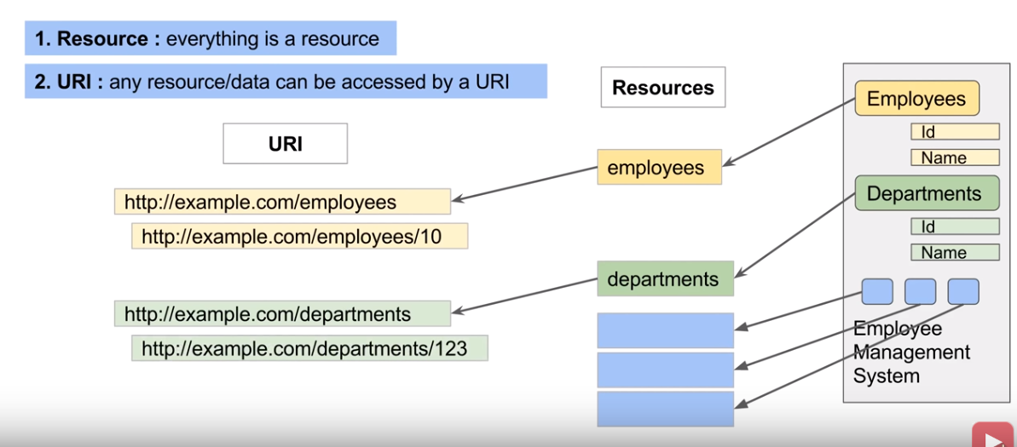

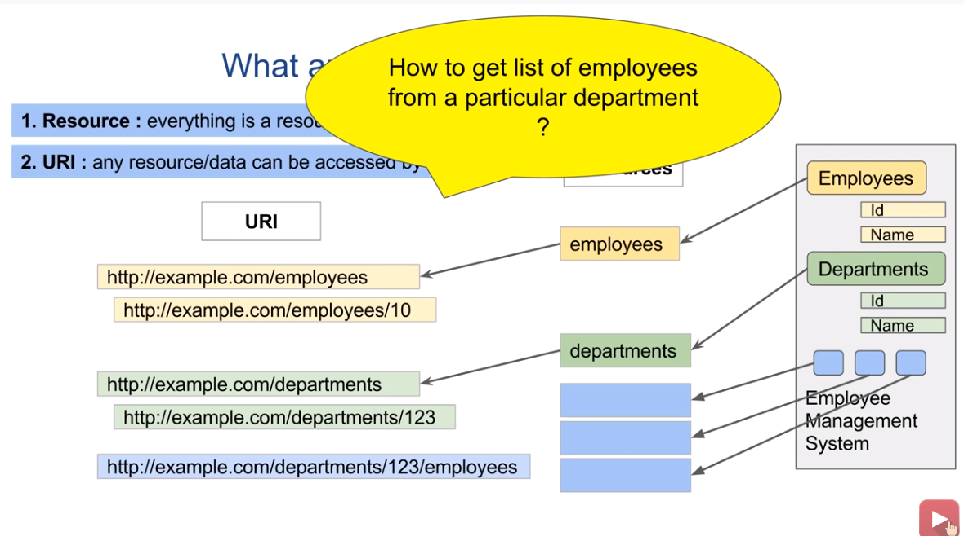

**HTTP:make explicit use of HTTP methods:**

**GET:**TO access the particular details of an employee:Using these methods we can access/modify any resource or resource information.



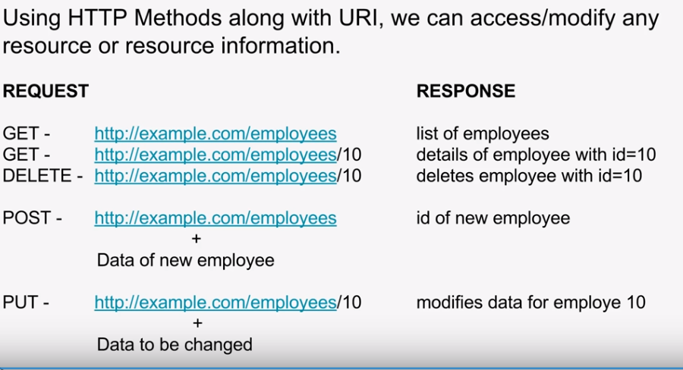

**STATELESS:**

All communication is statesless.Client has to send request which is independent.

Server doesnot store any state on information.

**Example:**Whenever you are adding an item to a cart,the server doesnot store that info.

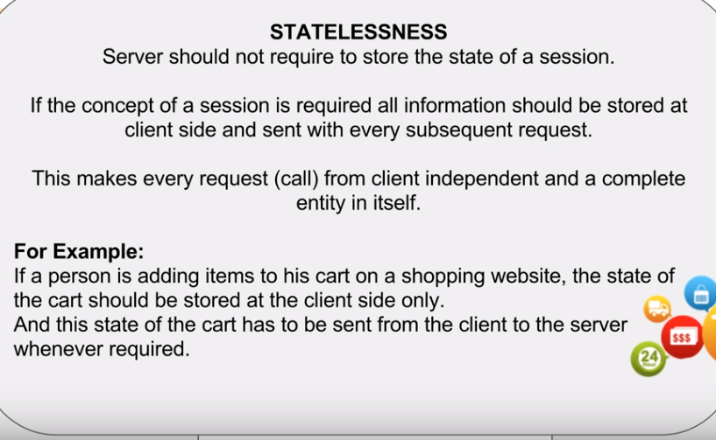

**CACHE:**

Happens at client side.Server doenot contain state of session in stateless.Whenever client sends req to server ,the server gives back the response which contains the actual data along with this it contains metadata in headers,which tells the client to store response locally or not**.**

**Layering:**

There can be multiple layers between Client and server.

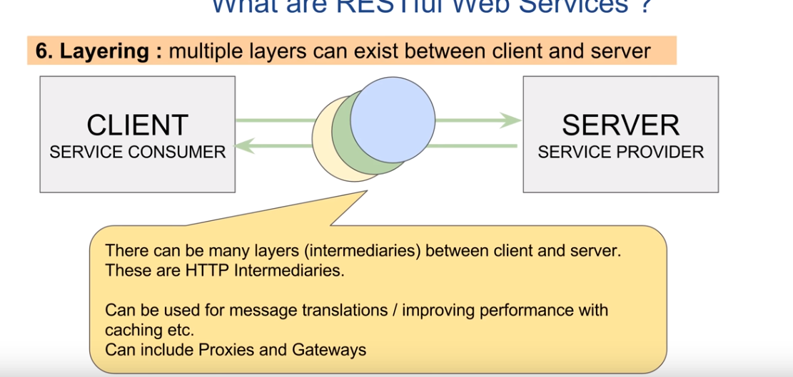

**Code on Demand:**

Ablity to download and execute code at client side.

