**DAILY ONLINE ACTIVITIES SUMMARY**

|  |  |  |  |  |  |  |  |
| --- | --- | --- | --- | --- | --- | --- | --- |
| **Date:** | **29-05-2020** | | | | **Name:** | **K Manasa** | |
| **Sem & Sec** | **8th 'A'** | | | | **USN:** | **4AL16C043** | |
| **Online Test Summary** | | | | | | | |
| **Subject** | | **BDA** | | | | | |
| **Max. Marks** | | **30** | | **Score** | | **18** | |
| **Certification Course Summary** | | | | | | | |
| **Course** | **Python for Machine learning** | | | | | | |
| **Certificate Provider** | | | **Great learning** | **Duration** | | | **3hr** |
| **Coding Challenges** | | | | | | | |
| **Problem Statement:Write a C Program to generate first N Armstrong Numbers** | | | | | | | |
| **Status:Solved** | | | | | | | |
| **Uploaded the report in Github** | | | | **Yes** | | | |
| **If yes Repository name** | | | | **Manasa** | | | |
| **Uploaded the report in slack** | | | | **Yes** | | | |

Online test details;(Attach the snapshot and briefly write the report for the same)

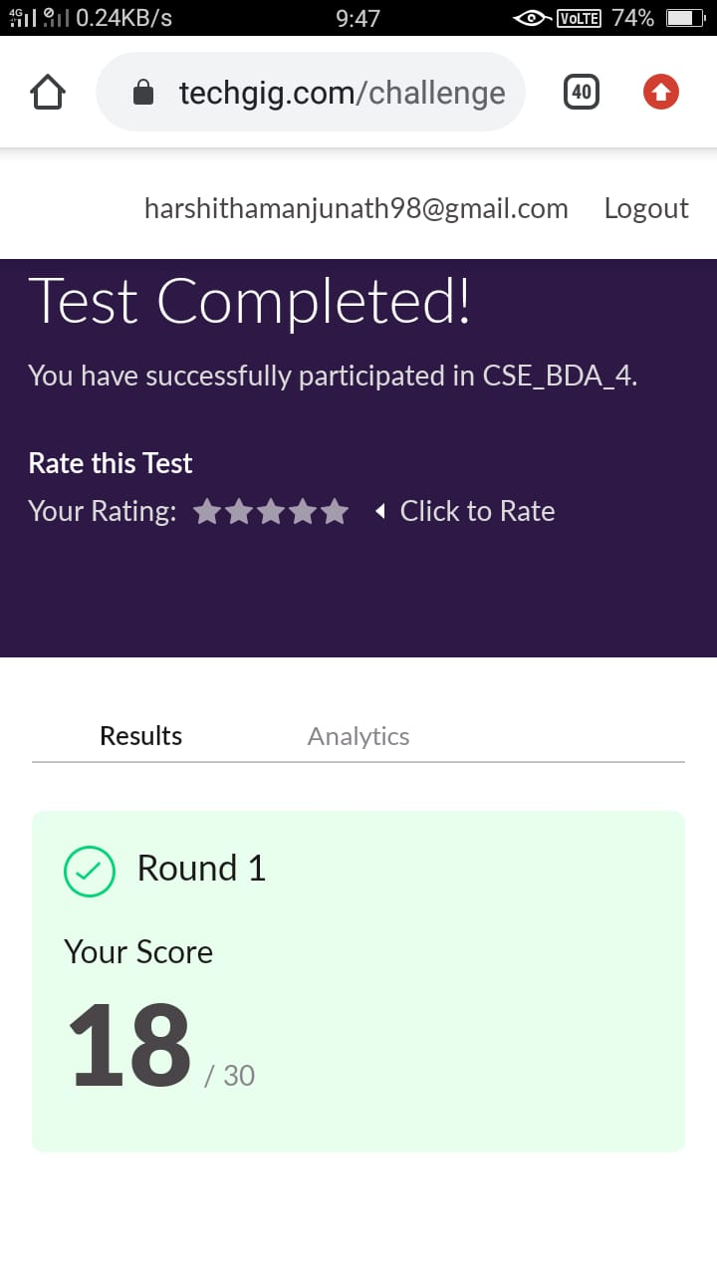

Certification Course Details: (Attach the snapshot and briefly write the report for the same)

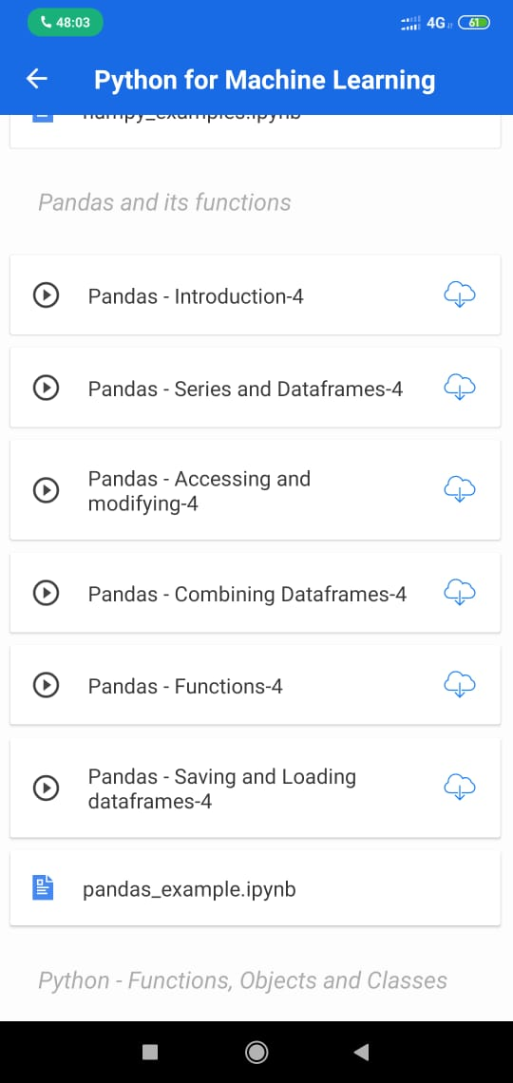

Online coding Detaills:

Program (Write a C Program to generate first N Armstrong Numbers

#include<stdio.h>

int main()

{

int n,r,sum=0,temp;

printf("enter the number=");

scanf("%d",&n);

temp=n;

while(n>0)

{

r=n%10;

sum=sum+(r*r*r);

n=n/10;

}

if(temp==sum)

printf("armstrong number ");

else

printf("not armstrong number");

return 0;

}

Output:

enter the number=153

armstrong number

enter the number= 371

armstrong number

enter the number=5

not armstrong number