**ONLINE MOVIE TICKET BOOKING**

A Course Project Report

in partial fulfillment of the degree

**Bachelor of Technology**

in

**Computer Science & Engineering**

**By**

2103A51L11 G. Manasa

2103A51L34 V. Sushma Sri

**Under the Guidance of**

Mr. K. Ravi Chythanya

Assistant Professor

**Submitted to**



**SCHOOL OF COMPUTER SCIENCE & ARTIFICIAL INTELLIGENCE**

# Nov, 2022

**SCHOOL OF COMPUTER SCIENCE & ARTIFICIAL INTELLIGENCE**

**CERTIFICATE**

This is to certify that the **Object Oriented Programming through Java Course Project Report entitled “ONLINE MOVIE TICKET BOOKING”** is a record of bonafide work carried out by the students **G. Manasa, V. Sushma Sri** bearing Roll No(s) **2103A51L11,2103A51L34**during the academic year 2022-23 in partial fulfillment of the award of the degree of **Bachelor of Technology** in **Computer Science & Engineering** by the SR University, Warangal.

**Lab in-charge Head of the Department**

**ACKNOWLEDGEMENT**

We take this opportunity to express my profound gratitude and deep regards to our guide

Mr. Kanegonda Ravi Chythanya sir HOD Dr M .Sheshikala mam who gave our team the

opportunity to do this wonderful project on the topic Online Movie Ticket Booking. We thank my guide for his exemplary guidance, monitoring and constant encouragement throughout the course of this thesis. The blessing, help and guidance given by him time to time shall carry us a long way in the journey of life on which we were about to embark. The project helped us learn how to do proper Research and we learned about many new things while doing the project. I also thank my team members for their constant encouragement to complete this project within the deadline.

**TABLE OF CONTENTS**

|  |  |  |
| --- | --- | --- |
| S. No | Title | Page. No |
|  | Abstract | 5 |
| 1 | Objective of the project | 6 |
| 2 | Definitions of the elements used in the project | 7 |
| 3 | Design | 8-9 |
| 4 | Implementation | 10-37 |
| 5 | Result Screens | 38 |
| 6 | Conclusion | 39 |

**ABSTRACT**

Online movie ticket booking system is basically made for providing the customers an anytime and anywhere service for booking cinema tickets and providing information about the movies and their schedule online.

Admin can use Online Movie Ticket Booking System Project to insert and delete data such as movie description, movie schedule which will update the related webpage and will be accessible by the customers.

Online Movie Ticket Booking System provide another way for the customers to buy cinema ticket. This system reduces work load on customers it is an automatic ticket booking system.

This system is basically aimed to provide complete information of the movie and schedule to the customer, according to which he can book the tickets.

1. **OBJECTIVE OF THE PROJECT**

In this project we book ticket using online movie Ticket reservation system. We enter into Web page by logging with User Name and Password. Later you can choose show timings and date you want. The main purpose of our online ticket booking system is to provide an alternate and convenient way for a customer to buy cinema tickets. It is an automatic system.

**DEFINITIONS OF THE ELEMENTS USED IN THE PROJECT**

1. JTextField : The object of a JTextField class is a text component that allows the editing of a single line text. It inherits JTextComponent class.
2. JLabel : The object of JLabel class is a component for placing text in a container. It is used to display a single line of read only text. The text can be changed by an application but a user cannot edit it directly. It inherits JComponent class.
3. JButton : The JButton class is used to create a labeled button that has platform independent implementation. The application result in some action when the button is pushed. It inherits AbstractButton class.
4. JTextArea : The object of a JTextArea class is a multi line region that displays text. It allows the editing of multiple line text. It inherits JTextComponent class.
5. JPasswordField : The object of a JPasswordField class is a text component specialized for password entry. It allows the editing of a single line of text. It inherits JTextField class.
6. JCheckBox : The JCheckBox class is used to create a checkbox. It is used to turn an option on (true) or off (false). Clicking on a CheckBox changes its state from "on" to "off" or from "off" to "on ".
7. JTable : The JTable class is used to display data in tabular form. It is composed of rows and columns.
8. JScrollBar : The object of JScrollbar class is used to add horizontal and vertical scrollbar. It is an implementation of a scrollbar. It inherits JComponent class.
9. JOptionPane : The JOptionPane class is used to provide standard dialog boxes such as message dialog box, confirm dialog box and input dialog box. These dialog boxes are used to display information or get input from the user.
10. **DESIGN:-**
    1. SCREENS



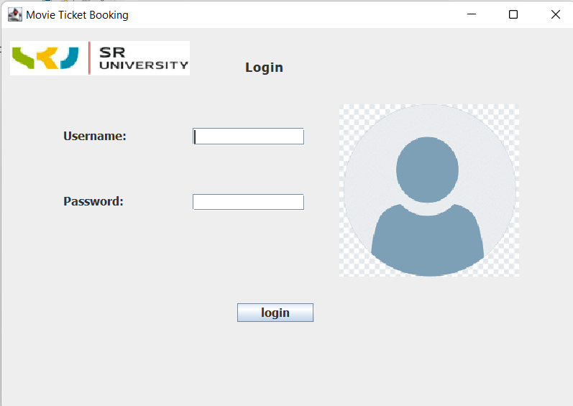

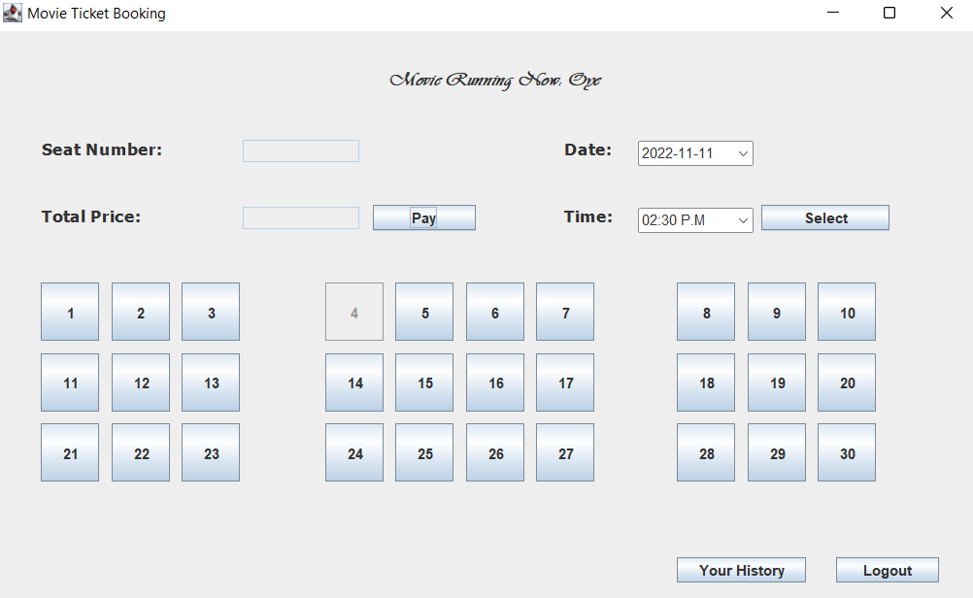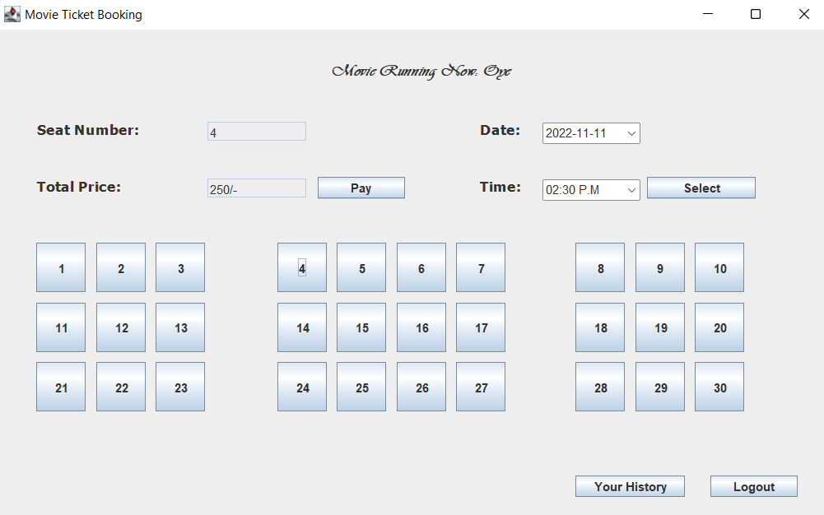

1. **IMPLEMENTATION**

**4.1Booking Screen:**

import java.awt.EventQueue;

import java.awt.*;

import java.awt.event.*;

import java.io.BufferedReader;

import java.io.File;

import java.io.FileReader;

import java.io.FileWriter;

import java.io.IOException;

import java.io.PrintWriter;

import java.security.PublicKey;

import java.sql.Date;

import java.text.DateFormat;

import java.text.SimpleDateFormat;

import java.time.LocalDate;

import java.time.format.DateTimeFormatter;

import java.util.ArrayList;

import java.util.Calendar;

import java.util.regex.Matcher;

import java.util.regex.Pattern;

import javax.print.attribute.standard.DateTimeAtCompleted;

import javax.security.auth.kerberos.KerberosTicket;

import javax.swing.*;

import javax.swing.border.EmptyBorder;

import javax.xml.stream.events.EntityReference;

import org.w3c.dom.DOMStringList;

import java.beans.PropertyChangeListener;

import java.beans.PropertyChangeEvent;

public class Booking extends JFrame implements ActionListener {

private JPanel contentPane;

JTextField seat, totalcost;

Choice type, block, time;

JLabel typelbl, blocklbl, timelbl, mblbl, rblbl, inputseatlbl, totallbl, title;

private JTextField seatNumbertxt;

private JTextField totalPricetxt;

private int selectedSeat;

static String movieNameFile="D:\\project\\moviename.txt";

static String loggedInUserFile = "D:\\project\\loggedinuser.txt";

static String bookingHistoryFile = "D:\\project\\BookingHistory.txt";

public static void main(String[] args) {

EventQueue.invokeLater(new Runnable() {

public void run() {

try {

Booking frame = new Booking();

frame.setVisible(true);

} catch (Exception e) {

e.printStackTrace();

}

}

});

}

public Booking() {

setTitle("Movie Ticket Booking");

setDefaultCloseOperation(JFrame.EXIT_ON_CLOSE);

setBounds(100, 100, 823, 514);

contentPane = new JPanel();

contentPane.setBorder(new EmptyBorder(5, 5, 5, 5));

setContentPane(contentPane);

contentPane.setLayout(null);

JLabel lblNewLabel_1 = new JLabel("Date:");

lblNewLabel_1.setFont(new Font("Tahoma", Font.BOLD, 14));

lblNewLabel_1.setBounds(470, 85, 55, 24);

contentPane.add(lblNewLabel_1);

JLabel lblNewLabel_2 = new JLabel("Time:");

lblNewLabel_2.setFont(new Font("Tahoma", Font.BOLD, 14));

lblNewLabel_2.setBounds(470, 140, 55, 24);

contentPane.add(lblNewLabel_2);

Choice choice_2 = new Choice();

choice_2.setBounds(531, 146, 95, 18);

contentPane.add(choice_2);

choice_2.add("11:00 A.M");

choice_2.add("02:30 P.M");

choice_2.add("06:00 P.M");

choice_2.add("09:30 P.M");

JLabel lblNewLabel_3 = new JLabel("Seat Number:");

lblNewLabel_3.setFont(new Font("Tahoma", Font.BOLD, 14));

lblNewLabel_3.setBounds(39, 79, 151, 37);

contentPane.add(lblNewLabel_3);

seatNumbertxt = new JTextField();

seatNumbertxt.setEditable(false);

seatNumbertxt.setBounds(205, 90, 96, 19);

contentPane.add(seatNumbertxt);

seatNumbertxt.setColumns(10);

JLabel total_Price = new JLabel("Total Price:");

total_Price.setFont(new Font("Tahoma", Font.BOLD, 14));

total_Price.setBounds(39, 140, 95, 24);

contentPane.add(total_Price);

totalPricetxt = new JTextField();

totalPricetxt.setEditable(false);

totalPricetxt.setBounds(205, 145, 96, 19);

contentPane.add(totalPricetxt);

totalPricetxt.setColumns(10);

JButton Button_1 = new JButton("1");

Button_1.addActionListener(new ActionListener() {

public void actionPerformed(ActionEvent e) {

seatNumbertxt.setText("1");

totalPricetxt.setText("250/-");

selectedSeat = 1;

}

});

Button_1.setBounds(39, 208, 48, 48);

contentPane.add(Button_1);

JButton Button_2 = new JButton("2");

Button_2.addActionListener(new ActionListener() {

public void actionPerformed(ActionEvent e) {

seatNumbertxt.setText("2");

totalPricetxt.setText("250/-");

selectedSeat = 2;

}

});

Button_2.setBounds(97, 208, 48, 48);

contentPane.add(Button_2);

JButton Button_3 = new JButton("3");

Button_3.addActionListener(new ActionListener() {

public void actionPerformed(ActionEvent e) {

seatNumbertxt.setText("3");

totalPricetxt.setText("250/-");

selectedSeat = 3;

}

});

Button_3.setBounds(155, 208, 48, 48);

contentPane.add(Button_3);

JButton Button_4 = new JButton("4");

Button_4.addActionListener(new ActionListener() {

public void actionPerformed(ActionEvent e) {

seatNumbertxt.setText("4");

totalPricetxt.setText("250/-");

selectedSeat = 4;

}

});

Button_4.setBounds(273, 208, 48, 48);

contentPane.add(Button_4);

JButton Button_5 = new JButton("5");

Button_5.addActionListener(new ActionListener() {

public void actionPerformed(ActionEvent e) {

seatNumbertxt.setText("5");

totalPricetxt.setText("250/-");

selectedSeat = 5;

}

});

Button_5.setBounds(331, 208, 48, 48);

contentPane.add(Button_5);

JButton Button_6 = new JButton("6");

Button_6.addActionListener(new ActionListener() {

public void actionPerformed(ActionEvent e) {

seatNumbertxt.setText("6");

totalPricetxt.setText("250/-");

selectedSeat = 6;

}

});

Button_6.setBounds(389, 208, 48, 48);

contentPane.add(Button_6);

JButton Button_7 = new JButton("7");

Button_7.addActionListener(new ActionListener() {

public void actionPerformed(ActionEvent e) {

seatNumbertxt.setText("7");

totalPricetxt.setText("250/-");

selectedSeat = 7;

}

});

Button_7.setBounds(447, 208, 48, 48);

contentPane.add(Button_7);

JButton Button_8 = new JButton("8");

Button_8.addActionListener(new ActionListener() {

public void actionPerformed(ActionEvent e) {

seatNumbertxt.setText("8");

totalPricetxt.setText("250/-");

selectedSeat = 8;

}

});

Button_8.setBounds(563, 208, 48, 48);

contentPane.add(Button_8);

JButton Button_9 = new JButton("9");

Button_9.addActionListener(new ActionListener() {

public void actionPerformed(ActionEvent e) {

seatNumbertxt.setText("9");

totalPricetxt.setText("250/-");

selectedSeat = 9;

}

});

Button_9.setBounds(621, 208, 48, 48);

contentPane.add(Button_9);

JButton Button_10 = new JButton("10");

Button_10.addActionListener(new ActionListener() {

public void actionPerformed(ActionEvent e) {

seatNumbertxt.setText("10");

totalPricetxt.setText("250/-");

selectedSeat = 10;

}

});

Button_10.setBounds(679, 208, 48, 48);

contentPane.add(Button_10);

JButton Button_11 = new JButton("11");

Button_11.addActionListener(new ActionListener() {

public void actionPerformed(ActionEvent e) {

seatNumbertxt.setText("11");

totalPricetxt.setText("200/-");

selectedSeat = 11;

}

});

Button_11.setBounds(39, 266, 48, 48);

contentPane.add(Button_11);

JButton Button_12 = new JButton("12");

Button_12.addActionListener(new ActionListener() {

public void actionPerformed(ActionEvent e) {

seatNumbertxt.setText("12");

totalPricetxt.setText("200/-");

selectedSeat = 12;

}

});

Button_12.setBounds(97, 266, 48, 48);

contentPane.add(Button_12);

JButton Button_13 = new JButton("13");

Button_13.addActionListener(new ActionListener() {

public void actionPerformed(ActionEvent e) {

seatNumbertxt.setText("13");

totalPricetxt.setText("200/-");

selectedSeat = 13;

}

});

Button_13.setBounds(155, 266, 48, 48);

contentPane.add(Button_13);

JButton Button_14 = new JButton("14");

Button_14.addActionListener(new ActionListener() {

public void actionPerformed(ActionEvent e) {

seatNumbertxt.setText("14");

totalPricetxt.setText("200/-");

selectedSeat = 14;

}

});

Button_14.setBounds(273, 266, 48, 48);

contentPane.add(Button_14);

JButton Button_15 = new JButton("15");

Button_15.addActionListener(new ActionListener() {

public void actionPerformed(ActionEvent e) {

seatNumbertxt.setText("15");

totalPricetxt.setText("200/-");

selectedSeat = 15;

}

});

Button_15.setBounds(331, 266, 48, 48);

contentPane.add(Button_15);

JButton Button_16 = new JButton("16");

Button_16.addActionListener(new ActionListener() {

public void actionPerformed(ActionEvent e) {

seatNumbertxt.setText("16");

totalPricetxt.setText("200/-");

selectedSeat = 16;

}

});

Button_16.setBounds(389, 266, 48, 48);

contentPane.add(Button_16);

JButton Button_17 = new JButton("17");

Button_17.addActionListener(new ActionListener() {

public void actionPerformed(ActionEvent e) {

seatNumbertxt.setText("17");

totalPricetxt.setText("200/-");

selectedSeat = 17;

}

});

Button_17.setBounds(447, 266, 48, 48);

contentPane.add(Button_17);

JButton Button_18 = new JButton("18");

Button_18.addActionListener(new ActionListener() {

public void actionPerformed(ActionEvent e) {

seatNumbertxt.setText("18");

totalPricetxt.setText("200/-");

selectedSeat = 18;

}

});

Button_18.setBounds(563, 266, 48, 48);

contentPane.add(Button_18);

JButton Button_19 = new JButton("19");

Button_19.addActionListener(new ActionListener() {

public void actionPerformed(ActionEvent e) {

seatNumbertxt.setText("19");

totalPricetxt.setText("200/-");

selectedSeat = 19;

}

});

Button_19.setBounds(621, 266, 48, 48);

contentPane.add(Button_19);

JButton Button_20 = new JButton("20");

Button_20.addActionListener(new ActionListener() {

public void actionPerformed(ActionEvent e) {

seatNumbertxt.setText("20");

totalPricetxt.setText("200/-");

selectedSeat = 20;

}

});

Button_20.setBounds(679, 266, 48, 48);

contentPane.add(Button_20);

JButton Button_21 = new JButton("21");

Button_21.addActionListener(new ActionListener() {

public void actionPerformed(ActionEvent e) {

seatNumbertxt.setText("21");

totalPricetxt.setText("100/-");

selectedSeat = 21;

}

});

Button_21.setBounds(39, 324, 48, 48);

contentPane.add(Button_21);

JButton Button_22 = new JButton("22");

Button_22.addActionListener(new ActionListener() {

public void actionPerformed(ActionEvent e) {

seatNumbertxt.setText("22");

totalPricetxt.setText("100/-");

selectedSeat = 22;

}

});

Button_22.setBounds(97, 324, 48, 48);

contentPane.add(Button_22);

JButton Button_23 = new JButton("23");

Button_23.addActionListener(new ActionListener() {

public void actionPerformed(ActionEvent e) {

seatNumbertxt.setText("22");

totalPricetxt.setText("100/-");

selectedSeat = 22;

}

});

Button_23.setBounds(155, 324, 48, 48);

contentPane.add(Button_23);

JButton Button_24 = new JButton("24");

Button_24.addActionListener(new ActionListener() {

public void actionPerformed(ActionEvent e) {

seatNumbertxt.setText("24");

totalPricetxt.setText("100/-");

selectedSeat = 24;

}

});

Button_24.setBounds(273, 324, 48, 48);

contentPane.add(Button_24);

JButton Button_25 = new JButton("25");

Button_25.addActionListener(new ActionListener() {

public void actionPerformed(ActionEvent e) {

seatNumbertxt.setText("25");

totalPricetxt.setText("100/-");

selectedSeat = 25;

}

});

Button_25.setBounds(331, 324, 48, 48);

contentPane.add(Button_25);

JButton Button_26 = new JButton("26");

Button_26.addActionListener(new ActionListener() {

public void actionPerformed(ActionEvent e) {

seatNumbertxt.setText("26");

totalPricetxt.setText("100/-");

selectedSeat = 26;

}

});

Button_26.setBounds(389, 324, 48, 48);

contentPane.add(Button_26);

JButton Button_27 = new JButton("27");

Button_27.addActionListener(new ActionListener() {

public void actionPerformed(ActionEvent e) {

seatNumbertxt.setText("27");

totalPricetxt.setText("100/-");

selectedSeat = 27;

}

});

Button_27.setBounds(447, 324, 48, 48);

contentPane.add(Button_27);

JButton Button_28 = new JButton("28");

Button_28.addActionListener(new ActionListener() {

public void actionPerformed(ActionEvent e) {

seatNumbertxt.setText("28");

totalPricetxt.setText("100/-");

selectedSeat = 28;

}

});

Button_28.setBounds(563, 324, 48, 48);

contentPane.add(Button_28);

JButton Button_29 = new JButton("29");

Button_29.addActionListener(new ActionListener() {

public void actionPerformed(ActionEvent e) {

seatNumbertxt.setText("29");

totalPricetxt.setText("100/-");

selectedSeat = 29;

}

});

Button_29.setBounds(621, 324, 48, 48);

contentPane.add(Button_29);

JButton Button_30 = new JButton("30");

Button_30.addActionListener(new ActionListener() {

public void actionPerformed(ActionEvent e) {

seatNumbertxt.setText("30");

totalPricetxt.setText("100/-");

selectedSeat = 30;

}

});

Button_30.setBounds(679, 324, 48, 48);

contentPane.add(Button_30);

JButton logoutbtn = new JButton("Logout");

logoutbtn.addActionListener(new ActionListener() {

public void actionPerformed(ActionEvent e) {

Login login = new Login();

login.setVisible(true);

dispose();

}

});

logoutbtn.setBounds(694, 434, 85, 21);

contentPane.add(logoutbtn);

JLabel lblNewLabel = new JLabel("");

lblNewLabel.setIcon(new ImageIcon("C:\\Users\\sushm\\Desktop\\java images\\sru-1.png"));

lblNewLabel.setBounds(10, 10, 200, 48);

contentPane.add(lblNewLabel);

Choice choice = new Choice();

choice.addItemListener(new ItemListener() {

public void itemStateChanged(ItemEvent e) {

disableAllSeats(Button_1, Button_2, Button_3, Button_4, Button_5, Button_6, Button_7, Button_8, Button_9, Button_10, Button_11, Button_12, Button_13, Button_14, Button_15, Button_16, Button_17, Button_18, Button_19, Button_20, Button_21, Button_22, Button_23, Button_24, Button_25, Button_26, Button_27, Button_28, Button_29, Button_30);

}

});

choice_2.addItemListener(new ItemListener() {

public void itemStateChanged(ItemEvent e) {

disableAllSeats(Button_1, Button_2, Button_3, Button_4, Button_5, Button_6, Button_7, Button_8, Button_9, Button_10, Button_11, Button_12, Button_13, Button_14, Button_15, Button_16, Button_17, Button_18, Button_19, Button_20, Button_21, Button_22, Button_23, Button_24, Button_25, Button_26, Button_27, Button_28, Button_29, Button_30);

}

});

choice.setBounds(531, 91, 95, 18);

contentPane.add(choice);

choice.add(LocalDate.now().toString());

for (int i = 1; i < 7; i++) {

choice.add(LocalDate.now().plusDays(i).toString());

}

JButton Pay_Button = new JButton("Pay");

Pay_Button.addActionListener(new ActionListener() {

public void actionPerformed(ActionEvent e) {

saveBooking(choice, choice_2, selectedSeat);

savePaymentInfoToAccount(selectedSeat, choice.getSelectedItem(), choice_2.getSelectedItem());

disableSeat(selectedSeat, Button_1, Button_2, Button_3, Button_4, Button_5, Button_6, Button_7, Button_8, Button_9, Button_10, Button_11, Button_12, Button_13, Button_14, Button_15, Button_16, Button_17, Button_18, Button_19, Button_20, Button_21, Button_22, Button_23, Button_24, Button_25, Button_26, Button_27, Button_28, Button_29, Button_30);

seatNumbertxt.setText("");

totalPricetxt.setText("");

//choice.select(0);

//choice_2.select(0);

JOptionPane.showMessageDialog(Pay_Button, "Your Booking is Succesful");

// readBooking();

}

});

Pay_Button.setBounds(312, 144, 85, 21);

contentPane.add(Pay_Button);

File file;

BufferedReader bReader = null;

String movieName = null;

try {

file = new File(movieNameFile);

bReader = new BufferedReader(new FileReader(file));

movieName = bReader.readLine();

bReader.close();

} catch (IOException e2) {

// TODO: handle exception

System.out.println("Exception Occured IO:::" + e2);

} catch (Exception e2) {

// TODO: handle exception

}

JLabel movieNamelbl = new JLabel("Movie Running Now: " + movieName);

movieNamelbl.setFont(new Font("Vivaldi", Font.BOLD | Font.ITALIC, 16));

movieNamelbl.setBounds(325, 23, 273, 35);

contentPane.add(movieNamelbl);

JButton fetchSeatsButton = new JButton("Select");

fetchSeatsButton.addActionListener(new ActionListener() {

public void actionPerformed(ActionEvent e) {

//reloadSeats

disableBookedSeats(choice, choice_2, Button_1, Button_2, Button_3, Button_4, Button_5, Button_6, Button_7, Button_8, Button_9, Button_10, Button_11, Button_12, Button_13, Button_14, Button_15, Button_16, Button_17, Button_18, Button_19, Button_20, Button_21, Button_22, Button_23, Button_24, Button_25, Button_26, Button_27, Button_28, Button_29, Button_30);

});

fetchSeatsButton.setBounds(632, 144, 106, 21);

contentPane.add(fetchSeatsButton);

disableAllSeats(Button_1, Button_2, Button_3, Button_4, Button_5, Button_6, Button_7, Button_8, Button_9, Button_10, Button_11, Button_12, Button_13, Button_14, Button_15, Button_16, Button_17, Button_18, Button_19, Button_20, Button_21, Button_22, Button_23, Button_24, Button_25, Button_26, Button_27, Button_28, Button_29, Button_30);

JButton btnNewButton = new JButton("Your History");

btnNewButton.addActionListener(new ActionListener() {

public void actionPerformed(ActionEvent e) {

BookingHistory bookingHistory = new BookingHistory();

bookingHistory.setVisible(true);

}

});

btnNewButton.setBounds(563, 434, 106, 21);

contentPane.add(btnNewButton);

}

public static String getLoggedInUser() {

try {

return readOldContent(loggedInUserFile);

} catch (Exception e) {

// TODO: handle exception

}

return "";

}

public static String getMovieName() {

return readOldContent(movieNameFile);

}

public static void savePaymentInfoToAccount(int seatNumber, String showDate, String showTime) {

// Saving Format::::::::::::

// Date Booked|UserName|Show Date|Show Time|Seat Number|MovieName|BookingID|

String loggedUser = getLoggedInUser();

String movieName = getMovieName();

java.util.Date date = new java.util.Date();

long bookingId = date.getTime();

String dateBooked = date.getDate() + "-" + date.getMonth() + "-" + (1900+date.getYear());

String content;

try {

content = readOldContent(bookingHistoryFile);

PrintWriter pWriter = new PrintWriter(new File(bookingHistoryFile));

if(content==null || content == "") {

pWriter.write(dateBooked+"|"+loggedUser+"|"+showDate+"|"+showTime+"|"+seatNumber+"|"+movieName+"|"+bookingId+"\n");

}

else {

pWriter.write(content+dateBooked+"|"+loggedUser+"|"+showDate+"|"+showTime+"|"+seatNumber+"|"+movieName+"|"+bookingId+"\n");

}

pWriter.close();

} catch (Exception e) {

// TODO: handle exception

System.out.println("Can't Save Booking History Exception Occured!");

}

}

public static void disableAllSeats(JButton Button_1, JButton Button_2, JButton Button_3, JButton Button_4, JButton Button_5,JButton Button_6,JButton Button_7,JButton Button_8,JButton Button_9,JButton Button_10,JButton Button_11,JButton Button_12,JButton Button_13,JButton Button_14,JButton Button_15,JButton Button_16,JButton Button_17,JButton Button_18,JButton Button_19,JButton Button_20,JButton Button_21,JButton Button_22,JButton Button_23,JButton Button_24,JButton Button_25,JButton Button_26,JButton Button_27,JButton Button_28,JButton Button_29,JButton Button_30) {

for(int i=1;i<=30;i++) {

disableSeat(i, Button_1, Button_2, Button_3, Button_4, Button_5, Button_6, Button_7, Button_8, Button_9, Button_10, Button_11, Button_12, Button_13, Button_14, Button_15, Button_16, Button_17, Button_18, Button_19, Button_20, Button_21, Button_22, Button_23, Button_24, Button_25, Button_26, Button_27, Button_28, Button_29, Button_30);

}

}

public static void disableSeat(int selectedSeat, JButton Button_1, JButton Button_2, JButton Button_3, JButton Button_4, JButton Button_5,JButton Button_6,JButton Button_7,JButton Button_8,JButton Button_9,JButton Button_10,JButton Button_11,JButton Button_12,JButton Button_13,JButton Button_14,JButton Button_15,JButton Button_16,JButton Button_17,JButton Button_18,JButton Button_19,JButton Button_20,JButton Button_21,JButton Button_22,JButton Button_23,JButton Button_24,JButton Button_25,JButton Button_26,JButton Button_27,JButton Button_28,JButton Button_29,JButton Button_30) {

switch (selectedSeat) {

case 1:

Button_1.setEnabled(false);

break;

case 2:

Button_2.setEnabled(false);

break;

case 3:

Button_3.setEnabled(false);

break;

case 4:

Button_4.setEnabled(false);

break;

case 5:

Button_5.setEnabled(false);

break;

case 6:

Button_6.setEnabled(false);

break;

case 7:

Button_7.setEnabled(false);

break;

case 8:

Button_8.setEnabled(false);

break;

case 9:

Button_9.setEnabled(false);

break;

case 10:

Button_10.setEnabled(false);

break;

case 11:

Button_11.setEnabled(false);

break;

case 12:

Button_12.setEnabled(false);

break;

case 13:

Button_13.setEnabled(false);

break;

case 14:

Button_14.setEnabled(false);

break;

case 15:

Button_15.setEnabled(false);

break;

case 16:

Button_16.setEnabled(false);

break;

case 17:

Button_17.setEnabled(false);

break;

case 18:

Button_18.setEnabled(false);

break;

case 19:

Button_19.setEnabled(false);

break;

case 20:

Button_20.setEnabled(false);

break;

case 21:

Button_21.setEnabled(false);

break;

case 22:

Button_22.setEnabled(false);

break;

case 23:

Button_23.setEnabled(false);

break;

case 24:

Button_24.setEnabled(false);

break;

case 25:

Button_25.setEnabled(false);

break;

case 26:

Button_26.setEnabled(false);

break;

case 27:

Button_27.setEnabled(false);

break;

case 28:

Button_28.setEnabled(false);

break;

case 29:

Button_29.setEnabled(false);

break;

case 30:

Button_30.setEnabled(false);

break;

}

}

public static void enableSeat(int selectedSeat, JButton Button_1, JButton Button_2, JButton Button_3, JButton Button_4, JButton Button_5,JButton Button_6,JButton Button_7,JButton Button_8,JButton Button_9,JButton Button_10,JButton Button_11,JButton Button_12,JButton Button_13,JButton Button_14,JButton Button_15,JButton Button_16,JButton Button_17,JButton Button_18,JButton Button_19,JButton Button_20,JButton Button_21,JButton Button_22,JButton Button_23,JButton Button_24,JButton Button_25,JButton Button_26,JButton Button_27,JButton Button_28,JButton Button_29,JButton Button_30) ;{

switch (selectedSeat) {

case 1:

Button_1.setEnabled(true);

break;

case 2:

Button_2.setEnabled(true);

break;

case 3:

Button_3.setEnabled(true);

break;

case 4:

Button_4.setEnabled(true);

break;

case 5:

Button_5.setEnabled(true);

break;

case 6:

Button_6.setEnabled(true);

break;

case 7:

Button_7.setEnabled(true);

break;

case 8:

Button_8.setEnabled(true);

break;

case 9:

Button_9.setEnabled(true);

break;

case 10:

Button_10.setEnabled(true);

break;

case 11:

Button_11.setEnabled(true);

break;

case 12:

Button_12.setEnabled(true);

break;

case 13:

Button_13.setEnabled(true);

break;

case 14:

Button_14.setEnabled(true);

break;

case 15:

Button_15.setEnabled(true);

break;

case 16:

Button_16.setEnabled(true);

break;

case 17:

Button_17.setEnabled(true);

break;

case 18:

Button_18.setEnabled(true);

break;

case 19:

Button_19.setEnabled(true);

break;

case 20:

Button_20.setEnabled(true);

break;

case 21:

Button_21.setEnabled(true);

break;

case 22:

Button_22.setEnabled(true);

break;

case 23:

Button_23.setEnabled(true);

break;

case 24:

Button_24.setEnabled(true);

break;

case 25:

Button_25.setEnabled(true);

break;

case 26:

Button_26.setEnabled(true);

break;

case 27:

Button_27.setEnabled(true);

break;

case 28:

Button_28.setEnabled(true);

break;

case 29:

Button_29.setEnabled(true);

break;

case 30:

Button_30.setEnabled(true);

break;

}

}

public static void disableBookedSeats(Choice dateChoice, Choice timeChoice, JButton Button_1, JButton Button_2, JButton Button_3, JButton Button_4, JButton Button_5,JButton Button_6,JButton Button_7,JButton Button_8,JButton Button_9,JButton Button_10,JButton Button_11,JButton Button_12,JButton Button_13,JButton Button_14,JButton Button_15,JButton Button_16,JButton Button_17,JButton Button_18,JButton Button_19,JButton Button_20,JButton Button_21,JButton Button_22,JButton Button_23,JButton Button_24,JButton Button_25,JButton Button_26,JButton Button_27,JButton Button_28,JButton Button_29,JButton Button_30) {

String dateSelected = dateChoice.getSelectedItem();

String timeSelected = timeChoice.getSelectedItem();

dateSelected = dateSelected.replace("-", "");

timeSelected = timeSelected.replace(":", "");

timeSelected = timeSelected.replace(".", "");

timeSelected = timeSelected.replace(" ", "");

String fileName = "D:\\project\\" + dateSelected + timeSelected + ".txt";

String oldContent = readOldContent(fileName);

ArrayList<Integer> seatNumbers = new ArrayList<Integer>();

seatNumbers = getSeatNumbersFromString(oldContent);

System.out.println("Already Booked Seats:" + seatNumbers);

for(int i=1;i<=30;i++) {

if(seatNumbers.contains(i)) {

continue;

}

enableSeat(i, Button_1, Button_2, Button_3, Button_4, Button_5, Button_6, Button_7, Button_8, Button_9, Button_10, Button_11, Button_12, Button_13, Button_14, Button_15, Button_16, Button_17, Button_18, Button_19, Button_20, Button_21, Button_22, Button_23, Button_24, Button_25, Button_26, Button_27, Button_28, Button_29, Button_30);

}

for(int seatNumber: seatNumbers) {

disableSeat(seatNumber, Button_1, Button_2, Button_3, Button_4, Button_5, Button_6, Button_7, Button_8, Button_9, Button_10, Button_11, Button_12, Button_13, Button_14, Button_15, Button_16, Button_17, Button_18, Button_19, Button_20, Button_21, Button_22, Button_23, Button_24, Button_25, Button_26, Button_27, Button_28, Button_29, Button_30);

}

}

public static ArrayList<Integer> getSeatNumbersFromString(String content){

Pattern pattern = Pattern.compile("\\d+");

if(content==null) {

return new ArrayList<Integer>();

}

Matcher m = pattern.matcher(content);

ArrayList<Integer> seatNumbers = new ArrayList<Integer>();

while(m.find()) {

seatNumbers.add(Integer.parseInt(m.group()));

}

return seatNumbers;

}

public static void saveBooking(Choice dateChoice, Choice timeChoice, int selectedSeat) {

String dateSelected = dateChoice.getSelectedItem();

String timeSelected = timeChoice.getSelectedItem();

dateSelected = dateSelected.replace("-", "");

timeSelected = timeSelected.replace(":", "");

timeSelected = timeSelected.replace(".", "");

timeSelected = timeSelected.replace(" ", "");

System.out.println(dateSelected + timeSelected + ".txt");

try {

String fileName = "D:\\project\\" + dateSelected + timeSelected + ".txt";

String oldContent = readOldContent(fileName);

File file = new File(fileName);

if (!file.exists()) {

file.createNewFile();

}

PrintWriter pWriter = new PrintWriter(file);

pWriter.append(oldContent + "#" + selectedSeat + "#");

pWriter.close();

} catch (Exception e) {

// TODO: handle exception

}

}

public static String readOldContent(String fileName) {

try {

FileReader fReader = new FileReader(new File(fileName));

int ch;

StringBuilder sBuilder = new StringBuilder();

while((ch=fReader.read())!=-1)

{

sBuilder.append((char)ch);

}

fReader.close();

return sBuilder.toString();

} catch (Exception e) {

// TODO: handle exception

}

return null;

}

public static void readBooking() {

try {

} catch (Exception e) {

}

}

}

1. **RESULTS**

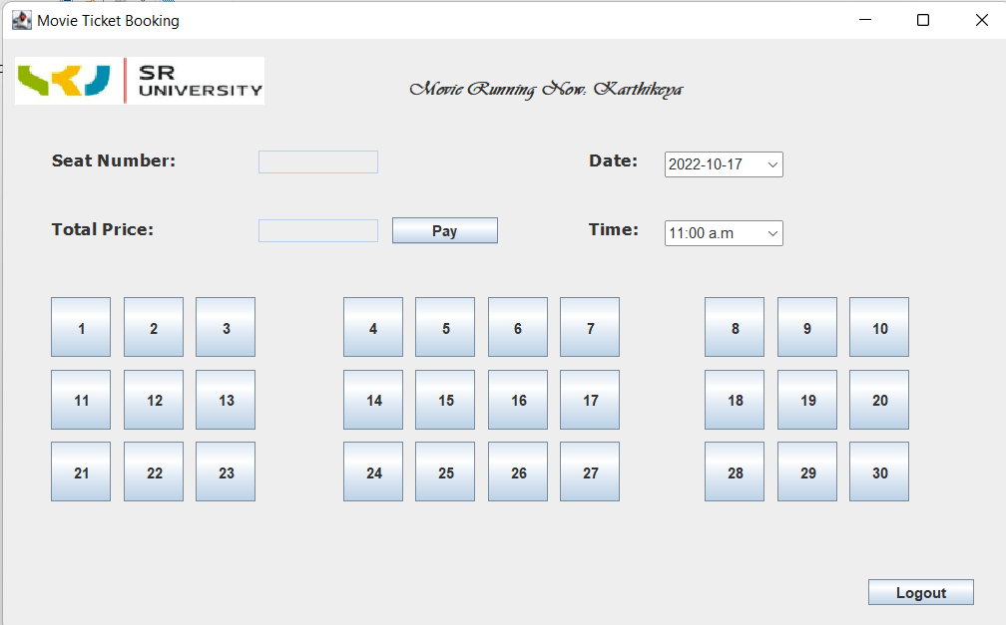

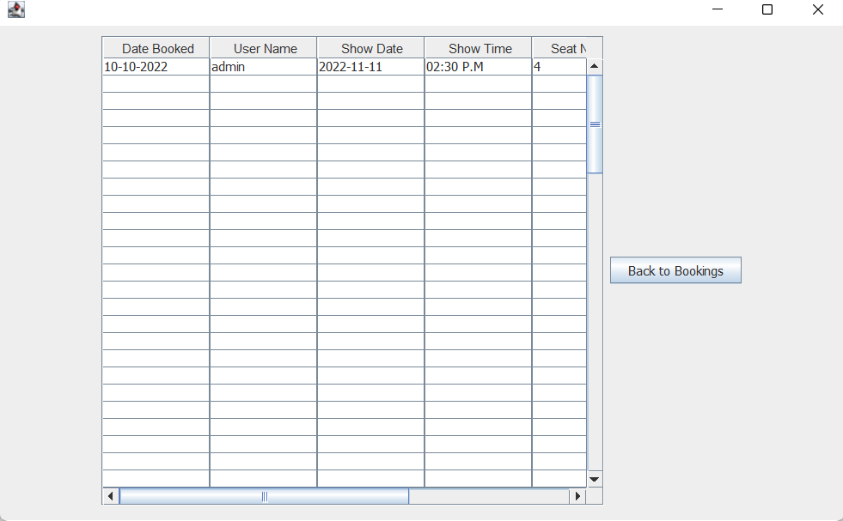

**6. CONCLUSION**

This project is developed successfully and the performance is found to be satisfactory. This project is designed to meet the requirements of assigning jobs. In this project we book ticket using online movie Ticket reservation system. We enter into Web page by logging with User Name and Password. Later you can choose show timings and date you want.The main purpose of our online ticket booking system is to provide an alternate and convenient way for a customer to buy cinema tickets. It is an automatic system.

This project is developed successfully and the performance is found to be satisfactory. This project is designed to meet the

requirements of assigning jobs

This project is developed successfully and the performance is found to be satisfactory. This project is designed to meet the

requirements of assigning jobs

This project is developed successfully and the performance is found to be satisfactory. This project is designed to meet the

requirements of assigning jobs

This project is developed successfully and the performance is found to be satisfactory. This project is designed to meet the

requirements of assigning jobs

This project is developed successfully and the performance is found to be satisfactory. This project is designed to meet the

requirements of assigning jobs

This project is developed successfully and the performance is found to be satisfactory. This project is designed to meet the

requirements of assigning jobs

This project is developed successfully and the performance is found to be satisfactory. This project is designed to meet the

requirements of assigning jobs

This project is developed successfully and the performance is found to be satisfactory. This project is designed to meet the

requirements of assigning jobs