TASK 7 REPORT
First Chart Story: Turning Numbers into a Narrative
VEDA TECHNOLOGY | Data Analytics Track | Level 1 · Day 7

1. Objective
To practise selecting suitable chart types for specific questions, labelling charts clearly, and combining chart insights into one concise narrative.

2. Dataset and method
This project uses a small, synthetic six-month sales dataset for practice. It is illustrative and does not represent actual company sales. Monthly sales are used for the bar and line charts; category totals are used for the pie chart.

3. Chart 1 — Monthly Sales Comparison
Question: How do monthly sales compare? Chart choice: Bar chart, because it compares values across discrete months.
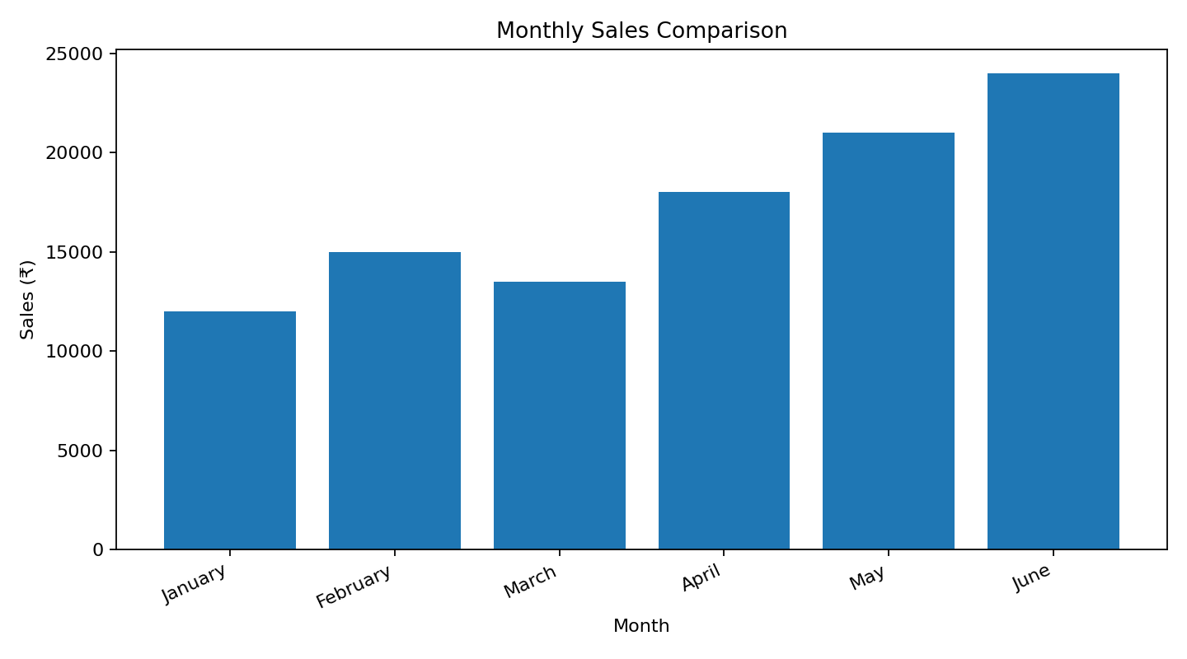
Takeaway: June has the highest monthly sales (₹24,000), while January has the lowest (₹12,000).

4. Chart 2 — Sales Trend from January to June
Question: How do sales change over time? Chart choice: Line chart, because it highlights movement across a time sequence.
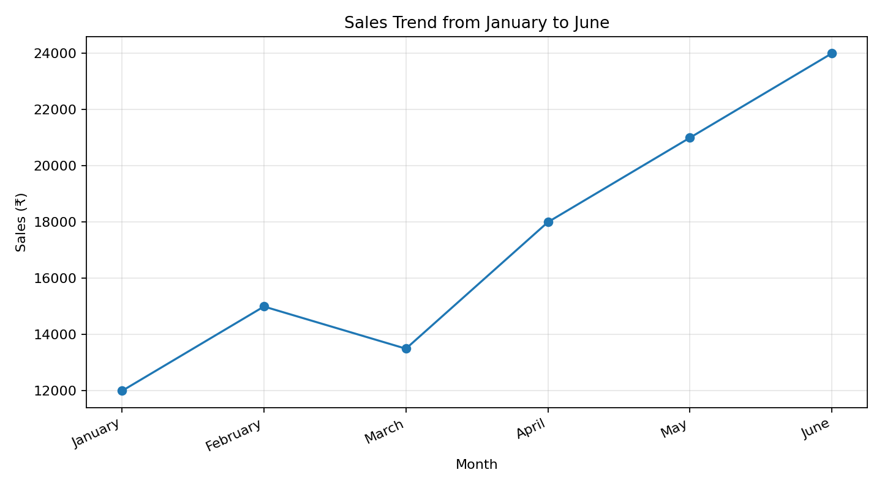
Takeaway: Sales double overall from January to June, with a temporary dip in March.

5. Chart 3 — Share of Sales by Product Category
Question: How is category sales distributed? Chart choice: Pie chart, because there are only three categories and the goal is to show parts of a whole.
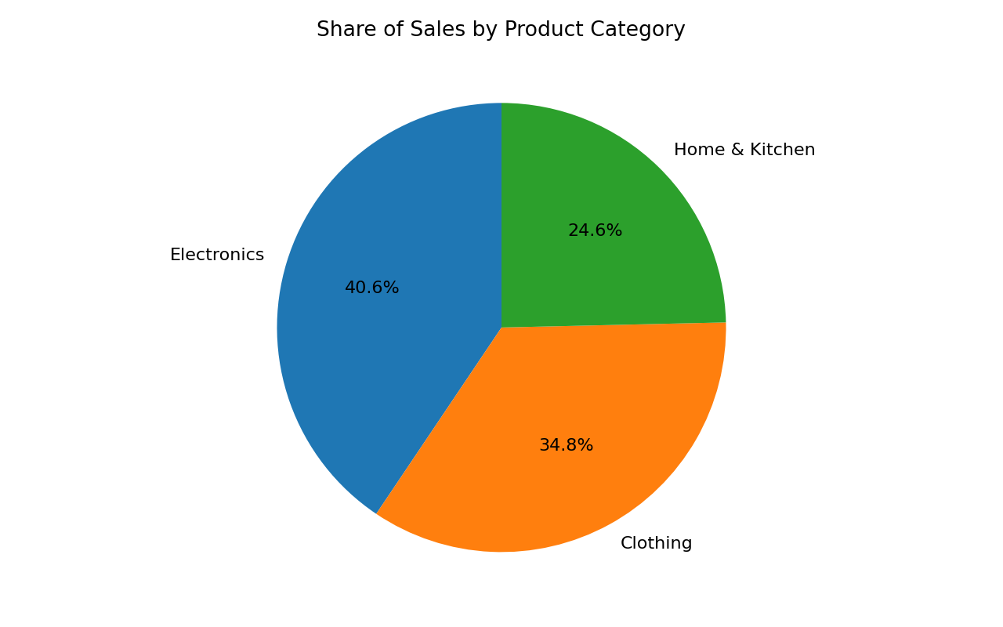
Takeaway: Electronics has the largest share (40.6%), followed by Clothing (34.8%) and Home & Kitchen (24.6%).

6. Combined narrative
The illustrative sales data shows overall growth during the first six months, with sales doubling from January to June despite a small decline in March. June records the highest monthly sales, suggesting stronger performance toward the end of the period. Across the three product categories, Electronics contributes the largest share of total category sales, followed by Clothing and Home & Kitchen. Together, the charts show both the time-based trend and category mix, while demonstrating that bars compare values, lines show change over time, and a pie chart summarizes a small number of parts of a whole.

7. Interview questions

When would you choose a bar chart over a line chart?
I choose a bar chart to compare separate categories, such as sales by product or revenue by region. I choose a line chart to show trends or changes over time, such as monthly sales.

Why are pie charts often discouraged in professional reporting?
Pie slices can be hard to compare when their sizes are similar, and too many slices create clutter. Bar charts are often clearer for precise comparisons. Pie charts work best for a simple part-to-whole view with only a few categories.

8. Conclusion
This task shows that effective data storytelling begins with a clear question, a suitable chart, readable labels, and a concise takeaway. The figures used are synthetic and should be replaced with real data for business decisions.

