DATABASE MANAGEMENT SYSTEM PROJECT REPORT

TOPIC: ZOO MANAGEMENT SYSTEM

**1)PROBLEM STATEMENT:**

In earlier days, Zoological gardens provided an opportunity to open up a whole new world of curiosity and interest, and sensitize visitors regarding the value and need for conservation of wildlife. Zoos were initially started for the entertainment of people. Gradually over the years, they have come to play an important role in conservation of wildlife. The ultimate goal of zoos is the conservation of animals. The entire detail of the “Zoo Park” and to elaborate more on providing the visitors entry tickets, keeping the animals’ details and maintaining their birth, death & updates certificates and information. Zoos face the problems of issuing a ticket and maintaining the animal’s data manually. It is extremely time consuming and complex. The data is stored in the form of a spreadsheet in MS Excel. This leads to the difficulty of calculating the data.

**2)STAGES OF ER DIAGRAM(HAND-DRAWN):**

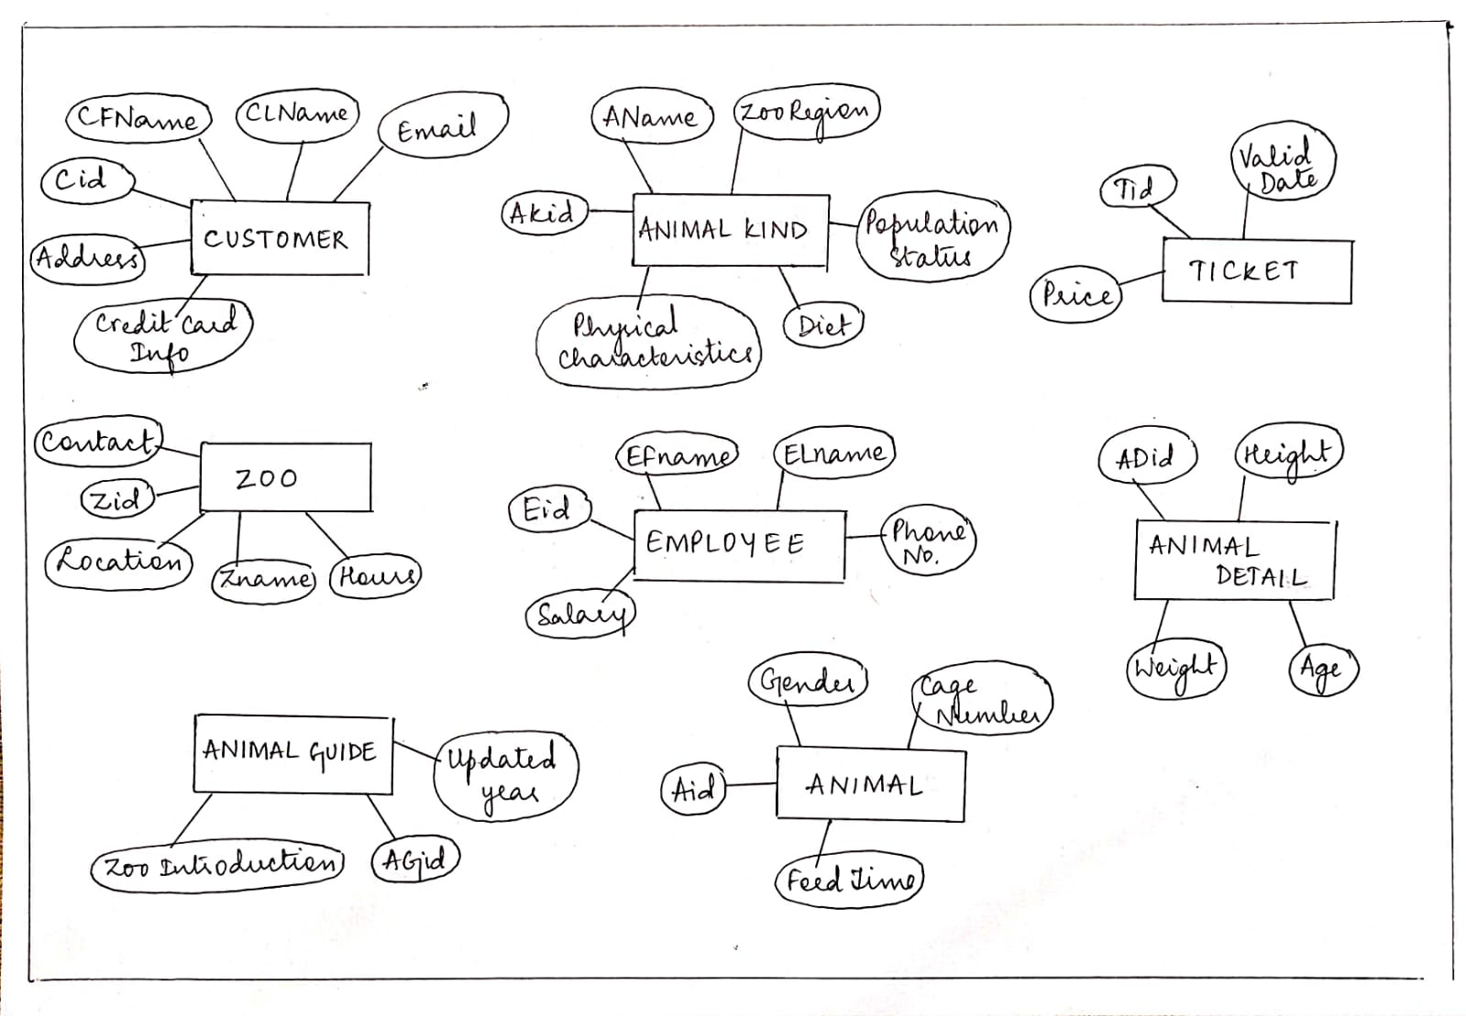

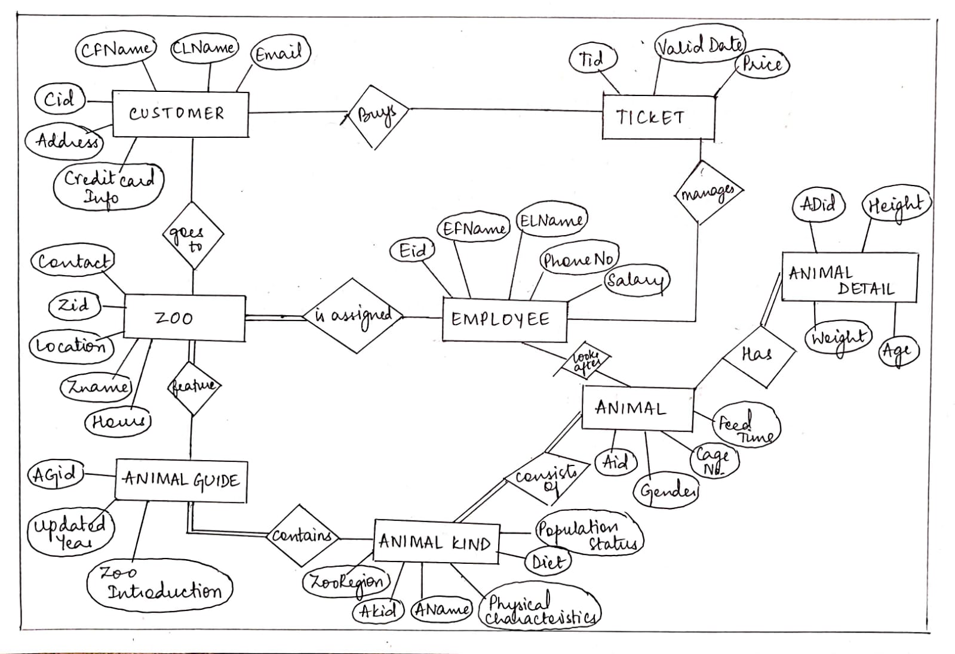

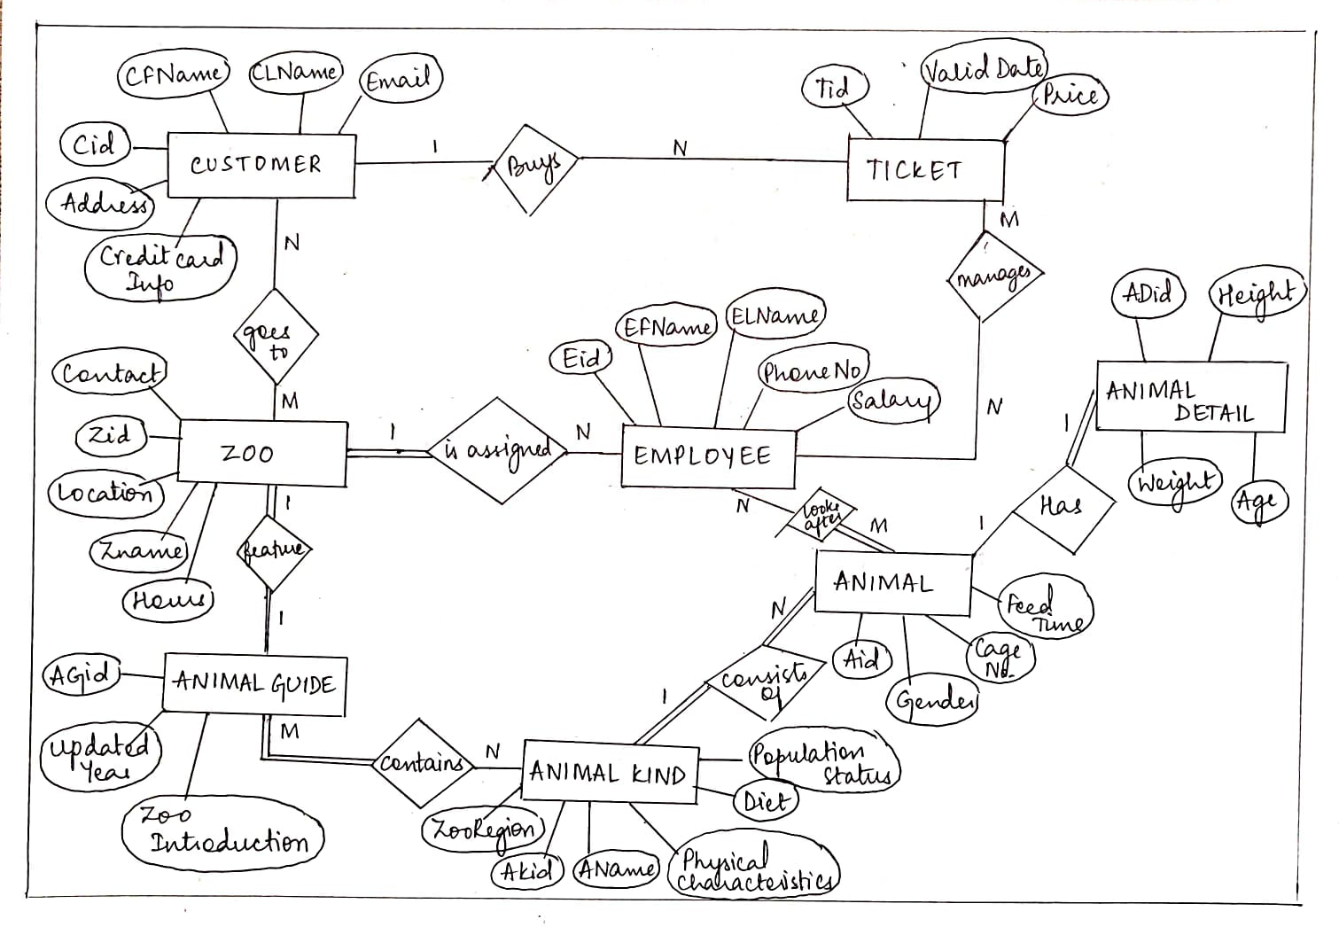

**3)TOOL USED:**

draw.io Diagrams.

Using this software, we can work offline on ER diagrams and save them locally using the draw.io/diagrams.net Desktop app for Windows.

We chose this tool because it has very helpful features.

**Features Include:**

* Easy to use diagramming tool with extras for power users.
* Easy to use.
* Intuitive interface.
* Extensive shape library.
* Lots of templates.
* Drag & drop functionality.
* Import & export various formats.
* Automatic layout.
* High performance.

It is a free and an open source software.

**4)REFERENCE LINKS FOR INSTALLATION:**

<https://www.draw.io/app>

<https://www.microsoft.com/en-us/p/drawio-diagrams/9mvvszk43qqw?activetab=pivot:overviewtab>

**5)FINAL ER DIAGRAM:**

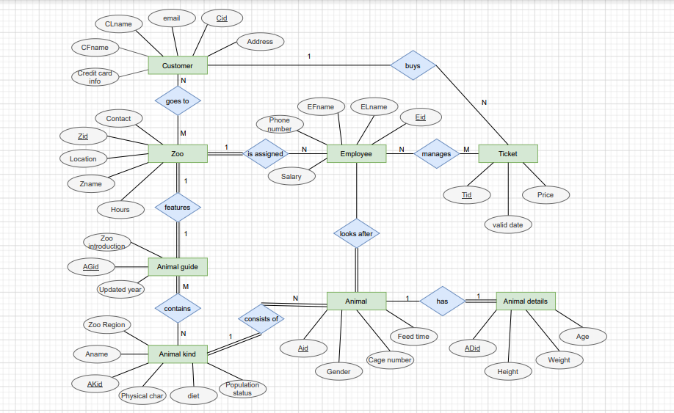

**MEMBER NAMES AND CONTRIBUTIONS:**

MANASA R: PES2UG19CS215 - Installation if tools and soft copy of ER diagram.

NAMITHA NAYAK: PES2UG19CS247 - Hand drawn snapshots of ER diagram.

NIDHI BHARATIYA: PES2UG19CS254 - Problem statement and compilation of the report.