SIMATS ENGINEERING (SAVEETHA SCHOOL OF ENGINEERING)
Department of Artificial Intelligence and Data Science
ASSESSMENT TOOL 2 – SCENARIO BASED

Course Code: | DSA03 | Course Title: | Natural Language Processing
CO Assessed: | CO2 – Manipulation | Assessment: | Assessment Tool 2 – SCENARIO BASED
Weightage: | 35% of CIA
CO5 Statement: | Design inflectional, derivational, finite-state parsing, stemming algorithms and for analyse morphological methods. (BL-3)
Student Name: | M.MANASA | Reg. No.: | 192425189
Section / Batch: | 2024 AIML | Date: | 06-08-2026

Code of Conduct
I ___M.Manasa(192425189)_______________________ (Name / Reg No) certify that this submission is my original work and that I have adhered to the guidelines specified for this assessment. I understand that any violation of academic integrity rules will result in disciplinary action.
Signature of the Student: ____M.Manasa___________________

Instructions
- Read all questions carefully before attempting the answers.
- Answer all five questions. Each question carries equal marks.
- Show all intermediate steps, calculations, probability computations, tagging decisions, and justifications wherever applicable.
- Duration: 30 minutes.

Section / Topic | Focus | Q Nos
English Word Classes, Tagsets for English, Stochastic Part of Speech Tagging, HMM | Morphological parsing of disagree, agreement, and agreeable; identification of prefixes, suffixes, base forms, and semantic effects of derivation. | Q1

Annexure A – SCENARIO BASED
A company is developing an NLP-based grammar checker for educational applications. The system is trained using a manually POS-tagged corpus. Your task is to recreate the Hidden Markov Model (HMM) without using any built-in NLP or HMM libraries.
From the given corpus,
- determine the Emission Probability
- determine the Transition Probability
- implement the Viterbi Algorithm
- predict the POS tags for the new input sentence.
Use only Python dictionaries, loops, and basic programming constructs.

Training Corpus
Sentence | POS Tags
The/DT boy/NN eats/VBZ rice/NN | DT NN VBZ NN
The/DT girl/NN drinks/VBZ milk/NN | DT NN VBZ NN
A/DT cat/NN drinks/VBZ milk/NN | DT NN VBZ NN
The/DT dog/NN chases/VBZ cat/NN | DT NN VBZ NN
A/DT teacher/NN teaches/VBZ students/NNS | DT NN VBZ NNS
Students/NNS study/VBP English/NN | NNS VBP NN
Birds/NNS fly/VBP high/RB | NNS VBP RB
Children/NNS play/VBP games/NNS | NNS VBP NNS

New Input Sentence
The cat drinks milk

Tasks
- Separate each sentence into words and POS tags.
- Compute the Emission Probability of every word.
- Compute the Transition Probability between POS tags.
- Recreate the Hidden Markov Model using Python dictionaries.
- Implement the Viterbi Algorithm without using any built-in HMM/NLP libraries.
- Predict the POS tag sequence for “The cat drinks milk”

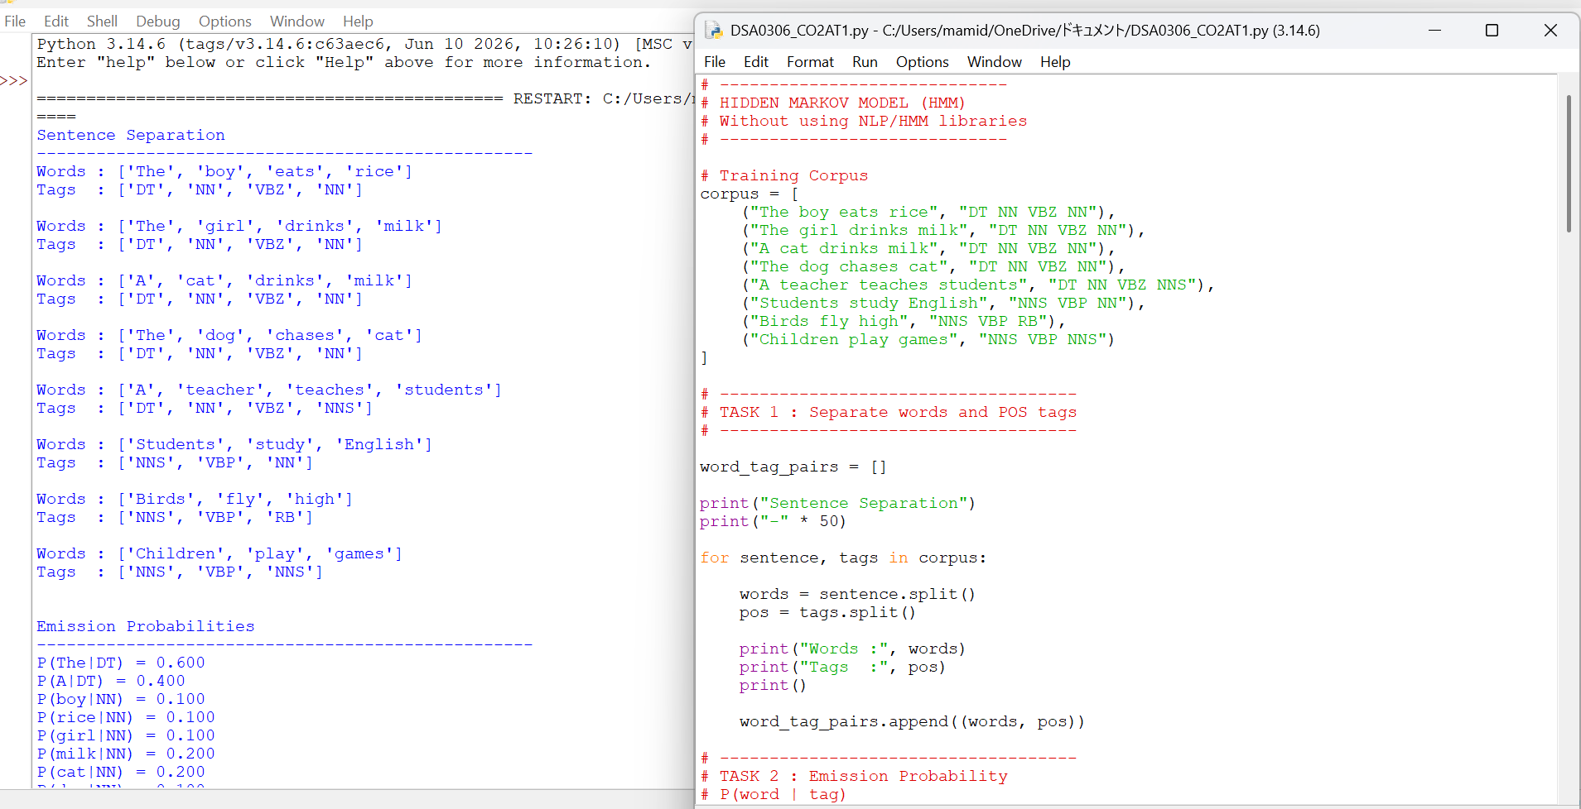
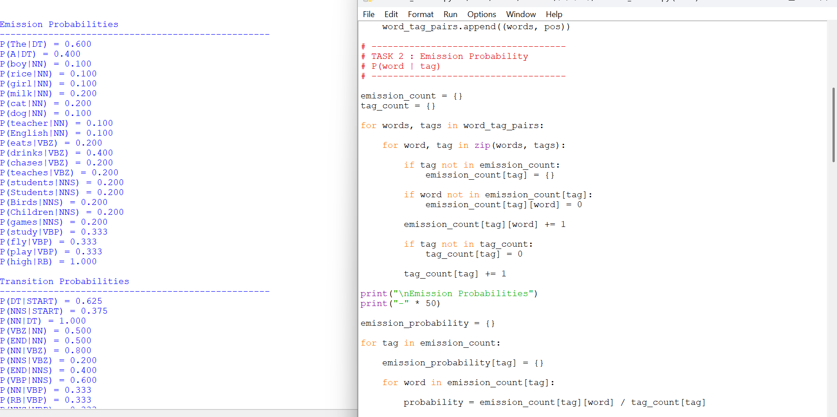
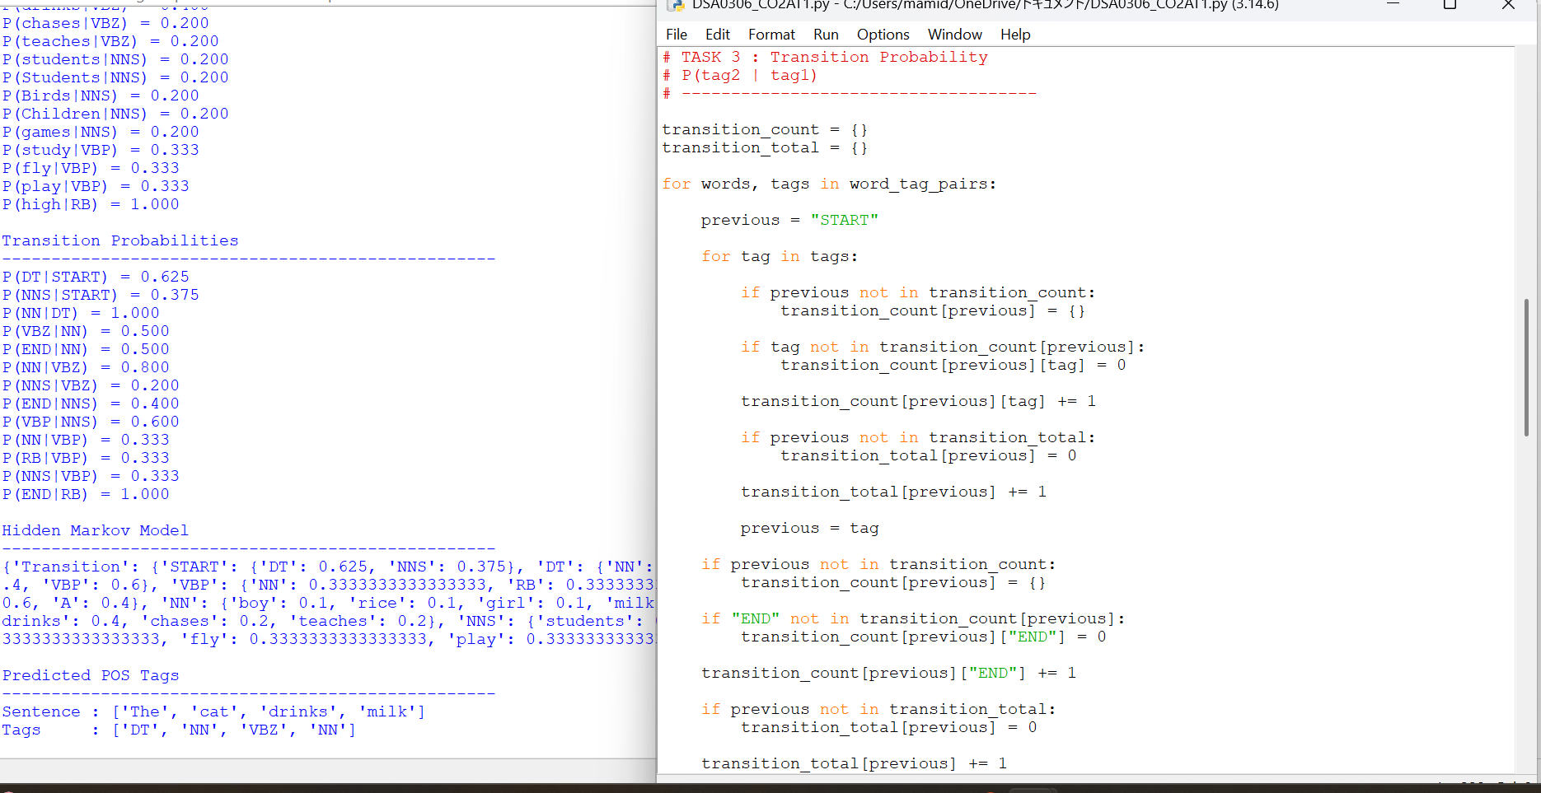
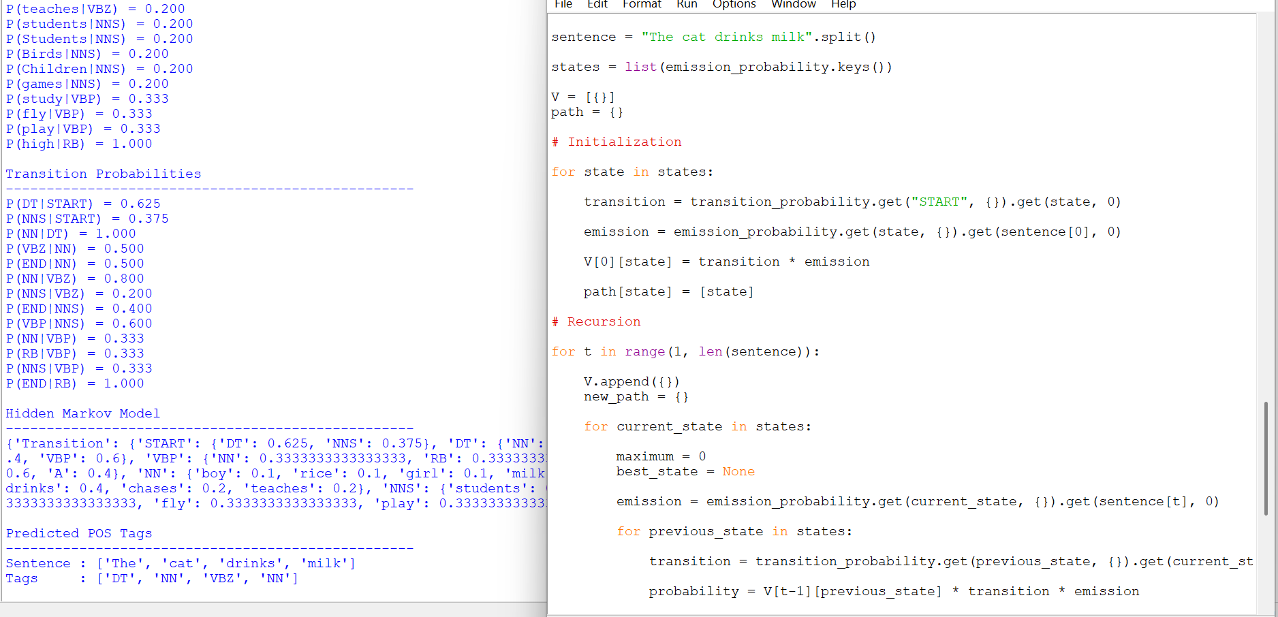

Rubrics for Calculation

Criteria | Weightage (%) | Level 4 (Exemplary) | Level 3 (Proficient) | Level 2 (Developing) | Level 1 (Beginning)
Understanding of Scenario | 20% | Demonstrates clear and complete understanding of the scenario and context | Shows good understanding with minor gaps | Partial understanding; misses key aspects | Misinterprets or fails to understand the scenario
Identification of Key Issues | 20% | Accurately identifies all relevant issues and factors involved | Identifies most key issues with minor omissions | Identifies limited issues; some irrelevant points | Unable to identify key issues
Application of Concepts | 25% | Applies appropriate concepts effectively to address the scenario | Applies concepts with minor errors | Limited or partially correct application | Unable to apply relevant concepts
Decision Making | 20% | Makes well-reasoned, logical decisions with strong rationale | Makes reasonable decisions with some justification | Makes weak decisions with limited justification | No clear decisions made or rationale provided
Clarity of Response | 15% | Response is clear, structured, and logically presented | Generally clear with minor issues | Somewhat unclear or poorly structured | Disorganized and difficult to understand

Q. No. / Criteria Level | Understanding of Scenario | Identification of Key Issues | Application of Concepts | Decision Making | Clarity of Response | Sub. Total | Total %
1 | 20 | 15 | 18 | 20 | 15 | 88 | 88
2
3
4
5

Faculty In-charge | Course Coordinator | Program Director
T.Kumaragurubaran
Signature: _______________ | Signature: _______________ | Signature: _______________
Date: ___________________ | Date: ___________________ | Date: ___________________

