

CO3-AT1 – Case Study

Name:M.Manasa
Reg no:192425189
Course code: MLA0401
Course: Deep learning

Question 1 – Medical Image Classification (X-ray: Normal vs Abnormal)

A hospital needs to classify X-ray images as Normal or Abnormal — a binary image classification task. A CNN is well suited here because it learns spatial patterns (fractures, opacities, lesions) directly from pixel data instead of relying on hand-crafted features.

Proposed CNN Architecture
Layer # | Layer Type | Configuration | Purpose
1 | Input | 224×224×1 grayscale | Pre-processed X-ray image
2-3 | Conv1 + Pool1 | 32 filters 3×3 ReLU / MaxPool 2×2 | Low-level edges & boundaries
4-5 | Conv2 + Pool2 | 64 filters 3×3 ReLU / MaxPool 2×2 | Mid-level texture, opacity patterns
6-7 | Conv3 + Pool3 | 128 filters 3×3 ReLU / MaxPool 2×2 | Disease-specific high-level patterns
8 | Flatten | — | 3D feature maps → 1D vector
9-10 | FC1 / FC2 | 256 / 64 neurons, ReLU, Dropout | Combine features into decision
11 | Output | 1 neuron, Sigmoid | Normal vs Abnormal probability

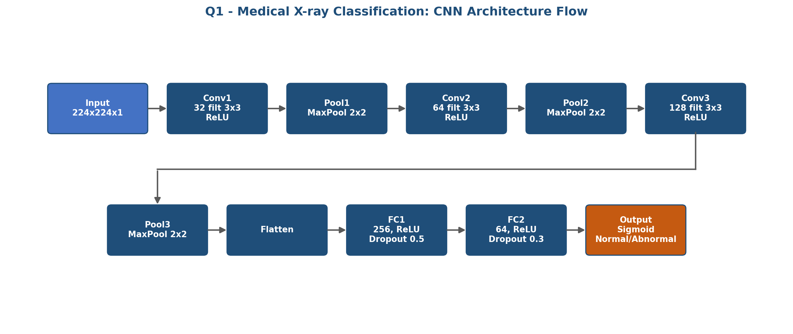
Dataset: Chest X-Ray Images (Pneumonia) dataset.
Classes used: NORMAL and PNEUMONIA. For the case study, NORMAL is treated as Normal and PNEUMONIA as Abnormal.
Recommended folder structure:
dataset/
train/
NORMAL/
PNEUMONIA/
validation/
NORMAL/
PNEUMONIA/
test/
NORMAL/
PNEUMONIA/
Dataset loading code for the existing 224×224×1 CNN:
Dataset Loading / Preparation Code:
import tensorflow as tf
train_ds = tf.keras.utils.image_dataset_from_directory(
"dataset/train",
image_size=(224, 224),
color_mode="grayscale",
batch_size=32,
label_mode="binary",
shuffle=True
)
val_ds = tf.keras.utils.image_dataset_from_directory(
"dataset/validation",
image_size=(224, 224),
color_mode="grayscale",
batch_size=32,
label_mode="binary",
shuffle=False
)
test_ds = tf.keras.utils.image_dataset_from_directory(
"dataset/test",
image_size=(224, 224),
color_mode="grayscale",
batch_size=32,
label_mode="binary",
shuffle=False
)
# Normalize pixel values to 0–1
normalization = tf.keras.layers.Rescaling(1./255)
train_ds = train_ds.map(lambda x, y: (normalization(x), y))
val_ds = val_ds.map(lambda x, y: (normalization(x), y))
test_ds = test_ds.map(lambda x, y: (normalization(x), y))
# Train
history = model.fit(train_ds, validation_data=val_ds, epochs=10)
model.evaluate(test_ds)

Implementation
from tensorflow.keras import layers, models

model = models.Sequential([
layers.Input(shape=(224, 224, 1)),
layers.Conv2D(32, (3,3), activation='relu', padding='same'),
layers.MaxPooling2D(2, 2),
layers.Conv2D(64, (3,3), activation='relu'),
layers.MaxPooling2D(2, 2),
layers.Conv2D(128, (3,3), activation='relu'),
layers.MaxPooling2D(2, 2),
layers.Flatten(),
layers.Dense(256, activation='relu'),
layers.Dropout(0.5),
layers.Dense(64, activation='relu'),
layers.Dropout(0.3),
layers.Dense(1, activation='sigmoid')
])

model.compile(optimizer='adam',
loss='binary_crossentropy',
metrics=['accuracy'])
model.summary()

Training Curves
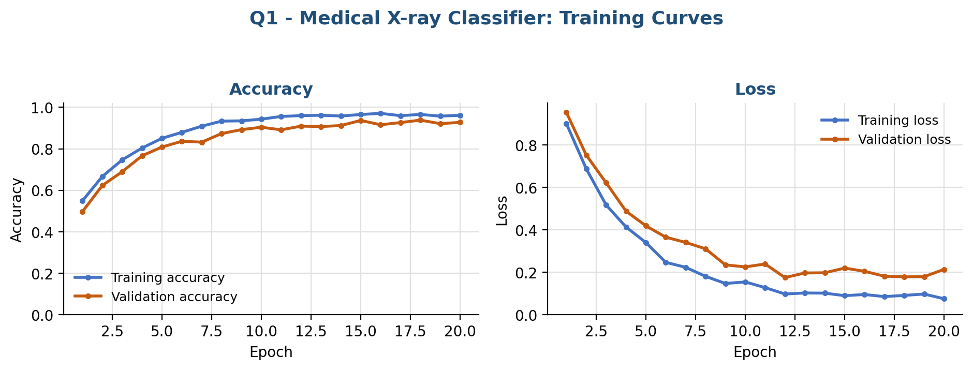
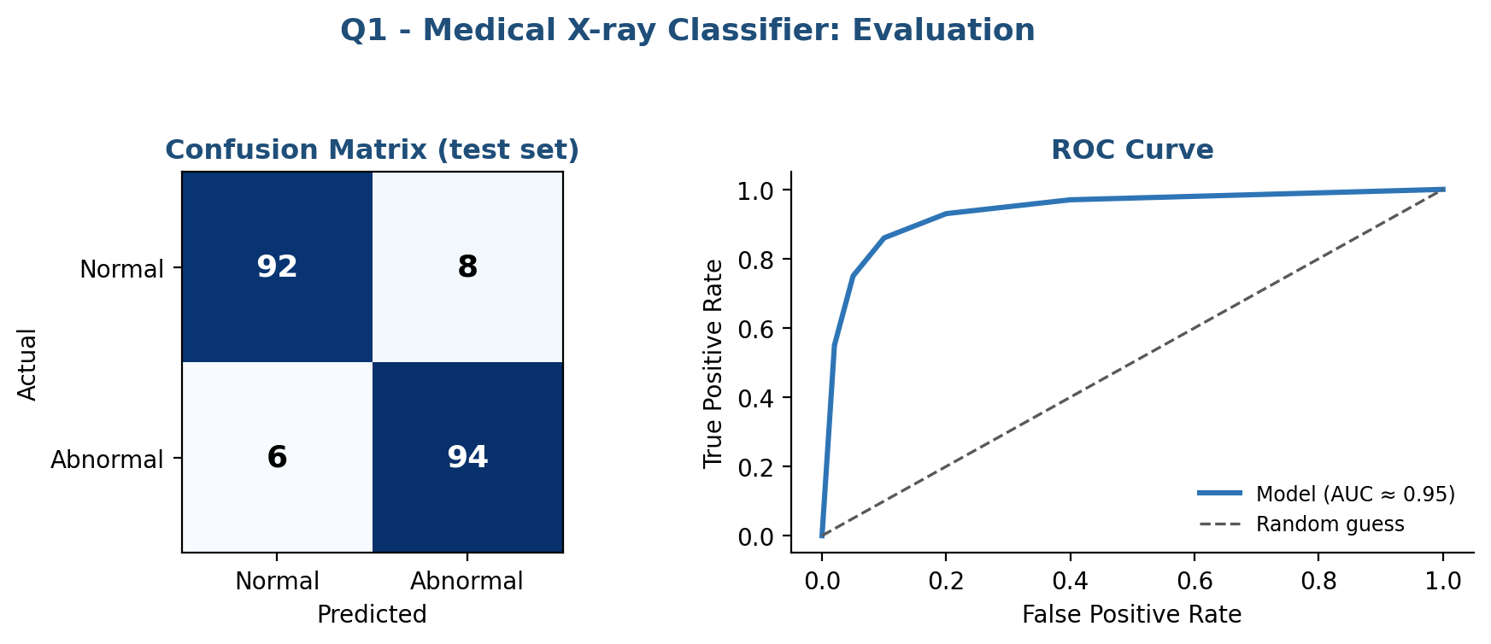

Key Justification
- Convolution layers exploit spatial structure — better than flattening raw pixels.
- Filter depth increases (32→64→128) as deeper layers must represent more complex patterns.
- Max pooling keeps the strongest diagnostic activation and adds shift tolerance.
- Dropout in FC layers reduces overfitting on limited medical datasets.
- Sigmoid output gives a probability so clinicians can set a confidence threshold.

Question 2 – Face Recognition System (College Security)

A college security system must identify/verify a person from a camera image against enrolled faces. Convolution layers detect facial features, feature maps capture where each pattern occurs, pooling summarizes and adds robustness, and the final layers turn all of this into an identity decision.

Pipeline
Stage | Layer / Step | Purpose
1 | Face detection + alignment | Locate and crop the face before the CNN
2-4 | Conv Blocks 1-3 (Conv+ReLU+Pool) | Edges → facial parts → unique geometry
5 | Flatten + Fully Connected | Produce a 128–512 dim face embedding
6 | Softmax / Distance Matching | Identify or verify against enrolled database

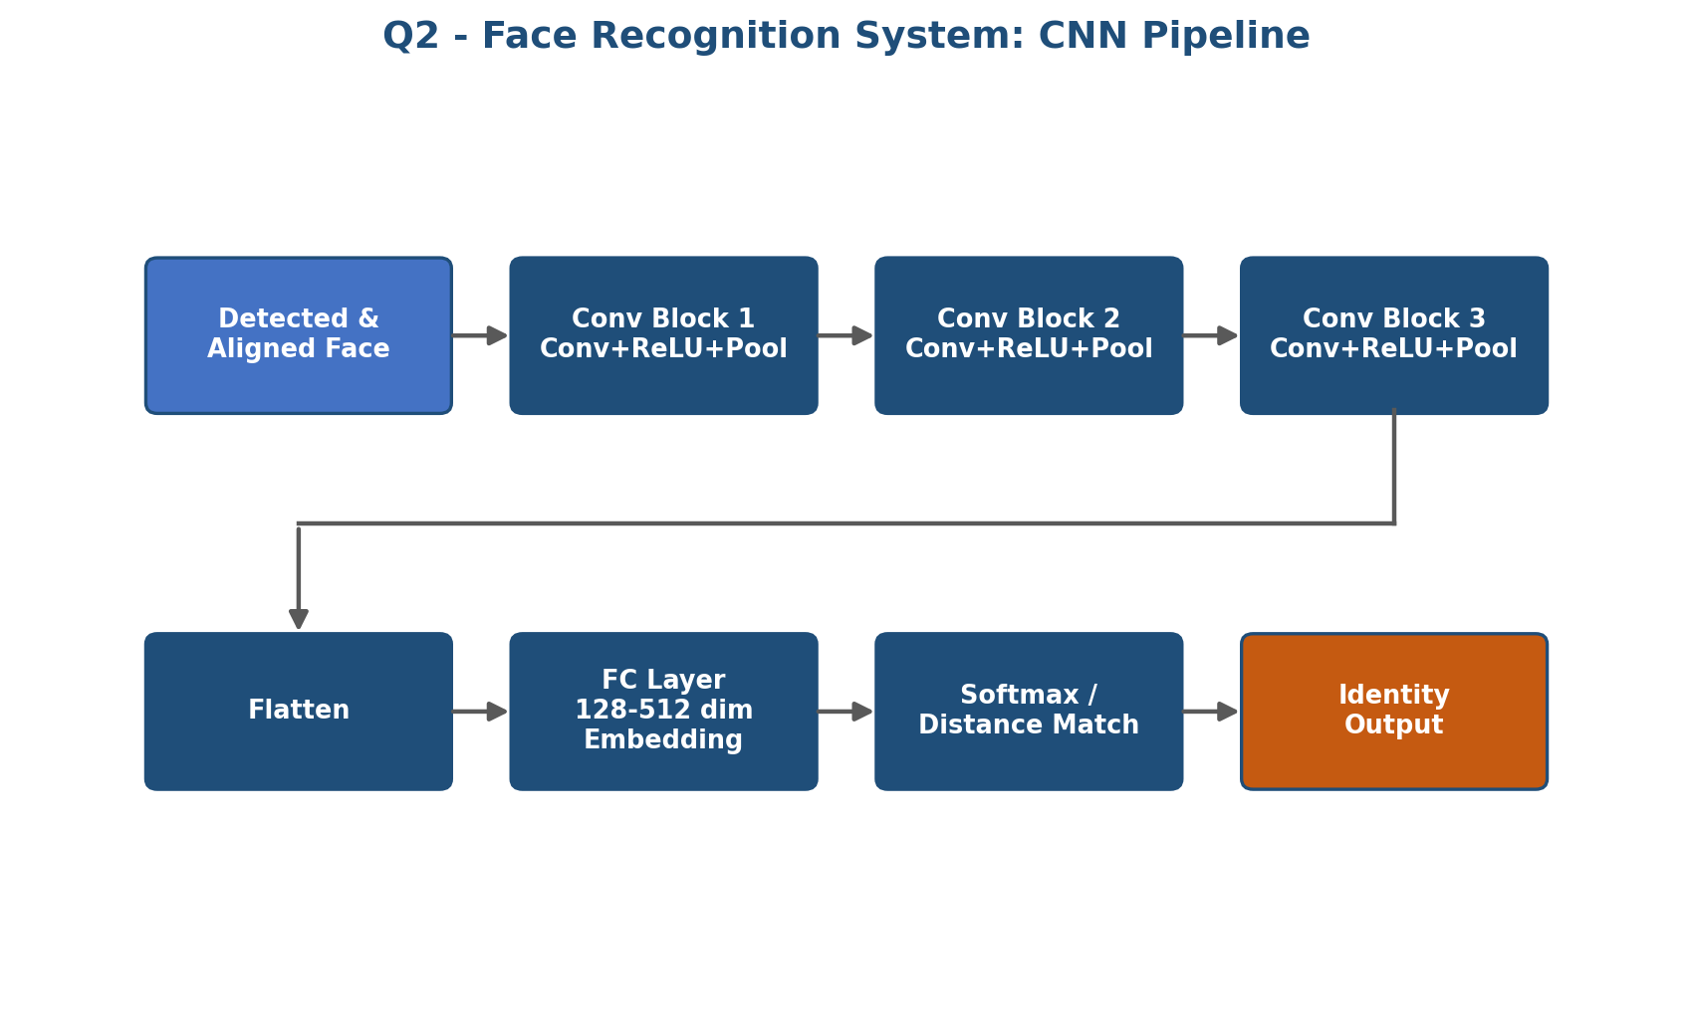
Dataset: Labeled Faces in the Wild (LFW) or a college-collected face dataset with consent.
Each person's images should be stored in a separate folder.
Recommended folder structure:
faces/
student_001/
img1.jpg
img2.jpg
student_002/
img1.jpg
img2.jpg
student_003/
img1.jpg
img2.jpg
The face model in the question produces a 128-dimensional embedding. The dataset should therefore contain multiple images per enrolled person so that embeddings of the same person can be compared.
Dataset Loading / Preparation Code:
import tensorflow as tf
face_ds = tf.keras.utils.image_dataset_from_directory(
"faces",
image_size=(160, 160),
batch_size=32,
label_mode="int",
shuffle=True
)
# Normalize RGB pixels
face_ds = face_ds.map(
lambda x, y: (tf.cast(x, tf.float32) / 255.0, y)
)
# The existing face_model converts each face image into a 128-D embedding.
# Example: generate embeddings for a batch
for images, labels in face_ds.take(1):
embeddings = face_model(images)
print("Embedding shape:", embeddings.shape)

Implementation (Embedding Model)
import tensorflow as tf
from tensorflow.keras import layers, models

def conv_block(x, filters):
x = layers.Conv2D(filters, (3,3), activation='relu', padding='same')(x)
return layers.MaxPooling2D(2, 2)(x)

inputs = layers.Input(shape=(160, 160, 3))
x = conv_block(inputs, 32)
x = conv_block(x, 64)
x = conv_block(x, 128)
x = layers.Flatten()(x)
embedding = layers.Dense(128)(x)
embedding = layers.Lambda(
lambda t: tf.math.l2_normalize(t, axis=1),
name='embedding')(embedding)

face_model = models.Model(inputs, embedding)
face_model.summary()
# Train with triplet loss so same-person embeddings stay close
# and different-person embeddings stay far apart.

Training Curve
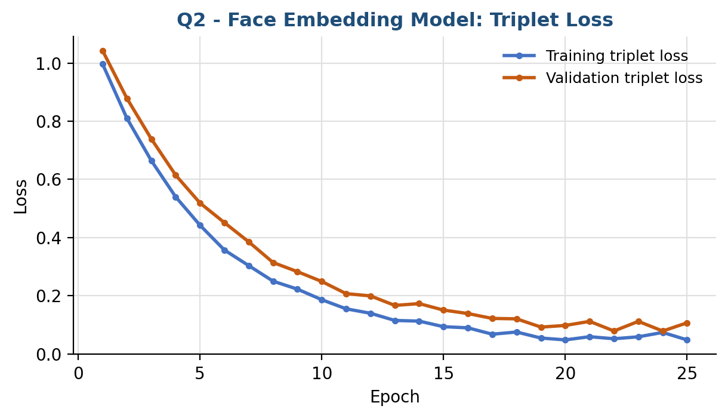
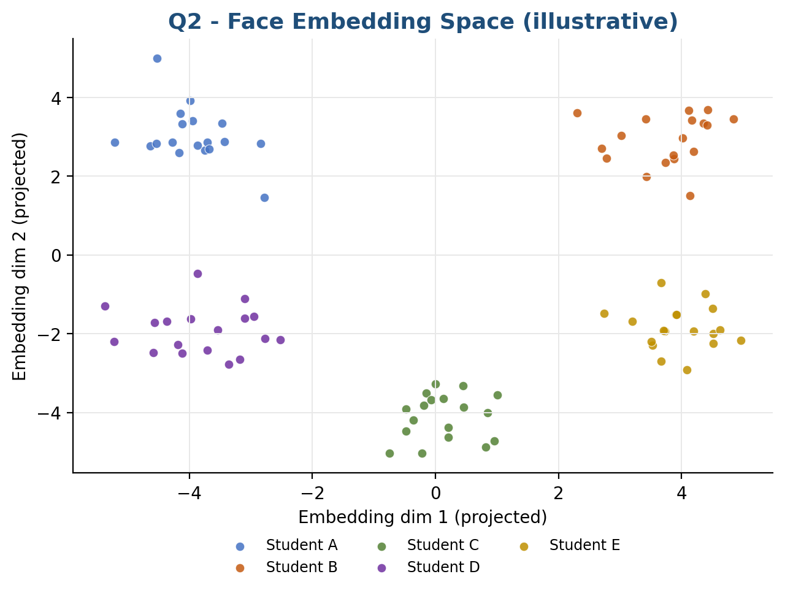

Key Points
- Embedding approach scales to new students without retraining the whole network.
- Liveness detection should be added to prevent photo/video spoofing.
- A confidence threshold with an 'unknown' class avoids forced false matches.

Question 3 – Autonomous Vehicles (Pedestrians, Vehicles, Road Signs)

The vehicle must locate and classify every relevant object in a camera frame in real time — an Object Detection task. A CNN backbone extracts multi-scale features; detection-specific heads then predict class and bounding box for each candidate region, followed by Non-Maximum Suppression to remove duplicate boxes.

Pipeline
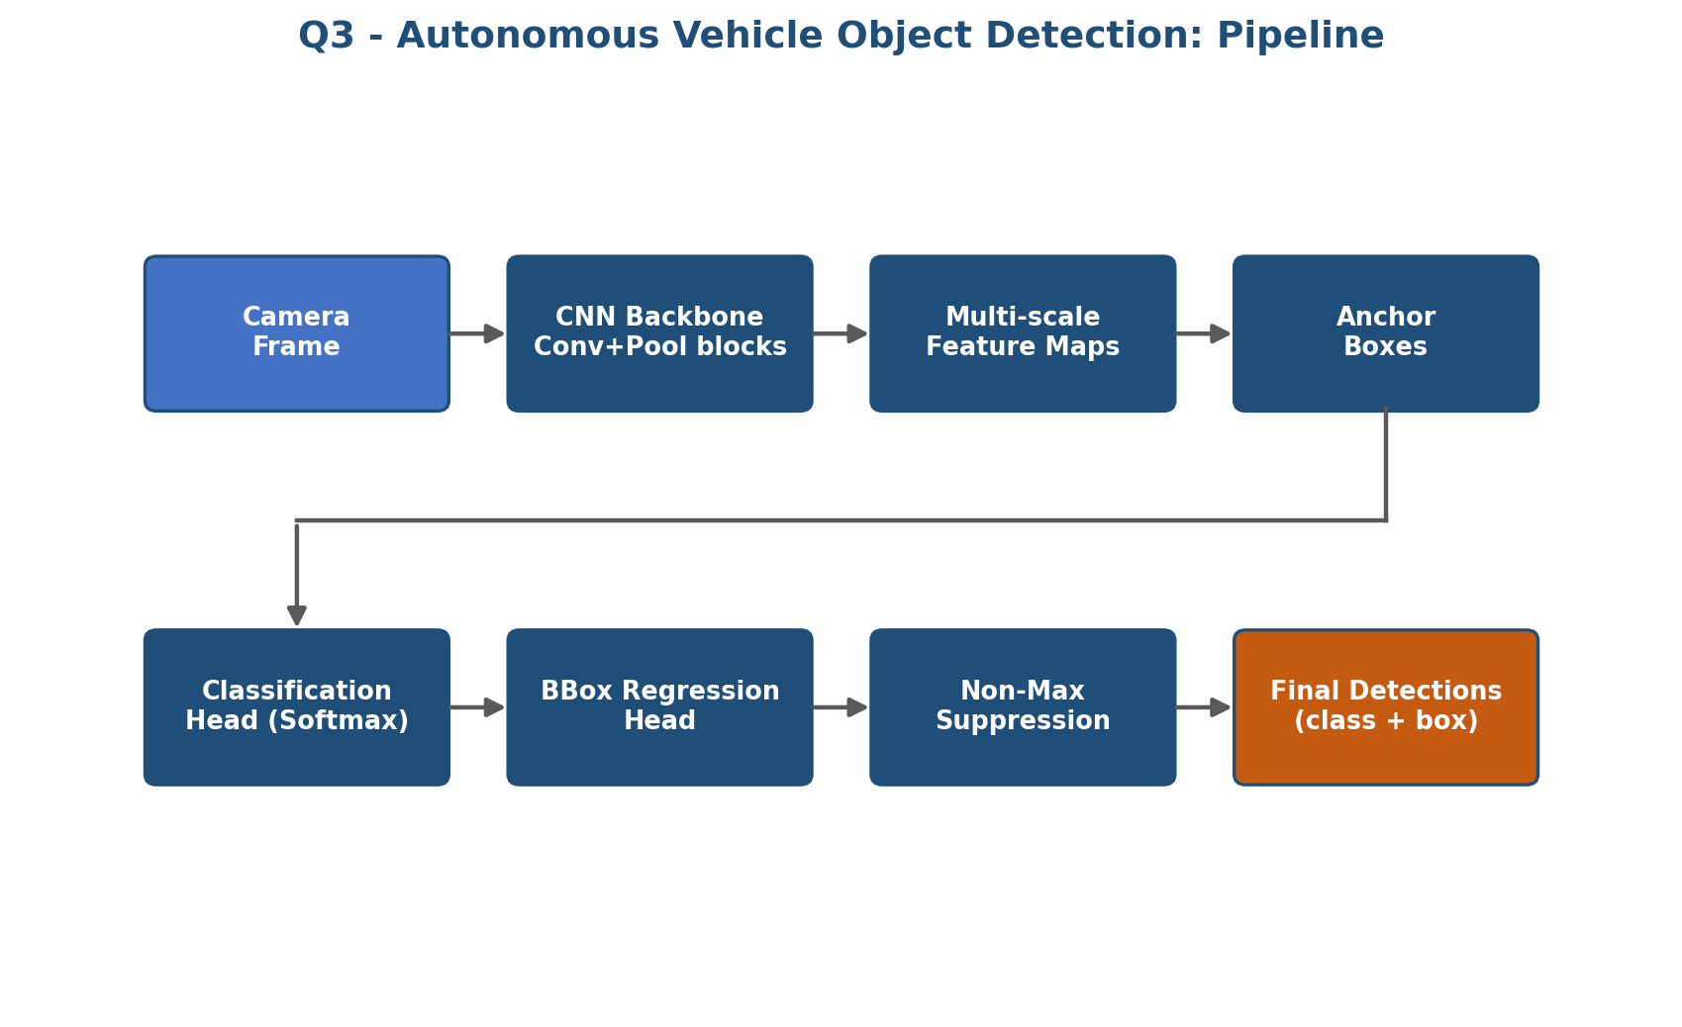
Dataset: COCO 2017 or KITTI object-detection dataset.
For the case study, relevant categories are:
• Person/Pedestrian
• Car/Vehicle
• Traffic sign
• Background
COCO is suitable for demonstrating people and vehicles and includes traffic-sign-related categories. KITTI is especially suitable for road-scene detection. The images must have bounding-box annotations because this question is an object-detection task.
Recommended prepared dataset structure:
detection_dataset/
images/
train/
val/
annotations/
train/
val/
Each image should have matching bounding-box annotations containing class ID and box coordinates.
Dataset Loading / Preparation Code:
# Example dataset loading with TensorFlow Datasets
import tensorflow as tf
import tensorflow_datasets as tfds
train_data, info = tfds.load(
"coco/2017",
split="train",
with_info=True
)
val_data = tfds.load(
"coco/2017",
split="validation"
)
# The detector in the question expects:
# 1. classification targets for each anchor
# 2. bounding-box targets for each anchor
#
# Therefore, COCO bounding boxes must be converted to the
# detector's anchor/grid format before model.fit() is called.
print("Number of training examples:", info.splits["train"].num_examples)

Implementation (Simplified Detection Head)
import tensorflow as tf
from tensorflow.keras import layers, models

backbone = tf.keras.applications.MobileNetV2(
input_shape=(224, 224, 3), include_top=False, weights='imagenet')
backbone.trainable = False

x = layers.Conv2D(256, (3,3), padding='same', activation='relu')(backbone.output)

num_classes, num_anchors = 4, 9 # pedestrian, vehicle, sign, background

cls_head = layers.Conv2D(num_anchors * num_classes, (1,1),
activation='sigmoid', name='classification_head')(x)
bbox_head = layers.Conv2D(num_anchors * 4, (1,1),
activation='linear', name='bbox_regression_head')(x)

detector = models.Model(backbone.input, [cls_head, bbox_head])
detector.summary()
# Post-process predictions with Non-Maximum Suppression (tf.image.non_max_suppression)

Training Losses
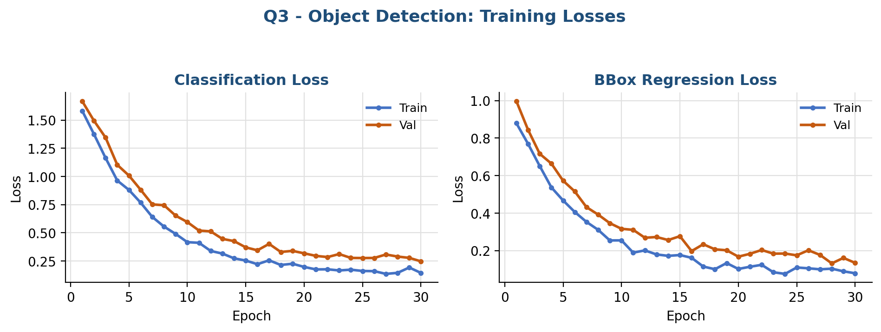
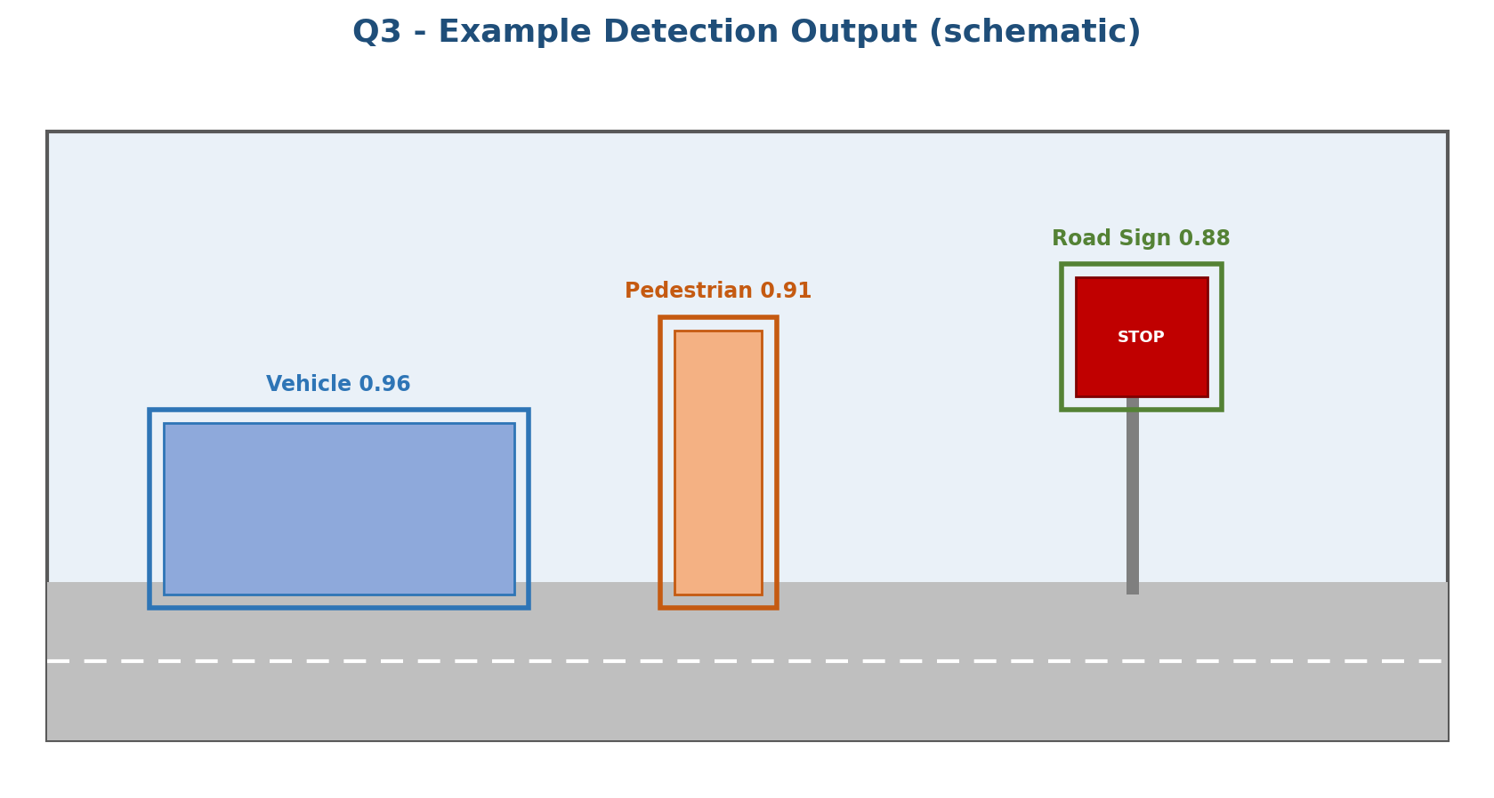

Key Points
- Early conv layers learn edges/colors; deeper layers learn whole-object shapes.
- Multi-scale feature maps let the model catch both small distant and large nearby objects.
- Detection output is fused with LiDAR/radar before the planning module acts.

Question 4 – CNN Overfitting (98% Train, 75% Test Accuracy)

A 23-point gap between train and test accuracy indicates overfitting — the model has memorized training images rather than learning generalizable patterns. Likely causes: excessive model complexity, small/non-diverse data, too many epochs, or weak regularization.
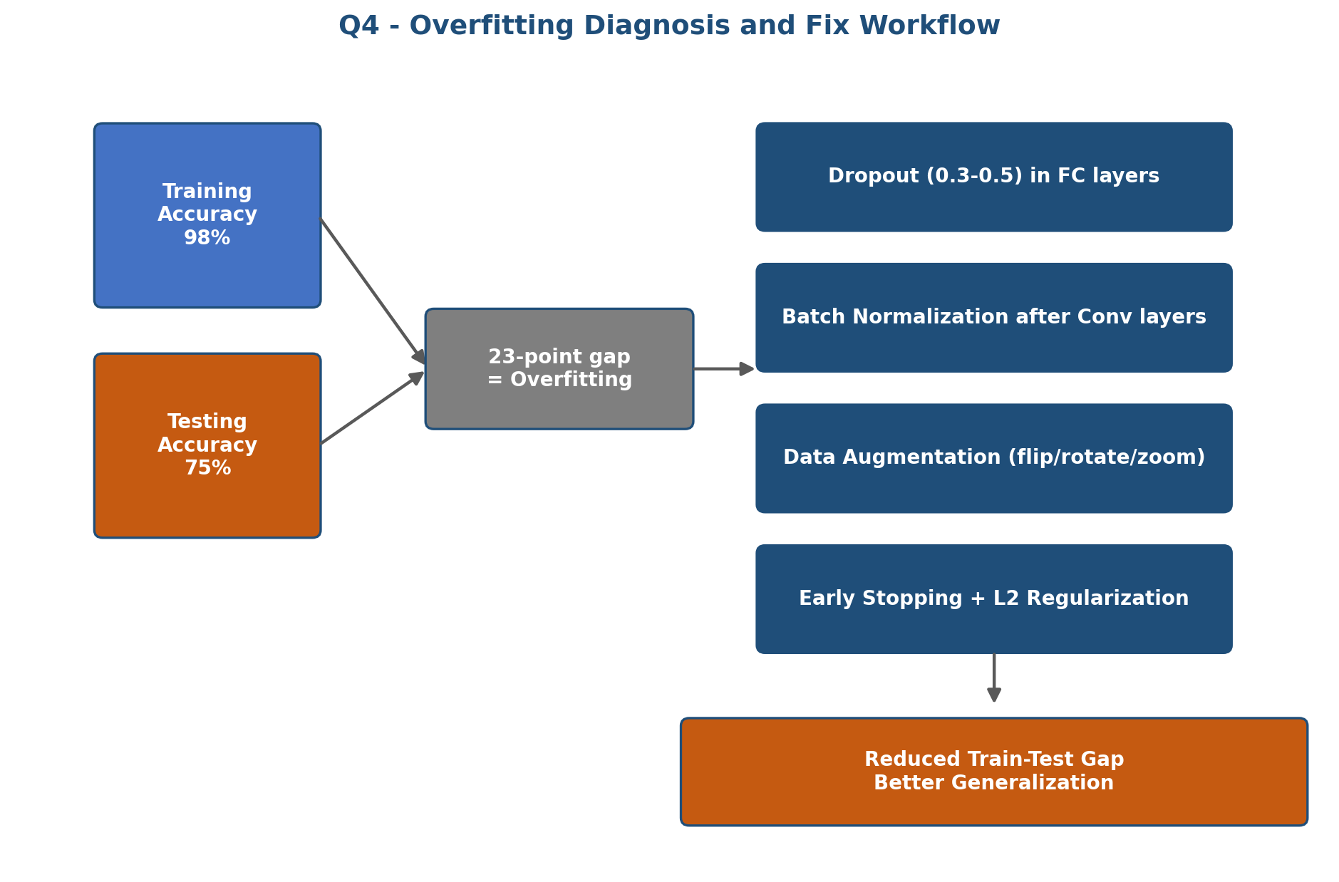
Dataset: CIFAR-10 image dataset.
CIFAR-10 contains 10 image classes and is useful for demonstrating overfitting and the effect of Dropout, Batch Normalization, L2 regularization, data augmentation, and Early Stopping.
The original model uses 128×128×3 input, so CIFAR-10 images are resized from 32×32 to 128×128.
Dataset Loading / Preparation Code:
import tensorflow as tf
(X_train, y_train), (X_test, y_test) = tf.keras.datasets.cifar10.load_data()
# Resize 32×32 images to the model's 128×128 input size
X_train = tf.image.resize(X_train, (128, 128)).numpy() / 255.0
X_test = tf.image.resize(X_test, (128, 128)).numpy() / 255.0
# Convert class labels to one-hot vectors
num_classes = 10
y_train = tf.keras.utils.to_categorical(y_train, num_classes)
y_test = tf.keras.utils.to_categorical(y_test, num_classes)
# Create a validation set
X_val = X_train[-5000:]
y_val = y_train[-5000:]
X_train = X_train[:-5000]
y_train = y_train[:-5000]
# Use the model from Question 4
history = model.fit(
datagen.flow(X_train, y_train, batch_size=32),
validation_data=(X_val, y_val),
epochs=50,
callbacks=[early_stop]
)
model.evaluate(X_test, y_test)

Implementation (Dropout + BatchNorm + Augmentation)
from tensorflow.keras import layers, models, regularizers
from tensorflow.keras.preprocessing.image import ImageDataGenerator
from tensorflow.keras.callbacks import EarlyStopping

model = models.Sequential([
layers.Conv2D(32, (3,3), padding='same', input_shape=(128,128,3)),
layers.BatchNormalization(),
layers.Activation('relu'),
layers.MaxPooling2D(2, 2),

layers.Conv2D(64, (3,3), padding='same'),
layers.BatchNormalization(),
layers.Activation('relu'),
layers.MaxPooling2D(2, 2),

layers.Flatten(),
layers.Dense(128, activation='relu',
kernel_regularizer=regularizers.l2(0.001)),
layers.Dropout(0.5),
layers.Dense(num_classes, activation='softmax')
])

model.compile(optimizer='adam', loss='categorical_crossentropy',
metrics=['accuracy'])

datagen = ImageDataGenerator(rotation_range=20, horizontal_flip=True,
zoom_range=0.2, brightness_range=[0.8, 1.2])

early_stop = EarlyStopping(monitor='val_loss', patience=5,
restore_best_weights=True)

model.fit(datagen.flow(X_train, y_train, batch_size=32),
validation_data=(X_val, y_val),
epochs=50, callbacks=[early_stop])

Accuracy: Before vs After Fix
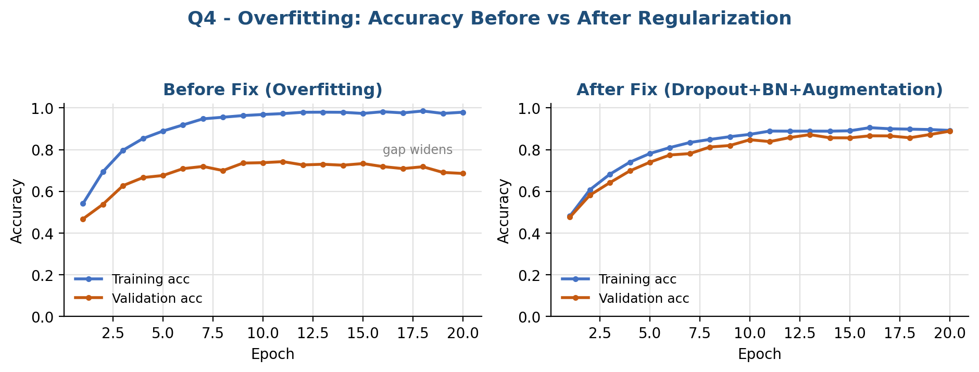

Key Points
- Dropout randomly deactivates neurons, forcing the network to learn redundant, general features.
- Batch Normalization stabilizes training and has a mild regularizing effect.
- Data augmentation expands effective dataset diversity without collecting new images.
- Early stopping halts training once validation loss stops improving.

Question 5 – Fruit Image Classification

A company wants to classify fruit images into categories (apple, banana, orange, etc.) — a standard multi-class classification task, since fruits are distinguished mainly by color, shape and texture, which convolution filters capture well.

Suitable CNN Architecture
Layer # | Layer Type | Configuration | Purpose
1 | Input | 128×128×3 RGB | Resized, normalized fruit image
2-3 | Conv1 + Pool1 | 32 filters 3×3 ReLU / MaxPool 2×2 | Edges, color boundaries
4-5 | Conv2 + Pool2 | 64 filters 3×3 ReLU / MaxPool 2×2 | Texture (skin patterns)
6-7 | Conv3 + Pool3 | 128 filters 3×3 ReLU / MaxPool 2×2 | Whole-fruit shape & combined features
8 | Flatten | — | 3D feature maps → 1D vector
9 | FC | 128 neurons, ReLU, Dropout 0.4 | Combine features into class-relevant patterns
10 | Output | N neurons, Softmax | Probability across fruit classes

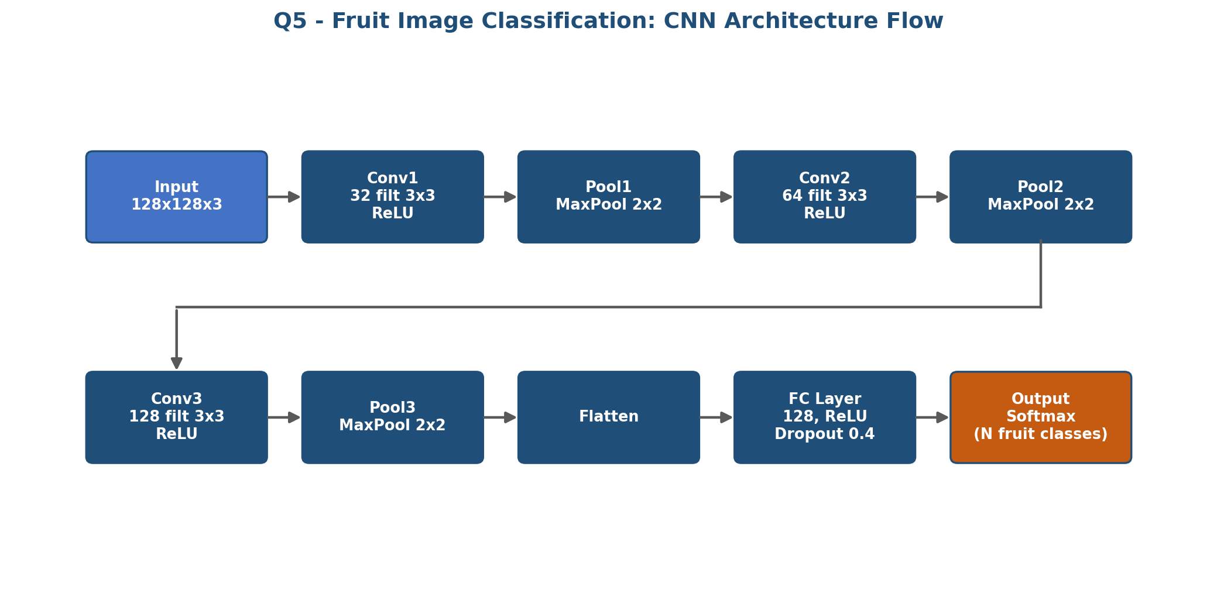

Dataset: Fruits-360 dataset.
For this case study, use five classes:
apple, banana, orange, grape, mango.
The images should be arranged by class because the code uses image_dataset_from_directory.
Recommended folder structure:
fruits/
train/
apple/
banana/
orange/
grape/
mango/
validation/
apple/
banana/
orange/
grape/
mango/
test/
apple/
banana/
orange/
grape/
mango/
Dataset Loading / Preparation Code:
import tensorflow as tf
train_ds = tf.keras.utils.image_dataset_from_directory(
"fruits/train",
image_size=(128, 128),
batch_size=32,
label_mode="categorical",
shuffle=True
)
val_ds = tf.keras.utils.image_dataset_from_directory(
"fruits/validation",
image_size=(128, 128),
batch_size=32,
label_mode="categorical",
shuffle=False
)
test_ds = tf.keras.utils.image_dataset_from_directory(
"fruits/test",
image_size=(128, 128),
batch_size=32,
label_mode="categorical",
shuffle=False
)
# Normalize images
normalization = tf.keras.layers.Rescaling(1./255)
train_ds = train_ds.map(lambda x, y: (normalization(x), y))
val_ds = val_ds.map(lambda x, y: (normalization(x), y))
test_ds = test_ds.map(lambda x, y: (normalization(x), y))
# Train the Question 5 model
history = model.fit(
train_ds,
validation_data=val_ds,
epochs=10
)
model.evaluate(test_ds)

Implementation
from tensorflow.keras import layers, models

num_classes = 5 # e.g. apple, banana, orange, grape, mango

model = models.Sequential([
layers.Input(shape=(128, 128, 3)),
layers.Conv2D(32, (3,3), activation='relu'),
layers.MaxPooling2D(2, 2),
layers.Conv2D(64, (3,3), activation='relu'),
layers.MaxPooling2D(2, 2),
layers.Conv2D(128, (3,3), activation='relu'),
layers.MaxPooling2D(2, 2),
layers.Flatten(),
layers.Dense(128, activation='relu'),
layers.Dropout(0.4),
layers.Dense(num_classes, activation='softmax')
])

model.compile(optimizer='adam', loss='categorical_crossentropy',
metrics=['accuracy'])
model.summary()

Training Curves
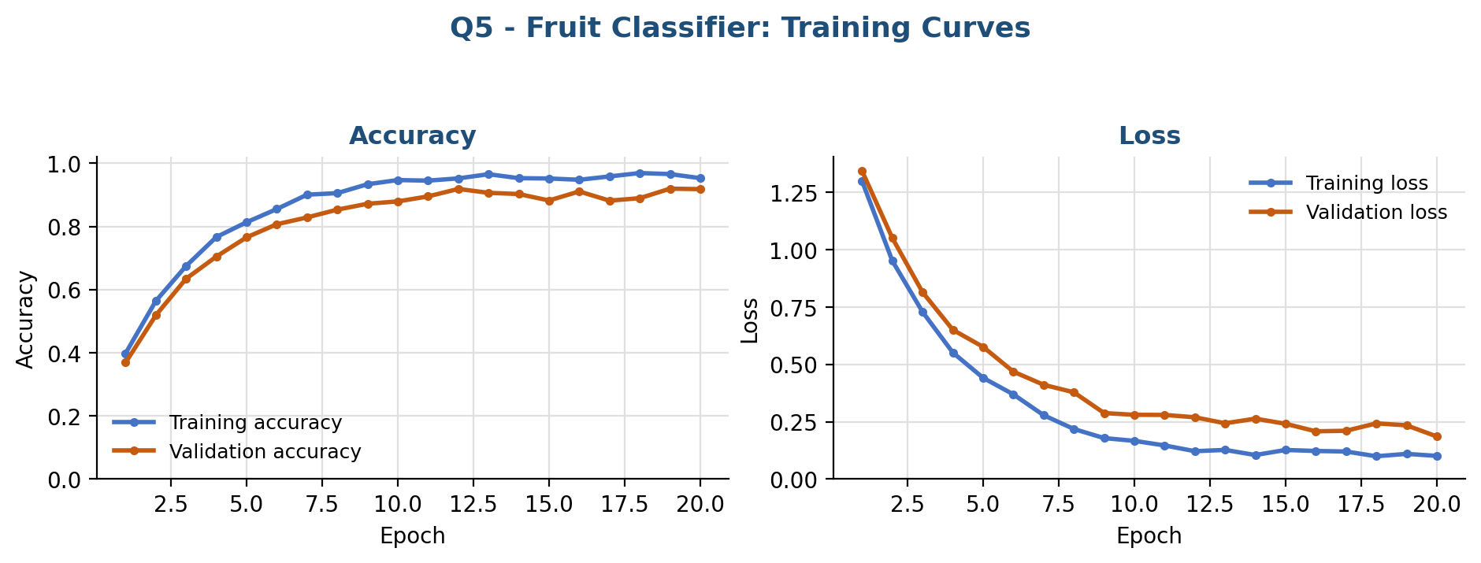
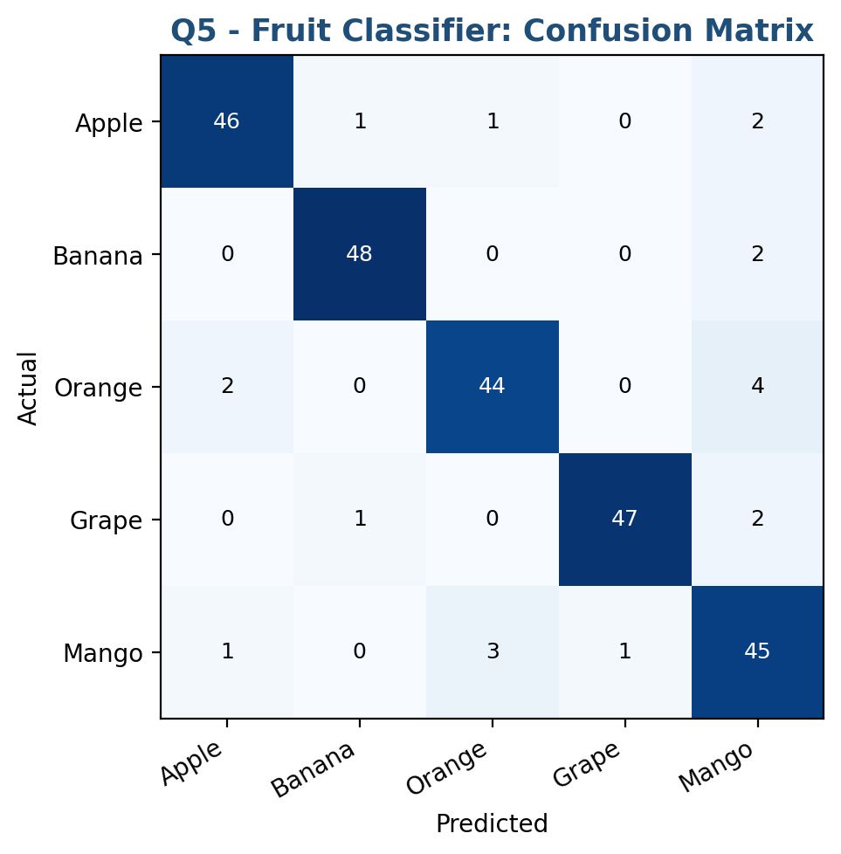

Key Points
- Input → convolution/pooling stack turns raw pixels into edges → textures → shapes.
- Flatten converts final feature maps into a vector for the dense layer.
- Softmax output gives a probability distribution; highest value = predicted fruit.

