

CO3–AT3 – COMPARATIVE ANALYSIS TASK

NAME:M.MANASA
REG NO:192425189
COURSE CODE: MLA0401
COURSE: DEEP LEARNING

CNN vs Traditional Neural Networks

A traditional Artificial Neural Network (ANN) mainly uses fully connected layers. A Convolutional Neural Network (CNN) is designed for image data and preserves spatial relationships while learning visual features automatically.
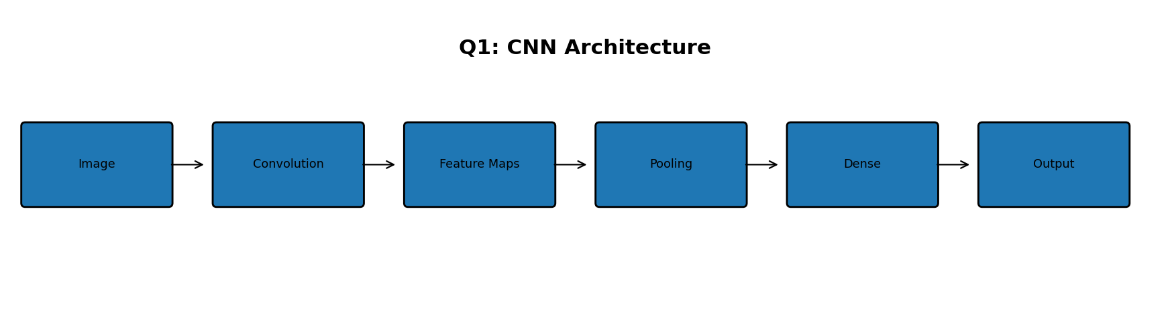

Working
- ANN: image pixels are commonly flattened before entering dense layers.
- CNN: convolution filters scan local image regions and learn edges, textures and shapes.
- Pooling reduces spatial dimensions and computation.
- Deeper CNN layers learn higher-level features before final classification.

Comparative Table
Aspect | Traditional ANN | CNN
Architecture | Mostly fully connected | Convolution + pooling + dense
Image structure | Often flattened | Spatial structure preserved
Feature extraction | More manual / less specialized | Automatically learned
Parameter sharing | Limited | Yes, filters are reused
Image computation | Can require many parameters | More efficient for images
Best suited for | Tabular/simple data | Images and spatial data
Applications | Simple classification, tabular prediction | Classification, detection, segmentation

Parameter Sharing
A CNN uses the same small filter at many image locations. For example, one 3×3 filter can detect an edge wherever that edge occurs. This greatly reduces parameters compared with connecting every pixel independently to many neurons.

Conclusion
CNNs are better suited to image processing because they learn spatial features, preserve local relationships and use parameter sharing.

2. AlexNet vs ResNet

AlexNet was a landmark CNN architecture that showed the power of deep learning for image recognition. ResNet later introduced residual connections, allowing much deeper CNNs to be trained effectively.
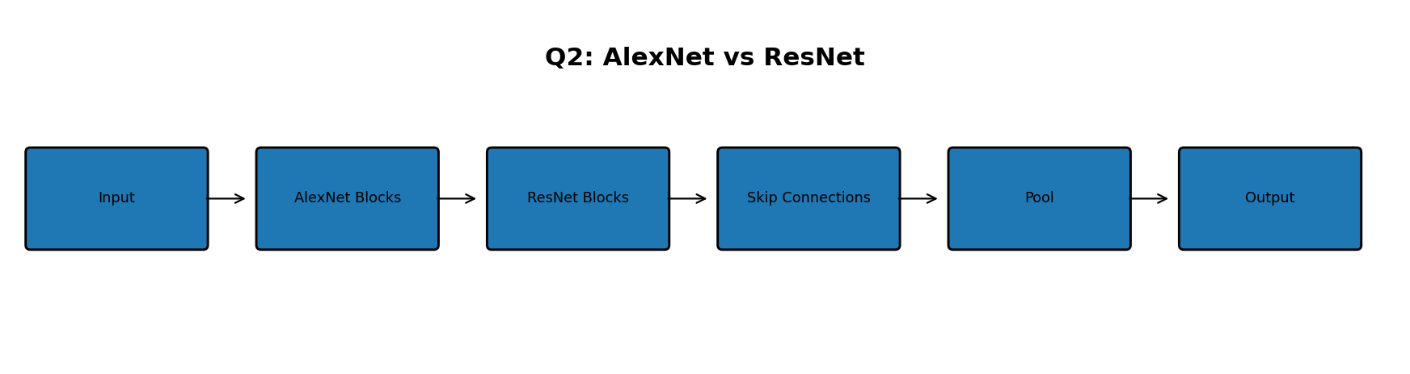

Comparative Table
Feature | AlexNet | ResNet
Year | 2012 | 2015
Depth | About 8 learnable layers | Common versions: 18–152 layers
Key idea | Deep CNN with ReLU, pooling and dropout | Residual/skip connections
Residual connections | No | Yes
Very deep training | More difficult | Much easier
Parameters | About 60 million | Depends on version; ResNet-50 ≈25.6 million
Classifier design | Uses large fully connected layers | Modern versions use global average pooling
Main strength | Historic breakthrough | Deep, trainable feature extraction

Residual Connection
A residual block learns F(x) and adds the original input x: H(x) = F(x) + x. The shortcut helps information and gradients pass through many layers, reducing degradation problems in very deep networks.

Architecture Comparison
AlexNet | ResNet
Input → Conv → ReLU → Pool → Conv → ReLU → Pool → Dense → Output | Input → Conv → Residual Blocks → Global Average Pool → Output
Ordinary stacked layers | Skip connections around blocks
Large dense classifier | More parameter-efficient modern classification head

Conclusion
AlexNet established deep CNNs as powerful image models, while ResNet made very deep networks easier to optimize through residual learning.

3. Max Pooling vs Average Pooling

Pooling reduces the spatial size of a feature map. It lowers computation and provides a compact representation of important features.
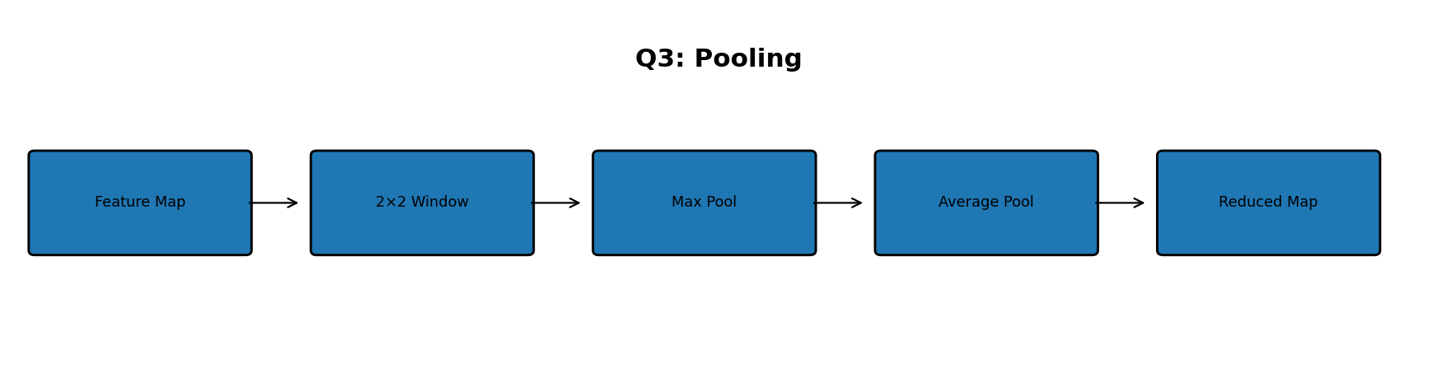

Example Feature Map
For the 4×4 feature map below, use a 2×2 window with stride 2:
4 | 2 |  | 1 |  | 3
5 | 6 |  | 2 |  | 4
7 | 3 |  | 8 |  | 1
2 | 9 |  | 4 |  | 6
Region |  | Max Pool |  | Average Pool
4,2,5,6 |  | 6 |  | 4.25
1,3,2,4 |  | 4 |  | 2.50
7,3,2,9 |  | 9 |  | 5.25
8,1,4,6 |  | 8 |  | 4.75
Max Pool output = [[6, 4], [9, 8]]. Average Pool output = [[4.25, 2.50], [5.25, 4.75]].

Comparative Table
Aspect | Max Pooling | Average Pooling
Operation | Select maximum | Calculate mean
Keeps | Strongest activation | Overall activation
Effect | Emphasizes salient features | Smooths/averages information
Advantage | Simple and effective for strong features | Retains overall response
Limitation | May discard useful values | May weaken strong features
Common use | Very common in CNNs | Useful when average response is meaningful

Conclusion
Max Pooling is useful when the strongest feature matters most, while Average Pooling summarizes the overall activation. Both reduce spatial dimensions.

4. CNN Regularization Techniques

Regularization reduces overfitting and improves generalization. Dropout, Batch Normalization and Data Augmentation work in different ways.
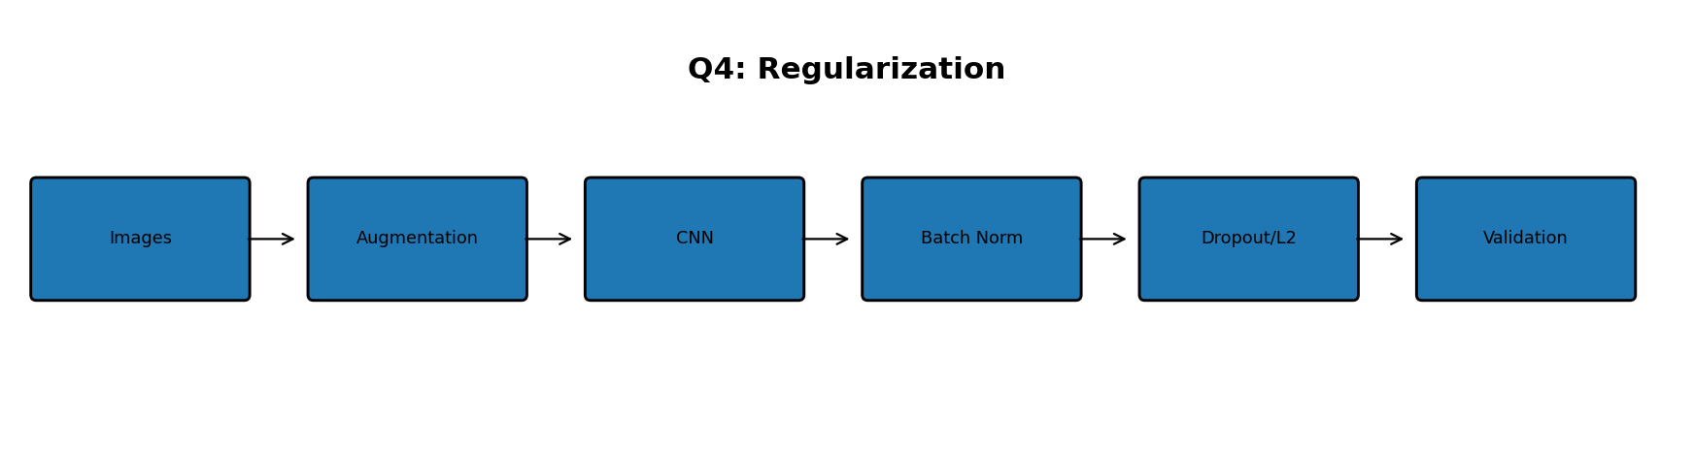

Working Principles
- Dropout randomly deactivates some neurons during training, preventing excessive dependence on particular neurons.
- Batch Normalization normalizes intermediate activations within mini-batches and uses learnable scale and shift parameters; it can stabilize training.
- Data Augmentation creates realistic variations such as small rotations, shifts, crops or flips to increase training diversity.

Comparative Table
Technique | Working | Advantages | Limitations
Dropout | Randomly disables neurons during training | Reduces co-adaptation and overfitting | Too much can hurt learning
Batch Normalization | Normalizes batch activations | Stable and often faster training | Depends on batch/statistical behavior
Data Augmentation | Creates realistic image variations | Improves diversity and generalization | Bad transformations can change labels
L2 Regularization | Penalizes large weights | Controls model complexity | Too much may underfit
Early Stopping | Stops when validation stops improving | Prevents unnecessary training | Needs validation monitoring

Which Technique?
Situation | Suitable Method | Reason
Small dataset | Data Augmentation | Adds realistic variation
Memorization/overfitting | Dropout or L2 | Adds regularization
Unstable training | Batch Normalization | Can stabilize optimization
Validation stops improving | Early Stopping | Prevents excessive training

Conclusion
Combining suitable regularization methods can reduce the gap between training and testing performance.

5. CNN Applications Analysis

CNNs are used for many vision tasks. The architecture should match the required output: classification for labels, detection for labels plus locations, and segmentation for pixel-level regions.
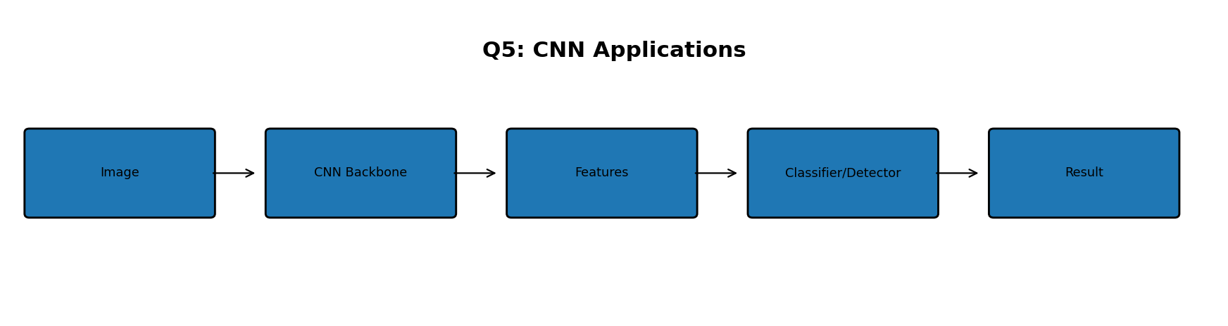

Application Comparison
Application | Task | Suitable CNN Approach | Major Challenges
Image Classification | Assign image class | CNN/ResNet/EfficientNet-style classifier | Class similarity, background variation
Object Detection | Find objects + locations | YOLO-style one-stage or Faster R-CNN-style two-stage detector | Small objects, occlusion, speed
Face Recognition | Match/identify faces | CNN feature embedding + classifier/matching | Pose, lighting, privacy
Medical Image Analysis | Classify/localize disease | CNN/ResNet transfer learning; segmentation when needed | Limited labels, imbalance, explainability
Autonomous Vehicles | Understand road scene | CNN backbone + detection/segmentation | Real-time speed, weather, safety

Explanation of Applications
- Image classification: CNN extracts global visual features and outputs class probabilities.
- Object detection: the model predicts both object category and bounding-box location.
- Face recognition: CNN learns a discriminative face representation that can be compared with enrolled identities.
- Medical analysis: CNNs can classify abnormalities; detection or segmentation is used when location or pixel-level regions are needed.
- Autonomous vehicles: CNN-based perception detects pedestrians, cars and signs and can segment road regions.

Classification vs Detection vs Segmentation
Task | Output | Example
Classification | Class label/probability | Apple
Object Detection | Bounding boxes + labels | Car + box
Segmentation | Pixel-level mask | Road/pedestrian pixels

Conclusion
CNNs provide the feature extraction foundation, but different applications need different heads and objectives. Detection and segmentation are especially important when location information is required.

Final Revision Table
Q | Comparison | Key Point
1 | CNN vs ANN | CNN preserves spatial information and shares filters.
2 | AlexNet vs ResNet | ResNet uses skip connections for deeper networks.
3 | Max vs Average Pooling | Max keeps the strongest value; Average computes the mean.
4 | Regularization methods | Dropout, BatchNorm and augmentation improve generalization differently.
5 | CNN applications | Classification, detection, recognition and segmentation have different outputs.
END OF CO3–AT3 ANSWERS

