NAME:MAMIDI MANASA
REG NO: 192425189
COURSE: COMPUTER VISION
COURSE CODE:ITA0512

- 28} A digital image has reduced contrast due to poor sensing conditions. Write a Python program to enhance a low-contrast image.
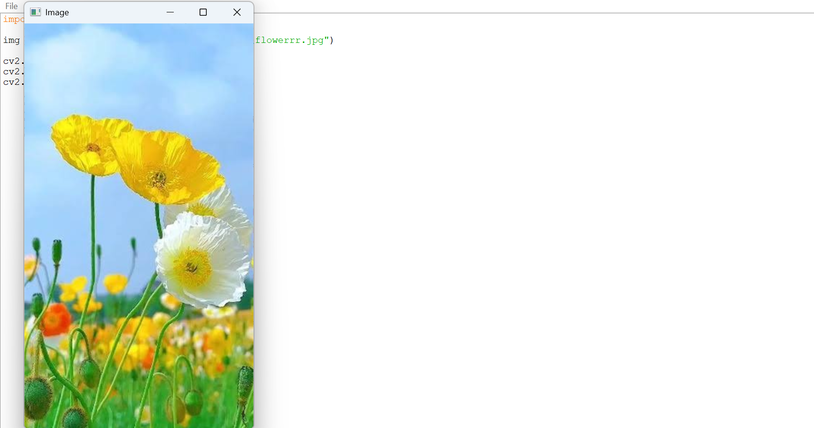

- 29}A machine vision system detects product defects. Write a Python program for defect detection.


- 30}A camera captures images with varying brightness levels. Write a Python program to adjust image brightness.

