How to import data from local machine to cloudera:

1. After we open cloudera goto

* Devices
* Shared folder
* Shared folder settings
* Machine folders then click add folder icon on right hand
* Copy the data path from your local machine
* Paste it in cloudera (Note\* : Do not forget folder name)
* After that select auto-mount and make permanent
* Click ok

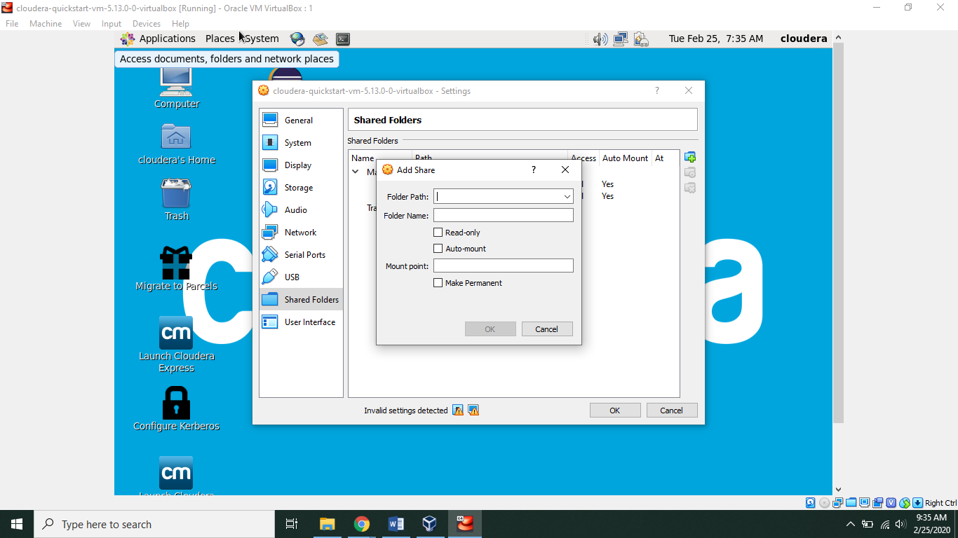

1. Now we have to open terminal in cloudera either by doing a right click on the screen or by clicking the terminal icon on top of screen

* Execute the commands given in image below
* Username : su
* Password : cloudera

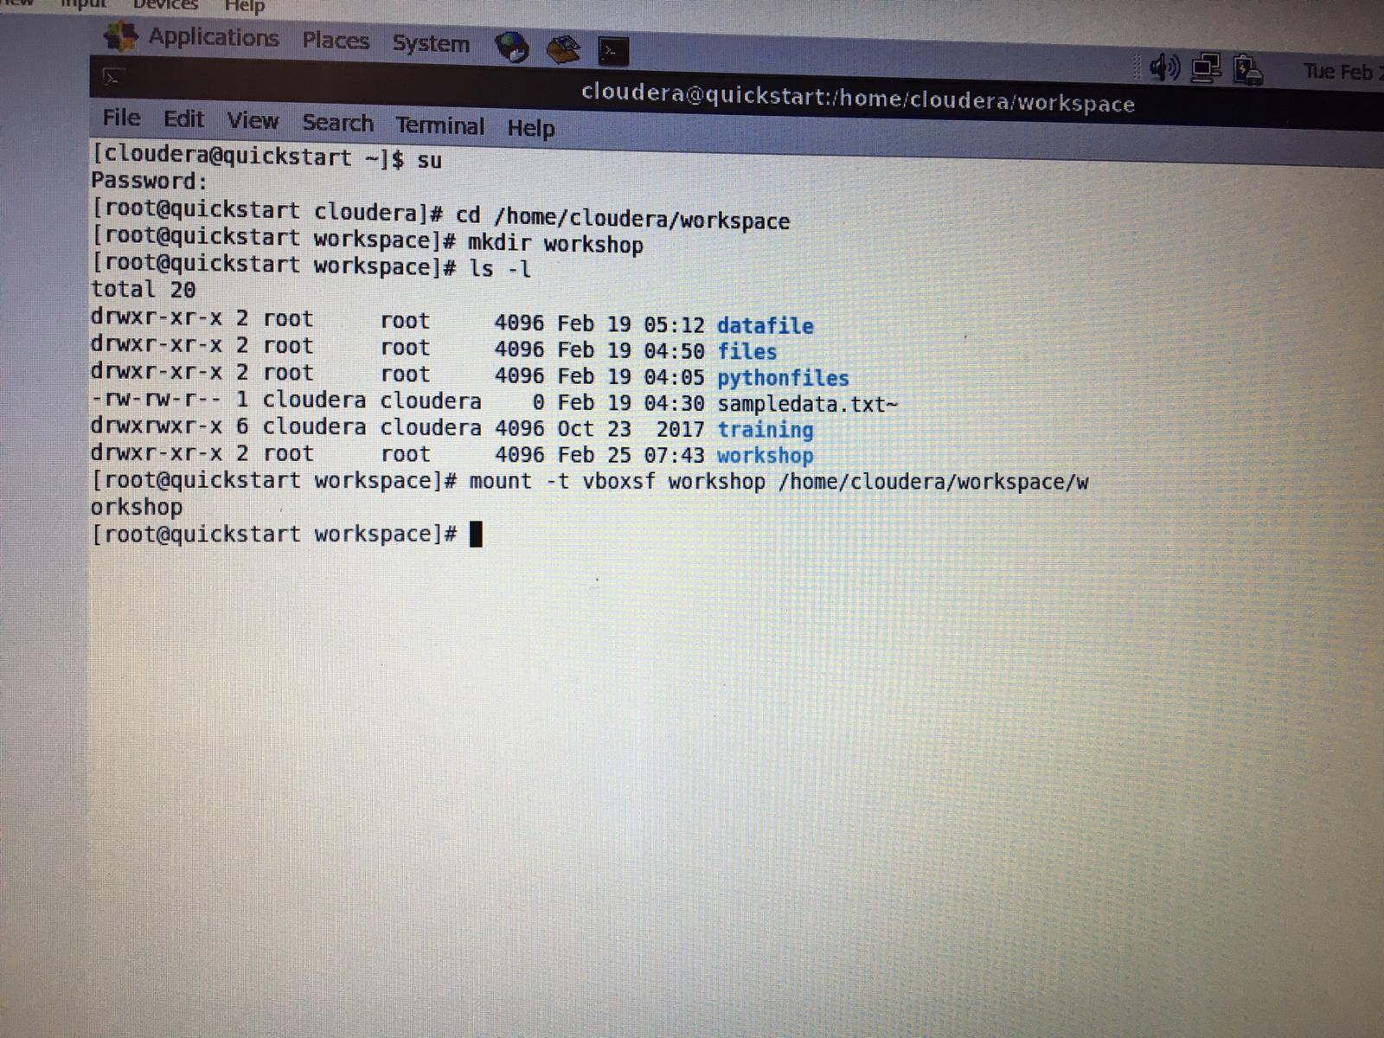

1. Now after we mount data , we have to load it into Hadoop

* Open new terminal execute following commands 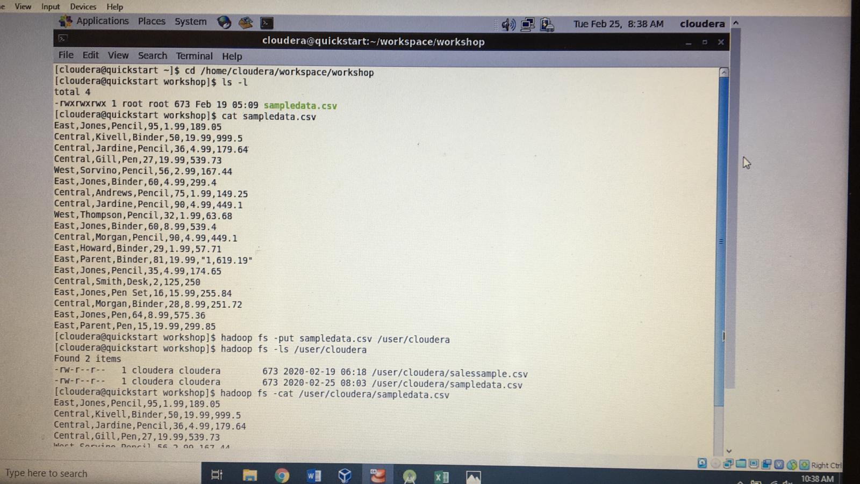

1. Now we have to open cloudera browser select hue present in taskbar.)

* If new user, both username and password is “cloudera”
* We can run our commands in hive terminal in hue or a command

Terminal.

* In this tutorial we use command prompt
* Execute the following commands

