Lab 5: Static Code Analysis
Pylint · Bandit · Flake8 on auction_system.py (Online Auction and Bidding System)

Field | Details
Name | Manasa K Yadav
SRN | PES1UG25CS824
Course | Software Engineering – Lab 5
Assigned repo | github.com/SETAPESU26/L5_65_auction-bidding
Submission repo | github.com/ManasaKYadav/SE-Labs-PES1UG25CS824 (folder LAB5)
Date | 30 October 2026

Tool | Before | After
Pylint score | 6.09 / 10 (33 messages) | 10.00 / 10 (0 messages)
Bandit issues | 3 (2 High, 1 Medium) | 0 – No issues identified
Flake8 warnings | 19 | 0

1. Introduction to Static Code Analysis
Static code analysis examines source code without executing it to find potential bugs, security vulnerabilities and style violations early in development, when they are cheapest to fix. Analysers parse the code and check it against rules for correctness, security and coding standards. In this lab three industry-standard Python tools were used:
Tool | Role | What it checks
Pylint | The strict code reviewer | Code quality and logical problems: naming conventions (PEP 8 snake_case), missing docstrings, broad exceptions, attributes defined outside __init__, unnecessary else, import order, design smells. Gives a score out of 10.
Flake8 | The grammar checker | PEP 8 style and formatting: blank lines between definitions, line length (79 chars), whitespace, trailing newlines, unused imports and syntax errors (pycodestyle + pyflakes).
Bandit | The app's security guard | Security vulnerabilities: insecure modules/imports, injection and XSS risks, unsafe template settings, hard-coded secrets. Reports each issue with a severity and confidence (Low / Medium / High).

1.1 Program under analysis
auction_system.py is an online auction and bidding system. An Auction class tracks reserve prices and closing times; the program accepts bids, picks the winner and final price (with a 5% buyer's premium), lists top bidders, renders HTML listings and bidder badges, exports bids as JSON and calls an XML-RPC payment gateway to charge the winner.

1.2 Procedure
- Created a virtual environment and installed the tools: python -m pip install pylint bandit flake8 jinja2 defusedxml
- Ran the original program and read its output to spot wrong behaviour.
- Ran the three tools and saved the reports (pylint_report_before.txt, bandit_report_before.txt, flake8_report_before.txt).
- Documented the issues, fixed them in three commits (Bandit, then Pylint + logic bugs, then Flake8), and re-ran the tools to produce the _after reports.
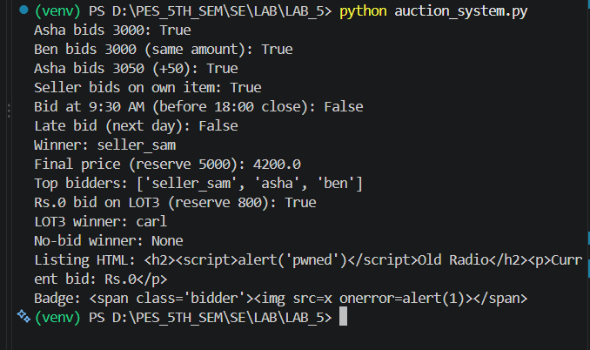
Figure 1 – Output of the original program. Equal and +50 bids, a seller bid and a Rs.0 bid are accepted, a valid 9:30 bid is rejected, the winner is chosen below the reserve, and the HTML output contains unescaped <script> / <img onerror> payloads.

2. Issues Identified Before Fixing
The tools were run on the original file. Pylint rated the code 6.09/10, Bandit found 3 security issues (2 High, 1 Medium) and Flake8 reported 19 style violations.
[ Paste screenshot here: Pylint output BEFORE fixing (score 6.09/10) ]
Command: python -m pylint auction_system.py
Figure 2 – Pylint before fixing: 33 messages, score 6.09/10.
[ Paste screenshot here: Bandit output BEFORE fixing (B411, B701, B704) ]
Command: python -m bandit -r auction_system.py
Figure 3 – Bandit before fixing: B411 (High), B701 (High), B704 (Medium).
[ Paste screenshot here: Flake8 output BEFORE fixing (19 lines) ]
Command: python -m flake8 auction_system.py
Figure 4 – Flake8 before fixing: E302 ×10, E501 ×8, E305 ×1.

3. Issue Identification Table
High and medium severity issues are listed first. Rows marked Bug are logic errors found by reading the program output – none of the three tools reported them.
Issue | Type | Line(s) | Description | Fix Approach
Insecure XML-RPC import (B411) | Security – High | 5, 73 | xmlrpc.client is vulnerable to XML attacks (e.g. entity expansion) when parsing untrusted responses | Import defusedxml.xmlrpc, call monkey_patch() and create the ServerProxy through defusedxml.xmlrpc.xmlrpc_client
Jinja2 autoescape disabled (B701) | Security – High | 65 | autoescape=False lets the <script> in an auction title reach the HTML unescaped (XSS) | Environment(autoescape=True)
Unsafe Markup (B704) | Security – Medium | 70 | Bidder name concatenated into Markup(), so attacker HTML is trusted (XSS) | Markup("<span ...>{}</span>").format(name) – format() escapes the argument
String time comparison | Bug – High | 22 | Times compared as strings: "2026-12-01 9:30" > "2026-12-01 18:00", so a valid morning bid is rejected | Parse times with datetime.strptime and compare datetimes
Reserve price ignored | Bug – High | 32–38 | winner() and finalPrice() return a winner/price even when the highest bid is below the reserve | Return None if highest < reserve_price
Equal / too-small bids accepted | Bug – Medium | 24 | >= accepts equal bids; MIN_INCREMENT is defined but never used | Require amount >= highest + MIN_INCREMENT
Seller bids on own item | Bug – Medium | 21–30 | Allows shill bidding by the seller | Reject bids where bidder == seller
Rs.0 bid accepted | Bug – Medium | 19, 24 | highest starts at 0, so a 0 bid is accepted and wins | Reject amount <= 0
Broad exception raised / caught (W0719, W0718) | Pylint – Warning | 23, 50 | Generic Exception is raised and caught, hiding real errors such as a wrong item id | Custom AuctionClosedError; bid() catches only KeyError and AuctionClosedError
Attribute defined outside __init__ (W0201), too many attributes (R0902) | Pylint – Warning | 11, 27 | leader does not exist until the first bid; class had 8 attributes | highest and leader became @property values computed from bids
Naming, docstrings, imports (C0103, C0114–C0116, C0411, R0205, R1705, R1724) | Pylint – Convention | many | camelCase names, no docstrings, stdlib imports after third-party, class Auction(object), unnecessary else | snake_case names, docstrings everywhere, stdlib imports first, class Auction:, else removed
Blank lines / long lines (E302, E305, E501) | Flake8 – Style | many | Only 1 blank line between top-level definitions; lines over 79 characters | 2 blank lines between definitions; long lines wrapped

4. Before and After Outputs of the Tools
Report file | Before fixing | After fixing
pylint_report_*.txt | 33 messages – rated 6.09/10 | No messages – rated 10.00/10
bandit_report_*.txt | 3 issues: B411 High, B701 High, B704 Medium | No issues identified (0 High, 0 Medium, 0 Low)
flake8_report_*.txt | 19 lines: E302 ×10, E501 ×8, E305 ×1 | Empty – no violations

The complete contents of all six report files follow.

pylint_report_before.txt
************* Module auction_system
auction_system.py:90:0: C0301: Line too long (109/100) (line-too-long)
auction_system.py:1:0: C0114: Missing module docstring (missing-module-docstring)
auction_system.py:11:0: C0115: Missing class docstring (missing-class-docstring)
auction_system.py:11:0: R0205: Class 'Auction' inherits from object, can be safely removed from bases in python3 (useless-object-inheritance)
auction_system.py:11:0: R0902: Too many instance attributes (8/7) (too-many-instance-attributes)
auction_system.py:21:4: C0116: Missing function or method docstring (missing-function-docstring)
auction_system.py:21:4: C0103: Method name "placeBid" doesn't conform to snake_case naming style (invalid-name)
auction_system.py:23:12: W0719: Raising too general exception: Exception (broad-exception-raised)
auction_system.py:24:8: R1705: Unnecessary "else" after "return", remove the "else" and de-indent the code inside it (no-else-return)
auction_system.py:32:4: C0116: Missing function or method docstring (missing-function-docstring)
auction_system.py:37:4: C0116: Missing function or method docstring (missing-function-docstring)
auction_system.py:37:4: C0103: Method name "finalPrice" doesn't conform to snake_case naming style (invalid-name)
auction_system.py:27:12: W0201: Attribute 'leader' defined outside __init__ (attribute-defined-outside-init)
auction_system.py:43:0: C0116: Missing function or method docstring (missing-function-docstring)
auction_system.py:43:0: C0103: Function name "createAuction" doesn't conform to snake_case naming style (invalid-name)
auction_system.py:47:0: C0116: Missing function or method docstring (missing-function-docstring)
auction_system.py:50:11: W0718: Catching too general exception Exception (broad-exception-caught)
auction_system.py:53:0: C0116: Missing function or method docstring (missing-function-docstring)
auction_system.py:53:0: C0103: Function name "topBidders" doesn't conform to snake_case naming style (invalid-name)
auction_system.py:58:8: R1724: Unnecessary "else" after "continue", remove the "else" and de-indent the code inside it (no-else-continue)
auction_system.py:64:0: C0116: Missing function or method docstring (missing-function-docstring)
auction_system.py:64:0: C0103: Function name "renderListing" doesn't conform to snake_case naming style (invalid-name)
auction_system.py:69:0: C0116: Missing function or method docstring (missing-function-docstring)
auction_system.py:69:0: C0103: Function name "bidderBadge" doesn't conform to snake_case naming style (invalid-name)
auction_system.py:72:0: C0116: Missing function or method docstring (missing-function-docstring)
auction_system.py:72:0: C0103: Function name "chargeWinner" doesn't conform to snake_case naming style (invalid-name)
auction_system.py:77:0: C0103: Function name "exportBids" doesn't conform to snake_case naming style (invalid-name)
auction_system.py:83:0: C0116: Missing function or method docstring (missing-function-docstring)
auction_system.py:83:0: C0103: Function name "secondsLeft" doesn't conform to snake_case naming style (invalid-name)
auction_system.py:88:0: C0116: Missing function or method docstring (missing-function-docstring)
auction_system.py:3:0: C0411: standard import "time" should be placed before third party imports "jinja2.Environment", "markupsafe.Markup" (wrong-import-order)
auction_system.py:4:0: C0411: standard import "json" should be placed before third party imports "jinja2.Environment", "markupsafe.Markup" (wrong-import-order)
auction_system.py:5:0: C0411: standard import "xmlrpc.client" should be placed before third party imports "jinja2.Environment", "markupsafe.Markup" (wrong-import-order)
auction_system.py:6:0: C0411: standard import "datetime.datetime" should be placed before third party imports "jinja2.Environment", "markupsafe.Markup" (wrong-import-order)

-----------------------------------
Your code has been rated at 6.09/10

pylint_report_after.txt

-------------------------------------------------------------------
Your code has been rated at 10.00/10 (previous run: 9.89/10, +0.11)

bandit_report_before.txt
Run started:2026-10-30 16:55:10.734347+00:00

Test results:
>> Issue: [B411:blacklist] Using xmlrpc.client to parse untrusted XML data is known to be vulnerable to XML attacks. Use defusedxml.xmlrpc.monkey_patch() function to monkey-patch xmlrpclib and mitigate XML vulnerabilities.
Severity: High Confidence: High
CWE: CWE-20 (https://cwe.mitre.org/data/definitions/20.html)
More Info: https://bandit.readthedocs.io/en/1.9.4/blacklists/blacklist_imports.html#b411-import-xmlrpclib
Location: .\auction_system.py:5:0
4 import json
5 import xmlrpc.client
6 from datetime import datetime

--------------------------------------------------
>> Issue: [B701:jinja2_autoescape_false] Using jinja2 templates with autoescape=False is dangerous and can lead to XSS. Use autoescape=True or use the select_autoescape function to mitigate XSS vulnerabilities.
Severity: High Confidence: High
CWE: CWE-94 (https://cwe.mitre.org/data/definitions/94.html)
More Info: https://bandit.readthedocs.io/en/1.9.4/plugins/b701_jinja2_autoescape_false.html
Location: .\auction_system.py:65:10
64 def renderListing(item_id):
65 env = Environment(autoescape=False)
66 template = env.from_string("<h2>{{ a.title }}</h2><p>Current bid: Rs.{{ a.highest }}</p>")

--------------------------------------------------
>> Issue: [B704:markupsafe_markup_xss] Potential XSS with ``markupsafe.Markup`` detected. Do not use ``Markup`` on untrusted data.
Severity: Medium Confidence: High
CWE: CWE-79 (https://cwe.mitre.org/data/definitions/79.html)
More Info: https://bandit.readthedocs.io/en/1.9.4/plugins/b704_markupsafe_markup_xss.html
Location: .\auction_system.py:70:11
69 def bidderBadge(name):
70 return Markup("<span class='bidder'>" + name + "</span>")
71

--------------------------------------------------

Code scanned:
Total lines of code: 90
Total lines skipped (#nosec): 0
Total potential issues skipped due to specifically being disabled (e.g., #nosec BXXX): 0

Run metrics:
Total issues (by severity):
Undefined: 0
Low: 0
Medium: 1
High: 2
Total issues (by confidence):
Undefined: 0
Low: 0
Medium: 0
High: 3
Files skipped (0):

bandit_report_after.txt
Run started:2026-10-30 17:28:54.897090+00:00

Test results:
No issues identified.

Code scanned:
Total lines of code: 132
Total lines skipped (#nosec): 0
Total potential issues skipped due to specifically being disabled (e.g., #nosec BXXX): 0

Run metrics:
Total issues (by severity):
Undefined: 0
Low: 0
Medium: 0
High: 0
Total issues (by confidence):
Undefined: 0
Low: 0
Medium: 0
High: 0
Files skipped (0):

flake8_report_before.txt
auction_system.py:11:1: E302 expected 2 blank lines, found 1
auction_system.py:43:1: E302 expected 2 blank lines, found 1
auction_system.py:47:1: E302 expected 2 blank lines, found 1
auction_system.py:53:1: E302 expected 2 blank lines, found 1
auction_system.py:64:1: E302 expected 2 blank lines, found 1
auction_system.py:66:80: E501 line too long (94 > 79 characters)
auction_system.py:69:1: E302 expected 2 blank lines, found 1
auction_system.py:72:1: E302 expected 2 blank lines, found 1
auction_system.py:77:1: E302 expected 2 blank lines, found 1
auction_system.py:83:1: E302 expected 2 blank lines, found 1
auction_system.py:88:1: E302 expected 2 blank lines, found 1
auction_system.py:89:80: E501 line too long (83 > 79 characters)
auction_system.py:90:80: E501 line too long (109 > 79 characters)
auction_system.py:93:80: E501 line too long (87 > 79 characters)
auction_system.py:94:80: E501 line too long (81 > 79 characters)
auction_system.py:95:80: E501 line too long (90 > 79 characters)
auction_system.py:96:80: E501 line too long (94 > 79 characters)
auction_system.py:101:80: E501 line too long (88 > 79 characters)
auction_system.py:107:1: E305 expected 2 blank lines after class or function definition, found 1

flake8_report_after.txt
(empty file: Flake8 reported no issues)

5. Results After Fixing the Issues
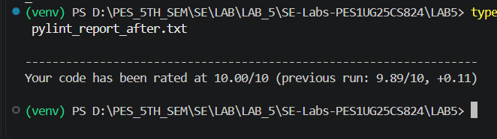
Figure 5 – Pylint after fixing: 10.00/10.
[ Paste screenshot here: Bandit output AFTER fixing (No issues identified) ]
Command: python -m bandit -r auction_system.py
Figure 6 – Bandit after fixing: No issues identified.
[ Paste screenshot here: Flake8 output AFTER fixing (no output = no issues) ]
Command: python -m flake8 auction_system.py
Figure 7 – Flake8 after fixing: no violations.
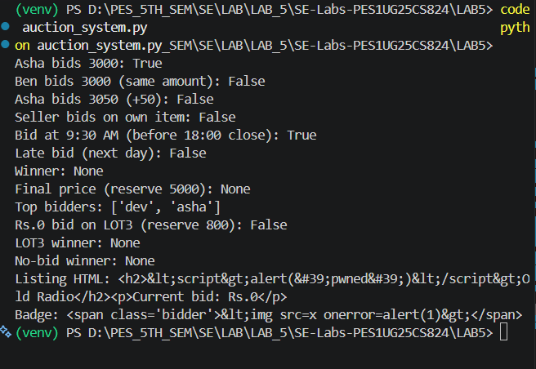
Figure 8 – Program output after fixing: invalid bids are rejected, the 9:30 bid is accepted, no winner below the reserve, and the HTML is escaped.

5.1 Key code changes
Before | After
import xmlrpc.client | import defusedxml.xmlrpc  defusedxml.xmlrpc.monkey_patch()
Environment(autoescape=False) | Environment(autoescape=True)
Markup("<span class='bidder'>" + name + "</span>") | Markup("<span class='bidder'>{}</span>").format(name)
if at > self.ends_at: | if parse_time(at) > self.ends_at:
if amount >= self.highest: | if bidder == self.seller or amount <= 0: return False  if self.bids and amount < self.highest + MIN_INCREMENT: return False
raise Exception("Auction closed")  except Exception: | raise AuctionClosedError("Auction closed")  except (KeyError, AuctionClosedError):
return self.leader | if not self.bids or self.highest < self.reserve_price: return None
main() | if __name__ == "__main__":  main()

5.2 Commit history (LAB5)
- Add original Lab 5 auction_system.py
- Add static analysis reports before fixes
- Fix Bandit security issues (B411, B701, B704)
- Fix Pylint issues and logic bugs
- Fix Flake8 style issues and document findings
- Add Lab 5 reflection; add final newline (Pylint 10.00, Flake8 clean); add screenshots

6. Reflection

Q1. Which issues were the easiest to fix, and which were the hardest? Why?
The easiest were the Flake8 style warnings (E302/E305 blank lines and E501 long lines) and Bandit's B701: they were purely mechanical – adding blank lines, wrapping long lines and changing autoescape=False to autoescape=True in one place. Pylint's naming (camelCase to snake_case) and missing-docstring warnings were also simple, though every call to the renamed functions had to be updated.
The hardest was B411 (insecure xmlrpc.client). Adding defusedxml.xmlrpc.monkey_patch() alone did not clear the warning, because Bandit flags the import itself, so the import and the ServerProxy had to be switched to defusedxml.xmlrpc. The logic bugs were harder still, because no tool reported them. They were found only by reading the program output: times compared as strings (a valid 9:30 bid was rejected), the reserve price ignored, equal and +50 bids accepted although MIN_INCREMENT was defined, a seller bidding on their own item, and a Rs.0 bid being accepted.

Q2. Did the static analysis tools report any false positives? If so, describe one example.
Partly. Bandit's B411 is arguably a false positive here: the payment gateway URL is a fixed, trusted server, yet Bandit flags any use of xmlrpc.client regardless of context. It was still fixed, because defusedxml costs little and protects against a compromised or spoofed server. Some Pylint messages were style preferences rather than defects, e.g. R0902 (too many instance attributes, 8/7) and missing docstrings – the code worked despite them. The tools also had false negatives: none of them detected the logic bugs, which were the most serious problems in the program.

Q3. How would you integrate static analysis tools into your actual software development workflow?
- Local development: run Flake8 and Pylint inside the editor (VS Code extensions) so issues appear while typing, and use a pre-commit hook that runs Flake8, Pylint and Bandit before each commit.
- Continuous Integration: a GitHub Actions workflow runs all three tools on every push and pull request, and fails the build if Bandit reports a High-severity issue, Flake8 reports any error, or the Pylint score drops below 9.5.
- Shared configuration: keep settings (line length, disabled checks) in setup.cfg or .pylintrc so the whole team uses the same rules.
- Complementary practices: because the tools cannot catch logic errors, combine them with unit tests and code review.

Q4. What tangible improvements did you observe in the code quality, readability, or potential robustness after applying the fixes?
- Scores: Pylint went from 6.09/10 to 10.00/10, Bandit from 3 issues (2 High, 1 Medium) to none, and Flake8 from 19 warnings to 0.
- Security: auction titles and bidder names are HTML-escaped, so the <script> and <img onerror> XSS payloads no longer run, and XML-RPC responses are parsed safely with defusedxml.
- Robustness: a custom AuctionClosedError replaced the generic raise/except Exception, so unrelated errors are no longer silently hidden; highest and leader are properties, so leader can never be undefined.
- Correctness: bids must beat the highest by MIN_INCREMENT, sellers cannot bid on their own items, zero bids are rejected, times are compared as real datetimes, and no winner or price is returned when the reserve is not met.
- Readability: snake_case names, docstrings on every function, grouped imports and an if __name__ == "__main__" guard make the code easier to read and safe to import.

Conclusion. Static analysis quickly found the style, quality and security problems in the program and gave a measurable way to confirm the fixes. It does not replace testing: the most serious defects here were logic errors that only careful reading and running of the program revealed.

