ShopNest Store – Power BI Dashboard Analysis

Manasa(Data & Analytics)

1. Introduction:
The ShopNest Store Power BI Capstone project focuses on analyzing e-commerce sales, delivery performance, customer behaviour, and revenue trends using multiple datasets. The objective of this project is to design an interactive Power BI dashboard that provides meaningful business insights through effective data modeling, DAX calculations, and visual analytics.
The dashboard integrates sales, orders, customers, reviews, payments, and time-based data to support data-driven decision making for ShopNest Store.

2. Data Overview
The project utilises multiple datasets, using star-schema approach with orders items table as centre table.
- Orders
- Order Items
- Customers
- Sellers
- Payments
- Order Reviews
- Products
- Product Category Translation
- Date Table (created using DAX)

3. Dashboard Design Overview
- A single-page interactive dashboard was created in Power BI.
- Visuals include bar charts, line charts, donut charts and clustered column charts
- Slicers were added for Year, Category, and State.
Below is the complete analysis of the eight tasks, including detailed explanations and visual snapshots.

3. DAX Measures:
We have created certain Measures to achieve the required solutions.
- Delayed Orders at order items level.
- Total Sales at order items level.
- Payment Count at order Payement level.
- Average rating at order review level
- on time orders and total orders at order level

Task 1: Top Categories by Revenue
Identify and visually represent the top 10 product categories by total sales.
Visualisation: Bar Chart to top 10 products by total sales
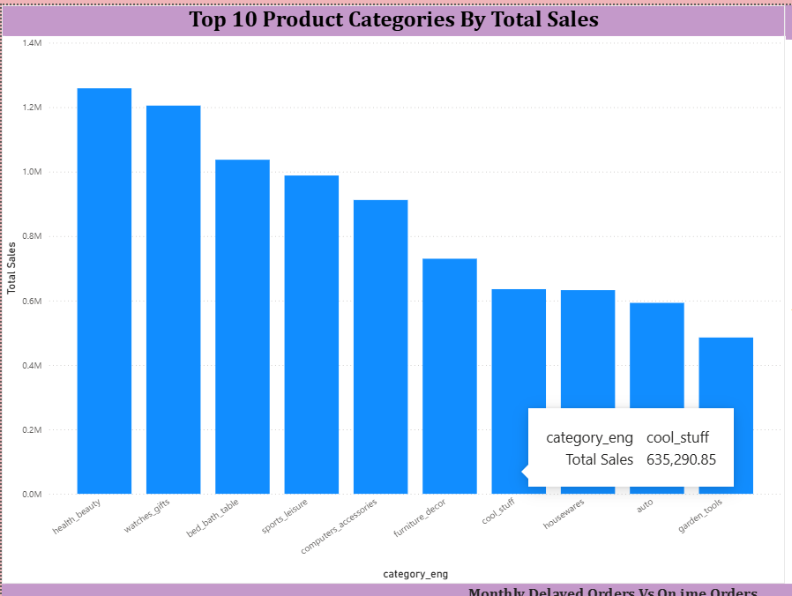

Explanation:
This visualisation highlights the top-performing product categories based on total sales value. The results show that a limited number of categories contribute significantly to overall revenue, indicating key revenue drivers for the business. This insight can help prioritise inventory planning and marketing efforts.
A new measure named Total Sales was created in the Order Items table using the following DAX formula:
Total Sales = SUM(Nexusgoods_order_items_Lookup[Price])
This measure calculates the total revenue generated from product sales.

Task 2. Delayed Orders Analysis
Determine the number of delayed orders in each category.
Visualisation – Clustered Bar Chart
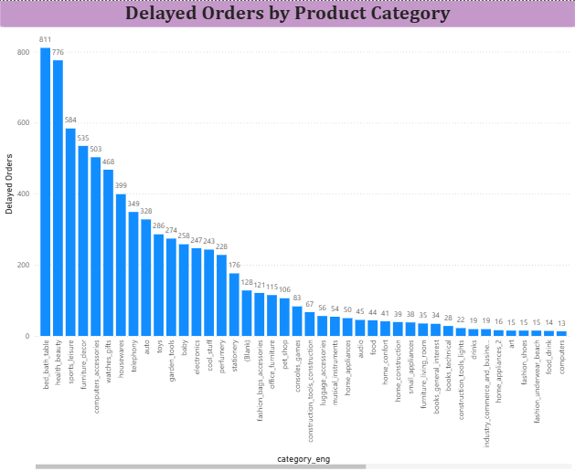
Explanation:
An order was classified as delayed when the actual delivery date exceeded the estimated delivery date. The chart reveals that certain categories experience higher delivery delays. To Achieve this We need to create 2 columns as Delayed orders and On Time orders and 1 Measure Is Delayed so that we can compare the data.
A calculated column was created to determine delivery delay:
Delivery Delay = IF(Orders[Actual Delivery Date] > Orders[Estimated Delivery Date], "Delayed", "On Time")
This allows us to measure delay frequency across product categories and regions.
A dedicated Date table was created using DAX to enable accurate time-based analysis such as monthly, quarterly, and yearly trends. This approach ensures consistent date filtering, correct month sorting, and reliable trend analysis across all visuals. The Date table was linked to the order purchase date and marked as the official date table for the model.

Task 3: Monthly Comparison of Delayed and On-Time Orders
Compare delayed orders with on-time orders on a monthly basis using drill through analysis.
Visualisation: Stacked Column Chart – Monthly Delayed vs On-Time Orders
And Also used drill through cross report feature in this visual.
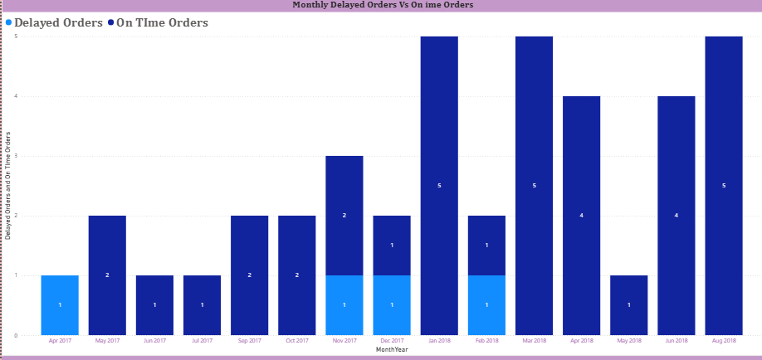
Explanation:
The stacked column chart compares delayed and on-time orders across months, revealing delivery performance trends. Drillthrough functionality allows users to right-click on any month and view detailed order-level delivery information, enabling deeper analysis of delivery issues and performance consistency.

Task 4: Payment Method Analysis
Analyse the most frequently used payment methods by customers.
Visualisation: Donut Chart – Payment Method Distribution
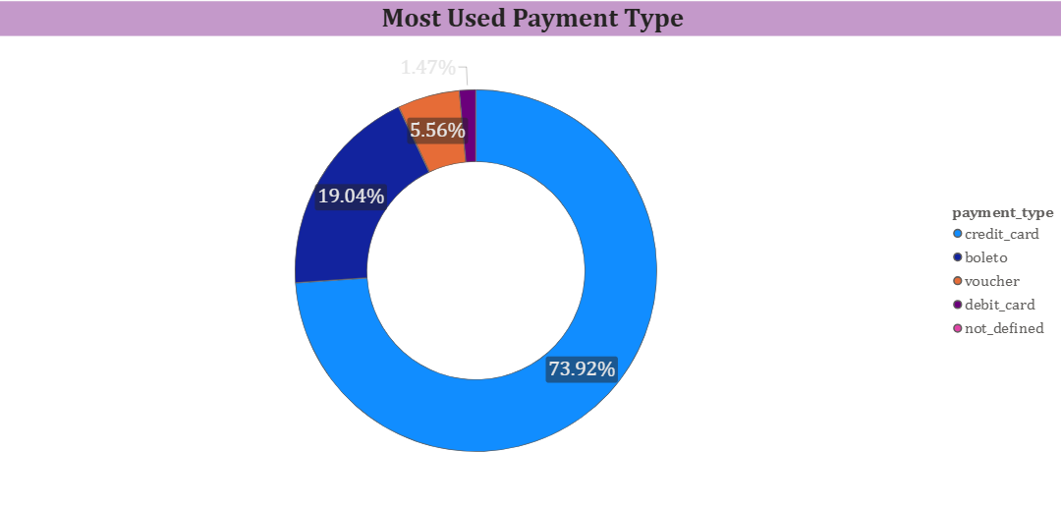

Explanation:
The donut chart illustrates customer payment preferences. Credit card is the dominant payment method, accounting for the majority of transactions. This suggests customers prefer instalment based or card-based payments. Marketing strategies can focus on card-based promotions.

Task 5: Product Rating Analysis.
Identify the top 10 highest-rated and bottom 10 lowest-rated products.

Visualisation: Bar Chart – Top 10 Highest-Rated Products.
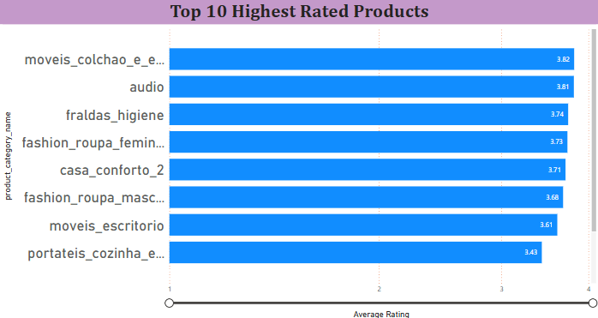
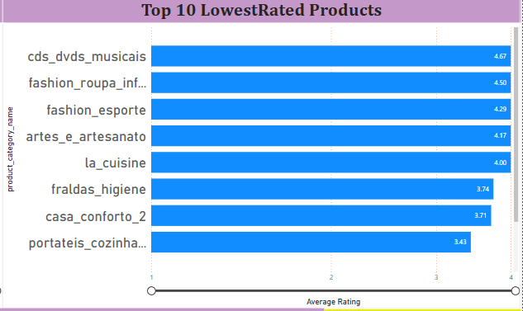

Explanation:
The analysis highlights products with the highest and lowest customer satisfaction levels. Multiple products share identical low ratings due to tied review scores. Including review counts provides additional context regarding rating reliability and customer sentiment.
I have used two charts to show the difference in the highest and lowest data.

Task 6: State-wise Sales Analysis.
Identify states with high and low sales to understand regional sales performance.

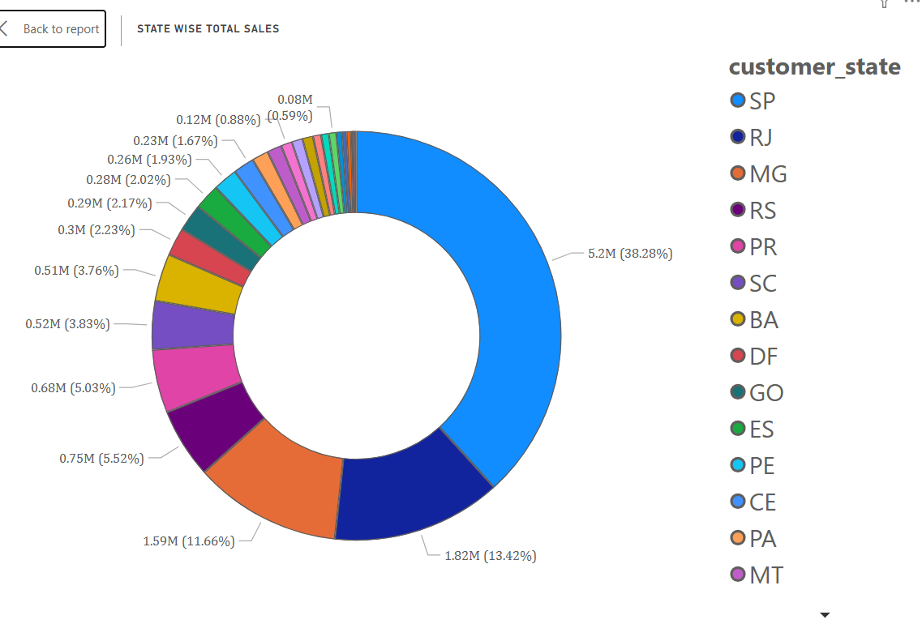
Visualisation: Bar Chart – State-wise Sales Performance.
Explanation:
This visualisation shows significant variation in sales across states. A small number of states contribute a large share of total revenue, while others show lower performance. These insights can support region-specific marketing and logistics strategies.
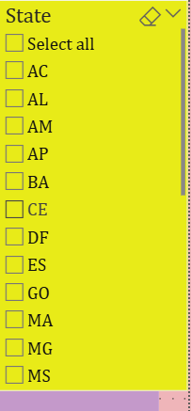
I have Created 3 slicers to see state wise analysis ,Product wise analysis and year wise analysis for better understanding.
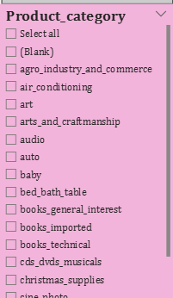
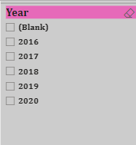

Task 7: Seasonal Sales Patterns:
Investigate and visualise seasonal sales patterns on a quarterly basis.

Visualisation:Line Chart – Quarterly Sales Trend.
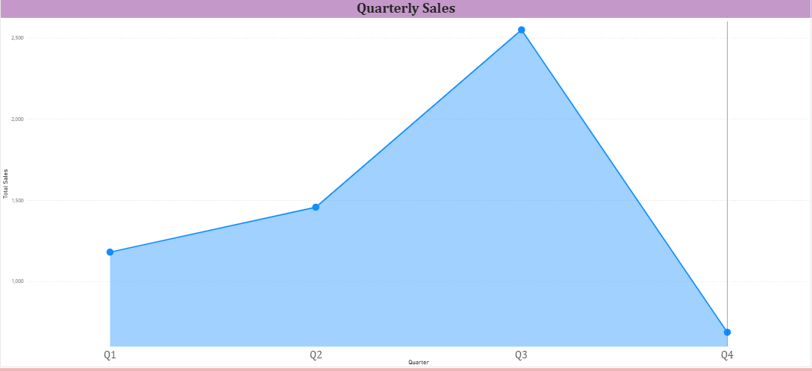

Explanation:
The quarterly sales trend reveals seasonal fluctuations throughout the year. Certain quarters consistently show higher sales, indicating predictable demand cycles. Understanding these patterns supports inventory planning and seasonal promotions.

Task 8: Revenue Analysis.
Determine the total revenue generated by ShopNest Store and analyze yearly trends.

Visualisation: Line Chart – Yearly Revenue Growth
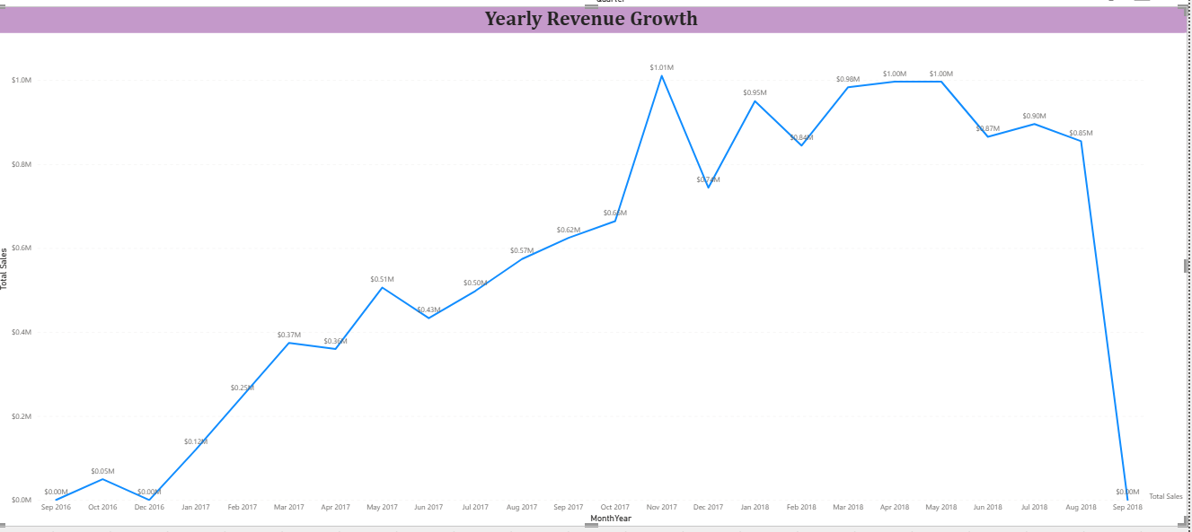

Explanation:
The yearly revenue analysis demonstrates a clear upward trend in total sales, indicating business growth over time. Data labels and a zero-based axis were applied to ensure precise and accurate representation of revenue trends.

5.Data Model Diagram:
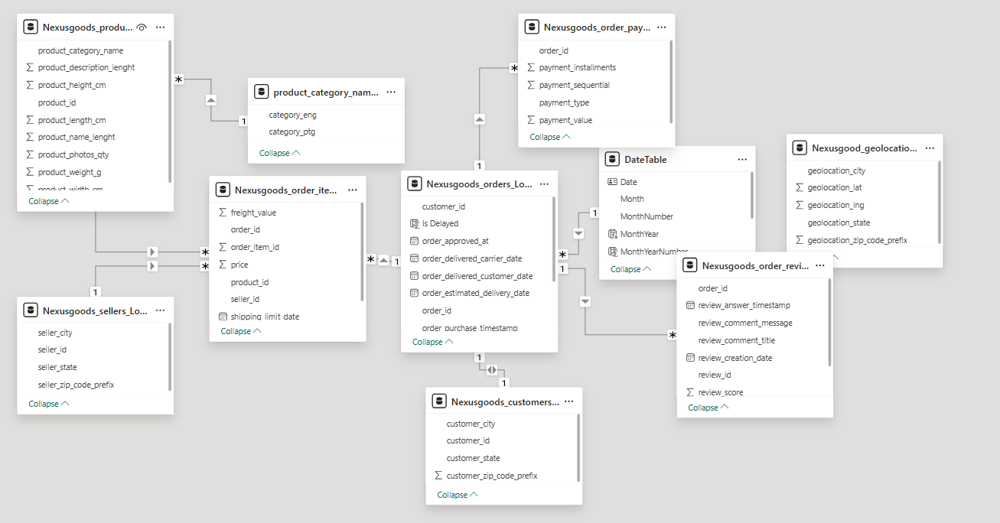

6. Conclusion
The ShopNest Power BI dashboard successfully provides actionable insights into sales performance, customer behavior, and delivery efficiency.
The analysis reveals that revenue is concentrated in a few product categories, delivery delays impact customer satisfaction, and seasonal sales trends influence overall profitability.
The dashboard enables management to make data-driven decisions regarding inventory, marketing strategy, and operational improvements.

