**BUBBLE SMASH GAME**

**Project Plan (Team # 9)**

**Schedule for four different increments:**

**Increment - 1:**

* Creation of Login Activity by using social media and Bubble tap Activity with single bubble at a time and displaying score on every tap on the bubble.
* Displaying scoreboard by counting number of bubbles tap.
* Creating UML Diagrams, Wireframes and user stories for every activity.

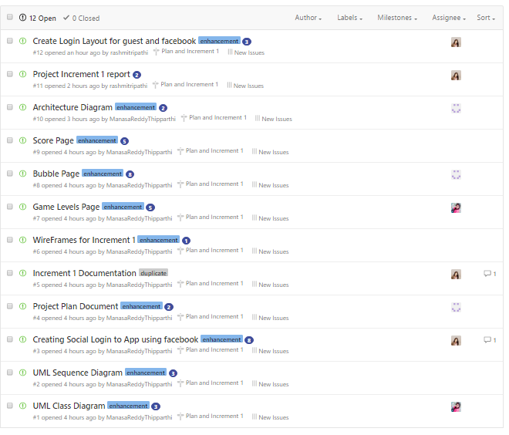

**Increment -2:**

* Showing multiple bubbles at a time on the screen.
* Implementing different levels like easy, intermediate and expert in the game, by increasing the speed in each level.
* Implementing two scoreboards classic and timebound.

**Increment -3:**

* Allowing the user to view his friends score when he logins through social networks.
* Displaying bubbles with different colours, so that tapping on a specific colour will increase the score and tapping on some bubbles decreases the score.

**Increment -4:**

* Displaying user image captured during login in the score board.
* Changing the bubble images based on the GPS Location.
* Resuming the game and allowing the player to start from where the position he has paused it.

**Project Timeline:**

* Increment – 1 : 9/23/2016
* Increment – 2 : 10/14/2016
* Increment – 3 : 11/4/2016
* Increment – 4 : 12/2/2016

**Members:**

* Manasa Thipparthi
* Saijyothi Gudibandi
* Rashmi Tripathi
* Ankita Wankhede

**Burndown Chart:**