BUBBLE SMASH GAME
(Project Plan Increment - 2 (Team # 9))

PROJECT PLAN (Using Zenhub Tool):

Milestones and Project Timelines:

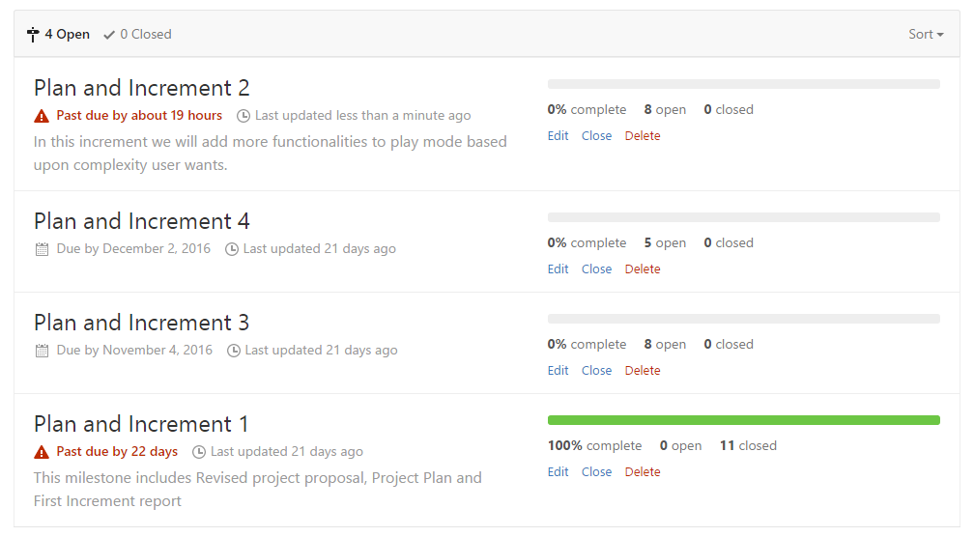

Burndown Chart:

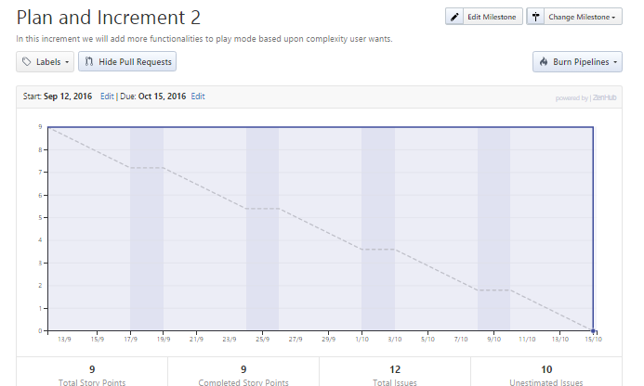

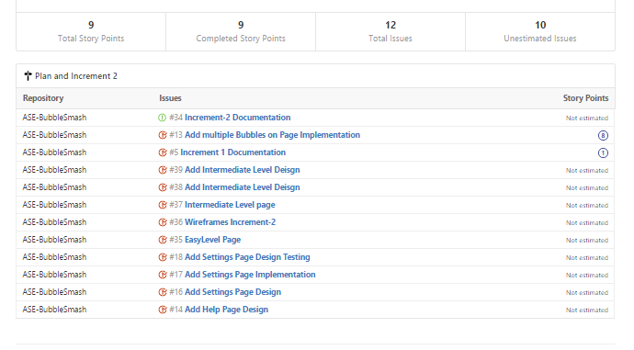

Report:

In this increment we have implemented an application for bubble smash project. We have created following pages.

Login Page:

The login page has 3 types of logins. One is Firebase login which is an ionic plugin which has an option to register with valid email id and can later login with the registered credentials. The other is through facebook login which is also an ionic plugin which helps to login to the app through facebook credentials. The third is through guest user logiin.

Registration Page:

This page has an option to register to the firebase plugin by providing valid email address and password and it also has an option to choose a security question for security purposes.

Help Page:

This page provides the user with the clues about how to play the game.

Setting page:

This page provides the option to change settings while playing game. The available setting options are Listen Music, Set Volume, Mute, Unmute, Yourr Nickname, Any Suggestions.

Level Page:

This page lists all the levels in the game there are 3 levels in the game they are Easy Intermediate, Difficult. By selecting each level it will navigate to the corresponding game level page.

Easy Level Page:

This is the game page where a single bubble moves at a time from top to bottom when you tap on a bubble it will smash and the count gets incremented.

Intermediate Level Page:

This page has multiple bubbles moving simultaneously with high speed tapping on bubbles the score gets recorded.

Score Page:

This page displays the score once the game is done. It also gives the number of escaped bubbles. It has option to quit or go to the home page to replay.

Wire Frames:

Login Page:

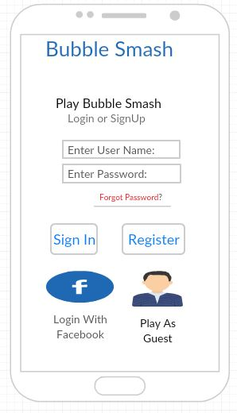

Register Page:

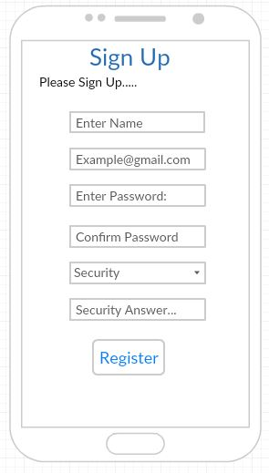

Level Page:

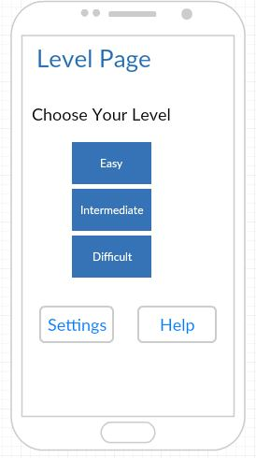

Settings Page:

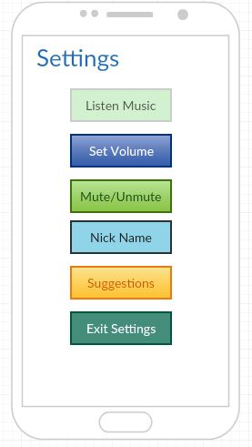

Help Page:

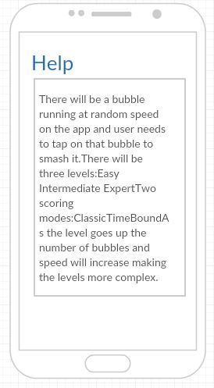

Easy Level Page:

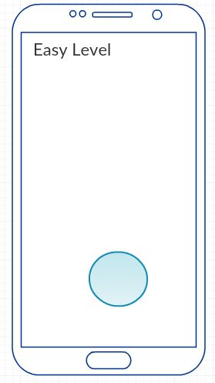

Intermediate Level Page:

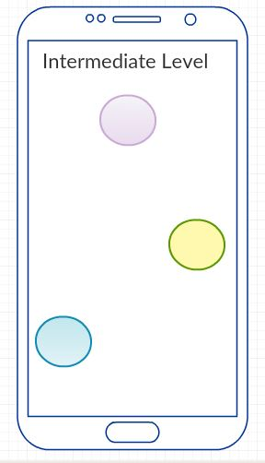

Score Page:

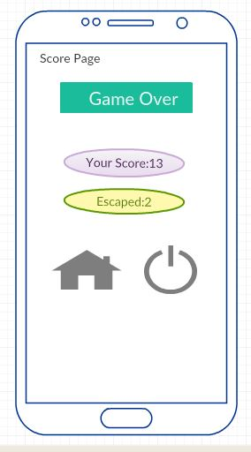

Architecture Diagram:

Class Diagram:

Sequence Diagram:

Implementation:

The source code is deployed in github in the following Url.

https://github.com/ManasaReddyThipparthi/ASE-BubbleSmash/wiki/Increment-2

Application Screenshots:

Login Page:

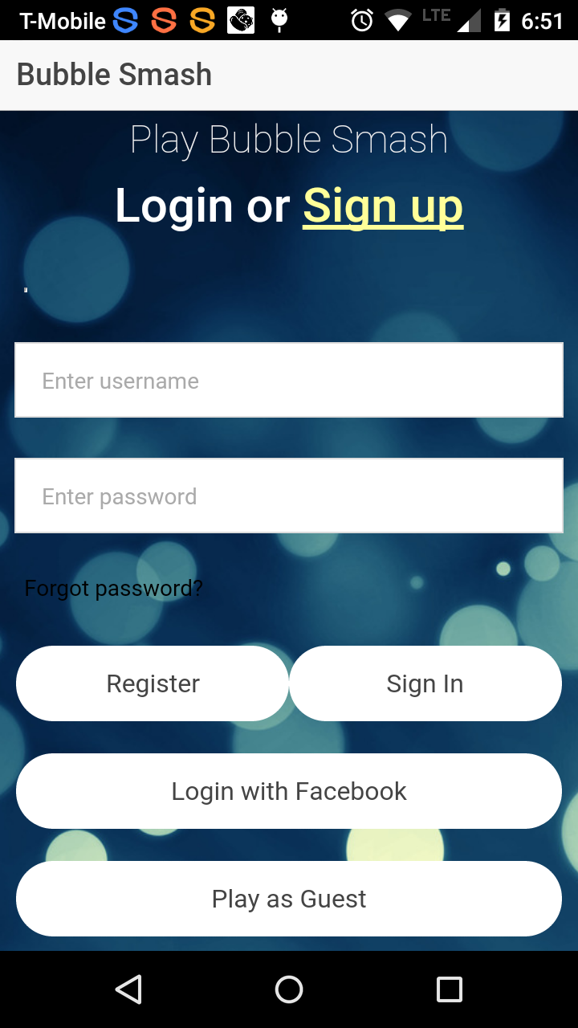

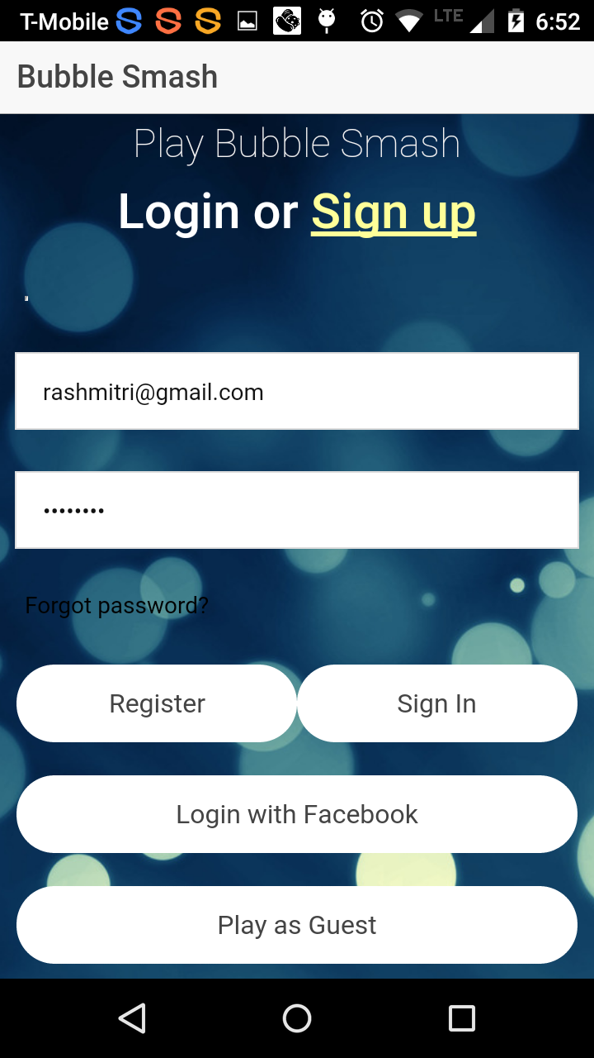

Facebook Login Page:

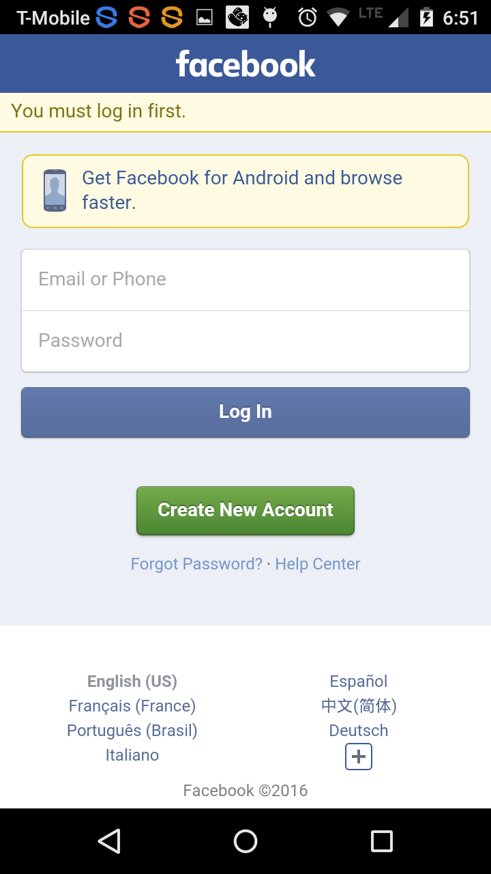

Register Page:

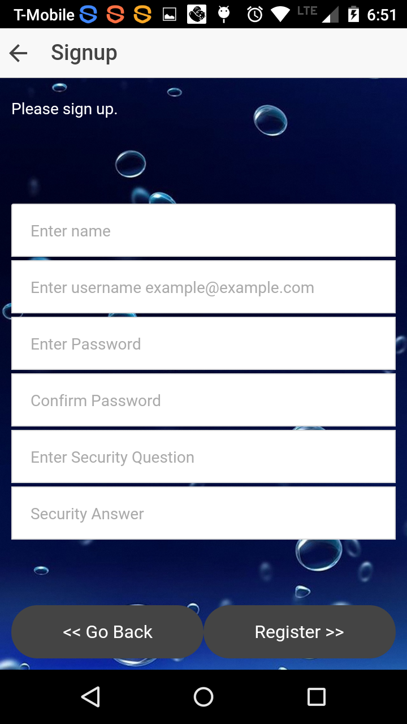

Level Page:

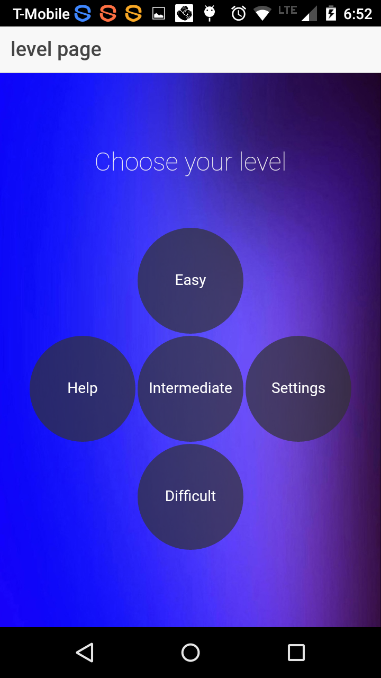

Settings Page:

Help Page:

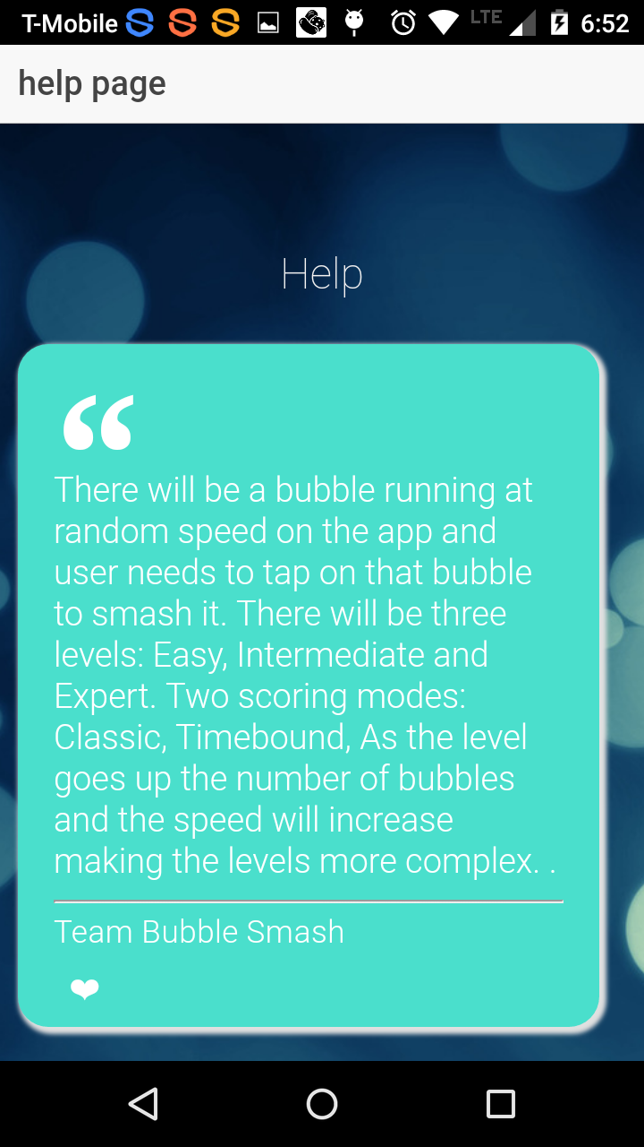

Easy Level Page:

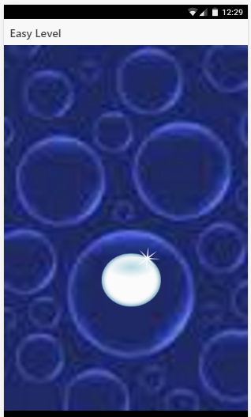

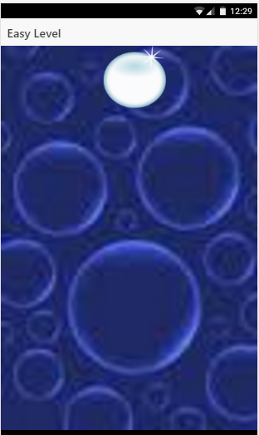

Intermediate Level Page:

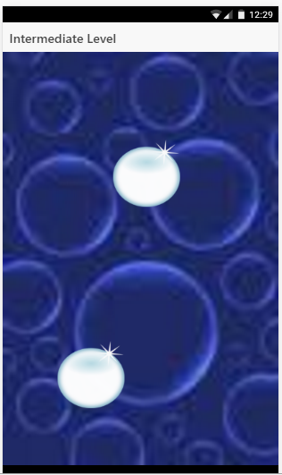

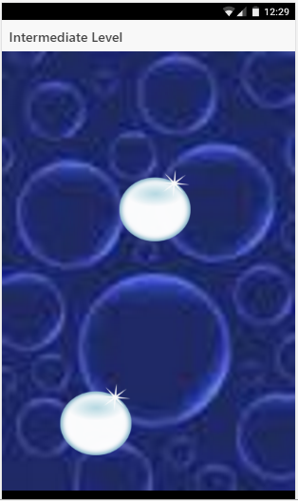

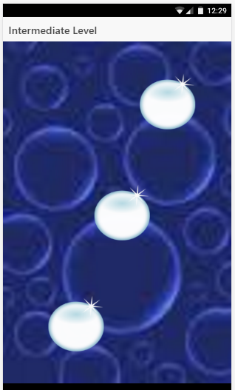

Score Page:

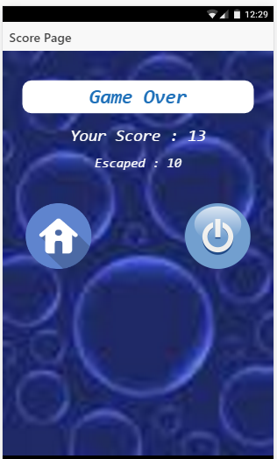

Project Management:

Issues:
