

Hidden Hurdles

(CS5542-Big Data Analytics and Apps)

Project Report-3

**By . . . .**

**Team 3**

*Thipparthi Manasa T - 40*

*Gudibandi SaiJyothi - 12*

*Puthana Sujitha - 33*

*Sri Harsha Kumar Raja Golla – 10*

Project Management

**Report your project progress and plan:**

We have completed the project of Hidden Hurdles game using 3 different methods namely External API (Clarifai), Machine Learning (Random Forest) and Tensor Flow in 3 different levels. We have also implemented Google conversation API using API.AI.

**Plan & Project Timelines, Members, Task Responsibility, and Implementation status report:**

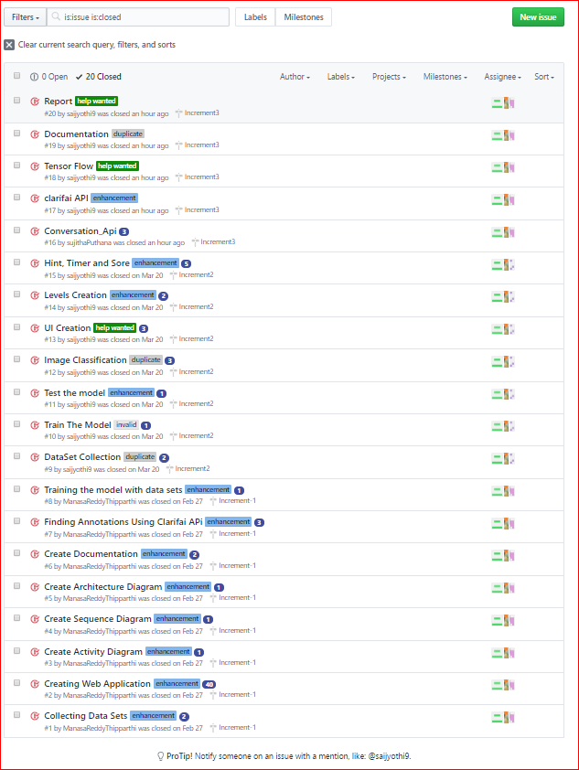

**Issues:**

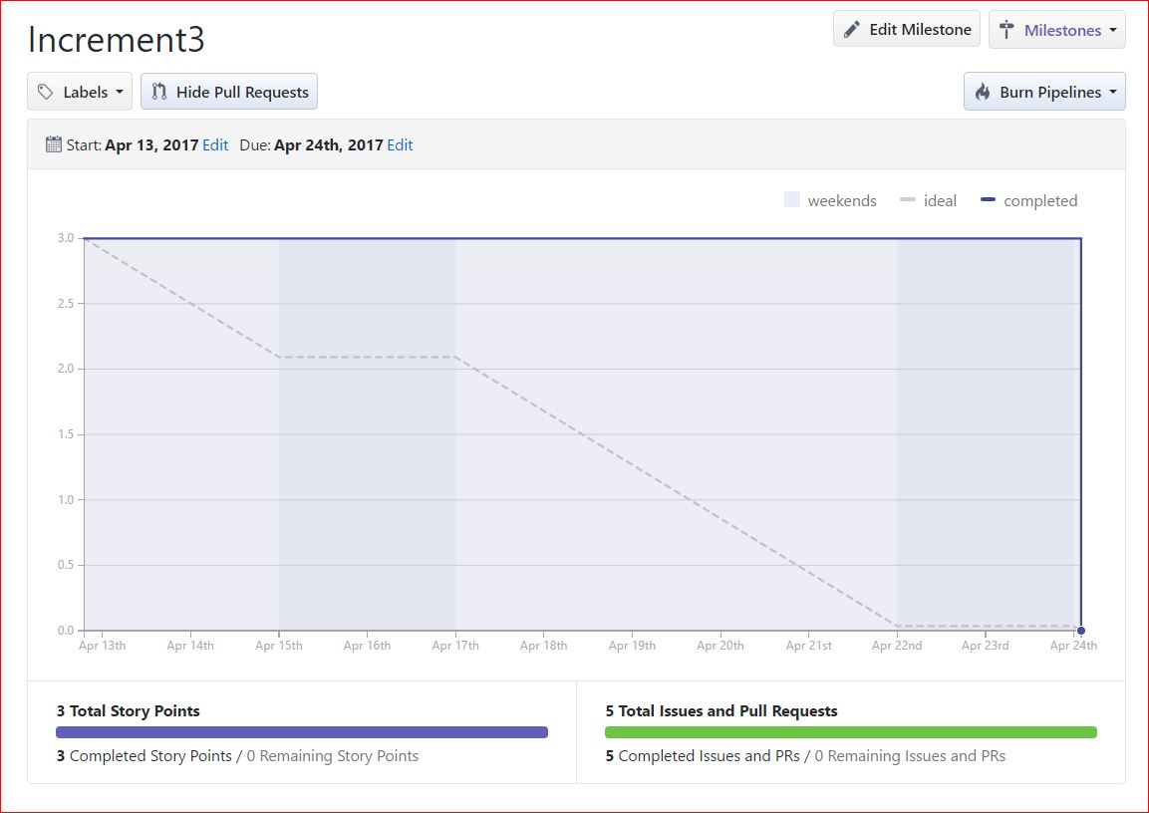

**Description**:

The core purpose of our project is to classify the image using External API (Clarifai API), Machine Learning(Spark) and Deep Learning (Tensor Flow) and compare to find the model which gives the best accuracy. Here we compared the above three approaches based on Accuracy and time measurements using our own Image data. We have designed a game with multiple levels where in the object images are hidden in the background and the users should find the image. Once the user finds the hidden image, then this image is sent to one of the three models to find out to which image class it belongs to and the result obtained is compared with the predefined values. For every correct selection, the score increments and the corresponding image name is mark as found. We have included 3 such levels and on successful completion of a single level user is moved on to next level. For the user’s convenience, we have included an Interactive Question Answering Google conversation API that can be useful in case of providing hints to the user in case of any help. And for this we have used certain tools like api.ai, Heroku and Mongo DB to save the results. The goal is to analyze an image selected by the player using Image Analysis in the three different approaches and produce the corresponding output. This output is then compared with the remaining models to find out the best accuracy rate.

**Responsibility:**

|  |  |
| --- | --- |
| **Team Member Name** | **Task Accomplished** |
| Manasa Thipparthi | Data Collection, Level1 Image Data Training, Designing UI: Level Page, Hints, Timer, Clarifai, Tensor Flow, Documentation-IEEE paper and Project Reports, Architecture Diagram. |
| SaiJyothi Gudibandi | Data Collection, Level1 Image Data Training, Designing UI: Level Page, Score, Clarifai, Tensor Flow, Documentation-IEEE paper and Project Reports, Activity Diagram. |
| Sujitha Puthana | Data Set Collection, Level3 image data training, Designing of UI game for level 3, Google conversation API, Documentation, Project Proposal. |
| Sri Harsha Kumar Raja Golla | Data Collection, Clarifai API, Designing UI: Level Page, Tensor Flow, Documentation-IEEE paper and Project Reports, Sequence Diagram. |

|  |  |
| --- | --- |
| **Task** | **Time taken to complete** |
| Data Set Collection | 8 Hours |
| Training of Data sets | 12 Hours |
| Designing of Web Application | 20 Hours |
| Google Conversation API | 5 Hours |
| Testing of Web Application | 7 Hours |
| Documentation | 12 Hours |
| Clarifai API | 4 Hours |
| Tensor Flow | 6 Hours |

**Time taken:**

**Contributions:**