**User Manual:**

This game is word-to-number puzzle. The letters from ‘a’ to ‘h’ correspond to numbers from 0 to 7.

|  |  |
| --- | --- |
| **Letter** | **Number** |
| A | 0 |
| B | 1 |
| C | 2 |
| D | 3 |
| E | 4 |
| F | 5 |
| G | 6 |
| H | 7 |

The player2 is given a list of words formed using different combinations of these 8 letters.

Now player1 provides a letter and a number. Player2 should form a meaningful word or pick a word from the list of words given to him, so that the summation of the numbers corresponding to the letters in the word should be equal to the number provided by player1.

Like for example,

If letter given is ‘a’ in 2nd position and number given is ‘3’. Player2 should make a word something like ‘cab’, which has ‘a’ in place 2.

If you see ‘c’ corresponds to 2; ‘a’ corresponds to ‘0’ and ‘b’ corresponds to ‘1’. By summing up these numbers, you get 2+0+1 = 3, which is equal to the number given by player1. Hence, player2 wins.

**How the system works:**

The letters are given using binary notations by toggling the switches up and down.

|  |  |  |
| --- | --- | --- |
| **Letter** | **Number** | **Binary Entries** |
| a | 0 | 000 |
| b | 1 | 001 |
| c | 2 | 010 |
| d | 3 | 011 |
| e | 4 | 100 |
| f | 5 | 101 |
| g | 6 | 110 |
| h | 7 | 111 |

The corresponding letters are displayed on the seven-segment display.

|  |  |  |
| --- | --- | --- |
| **Letter** | **Binary entries** | **seven segment display** |
| a | 000 | 0000010 |
| b | 001 | 1100000 |
| c | 010 | 0110001 |
| d | 011 | 1000010 |
| e | 100 | 0010000 |
| f | 101 | 0111000 |
| g | 110 | 0000100 |
| h | 111 | 1101000 |

The number is again given using toggle switches which is displayed on a seven-segment display:

|  |  |
| --- | --- |
| **4-bit Binary** | **Seven segment pattern HEX[0:6]** |
| 0000 | 0000001 |
| 0001 | 1001111 |
| 0010 | 0010010 |
| 0011 | 0000110 |
| 0100 | 1001100 |
| 0101 | 0100100 |
| 0110 | 0100000 |
| 0111 | 0001111 |
| 1000 | 0000000 |
| 1001 | 0000100 |
| 1010 | 0000010 |
| 1011 | 1100000 |
| 1100 | 0110001 |
| 1101 | 1000010 |
| 1110 | 0010000 |
| 1111 | 0111000 |

The summation is displayed on a separate seven segment display. It shows ‘F’ whenever the number and summation don’t match. It displays the correct summation only when it matches with the number. Also, since there are 3 letter and 4 letter words in the list. Player2 can make a choice whether to enter three letter word or 4 letter word by using another switch, by toggling which you can display only three letter words. Before the game begins, by default, all the toggle switches are set to ‘0’

**List of words:**

**Secret logic of player1**

This card is given only to player1

|  |  |
| --- | --- |
| **Word** | **Corresponding Summation** |
| Cab | 3 |
| Bag | 7 |
| Age | 10 |
| Hag | 13 |
| Beg | 11 |
| deaf | 12 |
| Fade | 12 |
| Café | 11 |
| bade | 8 |
| Bae | 5 |
| Dab | 4 |
| Cage | 10 |
| head | 13 |
| Ace | 6 |
| Bah | 8 |
| Gab | 7 |

**Cards supplied to player2:**

|  |  |  |  |
| --- | --- | --- | --- |
| **Letter** | **Number** |  | **Word** |
| a | 0 |  | Cab |
| b | 1 |  | Bag |
| c | 2 |  | Age |
| d | 3 |  | hag |
| e | 4 |  | beg |
| f | 5 |  | deaf |
| g | 6 |  | fade |
| h | 7 |  | café |
|  |  |  | bade |
|  |  |  | bae |
|  |  |  | dab |
|  |  |  | cage |
|  |  |  | head |
|  |  |  | ace |
|  |  |  | bah |
|  |  |  | gab |
|  |  |  | gae |

Player2 can make a choice from these words or can come up with new words but should be meaningful.

**Board Images:**

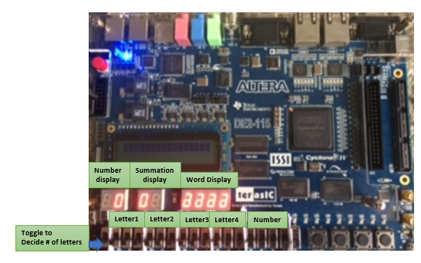

**3 letter word chosen by setting the toggle to 1.**

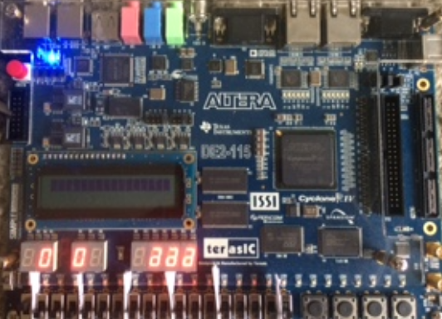

**Matching summation and word for 3 letter word case:**

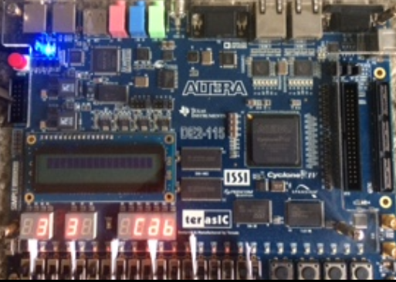

**Non matching summation and word for 3 letter word case:**

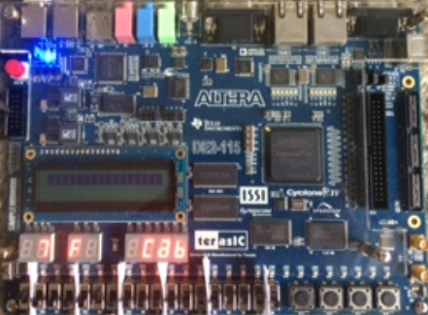

**Matching summation and word for 4 letter word case:**

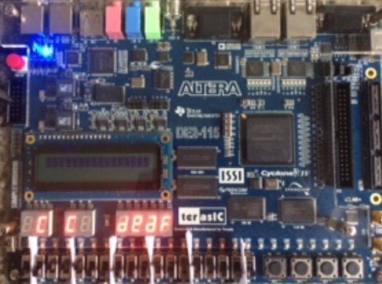

**Non matching summation and word case for 4 letter word case:**

