**Project**: This is the project title

**Student name**: John Smith

**Student UIN**: 0123456

**All sections are mandatory. Please do not change the format of this template.**

1. **Overview**

What is your website about? What are the methods do you plan to use, PHP, or JavaScript, or Python or a combination of them? Do you want to build it on top of a framework (e.g., Laravel) or not? Use the following table to show which features you have implemented, and which are not. I do not expect you to finish all of them at this stage, but I do expect you have worked out several. Including a screenshot of any working page.

1. **Milestone Accomplishments**

**List ALL specifications of this project and specify whether certain specifications are fulfilled or not.**

Table : Status of milestone specifications.

|  |  |  |
| --- | --- | --- |
| **Fulfilled** | **Feature#** | **Specification** |
| Yes | 1 |  |
| No | 2 |  |
|  | 3 |  |
|  | 4 |  |
|  | 5 |  |
|  | 6 |  |
|  | 7 |  |
|  | 8 |  |
|  | 9 |  |
|  | 10 |  |

1. **Architecture**

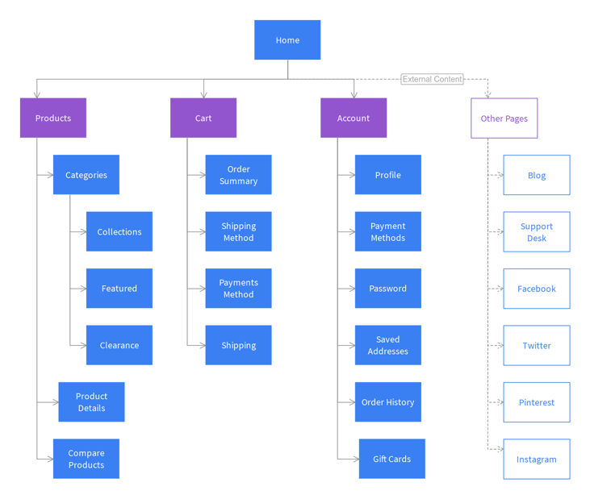**Describe the overall architecture of this project, including but not limited to the programming language, framework used, the major components and how they are connected. Draw a diagram similar to the one below.**

1. **Database Design**

Describe your database design including a table showing fields, data types, key types, and a few examples of rows.

|  |  |  |  |
| --- | --- | --- | --- |
| Field | Type | Key | Example |
| Id | INT | Primary | 1 |
| Username | VARCHAR(30) |  | Johnsmith |
| School | VARCHAR(30) |  | ODU |
| Year of birth | INT |  | 1990 |

1. **Implementation**

Describe how **each** specification is implemented. **Specify and highlight the program file in which each specification is implemented**. An example is shown below.

*Search box and search button:*

There is a search box at the landing page of my website and when a user searches for a word it redirects to the SERP page where the user finds the summary and download button and advanced search is also available it is accessible to the user only after they login. The code written for the elastic search in projectdata.php helped in indexing the data and the query written to implement the search functionality helps to redirect the user to SERP page. You can find the code in Resources->views->pages->index.blade.php