**Project**: This is the project title

**Student name**: John Smith

**Student UIN**: 0123456

**All sections are mandatory.**

1. **Overview**

What is your website about? What are the methods do you plan to use, PHP, or JavaScript, or Python or a combination of them? Do you want to build it on top of a framework (e.g., Laravel) or not? Use the following table to show which features you have implemented, and which are not. I do not expect you to finish all of them at this stage, but I do expect you have worked out several. Including a screenshot of any working page. You can copy this section from the previous report if you did not change anything. Or you can revise your writing in this section.

1. **Milestone Accomplishments**

**List ALL specifications of the CURRENT MILESTONE and specify which specifications are fulfilled or not.**

Table : Status of milestone specifications.

|  |  |  |
| --- | --- | --- |
| **Fulfilled** | **Feature#** | **Specification** |
| Yes | 1 |  |
| No | 2 |  |
|  | 3 |  |
|  | 4 |  |
|  | 5 |  |
|  | 6 |  |
|  | 7 |  |
|  | 8 |  |
|  | 9 |  |
|  | 10 |  |

1. **Architecture**

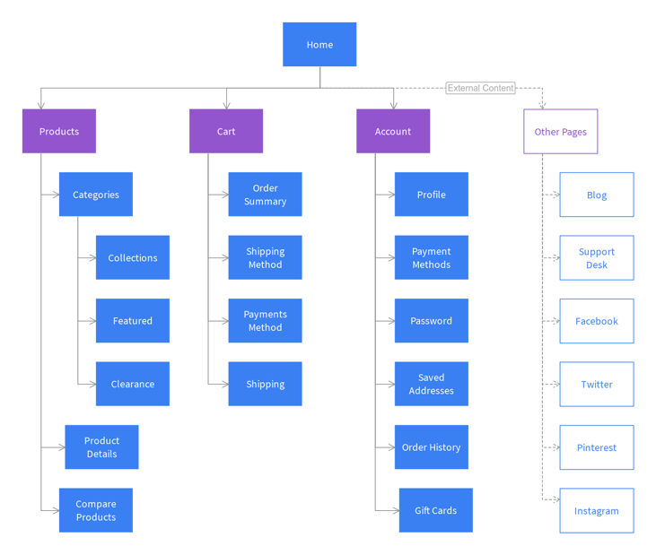**Describe the overall architecture of this project, including but not limited to the programming language, framework used, the major components and how they are connected. Draw a diagram similar to the one below.**

1. **Data**Talk about the data structure, how data were organized and stored.

1. **Elasticsearch Design**

Describe the mapping of Elasticsearch, including the field names, data types, and example data. If the text is too long, you can truncate it after the first 1-2 paragraphs.

1. **Implementation**

Describe how **each** specification is implemented. **Specify the program file in which each specification in this milestone is implemented**. An example is shown below.

*Search box and search button:*

There is a search box at the landing page of my website and when a user searches for a word it redirects to the SERP page where the user finds the summary and download button and advanced search is also available it is accessible to the user only after they login. The code written for the elastic search in projectdata.php helped in indexing the data and the query written to implement the search functionality helps to redirect the user to SERP page. You can find the code in Resources->views->pages->index.blade.php