**Project**: This is the project title

**Student name**: John Smith

**Student UIN**: 0123456

**This is the final report, so please report your progress of ALL milestones.**

**All sections are mandatory. It is OK to include screenshots of web pages, but please do NOT include screenshots of terminals (shell windows)!**

1. **Overview**

What is your website about? What are the methods do you plan to use, PHP, or JavaScript, or Python or a combination of them? What framework (e.g., Laravel, Bootstrap) do you use? You can copy this section from the previous report if you did not change anything. Or you can revise your writing in this section.

1. **Milestone Accomplishments**

**List ALL specifications of all MILESTONEs and specify which specifications are fulfilled or not.** Use the following table to show which features you have implemented, and which are not.

Table : Status of milestone specifications.

|  |  |  |  |
| --- | --- | --- | --- |
| **Fulfilled** | **Milestone** | **Feature#** | **Specification Description** |
| Yes | 1 | 1 |  |
| No | 1 | 2 |  |
|  | 1 | 3 |  |
|  |  | 4 |  |
|  |  | 5 |  |
|  |  | 6 |  |
|  |  | 7 |  |
|  |  | 8 |  |
|  |  | 9 |  |
|  |  | 10 |  |

1. **Architecture**

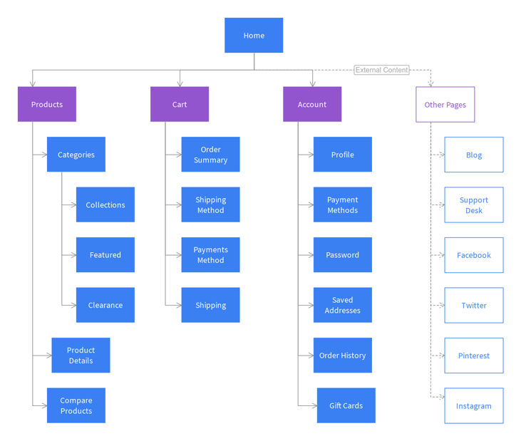**Describe the overall architecture of your web application, including the major components and how they are connected. Draw a diagram similar to the one below.**

1. **Database Design**

Describe your database design including a table showing fields, data types, key types, and a few examples of rows.

|  |  |  |  |
| --- | --- | --- | --- |
| Field | Type | Key | Example |
| Id | INT | Primary | 1 |
| Username | VARCHAR(30) |  | Johnsmith |
| School | VARCHAR(30) |  | ODU |
| Year of birth | INT |  | 1990 |

1. **Elasticsearch Design**

Describe the mapping of Elasticsearch, including the field names, data types, and example data.

1. **Implementation**

Describe how **each** specification is implemented. **Specify the program file in which each specification in this milestone is implemented**. An example is shown below.

*Search box and search button:*

There is a search box at the landing page of my website and when a user searches for a word it redirects to the SERP page where the user finds the summary and download button and advanced search is also available it is accessible to the user only after they login. The code written for the elastic search in projectdata.php helped in indexing the data and the query written to implement the search functionality helps to redirect the user to SERP page. You can find the code in Resources->views->pages->index.blade.php

**7. What would you change if you re-do this project?**

Justify why you want to make the changes.

**8. What do you want to say to the instructor?**

Feel free to make comments, either positive or negative. This will not impact your scores.