|  |
| --- |
|  |
| **Rock Paper Scissors Classifier** |
|  |

**Nishant KapoorManasa Challa**

Department of Computer Science Department of Computer Science

University at Buffalo University at Buffalo

[nkapoor2@buffalo.edu](mailto:nkapoor2@buffalo.edu) [manasasa@buffalo.edu](mailto:manasasa@buffalo.edu)

**1 Rock Paper Scissors Using Deep Learning**

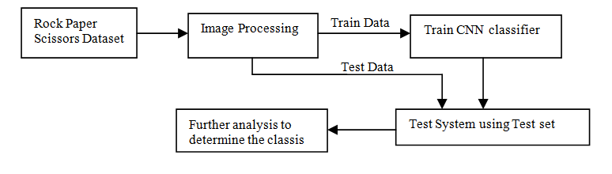

Fig. 1. The framework to recognize the Rock paper scissors gestures from images.

Each block of the flow diagram is clearly explained in the following sections. The steps in image processing are pre-processing and neural network training. From this, the trained model can be obtained which will classify any supplied image based on the trained dataset

**1.1 The Rock Scissors Paper Dataset**

The Rock Scissors Paper dataset that contains 2,413 images and 3 categories is considered for this project. We are using this dataset to make the system more realistic. In the dataset, there are 2320 training and 93 test images. There is some noise in the image so, we will do some pre processing on the image to get better accuracy. Further, the images have been rescaled to a unique size of 300x300 dimensions.

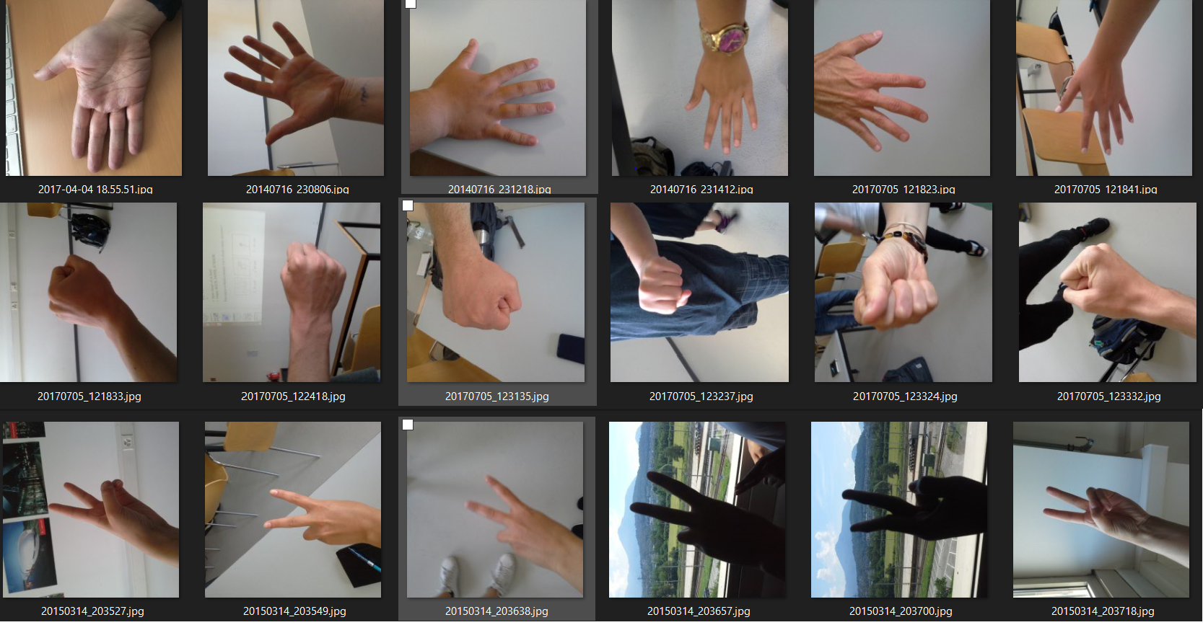

Fig. 2. Images of the food101 dataset

**1.2 Image preprocessing**

There are a few image pre processing techniques that we will use to ensure maximum efficiency. These techniques ensure that any image taken from any angle will be able to get classified.

**2 Models**

The models that we will use in this project are :-

**2.1 Convolution Neural Network**

Convolution Neural are also known as CNN and ConvNets. It is one of the most common algorithm that is used for image recognition and image classification. Object detection, face recognition are some of the examples where CNN is most commonly used.

**2.2 VGG-19**

VGG-19 is 19 layer deep convolution neural network. There is a pre trained version of VGG-19 that was trained on more than one million images from ImageNet Database. We can use this pre trained model to classify over 1000 object categories. We can use this model in our project to classify the hand gestures into Rock, Paper and Scissors.

**2.3 Neural Networks**

Deep learning refers to a type of algorithm called a neural network. Deep learning is a subset of machine learning. Machine learning is a subset of artificial intelligence. In addition to VGG-19 we will be adding our own neural network layers to increase the accuracy of the output. As a Venn diagram, it looks like this:

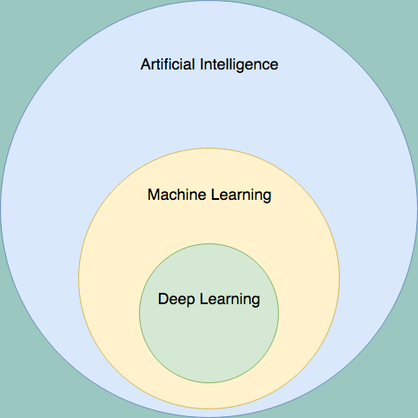

Fig. 3. Venn diagram

.