1. Consider the BN and answer the following T/F questions:

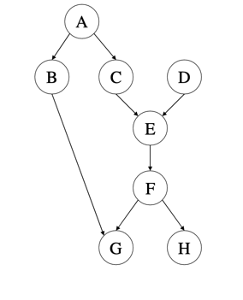

$B⊥C | A$

**True**

$A⊥F$

**False**

$A⊥F | E$

**True**

$B⊥H$

**False**

1. | G

**False**

1. Write the joint distribution of the above graph as a product of conditional distributions.

**P(A) . P(D) . P(B/A) . P(C/A) . P(E/C,D) . P(F/E0 . P(G/B,F) . P(H/F)**

1. How many CPT (conditional probability tables) does the BN in Q1 have?

**Six**