CarePredict AI: Hospital Appointment No-Show Intelligence

Project Description:
CarePredict AI is a machine learning-based web application that helps hospitals identify appointments that are at risk of being missed. The application analyzes patient and appointment information - age, gender, appointment timing, waiting days, neighbourhood, health conditions, and SMS reminder status - and uses a trained Random Forest classifier to estimate the probability that a given appointment will end in a no-show.
Rather than a bare probability number, the system is built as a Streamlit dashboard: it classifies each predicted probability into a Standard Reminder, Early Reminder, or Priority Follow-up action, surfaces a prioritized reminder queue across the existing appointment dataset, and presents no-show pattern analytics and model feature-importance insights. A lightweight session-based demo authentication layer gates access to the dashboard.

Scenario
Scenario 1: A care coordinator opens AI Prediction and enters a new appointment's details - age, gender, neighbourhood, scheduled and appointment dates, scheduled hour, and any relevant health or support flags. The trained Random Forest model returns a no-show probability under 30%, so the app classifies the appointment as a Standard Reminder and recommends the normal reminder workflow.
Scenario 2: For a different appointment with a longer waiting-day gap between scheduling and the visit, the model returns a no-show probability between 30% and 60%. The app classifies it as an Early Reminder and recommends contacting the patient earlier to confirm attendance.
Scenario 3: A hospital administrator opens the Smart Reminder Center to review the full appointment dataset at once. The page scores every appointment with the same Random Forest model, sorts them by no-show probability, and highlights the appointments at 60% or higher as Priority Follow-up. The administrator filters the queue by recommended action and SMS status, then downloads the resulting reminder priority list as a CSV file for the outreach team.

Technical Architecture:
Streamlit Frontend (app.py UI)
↓
Session-Based Demo Authentication
↓
Cached Data & Model Artifacts (data/processed_appointments.csv, models/*.pkl)
↓
Random Forest Prediction Engine
↓
Risk Classification & Reminder Dashboard

models/random_forest.pkl (trained classifier) | models/feature_columns.pkl (saved training-column order) | data/processed_appointments.csv (model-ready dataset used by the dashboard)

Description:
The application follows a layered architecture. A Streamlit frontend (app.py) renders the UI, collects appointment and patient details or a page selection, and displays results. A session-based authentication layer gates the dashboard: the demo Login and Sign Up forms accept any non-empty email and password, set st.session_state.authenticated, and do not connect to a real account store - no credentials are persisted or hashed. The trained Random Forest model (models/random_forest.pkl) and the saved training-column order (models/feature_columns.pkl) are loaded once via @st.cache_resource, and the model-ready dataset (data/processed_appointments.csv) is loaded once via @st.cache_data, so repeated predictions and page views do not reload the artifacts from disk.
(Note: This project's authentication is a demonstration layer only - any non-empty email and password combination is accepted, and no user record, password hash, or session persists beyond the current browser session. See Limitations.)
(Note: The data preprocessing and model training script that produced data/processed_appointments.csv, models/random_forest.pkl, and models/feature_columns.pkl was not among the project files reviewed for this documentation. Milestones 3 and 4 describe the resulting encoded columns and saved artifacts as observed in app.py's own usage of them, rather than the transformation or training code itself. See Limitations.)

Key Functions & Modular Components:
- Appointment Data Input Module: collects patient and appointment details - age, gender, appointment timing, waiting days, neighbourhood, health conditions, and SMS reminder status - through the AI Prediction form.
- Data Preprocessing & Feature Engineering: prepares appointment data and encodes the attributes the trained model was built on, such as one-hot encoded neighbourhood, appointment day, and age group columns.
- No-Show Probability Prediction Module: uses the trained Random Forest model to estimate the probability that a patient will miss the scheduled appointment.
- Risk Classification Module: classifies each predicted probability into Standard Reminder, Early Reminder, or Priority Follow-up.
- Risk Factor Analysis Module: surfaces the Random Forest model's most influential features on the Model Insights page so staff can understand what drives a prediction.
- Smart Reminder & Decision Support Module: provides the Streamlit dashboard that displays risk levels, recommended reminder actions, and a prioritized, filterable, downloadable list of appointments for follow-up.

Prerequisites:
- Python Programming Proficiency: for the Streamlit application logic, data handling, and prediction pipeline.
- Streamlit Framework Knowledge: for building the interactive multipage dashboard, session state, forms, and custom CSS styling.
- Scikit-learn Familiarity: RandomForestClassifier and predict_proba-based probability scoring.
- Pandas & NumPy: for loading the processed dataset, building the model input row, and computing group-wise summaries.
- Matplotlib & Seaborn: for exploratory data analysis charts (eda.py).
- Joblib: for loading the persisted Random Forest model and feature-column order from models/*.pkl.
- Version Control with Git: for tracking source changes, as reflected in requirements.txt and the project's module layout.

Project Workflow:

Milestone 1: Dataset Understanding and Data Quality Inspection
- Activity 1.1: Load the raw appointment dataset and inspect its shape, columns, and data types.
- Activity 1.2: Check data quality - missing values, duplicate rows, and the target distribution.

Milestone 2: Exploratory Data Analysis
- Activity 2.1: Engineer analysis-only features such as Waiting_Days, Appointment_Day, and Age_Group.
- Activity 2.2: Summarize no-show percentages across Gender, SMS status, Age Group, Appointment Day, and Waiting Days Group.
- Activity 2.3: Generate a six-panel visualization dashboard of attendance patterns.

Milestone 3: Data Preprocessing and Feature Engineering for Modeling
- Activity 3.1: Identify the model-ready, encoded feature set the trained model expects.
- Activity 3.2: Preserve the exact training-column order for consistent live predictions.

Milestone 4: Random Forest Model Training and Artifact Persistence
- Activity 4.1: Train the Random Forest classifier on the processed appointment data.
- Activity 4.2: Persist the trained model and feature-column order as .pkl artifacts.

Milestone 5: No-Show Prediction and Risk Classification Logic
- Activity 5.1: Build a model input row from patient and appointment values.
- Activity 5.2: Compute the no-show probability with the trained model.
- Activity 5.3: Classify the probability into a recommended reminder action.

Milestone 6: Streamlit Application Foundation
- Activity 6.1: Configure the Streamlit page and apply custom CSS styling.
- Activity 6.2: Load cached data and model artifacts with graceful error handling.
- Activity 6.3: Build the demo login and sign-up flow.

Milestone 7: Home and AI Prediction Interfaces
- Activity 7.1: Build the Home / Dashboard page.
- Activity 7.2: Build the AI Prediction page and form.

Milestone 8: Smart Reminder Center and Appointment Analytics
- Activity 8.1: Build the Smart Reminder Center with filters and CSV export.
- Activity 8.2: Build the Appointment Analytics page.

Milestone 9: Model Insights and Navigation
- Activity 9.1: Build the Model Insights page.
- Activity 9.2: Build the sidebar navigation and session-state page routing.

Milestone 10: Conclusion
- And then your detailed Conclusion section follows separately.

Milestone 1: Dataset Understanding and Data Quality Inspection
This milestone establishes a first-pass understanding of the raw patient appointment dataset before any feature engineering or modeling takes place, using inspect_data.py.

Activity 1.1: Load and Inspect the Dataset
inspect_data.py loads data/appointments.csv with pandas and prints its shape, column names, the first five rows, and each column's data type, giving a quick first look at the raw structure of the dataset.
df = pd.read_csv("data/appointments.csv")

print("Rows:", df.shape[0])
print("Columns:", df.shape[1])
print(df.columns.tolist())
print(df.head())
print(df.dtypes)
inspect_data.py - loading and inspecting the raw dataset

Activity 1.2: Check Data Quality
The script then checks for missing values per column, counts duplicate rows, and reports the distribution of the target column, No-show, both as raw counts and as percentages - the same target column used throughout the rest of the project. df.describe() is also printed to review basic statistics for the numeric columns.
print(df.isnull().sum())
print(df.duplicated().sum())

print(df["No-show"].value_counts())
print(df["No-show"].value_counts(normalize=True) * 100)

print(df.describe())
inspect_data.py - missing values, duplicates, and target distribution
This inspection pass does not modify appointments.csv or train any model; it exists purely to confirm the dataset is complete and correctly structured before exploratory analysis and preprocessing begin.

Milestone 2: Exploratory Data Analysis
Milestone 2 (eda.py) builds analysis-only columns on top of the raw dataset and summarizes how the no-show rate varies across patient and appointment attributes. Like inspect_data.py, eda.py only reads the CSV and works with in-memory columns - it does not train or save a machine learning model, and it does not modify the underlying file.

Activity 2.1: Engineer Analysis Features
eda.py parses ScheduledDay and AppointmentDay as dates and derives Waiting_Days as the integer number of days between them, plus Appointment_Day as the appointment's day name. Age is bucketed into five Age_Group ranges, and Waiting_Days is bucketed into five Waiting_Days_Group ranges. A No-show-binary column (1 for a recorded no-show, 0 otherwise) makes the percentage calculations below straightforward.
df["ScheduledDay"] = pd.to_datetime(df["ScheduledDay"])
df["AppointmentDay"] = pd.to_datetime(df["AppointmentDay"])

df["Waiting_Days"] = (df["AppointmentDay"] - df["ScheduledDay"]).dt.days
df["Appointment_Day"] = df["AppointmentDay"].dt.day_name()

age_bins = [-1, 17, 30, 45, 60, float("inf")]
age_labels = ["0-17", "18-30", "31-45", "46-60", "61+"]
df["Age_Group"] = pd.cut(df["Age"], bins=age_bins, labels=age_labels,
include_lowest=True)

df["No-show-binary"] = df["No-show"].eq("Yes").astype(int)
eda.py - engineered analysis columns

Activity 2.2: No-Show Percentage Summaries
no_show_percentages() groups the dataset by a given column and returns the mean of No-show-binary as a percentage, sorted from highest to lowest. print_group_summary() wraps this for readable console output. eda.py runs this breakdown across Gender, SMS_received, Age_Group, Appointment_Day (in calendar-week order), and Waiting_Days_Group, then reports the overall no-show rate, the waiting-time group with the highest no-show rate, and the no-show rate with versus without an SMS reminder.
def no_show_percentages(data, group_column):
return (data.groupby(group_column, observed=False)["No-show-binary"]
.mean().mul(100).sort_values(ascending=False))

overall_no_show = df["No-show-binary"].mean() * 100
highest_waiting_group = no_show_percentages(df, "Waiting_Days_Group").idxmax()
eda.py - group-wise no-show percentage summaries

Activity 2.3: Visualization Dashboard
eda.py builds a six-panel Matplotlib/Seaborn figure: an overall show-vs-no-show count plot, plus bar charts of the no-show percentage by Gender, SMS reminder status, Age Group, Appointment Day (Monday through Sunday), and Waiting Days Group. Each panel is generated from the same no_show_percentages() helper so every bar chart on the dashboard is computed consistently.
fig, axes = plt.subplots(2, 3, figsize=(18, 11))
fig.suptitle("Patient Appointment No-Show Analysis",
fontsize=16, fontweight="bold")

sns.countplot(data=df, x="No-show", order=["No", "Yes"], ax=axes[0, 0])

for column, title, axis, order in chart_data:
percentages = no_show_percentages(df, column)
sns.barplot(x=percentages.index, y=percentages.values,
color="steelblue", ax=axis)
eda.py - six-panel no-show analysis dashboard

Milestone 3: Data Preprocessing and Feature Engineering for Modeling
The preprocessing and training script that produced the model-ready dataset and feature-column list was not among the files reviewed for this documentation. This milestone describes the resulting, model-ready structure exactly as app.py depends on it, rather than the transformation code that built it.

Activity 3.1: Model-Ready Encoded Feature Set
app.py loads a processed dataset (data/processed_appointments.csv) whose columns already match what the trained Random Forest expects. create_model_input() in app.py shows exactly which columns the model was trained on: direct numeric/binary columns for Gender, Age, Scholarship, Hipertension, Diabetes, Alcoholism, Handcap, SMS_received, Waiting_Days, Appointment_Month, and Appointment_Hour, plus one-hot encoded columns following the patterns Neighbourhood_<value>, Appointment_Day_<value>, and Age_Group_<value>. (Hipertension and Handcap preserve the original column spelling from the source dataset.)
row = pd.DataFrame(0, index=[0], columns=feature_columns, dtype=int)
row["Gender"] = values["Gender"]
row["Age"] = values["Age"]
row["Scholarship"] = int(values["Scholarship"])
row["Hipertension"] = int(values["Hypertension"])
row["Diabetes"] = int(values["Diabetes"])
row["Alcoholism"] = int(values["Alcoholism"])
row["Handcap"] = int(values["Handicap"])
row["SMS_received"] = int(values["SMS received"])
row["Waiting_Days"] = values["Waiting_Days"]
row["Appointment_Month"] = values["Appointment_Month"]
row["Appointment_Hour"] = values["Appointment_Hour"]
app.py - create_model_input(): the encoded columns the model expects

Activity 3.2: Preserve the Training-Column Order
models/feature_columns.pkl stores the exact list and order of columns the model was fitted on. create_model_input() builds a single-row DataFrame with those columns as its index, fills in the direct values, and then sets a 1 in whichever one-hot column matches the submitted Neighbourhood, Appointment_Day, and Age_Group - guaranteeing that a live prediction row is always shaped identically to the data the model was trained on, even though the training script itself is not part of this project's reviewed files.
for category in (f"Neighbourhood_{values['Neighbourhood']}",
f"Appointment_Day_{values['Appointment_Day']}",
f"Age_Group_{values['Age_Group']}"):
if category in row.columns:
row[category] = 1
app.py - create_model_input(): aligning one-hot columns to the saved feature order

Milestone 4: Random Forest Model Training and Artifact Persistence
Per the project abstract, a scikit-learn Random Forest classifier was trained on the processed appointment data using a train-test split to estimate no-show probability. The training script itself was not among the reviewed project files, so this milestone documents only what is directly confirmed by the abstract and by how app.py loads and uses the trained artifacts.

Activity 4.1: Train the Random Forest Classifier
The abstract identifies scikit-learn's Random Forest as the algorithm used to estimate no-show probability from the processed appointment features, evaluated with a train-test split. Because the training script was not provided, its specific hyperparameters (such as the number of trees or maximum depth) are not reproduced here; app.py's Model Insights page does report the number of trees found on the loaded model at runtime (len(model.estimators_)).

Activity 4.2: Persist the Trained Model and Feature Columns
The trained classifier is saved to models/random_forest.pkl and the fitted feature-column order to models/feature_columns.pkl, both loaded via joblib. app.py caches both with @st.cache_resource so they are read from disk once per session.
MODEL_FILE = PROJECT_ROOT / "models" / "random_forest.pkl"
FEATURE_FILE = PROJECT_ROOT / "models" / "feature_columns.pkl"

@st.cache_resource
def load_model_artifacts():
return joblib.load(MODEL_FILE), joblib.load(FEATURE_FILE)
app.py - loading the persisted Random Forest model and feature columns
No evaluation metrics (ROC-AUC, precision, recall, F1 score, or a confusion matrix) were saved alongside the model. The application's own Model Insights page reflects this directly - it labels ROC-AUC and Precision/Recall/F1 as "Unavailable" and states in a caption that evaluation metrics were not saved as model artifacts, so this documentation does not report held-out performance numbers for the trained Random Forest (see Limitations).

Milestone 5: No-Show Prediction and Risk Classification Logic
Milestone 5 covers the shared prediction logic in app.py that both the AI Prediction form and the Smart Reminder Center rely on.

Activity 5.1: Compute the No-Show Probability
no_show_probability() looks up which position in the model's classes_ array corresponds to the no-show class (1) and reads that column from predict_proba(), returning a single probability between 0 and 1 for the submitted appointment row.
def no_show_probability(model, model_input):
no_show_index = list(model.classes_).index(1)
return float(model.predict_proba(model_input)[0, no_show_index])
app.py - no_show_probability()

Activity 5.2: Classify the Probability into a Reminder Action
action_for_probability() applies two fixed thresholds to turn the continuous probability into one of three reminder tiers: below 30% is a Standard Reminder, 30% up to 60% is an Early Reminder, and 60% or higher is a Priority Follow-up. action_explanation() maps each tier to a short, actionable recommendation for staff.
def action_for_probability(probability):
if probability < 0.30:
return "Standard Reminder"
if probability < 0.60:
return "Early Reminder"
return "Priority Follow-up"

def action_explanation(action):
return {
"Standard Reminder": "Use the normal reminder workflow.",
"Early Reminder": "Contact the patient earlier and allow extra
time to confirm.",
"Priority Follow-up": "Prioritize direct follow-up and
appointment confirmation.",
}[action]
app.py - action_for_probability() and action_explanation()

Milestone 6: Streamlit Application Foundation
app.py is the single-file Streamlit application. This milestone covers its page configuration, custom styling, cached artifact loading, and the demo authentication flow that gates the dashboard.

Activity 6.1: Page Configuration and Custom Styling
The page is configured once at import time, and add_styles() injects a block of custom CSS (via unsafe_allow_html=True) that themes the sidebar, hero banners, metric cards, and feature cards with the application's teal/navy/gold color palette, giving the dashboard a distinct look beyond Streamlit's defaults.
st.set_page_config(page_title="CarePredict AI", page_icon="🏥",
layout="wide")
app.py - Streamlit page configuration

Activity 6.2: Cached Data and Model Loading
load_required_assets() wraps load_data() and load_model_artifacts() in a try/except block: a missing file (FileNotFoundError) reports the specific missing filename, and other loading failures (OSError, ValueError, EOFError, or a pandas parser error) show a general error message - either way the app stops cleanly with st.stop() instead of crashing with a raw traceback.
def load_required_assets():
try:
data = load_data()
model, feature_columns = load_model_artifacts()
return data, model, feature_columns
except FileNotFoundError as error:
st.error(f"A required project file is missing: {error.filename}")
st.stop()
except (OSError, ValueError, EOFError, pd.errors.ParserError) as error:
st.error(f"Project data could not be loaded: {error}")
st.stop()
app.py - load_required_assets(): graceful missing-artifact handling

Activity 6.3: Demo Login and Sign-Up
show_authentication() presents a Login / Sign Up radio toggle. The Login form accepts any non-empty email and password and sets st.session_state.authenticated = True - the app's own caption states plainly that "Demo access: any non-empty email and password will work." The Sign Up form validates that required fields are filled and that the password and confirmation match, then likewise sets the session as authenticated. Neither path writes to a database, file, or hashed credential store - the authentication exists only to gate the dashboard for the current browser session (see Limitations).
if login:
if email.strip() and password:
st.session_state.authenticated = True
st.session_state.user_email = email.strip()
st.rerun()
st.caption("Demo access: any non-empty email and password will work.")
app.py - demo login verification

Milestone 7: Home and AI Prediction Interfaces
Milestone 7 covers the two pages faculty and staff see first: the landing dashboard and the on-demand prediction form.

Activity 7.1: Home / Dashboard Page
show_home() displays a hero banner, four top-line metrics (total appointments, total no-shows, no-show rate, and SMS reminders sent) computed by dashboard_metrics(), and a second row of "today's appointment intelligence" metrics built from reminder_records() - the total scored appointments and counts of Priority Follow-up, Early Reminder, and Standard Reminder recommendations. A bar chart compares show-up versus no-show counts, four feature cards summarize what the app does (Predict, Prioritize, Remind, Understand), and a button routes into the AI Prediction page via session state.

Activity 7.2: AI Prediction Page and Form
show_prediction() renders prediction_form(), a form collecting Patient Information (age, gender, neighbourhood), Appointment Details (scheduled date, appointment date, scheduled hour), and Health & Support checkboxes (Scholarship, Hypertension, Diabetes, Alcoholism, Handicap, SMS Received). On submit, Waiting_Days is computed automatically from the two dates, the values are assembled with create_model_input(), and no_show_probability() and action_for_probability() together produce the predicted probability, the recommended reminder action, and a short explanation, shown alongside the computed waiting days and appointment day.
scheduled = pd.Timestamp(scheduled_date).replace(hour=scheduled_hour)
appointment = pd.Timestamp(appointment_date)
waiting_days = (appointment.normalize() - scheduled.normalize()).days
if waiting_days < 0:
st.error("Appointment Date must be on or after Scheduled Date.")
return
app.py - prediction_form(): computing Waiting_Days and validating the dates

Milestone 8: Smart Reminder Center and Appointment Analytics
Milestone 8 covers the two pages that work across the whole existing appointment dataset rather than a single submitted form.

Activity 8.1: Smart Reminder Center
reminder_records() scores every row of the loaded dataset with the same trained model in a single predict_proba() call, builds a display table (Age, Gender, Waiting Days, SMS Received, No-show Probability, Recommended Action, Age Group, and an Appointment ID), and sorts it by probability, highest first. show_reminder_center() adds filters for Recommended Action, SMS Received, and Age Group, three summary metrics for the filtered queue, a capped 50-row preview table, and a CSV download button for the full filtered reminder priority list.
def reminder_records(data, model, feature_columns):
features = data[feature_columns].copy()
probabilities = model.predict_proba(features)[:, list(model.classes_).index(1)]
records = pd.DataFrame({"Age": data["Age"], ...,
"No-show Probability": probabilities})
records["Recommended Action"] = records["No-show Probability"].map(
action_for_probability)
return records.sort_values("No-show Probability", ascending=False)
app.py - reminder_records(): scoring the full dataset and building the priority queue

Activity 8.2: Appointment Analytics Page
show_analytics() builds readable group labels (Gender Label, SMS Label, Waiting Days Group, and de-prefixed Age Group / Neighbourhood / Appointment Day columns from the one-hot encoded data), then renders six bar charts of no-show percentage by group using percentage_by(), a helper matching the same pattern as eda.py's no_show_percentages(). A Key Findings section then reports, for up to four grouping columns, which category within that group has the highest no-show percentage.
def percentage_by(data, group_column, label="No-show %"):
return (data.groupby(group_column, dropna=False)["No-show"]
.mean().mul(100).sort_values(ascending=False)
.rename(label).to_frame())
app.py - percentage_by(): grouped no-show percentage for the Analytics page

Milestone 9: Model Insights and Navigation
Milestone 9 covers the transparency page for the loaded model and the sidebar navigation that ties all five pages together.

Activity 9.1: Model Insights Page
show_insights() reports the model name, the number of trees on the loaded Random Forest (len(model.estimators_)), and explicitly labels ROC-AUC and Precision/Recall/F1 as Unavailable with a caption explaining that evaluation metrics were not saved as model artifacts. It then ranks all feature importances from the model and charts the top 10 most influential features, followed by a text summary of the prediction pipeline: Appointment Data → Data Cleaning → Feature Engineering → Random Forest → No-Show Probability → Reminder Recommendation.
model_columns[2].metric("ROC-AUC", "Unavailable")
model_columns[3].metric("Precision / Recall / F1", "Unavailable")
st.caption("Evaluation metrics were not saved as model artifacts, so no
values are inferred here.")

importance = pd.DataFrame({"Feature": feature_columns,
"Importance": model.feature_importances_}
).sort_values("Importance", ascending=False)
app.py - show_insights(): honestly reporting unavailable evaluation metrics

Activity 9.2: Sidebar Navigation and Session State
main() initializes st.session_state.authenticated and st.session_state.page (defaulting to Home), shows the authentication screen until the session is authenticated, then loads the cached data and model artifacts and renders a sidebar with the signed-in user's email, a radio control for the five pages, and a Logout button that clears st.session_state.authenticated and reruns the app.
pages = ["🏠 Home", "🔮 AI Prediction",
"📋 Smart Reminder Center", "📊 Appointment Analytics",
"🧠 Model Insights"]
st.session_state.page = st.sidebar.radio(
"Main navigation", pages, index=pages.index(st.session_state.page))
app.py - main(): sidebar page navigation

Milestone 10: Deployment, Testing and Conclusion
Milestone 10 covers installing the project's dependencies and running the Streamlit application locally, along with an end-to-end verification pass.

Activity 10.1: Install Dependencies and Run the Application
requirements.txt pins the full dependency set, including Streamlit, pandas, NumPy, scikit-learn, joblib, Matplotlib and Seaborn for the EDA charts, and their supporting libraries. With the virtual environment activated and dependencies installed, the application is launched with:
pip install -r requirements.txt
streamlit run app.py
Installing dependencies and running the Streamlit application locally
Streamlit starts a local development server (by default at http://localhost:8501) and opens the app in the browser. On first load, show_authentication() presents the demo Login/Sign Up screen; the dashboard is only reachable after that session is marked authenticated.

Activity 10.2: Verify End-to-End Behavior
- Authentication check: confirm both Login and Sign Up accept a non-empty email and password, and that Logout returns to the authentication screen.
- Prediction check: submit the AI Prediction form across a few ages, neighbourhoods, and date combinations; confirm the probability, recommended action, waiting days, and appointment day update correctly, and that an appointment date before the scheduled date is rejected.
- Reminder Center check: confirm the filters, summary metrics, capped 50-row table, and CSV download all reflect the same filtered queue.
- Analytics check: confirm all six grouped bar charts and the Key Findings section render from the processed dataset.
- Insights check: confirm the model metadata, the Unavailable evaluation metrics, and the top-10 feature-importance chart render from the loaded model.
- Missing-artifact handling: confirm the app shows a clear error and stops if data/processed_appointments.csv or the models/*.pkl files are absent, rather than crashing.

Exploring the Application's Pages:

1. Login / Sign Up 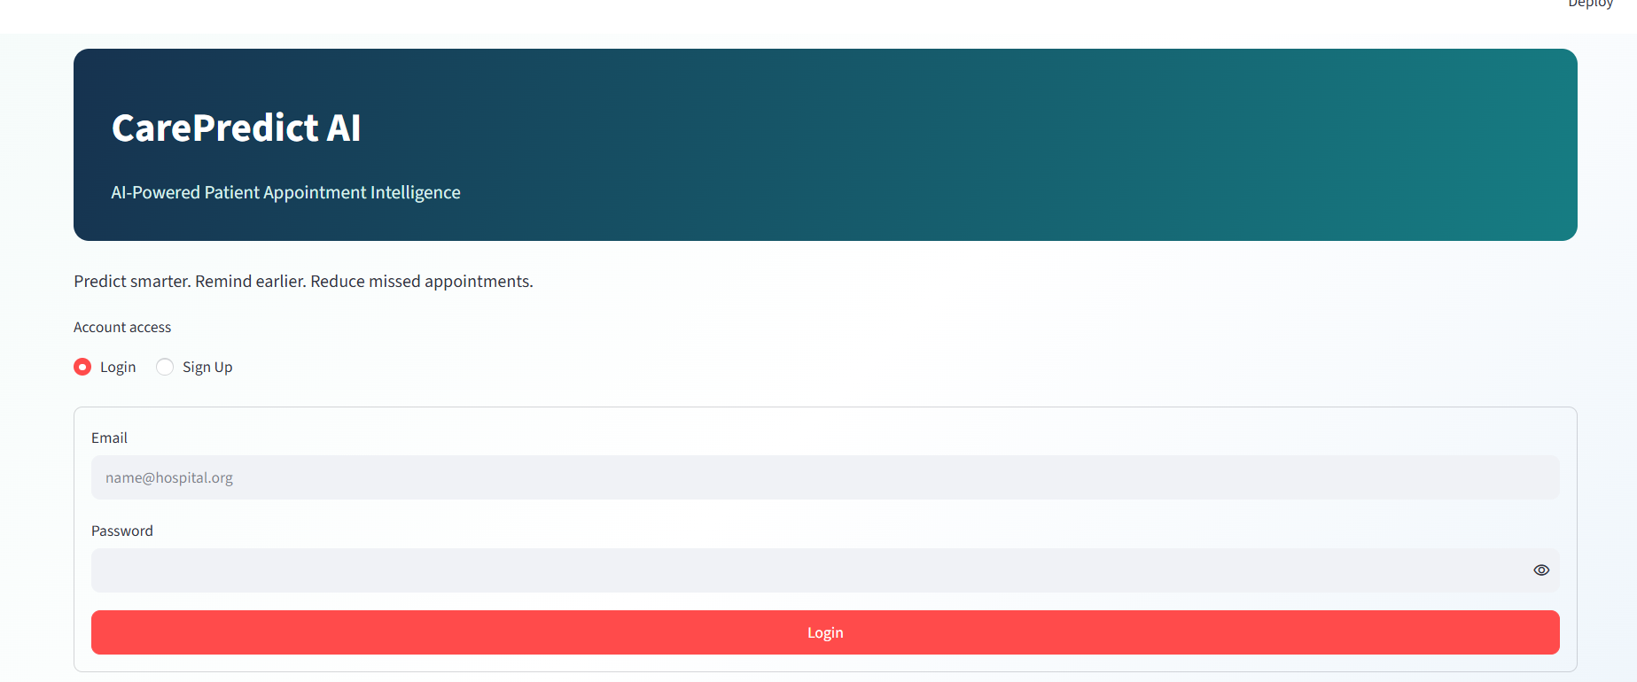
Description:A hero panel introduces CarePredict AI above a Login / Sign Up toggle. Login accepts any non-empty email and password for demo access. Sign Up collects full name, email, password, confirmation, and a role (Clinician, Care coordinator, Hospital administrator, or Student researcher), validating that required fields are filled and the passwords match before marking the session authenticated.

2. Home / Dashboard 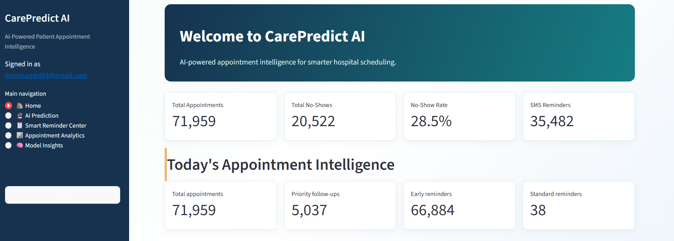
Description:The landing page after login shows total appointments, total no-shows, the no-show rate, and SMS reminders sent, followed by a second row of reminder-queue metrics (Priority Follow-ups, Early Reminders, Standard Reminders), a show-up vs no-show bar chart, four feature cards explaining the app's capabilities, and a button that routes into AI Prediction.

3. AI Prediction 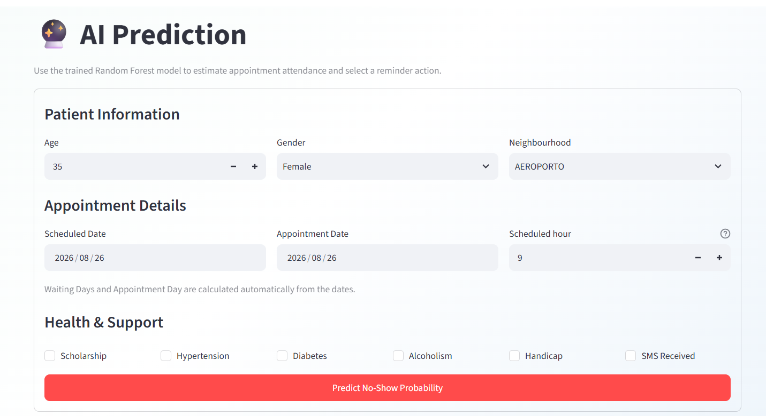
Description:A form for Patient Information, Appointment Details, and Health & Support flags. On submit, the trained Random Forest model returns a no-show probability, a recommended reminder action, and the automatically computed waiting days and appointment day.

4. Smart Reminder Center 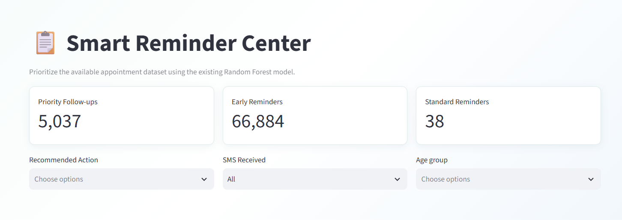
Scores the entire existing appointment dataset at once and presents it as a filterable, sortable reminder priority queue - filterable by Recommended Action, SMS Received, and Age Group - with summary counts, a capped preview table, and a CSV download of the full filtered list.

5. Appointment Analytics 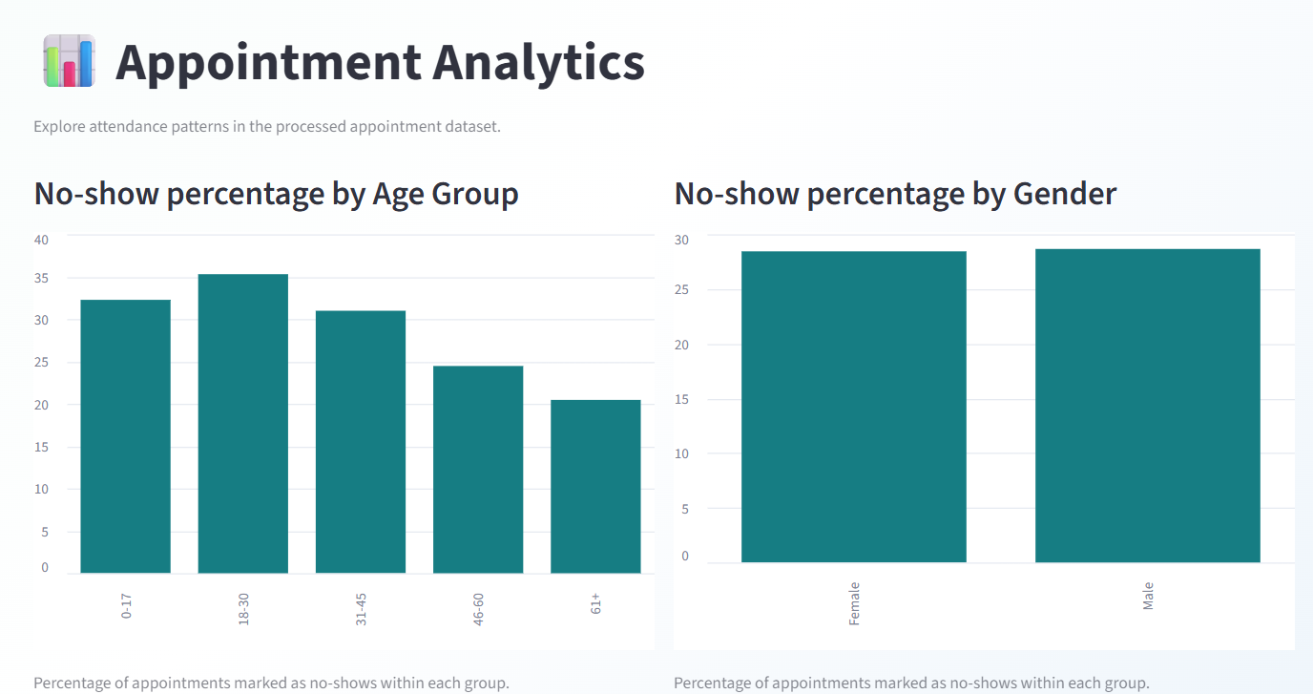 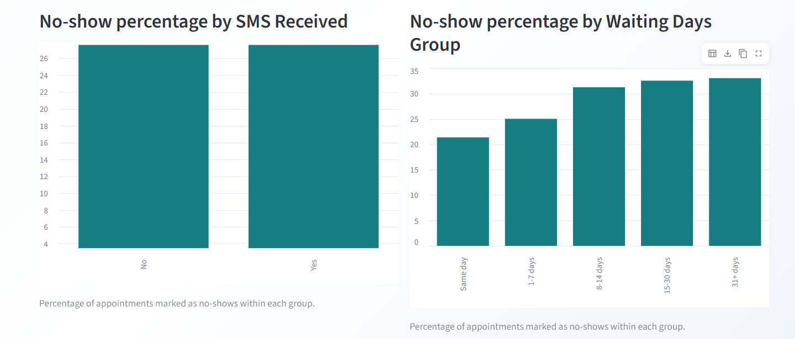 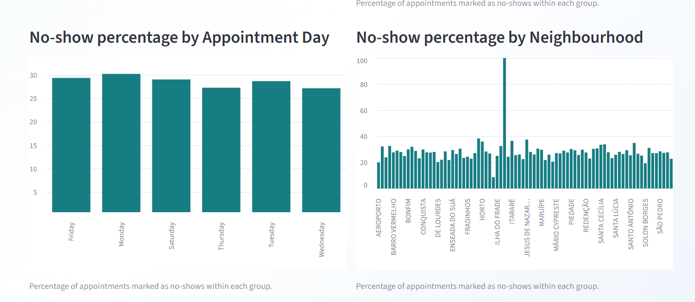
Description:Six bar charts of no-show percentage by Age Group, Gender, SMS Received, Waiting Days Group, Appointment Day, and Neighbourhood, followed by a Key Findings summary naming the highest-no-show category within each group.

6. Model Insights 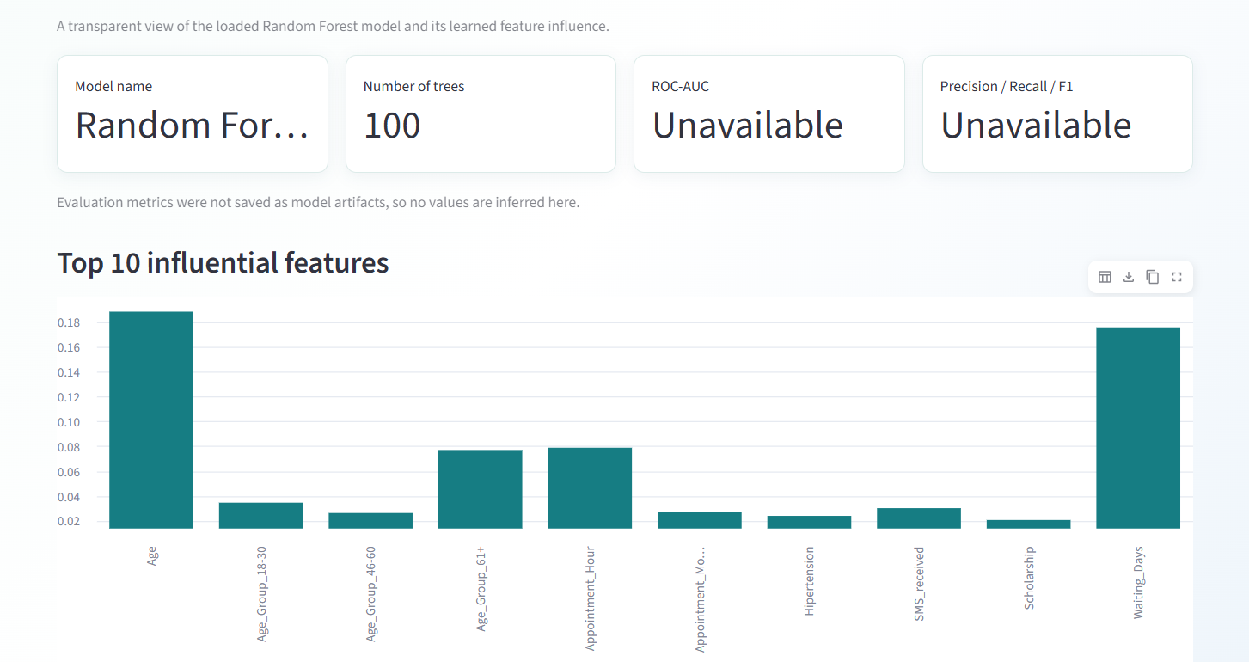
Description:Reports the loaded Random Forest's model name and tree count, explicitly marks ROC-AUC and Precision/Recall/F1 as Unavailable (since no evaluation metrics were saved as model artifacts), charts the top 10 most influential features, and summarizes the end-to-end prediction pipeline.

Conclusion:
CarePredict AI is a Streamlit-based decision-support tool that turns a patient's appointment and health details into an actionable no-show risk classification. A Random Forest classifier, trained on processed appointment data, estimates the probability that a given appointment will be missed, and that probability is mapped into one of three reminder tiers - Standard Reminder, Early Reminder, or Priority Follow-up - using fixed 30% and 60% thresholds.
The application is packaged as a five-page Streamlit dashboard - Home, AI Prediction, Smart Reminder Center, Appointment Analytics, and Model Insights - behind a lightweight, session-based demo authentication layer, and is supported by two exploratory data analysis scripts (inspect_data.py and eda.py) that summarize data quality and no-show patterns across gender, SMS reminder status, age group, appointment day, and waiting-time group. The project highlights how a single trained classifier can be turned into a practical, filterable reminder-prioritization workflow for hospital staff.

