MedSim AI: Synthetic Patient Scenario Studio
Project Description:
MedSim AI is a Generative AI web application that lets healthcare educators produce diverse, realistic clinical practice scenarios without ever touching real patient information. An instructor selects a specialty, learner level, learning objective, difficulty and case type, and the system uses Google's Gemini model to generate one complete, entirely fictional patient case - profile, chief complaint, initial presentation, vital signs, investigation results, clinical reasoning questions with expected answers and scoring guidance, instructor notes, and a hidden diagnosis.
The platform is built around dual-role workflows. Instructors author, review, publish and manage scenarios; students play published cases through a four-stage progressive clinical reasoning simulation and receive an automatically scored evaluation of their reasoning. Because every scenario is synthetically generated against a fixed structured schema, educators get unlimited varied practice material with zero patient-privacy exposure.
Scenarios:
Scenario 1: An instructor preparing a cardiology teaching session opens Create Simulation, selects the specialty, an intermediate learner level, a learning objective focused on chest pain differentials, a difficulty setting and a case type. The system returns a complete fictional patient case with a new patient name, plausible demographics and history, vitals, investigation results, reasoning questions and instructor notes, which the instructor reviews and publishes to the class.
Scenario 2: A student logs in, opens a published case, and works through the four simulation stages - reviewing the patient presentation and vital signs, then submitting their clinical reasoning and management plan. The answer is evaluated against the case's expected answer and scoring guidance, and the student receives a 0-100 score with an assessment, what they did well, what reasoning was missing, and one concrete improvement suggestion.
Scenario 3: The Gemini API is temporarily unavailable due to a quota limit while a student is mid-simulation. Rather than failing, the application falls back to a deterministic local evaluator that scores the submission on keyword overlap and coverage against the expected answer, so the simulation still completes and the session is still recorded.
Technical Architecture:
Streamlit Frontend (app.py entrypoint & router)
↓
UI Layer (ui_components.py - instructor & student views)
↓
Authentication Layer (auth.py - bcrypt hashing)
↓
AI Services (ai_service.py - Gemini generation & evaluation)
↓
Structured Output Schema (models.py - Pydantic Scenario)
↓
Data Layer (database.py - SQLite medsim.db)

medsim.db (users, scenarios, sessions tables) | .env (GEMINI_API_KEY) | assets/style.css (custom design system)
Description:
The application follows a modular monolith design centred on a Streamlit control loop. app.py is the entrypoint: it calls database.init_db() to provision tables before any page renders, configures the page, injects the custom stylesheet from assets/style.css, bootstraps the session-state variables, and dispatches to a view function based on st.session_state.current_page. All view rendering lives in ui_components.py, which delegates authentication to auth.py, persistence to database.py, and generation and evaluation to ai_service.py.
ai_service.py holds the Generative AI logic. generate_scenario() builds a configuration-driven prompt and calls the Gemini API with a response schema, so the model must return JSON matching the Pydantic Scenario model in models.py - this is what makes the output reliably structured rather than free text. evaluate_student_answer() scores a student's submitted reasoning against the case's expected answer and scoring guidance, and falls back to a deterministic local evaluator when the API is unavailable. database.py manages a local SQLite database (medsim.db) with three tables - users, scenarios and sessions - and auth.py hashes passwords with bcrypt before they are ever stored.
Key Functions & Modular Components:
- Scenario Generation Module (ai_service.generate_scenario): builds a configuration-driven prompt from specialty, learner level, objective, difficulty and case type, and calls Gemini with a response schema to return one complete fictional case.
- Structured Output Schema (models.py): Pydantic models - PatientProfile, VitalSigns, Question and Scenario - that define and validate the exact shape every generated case must satisfy.
- Answer Evaluation Module (ai_service.evaluate_student_answer): scores a student's clinical reasoning from 0 to 100 against the expected answer and scoring guidance, returning structured feedback.
- Local Fallback Evaluator (ai_service._local_evaluation): a deterministic keyword-coverage scorer that keeps the simulation functional when Gemini is unavailable or quota-limited.
- Authentication Module (auth.py): bcrypt password hashing and verification, plus login and registration helpers backed by the users table.
- Data Access Layer (database.py): SQLite schema initialization and all create, read, update and delete operations for users, scenarios and sessions, including instructor and student statistics.
- UI Layer (ui_components.py): renders every page - login, registration, dashboards, scenario creation, review, management, the simulation player and results - and manages role-based navigation.
Pre-requisites:
- Python Programming Proficiency: Python Documentation
- Streamlit Framework Knowledge: Streamlit Documentation
- Google Gen AI SDK Familiarity: Google Gen AI SDK Documentation
- Gemini API Key Setup: Google AI Studio API Keys
- Structured Output Knowledge: Gemini Structured Output Guide
- Pydantic Schema Validation: Pydantic Documentation
- Password Hashing with bcrypt: bcrypt Documentation
- Environment Variable Handling: python-dotenv Documentation
- SQLite Database Skills: Python sqlite3 Documentation
- Version Control with Git: Git Documentation
Project Workflow:
Milestone 1: Project Setup and Environment Configuration
- Activity 1.1: Install the project dependencies from requirements.txt.
- Activity 1.2: Configure the .env file with a valid GEMINI_API_KEY.
- Activity 1.3: Protect local artifacts using .gitignore.
Milestone 2: Structured Output Schema Design
- Activity 2.1: Define the PatientProfile, VitalSigns and Question models.
- Activity 2.2: Define the composite Scenario model used as the AI response schema.
Milestone 3: Database Schema and Data Access Layer
- Activity 3.1: Create the users, scenarios and sessions tables in SQLite.
- Activity 3.2: Implement scenario persistence, publishing and deletion helpers.
- Activity 3.3: Implement instructor and student statistics queries.
Milestone 4: Authentication with Password Hashing
- Activity 4.1: Implement bcrypt password hashing and verification.
- Activity 4.2: Implement the login and registration flows.
Milestone 5: AI Scenario Generation Service
- Activity 5.1: Create the Gemini client from the environment key.
- Activity 5.2: Engineer the scenario generation prompt.
- Activity 5.3: Enforce structured JSON output against the Scenario schema.
Milestone 6: AI Answer Evaluation and Local Fallback
- Activity 6.1: Engineer the evaluation prompt with a machine-readable SCORE line.
- Activity 6.2: Parse and normalize the returned score.
- Activity 6.3: Implement the deterministic local fallback evaluator.
Milestone 7: Application Entrypoint, Styling and Routing
- Activity 7.1: Configure the Streamlit page and load the custom stylesheet.
- Activity 7.2: Bootstrap the session-state variables.
- Activity 7.3: Implement the page router and role-aware top navigation.
Milestone 8: Instructor Workflows
- Activity 8.1: Build the instructor dashboard and statistics view.
- Activity 8.2: Build the Create Simulation form and generation pipeline.
- Activity 8.3: Build the review, publish and My Scenarios management views.
Milestone 9: Student Simulation Player and Results
- Activity 9.1: Implement the four-stage progressive reasoning state machine.
- Activity 9.2: Implement answer submission, evaluation and results display.
- Activity 9.3: Persist completed sessions and student progress.
Milestone 10: Deployment, Testing and Conclusion
- Activity 10.1: Run the application locally with Streamlit.
- Activity 10.2: Verify authentication, generation, simulation and fallback behavior.
Milestone 1: Project Setup and Environment Configuration
This milestone prepares the local environment so the application can authenticate with the Gemini API and bootstrap its database on first run.
Activity 1.1: Install the Project Dependencies
requirements.txt lists five direct dependencies. Each is installed into a local virtual environment before the application is started.
streamlit
python-dotenv
bcrypt
pydantic
google-genai
requirements.txt - the project's direct dependencies
streamlit provides the web framework, python-dotenv loads environment variables from the local .env file, bcrypt handles password hashing, pydantic validates the structured scenario schema, and google-genai is the SDK used to call the Gemini model.
Activity 1.2: Configure the Gemini API Key
The project ships a .env.example template. The developer copies it to .env in the project root and supplies a valid key. ai_service.py calls load_dotenv() at import time and reads the key when constructing the client, raising a clear error if it is missing.
GEMINI_API_KEY=your_api_key_here
.env - the single required environment variable
def get_gemini_client():
"""Create and return the Gemini client."""
api_key = os.getenv("GEMINI_API_KEY")
if not api_key:
raise ValueError("GEMINI_API_KEY is missing. Add it to your .env file.")
return genai.Client(api_key=api_key)
ai_service.py - constructing the Gemini client from the environment
Activity 1.3: Protect Local Artifacts with .gitignore
.gitignore excludes the secret-bearing .env file, the local virtual environment directories (.venv/ and venv/), and medsim.db - the SQLite database generated on first run - so credentials and local user data never reach version control.
Milestone 2: Structured Output Schema Design
Structured outputs are the core of this project: rather than parsing free-form model text, models.py defines Pydantic models that the Gemini call is constrained to fill, so every generated case arrives in a predictable, validated shape.
Activity 2.1: Define the Component Models
Three component models describe the pieces of a case. PatientProfile captures the fictional patient's identity and background, VitalSigns captures the five recorded observations as strings (so units and qualifiers are preserved), and Question pairs each clinical reasoning prompt with the expected answer and the scoring guidance used later during evaluation.
class PatientProfile(BaseModel):
name: str
age: int
gender: str
occupation: str
past_medical_history: List[str]

class VitalSigns(BaseModel):
heart_rate: str
blood_pressure: str
respiratory_rate: str
temperature: str
oxygen_saturation: str

class Question(BaseModel):
question_text: str
expected_answer: str
scoring_guidance: str
models.py - the component models
Activity 2.2: Define the Composite Scenario Model
Scenario composes those pieces into one complete case. Note the deliberate separation of student-facing and instructor-facing fields: chief_complaint, initial_presentation, vital_signs and investigation_results are progressively revealed to the learner, while instructor_notes and hidden_diagnosis are held back. This single model is what gets passed to Gemini as the response schema.
class Scenario(BaseModel):
profile: PatientProfile
chief_complaint: str
initial_presentation: str
vital_signs: VitalSigns
investigation_results: str
questions: List[Question]
instructor_notes: str
hidden_diagnosis: str
models.py - the composite Scenario model
Milestone 3: Database Schema and Data Access Layer
database.py owns all persistence. It uses Python's built-in sqlite3 module against a local file, medsim.db, and sets conn.row_factory = sqlite3.Row so query results can be converted to dictionaries.
Activity 3.1: Create the Database Schema
init_db() creates three tables if they do not already exist. app.py calls it before any page renders, so the schema is always provisioned on first run.
Table | Purpose | Key columns
users | Instructor and student accounts. | id, full_name, email (unique), password_hash, role, created_at
scenarios | Generated cases owned by an instructor. | id, instructor_id, title, specialty, learner_level, learning_objective, difficulty, case_type, scenario_data, published, created_at
sessions | Completed student attempts at a scenario. | id, student_id, scenario_id, score, completed, created_at

CREATE TABLE IF NOT EXISTS scenarios (
id INTEGER PRIMARY KEY AUTOINCREMENT,
instructor_id INTEGER NOT NULL,
title TEXT NOT NULL,
specialty TEXT NOT NULL,
learner_level TEXT NOT NULL,
learning_objective TEXT NOT NULL,
difficulty TEXT NOT NULL,
case_type TEXT NOT NULL,
scenario_data TEXT NOT NULL,
published BOOLEAN NOT NULL DEFAULT 0,
created_at DATETIME DEFAULT CURRENT_TIMESTAMP,
FOREIGN KEY(instructor_id) REFERENCES users(id)
)
database.py - the scenarios table
The generated case itself is stored in the scenario_data TEXT column as serialized JSON, while the generation parameters (specialty, learner level, objective, difficulty, case type) are stored as their own columns so scenarios can be listed and filtered without deserializing every record.
Activity 3.2: Scenario Persistence and Publishing
save_scenario() inserts a new case and returns its id. Publishing is controlled by the published flag: toggle_publish_scenario() flips it, and set_publish_scenario() sets it explicitly. Both are scoped by instructor_id in the WHERE clause, so an instructor can only change scenarios they own. get_published_scenarios() is the student-facing query, joining users to include the instructor's name, and delete_scenario() removes the scenario's sessions before the scenario itself so no orphaned session rows remain.
def toggle_publish_scenario(scenario_id: int, instructor_id: int) -> None:
"""Toggles the published flag of a scenario owned by the instructor."""
conn = get_connection()
cursor = conn.cursor()
cursor.execute(
"""
UPDATE scenarios
SET published = CASE WHEN published = 1 THEN 0 ELSE 1 END
WHERE id = ? AND instructor_id = ?
""",
(scenario_id, instructor_id)
)
conn.commit()
conn.close()
database.py - ownership-scoped publish toggle
Every query in database.py uses parameterized statements with ? placeholders rather than string formatting, which protects the database against SQL injection.
Activity 3.3: Instructor and Student Statistics
get_instructor_stats() returns four real dashboard figures computed directly from the database: the instructor's total scenarios, how many are published, how many completed student attempts those scenarios have received, and the average score across those attempts. get_student_stats() and get_student_sessions() give the learner-side equivalents - completed simulation count, average score, and a newest-first history of attempts joined to scenario details.
cursor.execute(
"""
SELECT AVG(s.score) FROM sessions s
JOIN scenarios sc ON s.scenario_id = sc.id
WHERE sc.instructor_id = ? AND s.completed = 1 AND s.score IS NOT NULL
""",
(instructor_id,)
)
avg_row = cursor.fetchone()[0]
avg_score = round(avg_row) if avg_row is not None else 0
database.py - average score across an instructor's scenarios
Milestone 4: Authentication with Password Hashing
auth.py sits between the UI layer and the users table, ensuring a plaintext password is never stored or compared directly.
Activity 4.1: Hash and Verify Passwords with bcrypt
hash_password() generates a fresh salt with bcrypt.gensalt() and hashes the password with it, so two users with the same password still produce different stored hashes. verify_password() uses bcrypt.checkpw(), which re-derives the hash using the salt embedded in the stored value and compares in constant time.
def hash_password(password: str) -> str:
"""Hashes a plaintext password using bcrypt."""
salt = bcrypt.gensalt()
hashed = bcrypt.hashpw(password.encode('utf-8'), salt)
return hashed.decode('utf-8')

def verify_password(plain_password: str, hashed_password: str) -> bool:
"""Verifies a plaintext password against a hashed password."""
return bcrypt.checkpw(plain_password.encode('utf-8'),
hashed_password.encode('utf-8'))
auth.py - salted bcrypt password hashing and verification
Activity 4.2: Login and Registration Flows
login_user() normalizes the email (stripped and lowercased), looks the user up, and returns the user dictionary only if verification succeeds - returning None for both a missing user and a wrong password, so the failure mode does not reveal which accounts exist. register_user() normalizes the email the same way, hashes the password before insertion, and returns None when database.create_user() reports a duplicate email via the users table's UNIQUE constraint.
def login_user(email: str, password: str) -> dict | None:
user = database.get_user_by_email(email.strip().lower())
if user is None:
return None
if not verify_password(password, user["password_hash"]):
return None
return user
auth.py - login with normalized email and hash verification
Milestone 5: AI Scenario Generation Service
generate_scenario() in ai_service.py is the heart of the Generative AI workflow: it turns the instructor's five configuration choices into one complete, validated, fictional clinical case.
Activity 5.1: Prompt Engineering for Scenario Generation
The function accepts specialty, learner_level, objective, difficulty and case_type, and interpolates them into a prompt that assigns the model the role of an educational clinical simulation designer. The prompt's requirements are what enforce the project's educational and safety goals - particularly the instruction to use a new fictional patient name every time (which produces the scenario diversity the project is built for), and the instruction that the hidden diagnosis must be supported by the case but must not appear in the student-facing chief complaint or initial presentation (which preserves the diagnostic challenge).
prompt = f"""
You are an educational clinical simulation designer.
Create ONE realistic, completely fictional clinical case for medical education.

Configuration:
- Specialty: {specialty}
- Learner level: {learner_level}
- Learning objective: {objective}
- Difficulty: {difficulty}
- Case type: {case_type}

Requirements:
- Use a NEW fictional patient name every time. Do not always use the same name.
- Generate a plausible age, gender, occupation and past medical history.
- Include chief complaint, initial presentation, vital signs and
investigation results.
- Include at least 2 clinical reasoning questions.
- For every question include expected_answer and scoring_guidance.
- Include instructor_notes and hidden_diagnosis.
- Keep all details internally consistent.
- The hidden diagnosis must be supported by the case but must NOT appear in
the student-facing chief complaint or initial presentation.
- Match the requested specialty, level, objective, difficulty and case type.
- This is a fictional educational simulation only, not real-patient advice.

Return ONLY data matching the supplied Scenario schema.
"""
ai_service.py - the scenario generation prompt
Difficulty variation and learner-level targeting are handled entirely through this prompt: the same code path produces a beginner or an advanced case depending on the values interpolated in, which is how the project delivers varied difficulty without separate generation logic.
Activity 5.2: Enforcing Structured JSON Output
The call to Gemini passes a config block that sets the response MIME type to application/json and supplies the Pydantic Scenario class as the response schema. This constrains the model to emit data matching the schema rather than prose. The SDK exposes an already-parsed object on response.parsed when available; if it is not, the code falls back to reading response.text and validating it explicitly with Scenario.model_validate(json.loads(text)), so an unstructured or malformed reply cannot silently pass through as a valid case.
response = client.models.generate_content(
model="gemini-2.5-flash",
contents=prompt,
config={
"response_mime_type": "application/json",
"response_schema": Scenario,
},
)

parsed = getattr(response, "parsed", None)
if parsed:
return parsed

text = getattr(response, "text", None)
if not text:
raise ValueError("Gemini returned an empty response.")
return Scenario.model_validate(json.loads(text))
ai_service.py - structured output with a Pydantic response schema
Any failure in this path is wrapped and re-raised as a RuntimeError carrying the underlying message, so the UI layer can report a generation failure clearly rather than surfacing a raw SDK traceback.
Milestone 6: AI Answer Evaluation and Local Fallback
evaluate_student_answer() scores a learner's submitted reasoning. Unlike generation, it returns formatted text rather than a JSON schema - but with a machine-readable first line so the interface can display a real score instead of a hardcoded value.
Activity 6.1: The Evaluation Prompt
The prompt supplies three inputs - the case's expected answer, its scoring guidance (used as the rubric), and the student's submission - and requests a fixed five-line output format. Two instructions are worth noting: the model is told explicitly not to award a high score merely because the answer is long, and it is reminded that this is a fictional educational case and must not produce personalized medical advice.
Evaluate ONLY the student's educational reasoning.
Give a score from 0 to 100 based on how well the student addresses the
expected reasoning and rubric. Do not give a high score merely because the
answer is long.

Return exactly this format:
SCORE: <integer 0-100>
ASSESSMENT: <one or two concise sentences>
CORRECT: <what the student did well>
MISSING: <important reasoning points that were missing or weak>
IMPROVEMENT: <one concise suggestion>

This is a fictional educational case. Do not provide personalized medical advice.
ai_service.py - the evaluation prompt's required output format
Activity 6.2: Score Extraction and Normalization
The returned text is searched with a case-insensitive regular expression for the SCORE line. If no SCORE line is present the response is rejected. If one is found, the value is clamped into the valid 0-100 range and written back into the text, so a model reply containing an out-of-range number is corrected before it reaches the interface or the database.
match = re.search(r"SCORE\s*:\s*(\d{1,3})", text, re.IGNORECASE)
if not match:
raise ValueError("Gemini evaluation did not contain a SCORE line.")

score = max(0, min(100, int(match.group(1))))
text = re.sub(
r"SCORE\s*:\s*\d{1,3}",
f"SCORE: {score}",
text,
count=1,
flags=re.IGNORECASE,
)
ai_service.py - extracting and clamping the returned score
Activity 6.3: The Deterministic Local Fallback Evaluator
If the Gemini call fails for any reason - a missing key, a network error, or a quota limit - the exception is caught and _local_evaluation() runs instead, so a student is never left with a broken simulation. An empty submission returns a score of zero with explanatory feedback. Otherwise, both the expected answer and the student answer are reduced to sets of meaningful words (stop words and words of three characters or fewer are discarded), and the overlap between those sets gives a coverage ratio.
overlap = len(expected_words & answer_words)
coverage = overlap / max(1, len(expected_words))

# Reward reasoning length modestly, but do not let length dominate.
score = round(min(100, 35 + coverage * 55 + min(len(answer_words), 80) / 80 * 10))
ai_service.py - the deterministic fallback score
The formula weights conceptual coverage far more heavily than length: coverage contributes up to 55 points while answer length contributes at most 10, on top of a 35-point base. The fallback then emits the same five-line SCORE / ASSESSMENT / CORRECT / MISSING / IMPROVEMENT format as the Gemini path, so the interface consuming it needs no special handling.
Milestone 7: Application Entrypoint, Styling and Routing
app.py is a compact entrypoint whose only responsibilities are bootstrapping, configuration and dispatch; all rendering is delegated to ui_components.py.
Activity 7.1: Page Configuration and Custom Styling
database.init_db() is called at module level, before main() runs, so the tables always exist before any page renders. main() then configures the page and calls load_css(), which reads assets/style.css and injects it with unsafe_allow_html=True. The loader catches FileNotFoundError and passes silently, so a missing stylesheet degrades the appearance without breaking the application.
st.set_page_config(
page_title="MedSim AI",
page_icon="🩺",
layout="wide",
initial_sidebar_state="collapsed"
)

# Load custom CSS
load_css("assets/style.css")
app.py - Streamlit page configuration and stylesheet injection
Activity 7.2: Session State Bootstrap
Four session-state variables are initialized if absent: current_page (defaulting to the login view), user_role (instructor or student), user_id, and user_name. These drive both routing and role-based access for the rest of the session.
if 'current_page' not in st.session_state:
st.session_state.current_page = 'auth_login'
if 'user_role' not in st.session_state:
st.session_state.user_role = None # 'instructor' or 'student'
if 'user_id' not in st.session_state:
st.session_state.user_id = None
if 'user_name' not in st.session_state:
st.session_state.user_name = None
app.py - session state bootstrap
Activity 7.3: Page Router and Role-Aware Navigation
The top navigation bar is rendered only when the current page is not one of the two authentication pages, so the login and registration screens stay clean. render_top_nav() in ui_components.py inspects the stored user role and conditionally shows instructor-only tabs such as Create Sim and My Scenarios. The router itself is a straightforward dispatch on current_page, with a catch-all error branch for an unrecognized value.
page = st.session_state.current_page

if page == 'auth_login':
ui_components.render_login()
elif page == 'auth_register':
ui_components.render_register()
elif page == 'dashboard':
ui_components.render_dashboard(st.session_state.user_role)
elif page == 'create_sim':
ui_components.render_create_simulation()
elif page == 'review_sim':
ui_components.render_review_simulation()
elif page == 'play_sim':
ui_components.render_simulation_player()
elif page == 'results':
ui_components.render_results()
elif page == 'assistant':
ui_components.render_assistant()
elif page == 'my_scenarios':
ui_components.render_my_scenarios()
else:
st.error("Page not found.")
app.py - the page router
Milestone 8: Instructor Workflows
The instructor side of the application covers authoring, reviewing, publishing and managing scenarios, all rendered from ui_components.py against the data access layer.
Activity 8.1: Instructor Dashboard
The dashboard is the instructor's hub after login. It presents the real statistics returned by get_instructor_stats() - total scenarios created, published cases, completed student attempts across those scenarios, and the average score - and provides entry points to the authoring and management views through the role-aware top navigation.
Activity 8.2: Create Simulation and the Generation Pipeline
The Create Simulation form collects the five generation parameters: specialty, learner level, learning objective, difficulty and case type. On submission, those values are passed to ai_service.generate_scenario(), which returns a validated Scenario object. The generated case is then serialized and persisted with save_scenario() together with its generation parameters, defaulting to unpublished so the instructor can review it before learners can see it.
scenario = ai_service.generate_scenario(
specialty=specialty,
learner_level=learner_level,
objective=objective,
difficulty=difficulty,
case_type=case_type,
)

scenario_id = database.save_scenario(
instructor_id, title, specialty, learner_level, learning_objective,
difficulty, case_type, scenario_data, published=False
)
The generation-to-persistence pipeline
Because generation depends on an external service, the creation flow is written defensively: a generation failure raises a RuntimeError from ai_service.py rather than producing a partial record, and the application surfaces the problem instead of saving an invalid scenario. Whatever path is taken, the object reaching save_scenario() always satisfies the Pydantic Scenario schema.
Activity 8.3: Review, Publish and My Scenarios
The review view renders the full generated case - patient profile, chief complaint, presentation, vitals, investigation results, questions with their expected answers and scoring guidance, instructor notes and hidden diagnosis - so the instructor can validate educational quality before release. My Scenarios lists everything the instructor owns, newest first, via get_instructor_scenarios(), with publish and delete controls wired to toggle_publish_scenario() and delete_scenario(). Both mutations are scoped by instructor_id, so one instructor cannot alter another's material, and deletion removes the scenario's sessions first.
Milestone 9: Student Simulation Player and Results
The student side plays published scenarios through a four-stage progressive reasoning state machine, tracked entirely in Streamlit session state so progress survives the reruns Streamlit performs on every interaction.
Activity 9.1: The Four-Stage State Machine
Progression is tracked with session-state keys including sim_stage, sim_scenario_id, sim_answer, sim_saved, sim_final_score and sim_feedback. Case information is revealed progressively rather than all at once, which is what forces genuine clinical reasoning instead of pattern matching against a full case dump.
Stage | What the learner sees | What happens
1 - Patient Presentation | Demographics, chief complaint, initial presentation and vital signs. | The learner reviews the case before any questions are shown.
2 - Clinical Reasoning | The scenario's Question items. | The learner submits diagnostic reasoning and a management plan, captured in sim_answer.
3 - Evaluation | A processing state. | evaluate_student_answer() scores the submission against the expected answer and scoring guidance.
4 - Results | Score, assessment, correct points, missing points and an improvement suggestion. | The completed session is persisted to the database.
Activity 9.2: Answer Submission and Evaluation
When the learner submits in Stage 2, ui_components.py calls ai_service.evaluate_student_answer() with the student's text, the question's expected_answer and its scoring_guidance as the rubric. The returned five-line block is parsed for the SCORE value and the qualitative sections, which are displayed in Stage 4. If Gemini is unavailable the local fallback described in Milestone 6 supplies the same structure transparently, so the learner's experience is uninterrupted.
Activity 9.3: Session Persistence and Progress
On reaching Stage 4, the attempt is committed with save_session(), which stores the student id, scenario id and score and marks the row completed. That single insert feeds several views at once: get_student_stats() and get_student_sessions() drive the learner's completed count, average score and attempt history, while the same rows feed the instructor dashboard's attempt and average-score figures. On logout, the simulation runtime keys are purged from session state so no partial progress leaks between users sharing a browser.
def save_session(student_id: int, scenario_id: int, score: int) -> int:
"""Saves a completed student session and returns its id."""
conn = get_connection()
cursor = conn.cursor()
cursor.execute(
"""
INSERT INTO sessions (student_id, scenario_id, score, completed)
VALUES (?, ?, ?, 1)
""",
(student_id, scenario_id, score)
)
conn.commit()
session_id = cursor.lastrowid
conn.close()
return session_id
database.py - persisting a completed simulation session
Milestone 10: Deployment, Testing and Conclusion
The final milestone covers running the application locally and verifying each subsystem end to end.
Activity 10.1: Run the Application Locally
With a virtual environment created and activated, dependencies installed and the .env file populated, the application is launched with Streamlit:
python -m venv .venv
.venv\Scripts\activate # Windows
source .venv/bin/activate # macOS / Linux

pip install -r requirements.txt

streamlit run app.py
Creating the environment, installing dependencies and running the application
Streamlit starts a local development server (by default at http://localhost:8501) and opens the application in the browser. On the very first run, database.init_db() provisions medsim.db with the users, scenarios and sessions tables, and the login page is presented.
Activity 10.2: Verify End-to-End Behavior
- Authentication check: register an instructor and a student account, confirm a duplicate email is rejected, confirm a wrong password fails, and inspect the users table to confirm password_hash stores a bcrypt hash rather than plaintext.
- Generation check: create scenarios across different specialties, learner levels and difficulties, and confirm each returns a distinct fictional patient name and a case that matches the requested configuration.
- Structured output check: confirm every generated case contains all Scenario fields, including at least two questions each carrying an expected answer and scoring guidance.
- Publishing check: confirm an unpublished scenario is invisible to students, that publishing makes it appear, and that deleting a scenario also removes its sessions.
- Simulation check: play a published case through all four stages and confirm the hidden diagnosis is not revealed in the student-facing presentation.
- Evaluation check: submit a strong answer and a weak answer and confirm the scores differ sensibly and stay within 0-100.
- Fallback check: temporarily remove or invalidate the API key and confirm the local evaluator still produces a score and structured feedback rather than an error.
- Persistence check: confirm a completed session updates both the student's history and the instructor's attempt count and average score.
Exploring the Application's Pages:
1. Login / Register
The entry point of the application. Login verifies the submitted email and password against the bcrypt hash stored in the users table and populates the session with the user's id, name and role. Registration collects a full name, email, password and role, hashes the password before storage, and rejects an email that is already registered.
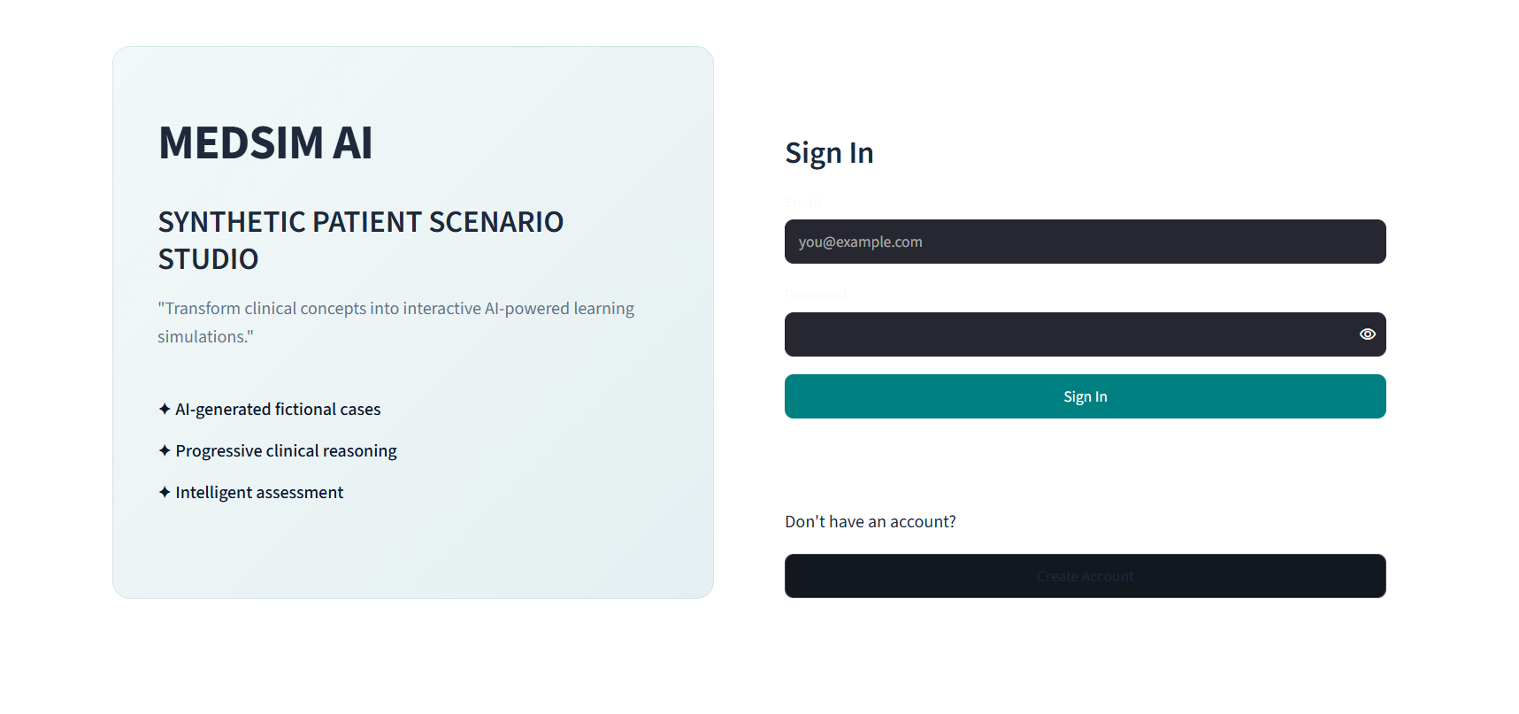
2. Dashboard
A role-aware landing page. Instructors see their real scenario statistics - total scenarios, published cases, completed student attempts and average score - with entry points into authoring and management. Students see their completed simulation count, average score and recent attempt history.
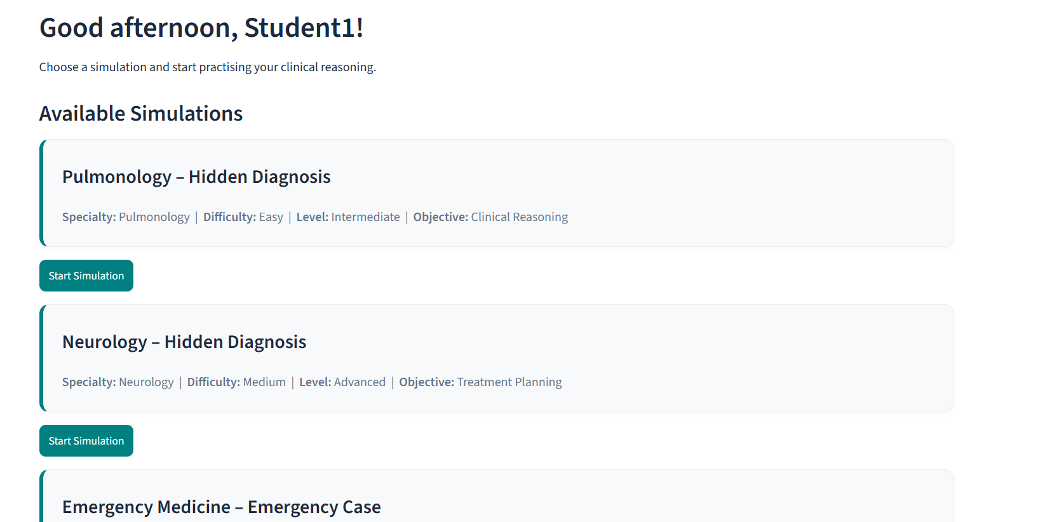
3. Create Simulation
The instructor authoring form. It collects specialty, learner level, learning objective, difficulty and case type, sends them to the Gemini-backed generation service, and returns a complete fictional case validated against the Scenario schema, saved as unpublished pending review.
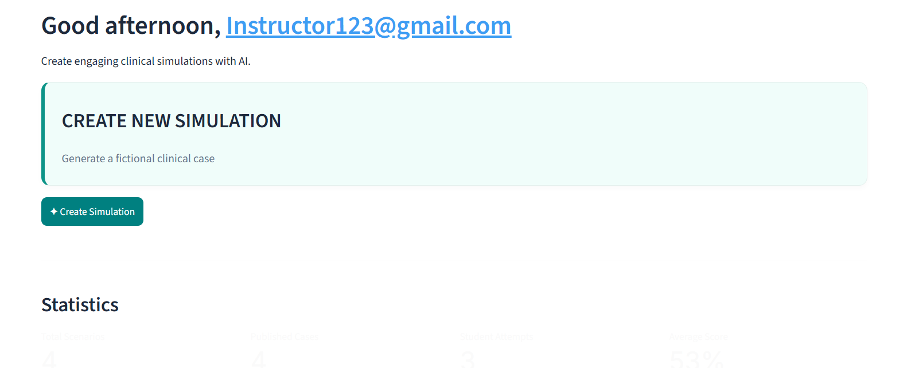
4. Review Simulation
Displays the full generated case for instructor validation - patient profile, chief complaint, initial presentation, vital signs, investigation results, each reasoning question with its expected answer and scoring guidance, the instructor notes, and the hidden diagnosis - before the case is released to learners.
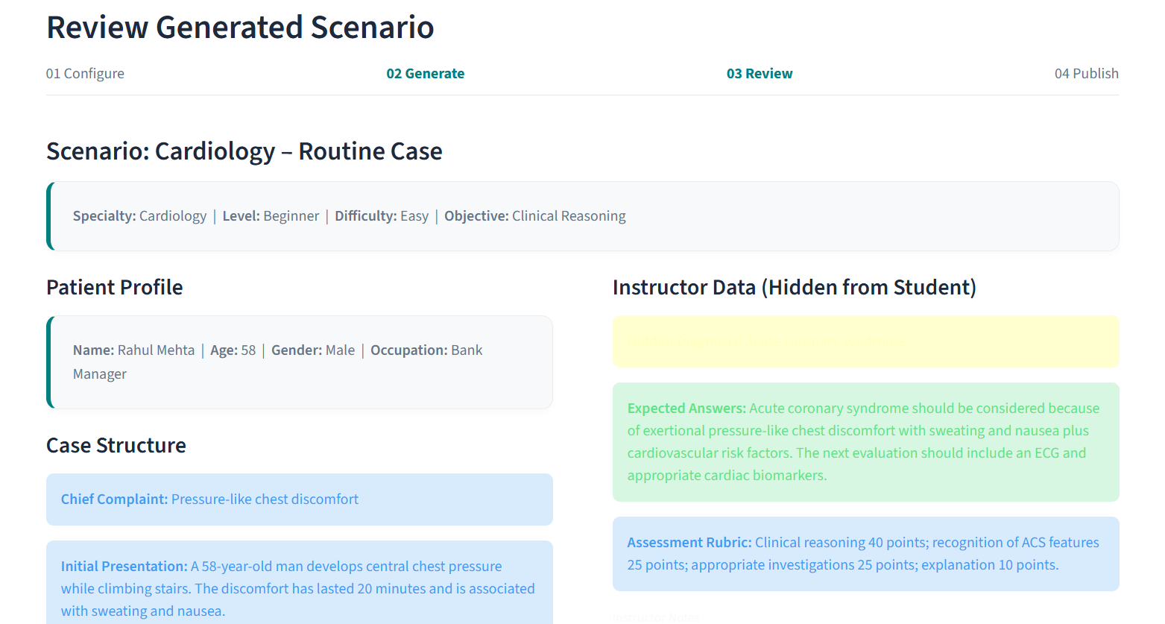
5. My Scenarios
Lists every scenario the signed-in instructor owns, newest first, with its specialty, learner level, difficulty, objective, case type, publication state and creation date. Publish, unpublish and delete controls act only on scenarios the instructor owns.
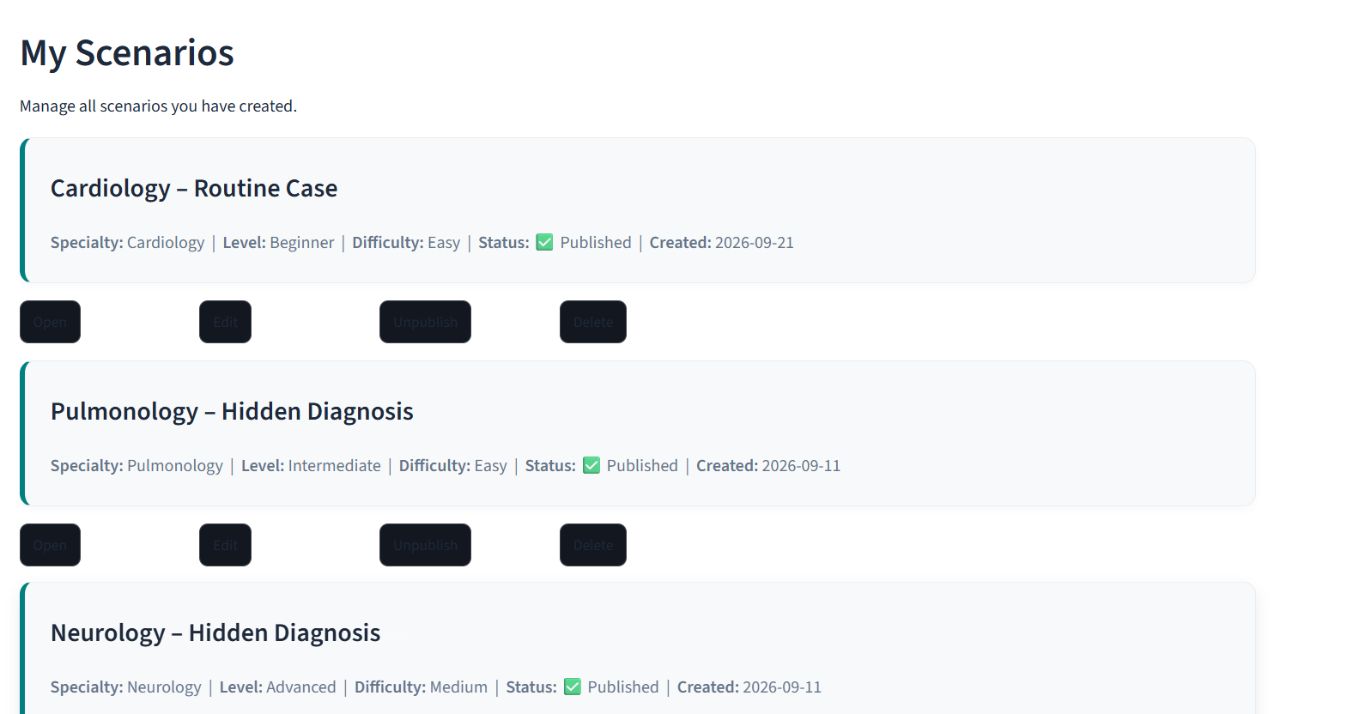
6. Simulation Player
The student-facing runtime. It progresses through the four stages - patient presentation and vitals, clinical reasoning and answer submission, evaluation, and results - revealing case information progressively and keeping the hidden diagnosis out of the student-facing text.
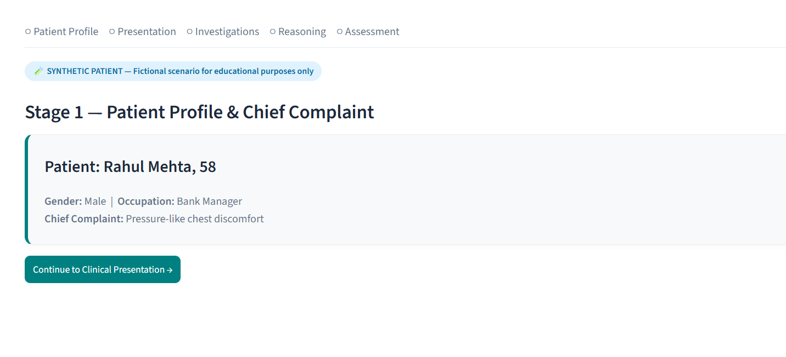
7. Results
Presents the evaluated outcome: the 0-100 score, a concise assessment, what the learner reasoned well, which important points were missing or weak, and one improvement suggestion. The completed session is persisted so it feeds both student progress and instructor statistics.
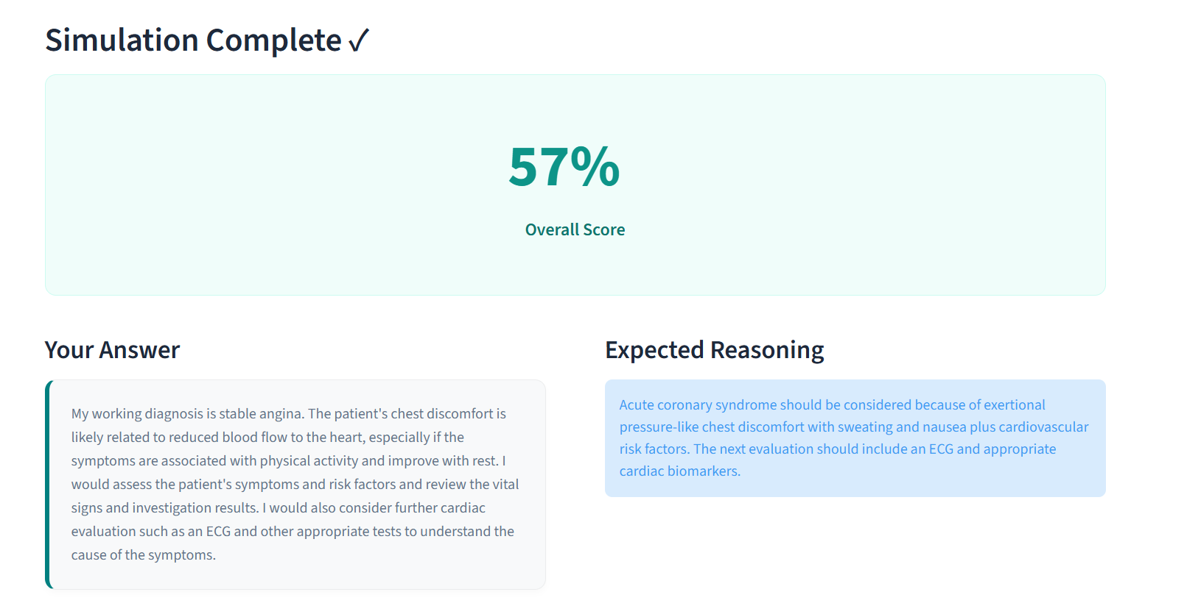
Conclusion:
MedSim AI is a Generative AI application that solves a concrete problem in healthcare education: instructors need diverse, realistic practice scenarios, but real patient records cannot be used for teaching without exposing private information. The system generates entirely fictional clinical cases on demand from five instructor-chosen parameters - specialty, learner level, learning objective, difficulty and case type - using Google's Gemini model constrained by a Pydantic response schema, so every case arrives complete and structurally valid rather than as free-form text needing manual parsing.
Each generated scenario carries a fictional patient profile, chief complaint, initial presentation, vital signs, investigation results, clinical reasoning questions with expected answers and scoring guidance, instructor notes, and a hidden diagnosis deliberately kept out of the student-facing material. Instructors review and publish cases through a Streamlit dashboard backed by a SQLite database with bcrypt-hashed authentication; students play published cases through a four-stage progressive reasoning simulation and receive an automatically scored evaluation with structured feedback, backed by a deterministic local fallback evaluator so the experience survives an API outage.
Completed sessions feed both learner progress tracking and instructor-level analytics, closing the loop from scenario authoring to measured learning outcomes. The project demonstrates how structured outputs and careful prompt engineering can turn a general-purpose language model into a dependable, privacy-safe teaching tool that produces unlimited varied practice material for healthcare educators.

