2. PROJECT INTRODUCTION
In today's transportation and logistics industry, managing a fleet of vehicles efficiently is essential for reducing operational costs, improving driver performance, and ensuring the safety of vehicles. Logistics companies operate multiple delivery vehicles across different locations, making it difficult to continuously monitor vehicle movements, driving behaviour, fuel consumption, and compliance with assigned routes.
The GPS Tracker Fleet Violation and Idling Cost Engine is a Python-based software system designed to monitor and analyse GPS data received from delivery vehicles. The system processes GPS tracker records containing vehicle ID, driver details, timestamps, geographical coordinates, speed, and ignition status to identify different types of driving violations and operational issues.
The system detects five major events: geofence violations, overspeeding, excessive idling, night driving, and GPS signal loss. It uses predefined business rules and consecutive GPS readings to identify these events accurately. Additionally, it calculates the fuel cost wasted during vehicle idling based on the vehicle's idle fuel consumption rate and the current fuel price.
The system also evaluates individual driver performance by assigning a daily score based on the violations detected. Finally, it generates an event log for each vehicle and a daily fleet report containing violation details, idling costs, and driver performance scores.
The proposed system aims to help fleet owners make better operational decisions, reduce unnecessary fuel expenses, monitor driver behaviour, and improve overall fleet management through automated GPS data processing and rule-based analysis.

3. PROBLEM STATEMENT
Logistics companies manage multiple delivery vehicles that travel across different geographical locations every day. Monitoring vehicle movements, driver behaviour, speed limits, fuel consumption, and route compliance manually is difficult and time-consuming. Without an automated monitoring system, fleet owners may fail to identify vehicles travelling outside their assigned zones, overspeeding, excessive engine idling, and unauthorized night driving.
Furthermore, GPS connectivity interruptions can result in missing vehicle location information, making it difficult to maintain accurate monitoring records. Excessive idling also leads to unnecessary fuel consumption and increased operational expenses. The absence of a systematic driver performance evaluation method makes it challenging for fleet owners to identify unsafe driving patterns and take corrective actions.
Therefore, there is a need for an automated GPS-based monitoring system that can process vehicle tracking data, detect violations using predefined business rules, calculate fuel wastage costs, and evaluate driver performance.
The GPS Tracker Fleet Violation and Idling Cost Engine aims to address these challenges by developing a Python-based system that analyses GPS tracker data, identifies five major vehicle events, calculates idling fuel costs, assigns daily driver scores, and generates comprehensive fleet reports.

4. PROJECT OBJECTIVES
The main objective of the GPS Tracker Fleet Violation and Idling Cost Engine is to develop an automated Python-based system that monitors vehicle activities, detects driving violations, calculates fuel wastage costs, and evaluates driver performance using GPS tracker data.
The specific objectives of the project are:
- Vehicle Registration: To register and maintain vehicle details, including vehicle ID, driver information, assigned geographical zone, speed limit, and idle fuel consumption rate.
- Geofence Monitoring: To monitor vehicle locations and identify geofence violations when vehicles move outside their assigned geographical boundaries.
- Overspeed Detection: To detect vehicles exceeding their permitted speed limits using predefined speed thresholds and consecutive GPS readings.
- Idling Detection: To identify vehicles whose engines remain ON while stationary for more than 10 consecutive minutes.
- Night Driving Detection: To identify vehicle movements occurring between 11:00 PM and 5:00 AM.
- GPS Connectivity Monitoring: To detect GPS signal interruptions when the time gap between consecutive GPS readings exceeds 15 minutes.
- Fuel Cost Calculation: To calculate the fuel expenses caused by excessive vehicle idling based on idle duration, fuel consumption rate, and fuel price.
- Driver Performance Evaluation: To calculate daily driver performance scores based on the number and types of violations detected.
- Automated Report Generation: To generate vehicle-wise event logs and daily fleet reports containing violation details, idling costs, and driver scores.
- Data Validation: To validate GPS records and reject invalid geographical coordinates and incorrectly ordered timestamps without affecting event detection counters.

5. PROJECT SCOPE
The scope of the GPS Tracker Fleet Violation and Idling Cost Engine is to develop a Python-based automated system that monitors and analyses GPS tracking data from delivery vehicles to identify driving violations, calculate fuel wastage, and evaluate driver performance.
The system focuses on processing GPS records provided through input files and generating meaningful reports for fleet owners.

5.1 Functional Scope
The project includes the following functionalities:
- Vehicle Management: Register multiple vehicles along with their driver details, assigned geographical zones, permitted speed limits, and idle fuel consumption rates.
- Geofence Management: Define rectangular geographical boundaries using minimum and maximum latitude and longitude values to monitor vehicle movements within assigned zones.
- GPS Data Processing: Read and process GPS tracking records containing vehicle ID, timestamp, latitude, longitude, speed, and ignition status.
- Violation Detection: Automatically detect the following five events:
  - GEOFENCE violations.
  - OVERSPEED violations.
  - IDLING events.
  - NIGHT_DRIVE events.
  - GPS_LOST events.
- Event Management: Record the start time, end time, and duration of detected events for each vehicle.
- Idling Cost Calculation: Calculate fuel expenses caused by excessive idling using the vehicle's idle fuel consumption rate and the specified fuel price of Rs. 92 per litre.
- Driver Performance Scoring: Assign a daily performance score starting from 100 and deduct points based on detected violations.
- Report Generation: Generate vehicle-wise event logs and daily fleet reports containing violation counts, idling costs, and driver performance scores.
- Data Validation: Reject GPS records containing invalid geographical coordinates or timestamps that are not in chronological order.

5.2 Technical Scope
The project will be developed using the following technologies:
Technology | Purpose
Python 3.10+ | Main programming language
VS Code | Code development and execution
CSV Files | Storing vehicle details and GPS records

6. PROJECT GLOSSARY
The following table describes the important technical terms used in the GPS Tracker Fleet Violation and Idling Cost Engine.
Sl. No. | Term | Description
1 | GPS (Global Positioning System) | A satellite-based navigation system used to determine the geographical location of a vehicle.
2 | GPS Ping | A location record received from a vehicle's GPS tracker at a particular time.
3 | Vehicle ID | A unique identification number assigned to each vehicle in the fleet.
4 | Driver | The person responsible for operating a particular vehicle.
5 | Geofence | A predefined geographical boundary used to monitor whether a vehicle is inside or outside its assigned area.
6 | Latitude | A geographical coordinate that represents the north-south position of a location.
7 | Longitude | A geographical coordinate that represents the east-west position of a location.
8 | GPS Timestamp | The date and time at which a GPS ping is recorded.
9 | Speed Limit | The maximum permitted speed assigned to a vehicle, measured in kilometres per hour (km/h).
10 | Ignition Status | Indicates whether the vehicle engine is ON or OFF.
11 | GEOFENCE Event | An event generated when a vehicle moves outside its assigned geographical boundary according to the predefined business rules.
12 | OVERSPEED Event | An event generated when a vehicle exceeds its permitted speed threshold for the required consecutive GPS readings.
13 | IDLING Event | An event generated when the vehicle engine remains ON while its speed is zero for more than 10 consecutive minutes.
14 | NIGHT_DRIVE Event | An event generated when a vehicle moves at a speed above 5 km/h between 11:00 PM and 5:00 AM.
15 | GPS_LOST Event | An event generated when the time gap between two consecutive valid GPS pings exceeds 15 minutes.
16 | Event Detection | The process of identifying vehicle violations by analysing GPS records using predefined business rules.
17 | Consecutive Pings | GPS records received continuously without interruption that satisfy a particular condition.
18 | Event Log | A record containing detected vehicle events, including their start times and end times.
19 | Idle Fuel Consumption | The quantity of fuel consumed by a vehicle per hour while its engine is running without movement.
20 | Idling Cost | The monetary cost of fuel consumed during vehicle idling.
21 | Driver Score | A numerical value representing a driver's daily performance, starting from 100 and decreasing according to detected violations.
22 | Fleet | A group of vehicles operated and managed by a company or organization.
23 | Fleet Report | A daily summary containing vehicle events, idling costs, and driver performance scores.
24 | Data Validation | The process of checking GPS records for valid coordinates and chronological timestamp order before processing them.
25 | Business Rules | Predefined conditions that determine how the system detects events, calculates costs, and evaluates driver performance.
26 | CSV (Comma-Separated Values) | A file format used to store structured data in rows and columns.
27 | Python | A high-level programming language used to develop the fleet monitoring system.
28 | Object-Oriented Programming (OOP) | A programming approach that organizes code using classes and objects.
29 | Unit Testing | The process of testing individual components of a program to verify that they work correctly.
30 | Edge Case | A special or boundary condition that must be handled correctly by the system.

7. CLASS DIAGRAM

7.1 Introduction
A class diagram represents the structural design of a software system by illustrating its classes, attributes, methods, and relationships. It helps organize the system into separate components, making the software easier to develop, understand, maintain, and modify.
The GPS Tracker Fleet Violation and Idling Cost Engine uses object-oriented programming (OOP) concepts to divide the system into different classes, each responsible for a specific functionality.

7.2 Classes and Their Responsibilities
The system consists of the following ten major classes:
1. Vehicle Class
Stores vehicle-related information.
Attributes:
- vehicle_id
- driver_id
- zone_id
- speed_limit
- idle_fuel_rate
Methods:
- register_vehicle()
- get_vehicle_details()
2. Driver Class
Maintains driver information.
Attributes:
- driver_id
- driver_name
Methods:
- get_driver_details()
3. GeofenceZone Class
Defines the geographical boundaries assigned to vehicles.
Attributes:
- zone_id
- min_latitude
- max_latitude
- min_longitude
- max_longitude
Methods:
- is_inside_zone()
4. GPSPing Class
Stores GPS tracking information received from vehicles.
Attributes:
- vehicle_id
- timestamp
- latitude
- longitude
- speed
- ignition_status
Methods:
- validate_ping()
5. Event Class
Maintains details of detected vehicle events.
Attributes:
- event_type
- vehicle_id
- start_time
- end_time
Methods:
- open_event()
- close_event()
6. GPSProcessor Class
Handles GPS data reading, validation, and processing.
Methods:
- read_gps_data()
- validate_data()
- process_ping()
7. EventDetector Class
Detects vehicle violations based on predefined business rules.
Attributes:
- event_counters
- active_events
Methods:
- detect_geofence()
- detect_overspeed()
- detect_idling()
- detect_night_drive()
- detect_gps_lost()
8. CostCalculator Class
Calculates fuel expenses caused by vehicle idling.
Attributes:
- fuel_price
Methods:
- calculate_idle_cost()
9. DriverScorer Class
Calculates the daily performance score of each driver.
Attributes:
- initial_score
Methods:
- calculate_score()
10. FleetReport Class
Generates event logs and daily fleet reports.
Methods:
- generate_event_log()
- generate_daily_report()
- display_report()

7.3 Relationships Between Classes
The classes interact with each other to perform the complete fleet monitoring process.
- A Driver is associated with a Vehicle.
- A Vehicle is assigned to a GeofenceZone.
- A Vehicle generates multiple GPSPing records.
- GPSProcessor processes and validates GPSPing records.
- EventDetector analyses valid GPS records and detects violations.
- Event stores the detected event details.
- CostCalculator calculates the idling fuel cost.
- DriverScorer calculates the driver's daily performance score.
- FleetReport collects the processed information and generates the final reports.

7.4 Class Diagram Description
The class diagram represents the structural organization of the proposed fleet monitoring system. It contains ten major classes that work together to process GPS data, identify vehicle violations, calculate idling expenses, and evaluate driver performance.
The Vehicle, Driver, and Geofence Zone classes maintain vehicle and geographical information. GPSPing stores incoming tracking records, while GPSProcessor validates and processes these records.
EventDetector identifies five major events: GEOFENCE, OVERSPEED, IDLING, NIGHT_DRIVE, and GPS_LOST. The Event class maintains the details of detected events.
CostCalculator and DriverScorer perform fuel cost calculations and driver performance evaluation. Finally, FleetReport generates vehicle-wise event logs and daily fleet reports.
This modular class structure improves code organization, readability

8.State Diagrams
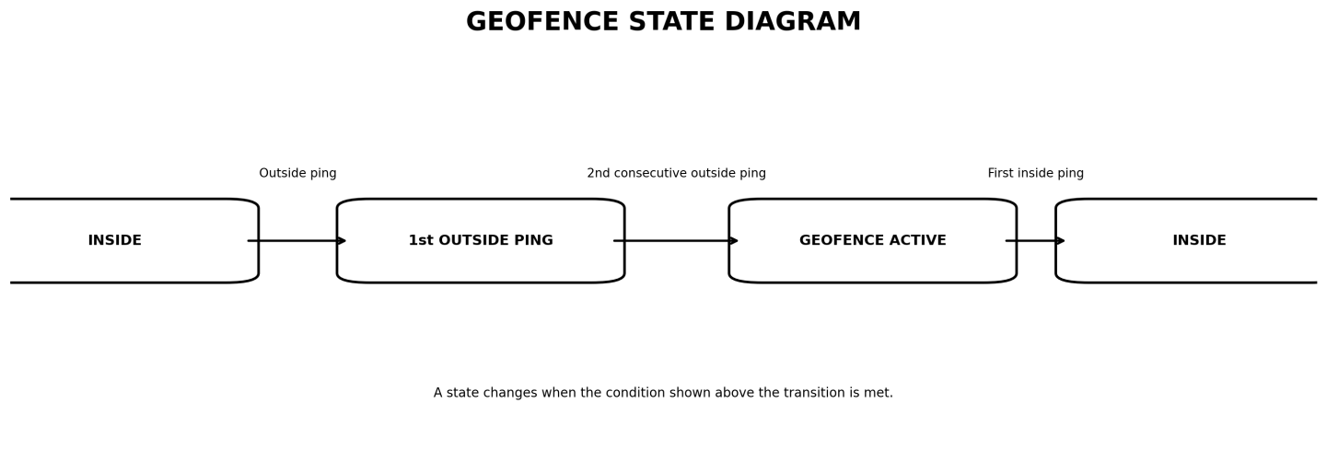
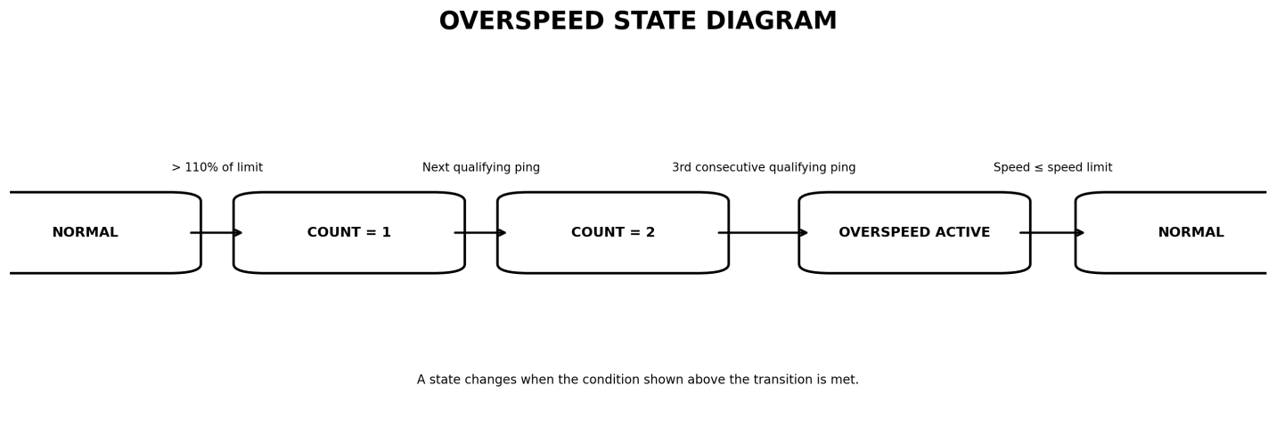
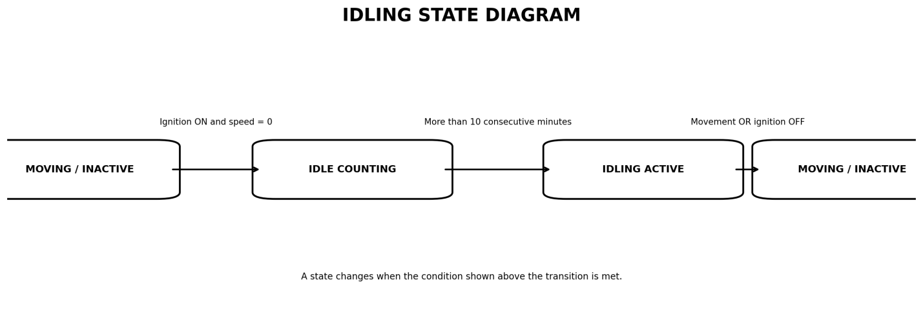
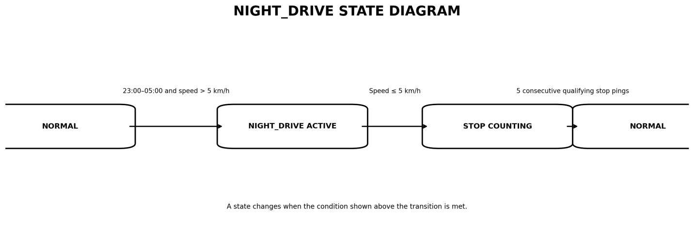
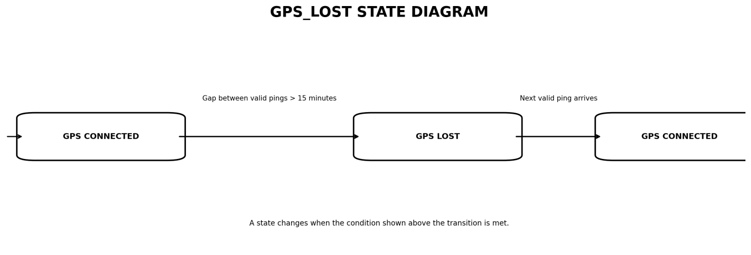

9. BUSINESS RULE REGISTER

9.1 Introduction
A Business Rule Register is a document that defines the conditions and actions followed by the system to identify vehicle violations, calculate costs, and evaluate driver performance.
The following business rules are implemented in the GPS Tracker Fleet Violation and Idling Cost Engine.

9.2 Business Rule Register Table
Rule ID | Business Rule | Condition / Description | Expected System Action
BR-01 | Geofence Violation | A vehicle is considered outside its assigned rectangular geofence when its GPS coordinates fall outside the defined boundaries. Two consecutive outside pings are required. | Generate a GEOFENCE event after two consecutive outside pings. Close the event when the first inside ping is received.
BR-02 | Overspeed Detection | A vehicle exceeds its assigned speed limit by more than 10% for three consecutive GPS pings. | Generate an OVERSPEED event after three consecutive qualifying pings. Close the event when speed becomes equal to or less than the assigned speed limit.
BR-03 | Excessive Idling | A vehicle has its ignition ON and speed equal to zero for more than 10 consecutive minutes. | Generate an IDLING event from the 11th minute. Close the event when the vehicle starts moving or ignition is switched OFF.
BR-04 | Night Driving | A vehicle moves at a speed greater than 5 km/h between 11:00 PM and 5:00 AM. | Generate a NIGHT_DRIVE event. Close the event when speed remains at or below 5 km/h for five consecutive pings.
BR-05 | GPS Signal Loss | The time gap between two consecutive valid GPS pings is greater than 15 minutes. | Generate a GPS_LOST event for the missing time interval and reset all consecutive event detection counters.
BR-06 | Driver Performance Score | Every driver starts with a daily score of 100 points. Points are deducted based on detected violations. | Deduct 5 points for GEOFENCE, 10 points for OVERSPEED, 2 points for IDLING, and 15 points for NIGHT_DRIVE. The minimum score is 0. GPS_LOST has no score penalty.
BR-07 | Data Validation | GPS records containing invalid latitude or longitude values, or timestamps earlier than the previous accepted ping for that vehicle, are rejected. | Display an error message for invalid records. Rejected records must not affect event detection counters or processing.

9.3 Idling Cost Calculation
The system calculates the fuel cost caused by excessive vehicle idling using the following formula:
Idling Cost = (Idle Minutes / 60) × Idle Fuel Rate × Fuel Price
Where:
- Idle Minutes = Total idling duration in minutes.
- Idle Fuel Rate = Fuel consumed per hour in litres.
- Fuel Price = ₹92 per litre.
The calculated cost is rounded to two decimal places.

9.4 Important Business Rule Conditions
The system must also handle the following special conditions:
- A vehicle exactly on the geofence boundary is considered inside the zone.
- Speed exactly 10% above the assigned speed limit does not count as overspeeding.
- Idling for exactly 10 minutes does not generate an IDLING event.
- If movement starts at 10:59 PM and continues after 11:00 PM, night driving is detected from the first qualifying ping at or after 11:00 PM.
- A GPS gap of exactly 15 minutes does not generate a GPS_LOST event.

9.5 Conclusion
The Business Rule Register provides a clear reference for implementing and testing the system. These rules ensure consistent violation detection, accurate idling cost calculation, proper driver scoring, and reliable fleet reporting.

10. EDGE CASES AND HANDLING

10.1 Introduction
Edge cases are unusual or boundary conditions that may occur while processing GPS data. Handling these cases correctly helps the system avoid incorrect violation detection, inaccurate cost calculations, and errors in driver performance scores.
The following edge cases are considered in the GPS Tracker Fleet Violation and Idling Cost Engine.

10.2 Edge Cases and Handling Table
Sl. No. | Edge Case | Expected System Handling
1 | Vehicle GPS coordinates are exactly on the geofence boundary. | Consider the vehicle inside the assigned geofence. Do not generate a GEOFENCE event.
2 | Vehicle moves outside the geofence for only one GPS ping. | Do not generate a GEOFENCE event. Reset the consecutive outside-ping counter when the next inside ping arrives.
3 | Vehicle speed is exactly 10% above the assigned speed limit. | Do not count it as overspeeding because the speed must be more than 10% above the limit.
4 | Vehicle exceeds the speed threshold for only two consecutive pings. | Do not generate an OVERSPEED event. Three consecutive qualifying pings are required.
5 | Vehicle idles for exactly 10 minutes and then starts moving. | Do not generate an IDLING event because idling must continue for more than 10 minutes.
6 | Vehicle ignition is OFF while speed is zero. | Do not consider this as idling. Reset the idle counter.
7 | Vehicle starts moving at 10:59 PM and continues moving after 11:00 PM. | Generate a NIGHT_DRIVE event from the first qualifying movement ping at or after 11:00 PM.
8 | Vehicle speed becomes exactly 5 km/h during night hours. | Treat it as stopped for night-driving detection because the trigger condition requires speed greater than 5 km/h.
9 | Vehicle speed remains at or below 5 km/h for only four consecutive pings. | Keep the NIGHT_DRIVE event active. Close it only after five consecutive qualifying pings.
10 | Time gap between two consecutive GPS pings is exactly 15 minutes. | Do not generate a GPS_LOST event because the gap must be greater than 15 minutes.
11 | Time gap between two consecutive GPS pings is more than 15 minutes. | Generate a GPS_LOST event for the missing interval and reset all consecutive event detection counters.
12 | GPS record contains latitude outside -90 to +90 or longitude outside -180 to +180. | Reject the record and display an error message. Do not update event detection counters.
13 | GPS record contains a timestamp earlier than the previous accepted ping for the same vehicle. | Reject the out-of-order record and display an error message. Do not process it.
14 | Driver score becomes negative after multiple violations. | Set the final driver score to 0. The score must never be negative.
15 | A vehicle has no GPS records for the processing period. | Do not invent vehicle movement or violation events. Report that no GPS data was received for that vehicle.

10.3 Error Handling
The system follows these error-handling procedures:
- Invalid GPS Coordinates: Reject records containing latitude or longitude outside the valid geographical range.
- Invalid Timestamps: Reject GPS records containing out-of-order timestamps.
- Missing Vehicle Information: Display an error if a GPS record refers to an unregistered vehicle.
- Missing Geofence Information: Display an error if a registered vehicle has no valid assigned geofence.
- Invalid GPS Records: Ensure rejected records do not affect event counters or violation detection.
- GPS Connectivity Loss: Detect gaps greater than 15 minutes and generate GPS_LOST events.
- Score Limitation: Ensure that the driver's final daily score does not fall below zero.

10.4 Conclusion
Handling edge cases ensures that the system works reliably even under unusual conditions. These checks improve the accuracy of GPS processing, violation detection, idling cost calculation, and driver performance evaluation.

