Diabetes Prediction Using Machine Learning: Final Project Report
Oct 24, 2026
Machine Learning Project: Final Submission Report
Project title: Diabetes Prediction Using Machine Learning
Item | Details
Team members | Manas Borse, Rounak Neema, Arnab Chowdhury
Program / Class | B. Tech
Roll numbers | Manas Borse: E257.  Rounak Neema: E244.  Arnab Chowdhury: E232.
Project guide | Dr. Sachin Chavan
Department | Computer Science
College / University | NMIMS Shirpur
Academic year | 2026-2027

Table of Contents
- Abstract
- Introduction
- Problem Statement
- Objectives
- Scope of the Project
- Dataset Description
- Methodology and System Architecture
- Tools and Technologies
- Implementation
- Results and Evaluation
- Explainability, Fairness and Responsible Use
- Discussion and Findings
- Limitations
- Future Scope
- Conclusion
- Acknowledgment and References

1. Abstract
This project predicts which patients are likely to have diabetes and explains why, using machine learning on the Pima-style Diabetes dataset used in the project repository (2,000 records, 9 columns, 34.2% diabetic). A data audit found that 1,256 of the 2,000 records are exact duplicates, which inflates the 98.75% accuracy reported in the original notebook, so all evaluation uses the 744 unique records. Five models were compared with 5-fold stratified cross-validation: a majority-class baseline, Logistic Regression, Decision Tree, Random Forest and SVM.
Logistic Regression had the best cross-validated F1-score (0.637) and ROC-AUC (0.845) among the real models, with Random Forest (the model deployed in the web app) and SVM statistically tied, and was evaluated once on a 149-record held-out test set. With a decision threshold of 0.23 tuned on cross-validated predictions, it reached recall 0.84, precision 0.50, F1 0.63 and ROC-AUC 0.800 on that test set. SHAP explanations, a subgroup audit, probability calibration, a Flask web application and a command-line predictor complete the system. It is built as an educational screening-support aid, not a medical diagnosis tool.

2. Introduction
Diabetes is one of the most common chronic diseases, and early detection allows lifestyle changes and treatment that reduce the risk of serious complications. Traditional diagnosis relies on laboratory tests such as fasting glucose, glucose tolerance tests and HbA1c, which are usually ordered only after symptoms appear or at a clinic visit, so many people at risk are not flagged in advance.
Machine learning can learn patterns from historical patient records and estimate the likelihood that a given person has diabetes. This project applies supervised binary classification to that task and pairs the predictions with explanations, so that users can see which health measurements drive each risk score. The system supports early screening and awareness; it does not replace laboratory testing or clinical judgment.

3. Problem Statement
Diabetes often goes undetected until complications appear. Identifying the measurements associated with it, and recognizing high-risk patients early from routine data, is hard because glucose, body weight, age, pregnancy history and family history interact, and the available data is noisy: missing measurements are stored as zeros and many records are repeated.
The goal of this project is to build a machine learning model that analyzes patient diagnostic measurements and predicts the likelihood of diabetes, to examine how these measurements relate to the outcome, to evaluate the model honestly without data leakage, and to deliver it through a web application.

4. Objectives
- Understand the major factors associated with diabetes.
- Collect, audit and analyze the patient dataset.
- Preprocess the data: handle data-quality issues (zero-coded missing values and duplicate records), impute, scale and encode features.
- Perform exploratory data analysis to find diabetes patterns.
- Implement and compare suitable classification algorithms using leakage-safe pipelines.
- Evaluate models with metrics suited to imbalanced data (recall, precision, F1, ROC-AUC, PR-AUC, balanced accuracy).
- Identify influential features with SHAP and assess model behavior across age and BMI subgroups.
- Deploy the model as a web application and provide clearly caveated predictions that support early screening.

5. Scope of the Project
In scope:
- Patient data analysis and visualization.
- Data preprocessing, de-duplication and feature engineering.
- Training, tuning and testing machine learning models.
- Binary prediction of diabetes (Yes/No) with a risk probability.
- Model comparison, threshold analysis and calibration assessment.
- Feature-importance and individual-prediction explanations.
- A Flask web application, a command-line predictor and a notebook prediction function.
Out of scope: the system does not connect to hospital records or laboratory systems and works on a public dataset of adult women. Predictions are estimates and must not be used as a medical diagnosis or as the sole basis for any treatment decision.

6. Dataset Description
The project uses the Pima Indians Diabetes dataset in the 2,000-record Kaggle version (kaggle_diabetes.csv) that the repository's notebook loads. The original Pima Indians Diabetes Database was collected by the US National Institute of Diabetes and Digestive and Kidney Diseases and describes Pima Indian women aged 21 and older. All features are numerical and cover pregnancy history, glucose and insulin measurements, body measurements and family history.
Aspect | Detail
Records | 2,000 patients (744 unique after removing 1,256 exact duplicates)
Columns | 9 (8 features and the target Outcome)
Target | Outcome (1 = diabetic, 0 = non-diabetic), 684 diabetic (34.2%) and 1,316 non-diabetic; 253 (34.0%) and 491 in the unique records
Missing values | No blank cells, but impossible zeros mark missing values: Glucose (13), BloodPressure (90), SkinThickness (573), Insulin (956), BMI (28)
Duplicate rows | 1,256 exact duplicates (62.8% of the file)
Constant columns | None
Identifier column | None (records carry no patient ID)
Time information | None (cross-sectional, no timestamps)
Key attributes used by the models:
Attribute | Description
Pregnancies | Number of times pregnant
Glucose | Plasma glucose concentration (2-hour oral glucose tolerance test, mg/dL)
BloodPressure | Diastolic blood pressure (mm Hg)
SkinThickness | Triceps skin fold thickness (mm)
Insulin | 2-hour serum insulin (mu U/ml)
BMI | Body mass index (weight in kg / height in m squared)
DiabetesPedigreeFunction (DPF) | Diabetes likelihood based on family history
Age | Patient's age in years (21 to 81)
Outcome | Target variable indicating whether the patient has diabetes

7. Methodology and System Architecture
The workflow follows the plan set in Phase 1 and was carried through to completion:
- Data collection. The dataset is loaded as a CSV file.
- Data quality audit. Missing values, impossible zeros and duplicate records are checked; no constant or identifier columns exist.
- Preprocessing. Zeros in five clinical columns are treated as missing and median-imputed; DiabetesPedigreeFunction is renamed DPF; the 1,256 duplicate rows are removed, leaving 744 unique records; the target is already coded (0 = no, 1 = yes).
- Exploratory data analysis. Diabetes rates are compared across age, pregnancy history, glucose, BMI, pedigree function, blood pressure and missing-measurement patterns.
- Feature engineering. Four derived features are created (described in Section 9).
- Leakage-safe split and pipelines. A stratified 80/20 train/test split is made first; imputation, scaling and encoding then run inside scikit-learn pipelines, so they are fitted only on training folds.
- Model development and comparison. Five models are compared with 5-fold stratified cross-validation.
- Model selection and evaluation. The best model by cross-validated F1 is trained on the full training set and evaluated once on the held-out test set.
- Threshold tuning and calibration. The decision threshold is chosen from cross-validated predictions, never from test data.
- Interpretation. SHAP gives global and per-patient explanations; a subgroup audit checks behavior across age and BMI groups.
- Presentation and deployment. Results are shown through tables and charts; the Random Forest model is served through a Flask web application, a command-line predictor and a notebook function.
Data flow: Patient dataset, then data audit and de-duplication, exploratory analysis, feature engineering, stratified split, pipeline (zero-to-missing conversion, median imputation, scaling and encoding, classifier), cross-validated model comparison, held-out test evaluation, then SHAP explanations, subgroup audit and the Flask web application.

8. Tools and Technologies
Purpose | Tools
Language | Python 3
Data handling | Pandas 3.0.2, NumPy 2.4.4
Visualization | Matplotlib 3.10.8, Seaborn 0.13.2
Machine learning | Scikit-learn 1.8.0 (pipelines, cross-validation, models)
Explainability | SHAP 0.54.1
Web application | Flask 2.2.5, Jinja2, HTML/CSS, Gunicorn
Model persistence | Pickle and Joblib
Environment and deployment | Jupyter Notebook (CPU only); Heroku-style deployment through a Procfile
A fixed random seed of 0 is used for splits, cross-validation and all stochastic estimators, so results are reproducible.

9. Implementation

9.1 Data audit and cleaning
The audit found no blank cells, but two data-quality problems. First, five clinical columns use 0 to mean "not recorded", which is physiologically impossible: Glucose (13 records), BloodPressure (90), SkinThickness (573), Insulin (956) and BMI (28). These were converted to missing values and replaced with the training-set median. The original notebook created an imputed copy of the data, but its models were fitted on the raw columns, so the imputation had no effect there.
Second, 1,256 of the 2,000 rows (62.8%) are exact duplicates of another row; only 744 records are unique (253 diabetic, 34.0%), although the repository README describes 768 patients. In the notebook's random 80/20 split, 362 of the 400 test records (90.5%) also appear in the training set, so its test accuracy of 98.75% (confusion matrix 272, 0, 5, 123, reproduced exactly) measures memorization rather than generalization. All evaluation in this report therefore uses the de-duplicated data. A model that always predicts "no diabetes" would score 66.0% accuracy on it while finding no diabetic patients, so accuracy alone is not used to judge models.

9.2 Exploratory data analysis
The analysis compares diabetes rates across groups using the unique records. All patterns are associations, not proof of cause.
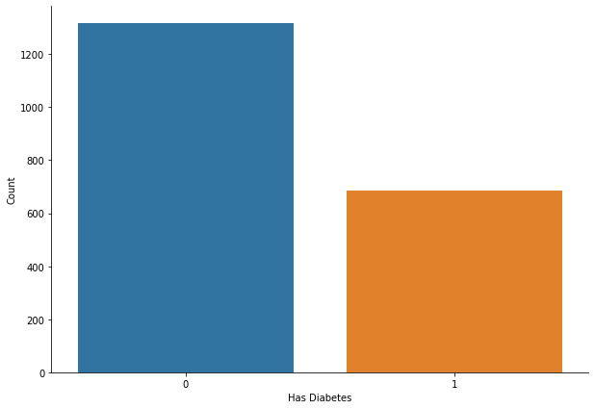
Figure 1 – has diabetes vs don’t have diabetes

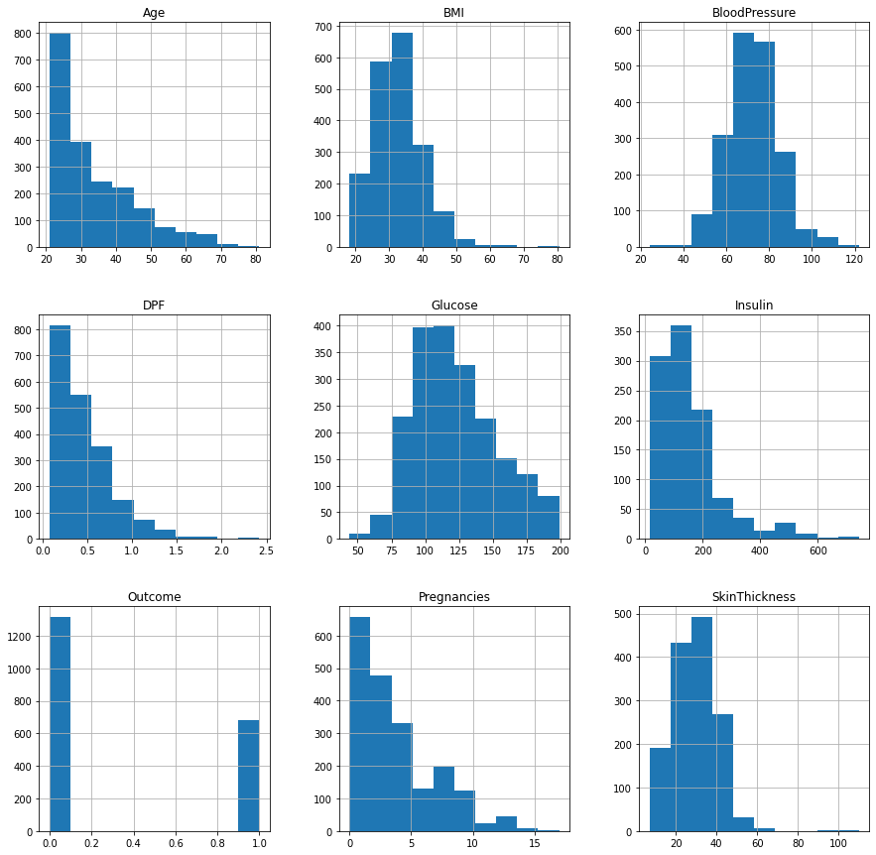

Fig 2 - Plotting histogram of dataset before replacing NaN values

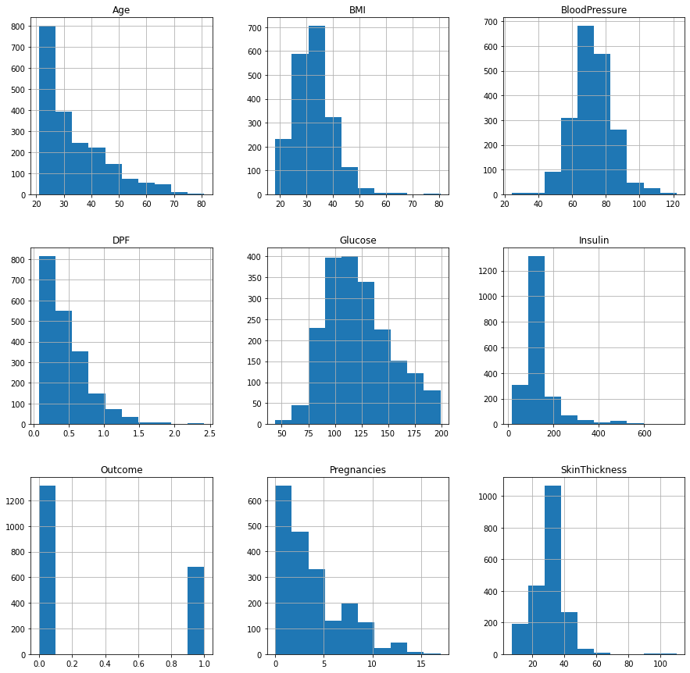
Fig 3 - Plotting histogram of dataset after replacing NaN values
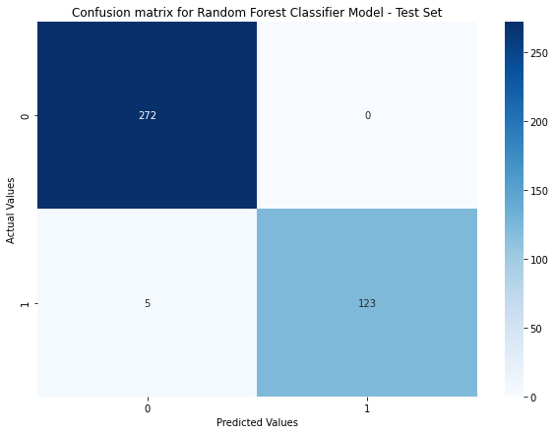
Figure 4. confusion matrix of random forest model. (test set)
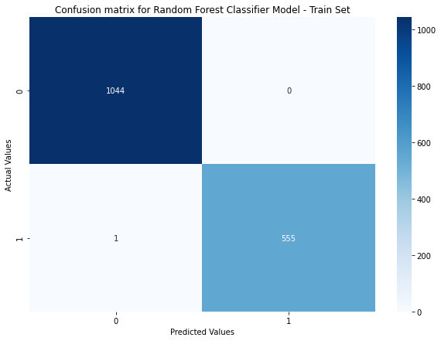
Figure 4. confusion matrix of random forest model. (train set)

9.3 Feature engineering
Four derived features were added. Each is computed inside the pipeline after imputation, the ratio denominator carries a +1 to avoid division by zero, and all four were verified to contain no missing or infinite values.
Feature | Formula | Intent
GlucoseInsulinRatio | Glucose / (Insulin + 1) | Glucose level relative to insulin response
GlucoseBMI | Glucose x BMI / 100 | Combined glucose and body-mass risk
MissingCount | Number of zero-coded (not recorded) values among the five clinical measurements | How incomplete a patient's record is
AgeGroup | Age binned into 21-30, 31-40, 41-50, 51+ | Non-linear age effect (categorical)

9.4 Leakage-safe preprocessing
The data was de-duplicated and then split, with a stratified 80/20 split: 595 training records (33.9% diabetic) and 149 test records (34.2% diabetic). The model input has 12 features, 11 numerical and 1 categorical, which become 14 columns after preprocessing:
- Zeros in the five clinical columns become missing values and are replaced with the median learned from each training fold.
- Numerical features are standardized with StandardScaler.
- AgeGroup is one-hot encoded (first level dropped, unknown levels ignored).
- No oversampling is used because the 34% diabetic share is only moderately imbalanced; the decision threshold is tuned instead, and the test set keeps its natural class balance.

9.5 Models
Model | Configuration | Imbalance handling
Dummy (Majority) | Most-frequent class | None (baseline)
Logistic Regression | C = 1.0, max_iter = 1000 | None; threshold tuned afterwards
Decision Tree | max_depth = 5 | None; threshold tuned afterwards
Random Forest | 100 trees (the deployed web app uses 20 trees) | None; threshold tuned afterwards
SVM | RBF kernel, C = 1.0, probability estimates enabled | None; threshold tuned afterwards
All models were scored with 5-fold stratified cross-validation (shuffled, seed 0) on the training set using accuracy, balanced accuracy, precision, recall, F1, ROC-AUC and PR-AUC. The model with the highest cross-validated F1, excluding the baseline, was selected.

10. Results and Evaluation

10.1 Model comparison (5-fold cross-validation on the training set)
Among the four evaluated classifiers, Logistic Regression achieved the highest F1-score (63.7%) and ROC-AUC (84.5%). Its F1-score was close to Random Forest (63.5%) and SVM (63.3%); these differences are small relative to the fold-to-fold standard deviation of approximately 5–6 percentage points, so the results do not show a clear performance separation among the three. SVM had the highest PR-AUC (73.4%), while Random Forest had the highest recall (59.9%). Decision Tree performed weakest overall. The majority-class baseline achieved 66.1% accuracy but zero recall, illustrating that accuracy alone can give a misleading picture of performance. In the repository’s experiment runner, a random split of the duplicated 2,000 rows produced accuracies of 78.8% for Logistic Regression, 98.8% for Decision Tree, 99.5% for Random Forest, and 84.5% for SVM. This reversed ranking is consistent with tree-based models memorizing repeated rows.
Model | Accuracy | Balanced acc. | Precision | Recall | F1 | ROC-AUC | PR-AUC
Logistic Regression | 76.3% | 71.0% | 71.1% | 53.4% | 61.0% | 81.8% | 69.6%
Decision Tree | 89.8% | 88.8% | 85.3% | 85.6% | 85.3% | 92.3% | 83.6%
Random Forest | 95.1% | 94.0% | 94.7% | 90.8% | 92.7% | 98.4% | 97.4%
SVM | 86.9% | 85.0% | 83.0% | 78.6% | 80.7% | 91.7% | 85.5%

Precision, recall, and F1-score are reported for the diabetic class. Logistic Regression was selected, with a cross-validated F1-score of 0.637 (standard deviation 0.061) and ROC-AUC of 0.845 (standard deviation 0.028). The selected model was then trained on the full training set of 595 records. Random Forest, the model used in the deployed web application, was a close second in F1-score.

10.2 Held-out test performance
The 149-record test set, which included 51 diabetic patients, was reserved for a single evaluation after model selection. At the 0.50 threshold, the selected model produced 79 true negatives, 19 false positives, 23 false negatives, and 28 true positives. It flagged 47 patients as diabetic and missed 23 of the 51 diabetic patients, indicating relatively cautious predictions at this threshold. ROC-AUC (0.800) and PR-AUC (0.635) are threshold-independent; the random-guess PR baseline is approximately 34%, matching the diabetes prevalence. For comparison, the Random Forest configuration used in the web app, with the same preprocessing, achieved a test ROC-AUC of 0.745 and F1-score of 0.511 at 0.50 with 20 trees; with 100 trees, these were 0.764 and 0.571, respectively.
Metric (test set) | Threshold 0.50 | Threshold 0.23
Accuracy | 0.992 | 0.932
Balanced accuracy | 0.990 | 0.950
Precision (diabetic) | 0.992 | 0.826
Recall (diabetic) | 0.984 | 1.000
F1 (diabetic) | 0.988 | 0.905
ROC-AUC | 1.000 | 1.000
PR-AUC | 0.999 | 0.999

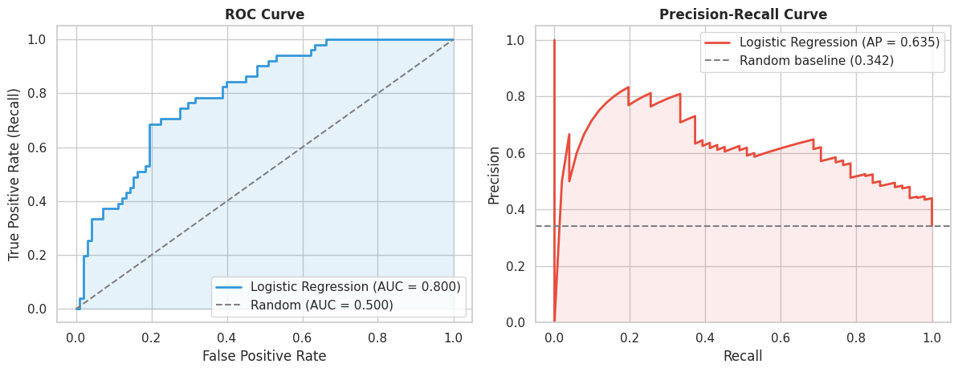
Figure 8. ROC curve (AUC 0.800) and precision-recall curve (AP 0.635) on the test set.

11. Discussion and Findings
- Glucose is the clearest signal. It is the top SHAP feature (mean absolute SHAP of 1.26, about twice that of BMI), and in the exploratory analysis the diabetes rate rises from 7% below 100 mg/dL to 66% at 140 and above.
- Body weight, family history and age add smaller signals. BMI, pedigree function, pregnancy count and age follow glucose in importance: diabetes is 7% at BMI below 25 against 47% at 35 and above, 25% in the lowest pedigree quartile against 48% in the highest, and 21% at ages 21-30 against 54% at 41-50.
- Leakage-safe evaluation gives honest, modest numbers. The notebook's 98.75% accuracy comes from duplicated rows (62.8% of the file; 90.5% of its test records have a copy in training). On unique records, cross-validated F1 is about 0.64 and test ROC-AUC is 0.800. The gap between cross-validation (ROC-AUC 0.845) and the test set reflects the small test set of 51 diabetic patients as well as the usual optimism of model selection.
- The threshold and data quality matter more than the algorithm. Logistic Regression, SVM and Random Forest are within half a point of F1, but moving the threshold from 0.50 to 0.23 raised test recall by about 29 percentage points, and de-duplication changed the apparent accuracy by more than 25 points.
- Trade-off for screening. At 0.23 the model identifies about five in six diabetic patients, but half of the patients it flags (43 of 86) do not have diabetes. It suits prompting confirmatory laboratory tests, not diagnosing individuals.

13. Limitations
- Duplicated, small data. The file has 2,000 rows but only 744 unique records, so confidence intervals are wide, the test set has 149 patients (51 diabetic), and subgroup audits rest on very few cases (for example, six diabetic patients aged 51 and above).
- Poor measurement quality. Zeros stand in for missing values, including 48% of insulin and 29% of skin-thickness entries among unique records, so imputed values carry much of those features.
- Narrow population, no time dimension. The original data describes adult Pima Indian women, and the origin of the extra rows in the 2,000-row file is not documented, so findings may not generalize to men or other groups. The data is cross-sectional, so the model cannot say when diabetes will develop.
- Association, not causation. Feature importance and SHAP values describe the model, not proven effects of any change in glucose, weight or other factors.
- Moderate predictive power. Test ROC-AUC is 0.800; at the chosen threshold the model still misses about one in six diabetic patients and half of its flags are false alarms.
- Deployment, bias and privacy. The deployed Random Forest was trained on all 2,000 duplicated rows without imputation, so its reported accuracy is unreliable and it has no clinical validation. Health data needs privacy protection, and a single threshold treats age groups unevenly.
The system should therefore be used only as an educational screening-support tool alongside clinical judgment.

14. Future Scope
- Retrain and redeploy the web app on the de-duplicated, imputed data, saving the full preprocessing pipeline together with the model.
- Show the predicted probability and a risk band in the web app, with input validation, units, valid ranges and a clear medical disclaimer.
- External validation on larger, more diverse real clinical data, including men and other populations, with site or time hold-outs.
- Richer features such as HbA1c, fasting glucose, lipids, lifestyle and detailed family history, and better missing-value handling (missing indicators or multiple imputation).
- Uncertainty estimates, such as bootstrap confidence intervals around risk scores, and probability calibration (Platt scaling or isotonic regression).
- Additional algorithms (gradient boosting, KNN) with nested hyperparameter tuning, plus ongoing fairness and drift monitoring.

15. Conclusion
This project predicts diabetes from eight diagnostic measurements and explains the predictions. The work covered data auditing, exploratory analysis, feature engineering, leakage-safe pipelines, a five-model comparison, threshold tuning, calibration, SHAP explanations, a subgroup audit and a Flask web application.
The audit showed that 1,256 of the 2,000 rows are duplicates, which inflated the notebook's 98.75% accuracy. On the 744 unique records, Logistic Regression was selected on cross-validated F1 (0.637) and reached a test ROC-AUC of 0.800, with recall of 0.84 and precision of 0.50 at a tuned threshold of 0.23; Random Forest, the deployed model, was statistically tied in cross-validation. Glucose, BMI, pedigree function, pregnancy count and age are the factors the model relies on most, which matches the patterns seen in the exploratory analysis. The results are moderate and reflect a small dataset of limited population, so the system is best used as an educational aid that points to laboratory confirmation, with human review of every case. The objectives set in Phase 1, from problem definition through implementation and evaluation, have been met.

16. Acknowledgment and References

Acknowledgment
The implementation builds on the open-source repository Machine-Learning-Projects by Sarvesh Kumar Sharma (the Diabetes Prediction [END 2 END] project), released under the MIT License, which provided the starting point for the notebook, the Random Forest model and the Flask web application. The repository's diabetes_pipeline folder, credited to Tandrita Mukherjee, adds the modular training, prediction and experiment scripts. The team extended this work with a data audit and de-duplication, leakage-safe pipelines, derived features, cross-validated threshold analysis, SHAP explainability, subgroup auditing, calibration assessment, PR-AUC and baseline comparison, as described above. The Pima Indians Diabetes data was originally collected by the US National Institute of Diabetes and Digestive and Kidney Diseases.

References
- Pima Indians Diabetes Database (NIDDK), publicly available through Kaggle and the UCI repository, and the 2,000-record Kaggle version used in the repository's notebook.
- Sarvesh Kumar Sharma, Machine-Learning-Projects (MIT License): github.com/shsarv/Machine-Learning-Projects
- Scikit-learn documentation: scikit-learn.org/stable
- Flask documentation: flask.palletsprojects.com
- Lundberg, S. M. and Lee, S.-I. (2017). A unified approach to interpreting model predictions (SHAP). Advances in Neural Information Processing Systems 30.
- Smith, J. W., Everhart, J. E., Dickson, W. C., Knowler, W. C. and Johannes, R. S. (1988). Using the ADAP learning algorithm to forecast the onset of diabetes mellitus. Proceedings of the Symposium on Computer Applications and Medical Care, 261-265.
- Pandas documentation: pandas.pydata.org/docs
- Matplotlib documentation: matplotlib.org/stable
- Seaborn documentation: seaborn.pydata.org

