PROGRAM:
<!DOCTYPE html>
<html ng-app="taskApp">
<head>
<meta charset="UTF-8">
<title>Simple ToDo List</title>

<!-- AngularJS CDN -->
<script src="https://ajax.googleapis.com/ajax/libs/angularjs/1.8.2/angular.min.js"></script>

<style>
body {
font-family: Arial, sans-serif;
background-image:url("do to list.webp");
padding: 30px;
}

.container {
width: 350px;
margin: auto;
background: white;
padding: 20px;
border-radius: 8px;
box-shadow: 0 0 10px #ccc;
}

.completed {
text-decoration: line-through;
color: gray;
}
</style>
</head>

<body ng-controller="TaskController">

<div class="container">
<h2>My ToDo List</h2>

<!-- Using ng-bind -->
<p>
<span ng-bind="remaining()"></span> of
<span ng-bind="tasks.length"></span> remaining
</p>

<!-- Add Task -->
<input type="text" ng-model="newTask" placeholder="Add new task">
<button ng-click="addTask()">Add</button>

<br><br>

<!-- Task List -->
<ul>
<li ng-repeat="task in tasks">
<input type="checkbox" ng-model="task.completed">

<span ng-class="{'completed': task.completed}"
ng-bind="task.name">
</span>
</li>
</ul>
</div>

<script>
var app = angular.module("taskApp", []);

app.controller("TaskController", function($scope) {

$scope.tasks = [
{name: "Learn AngularJS", completed: false},
{name: "Build Simple App", completed: false}
];

$scope.addTask = function() {
if ($scope.newTask) {
$scope.tasks.push({
name: $scope.newTask,
completed: false
});
$scope.newTask = "";
}
};

$scope.remaining = function() {
var count = 0;
angular.forEach($scope.tasks, function(task) {
if (!task.completed) count++;
});
return count;
};

});
</script>

</body>
</html>

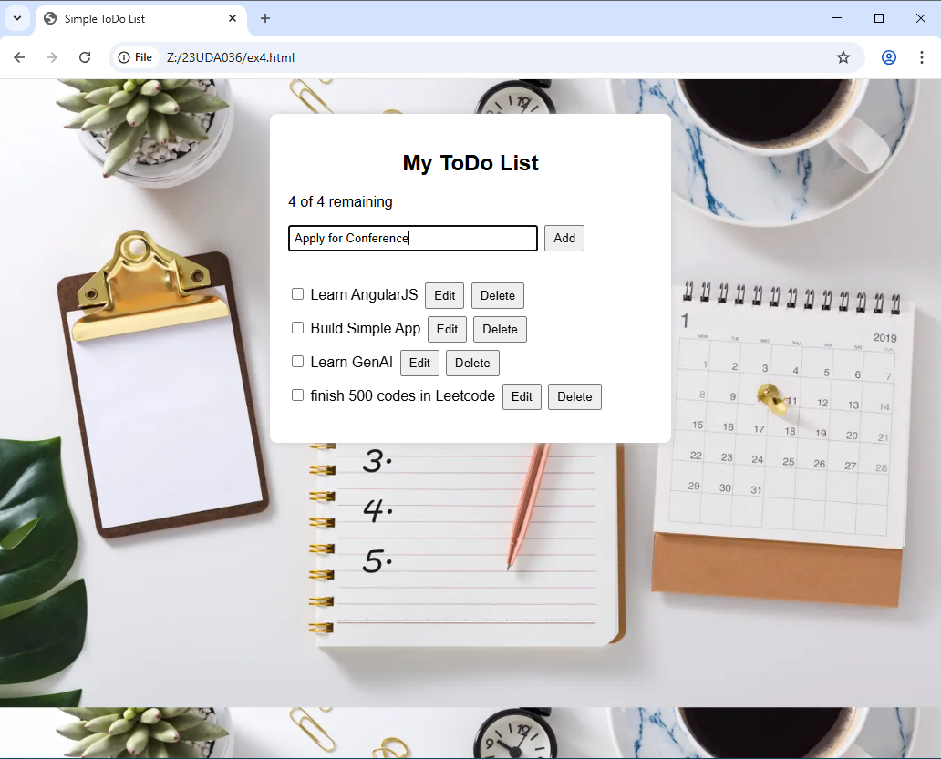
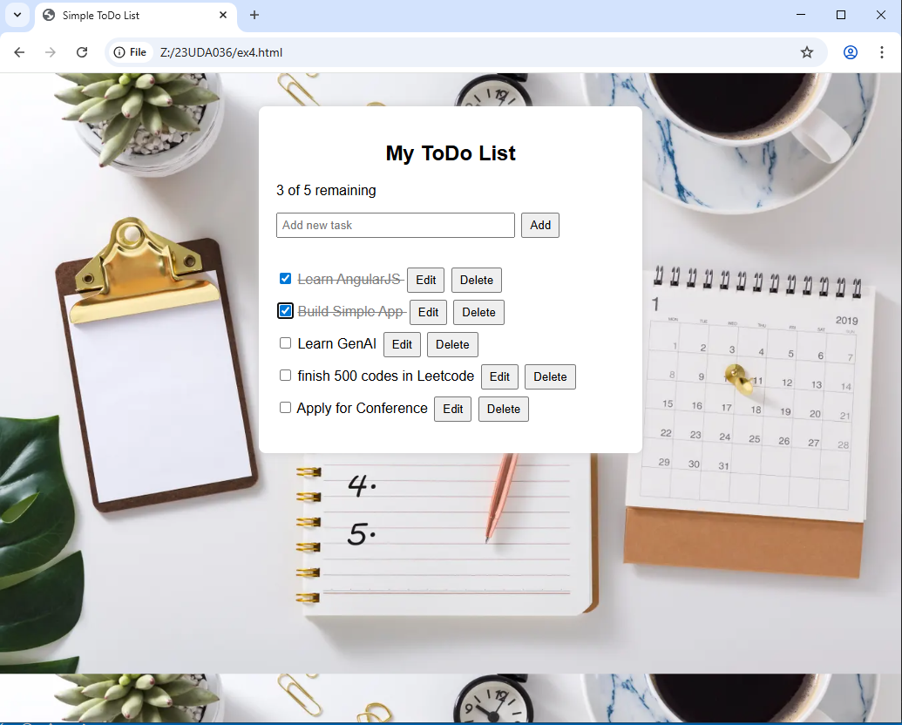
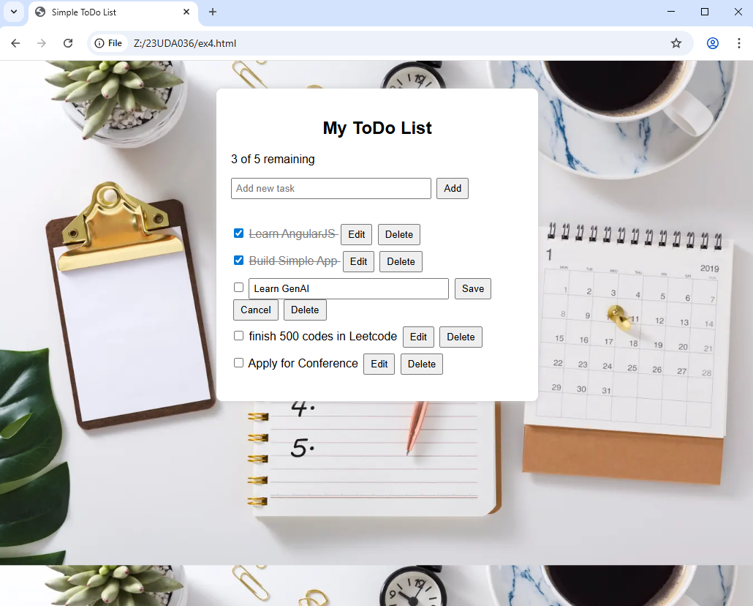
After Deletion:
