Experiment-2

**Aim:** To implement and evaluate a classification problem using Naïve Bayes. Here, the classification problems considered are E-Mail Spam/Non-Spam Classification and Heart Disease Prediction.

**Software used:** Python

**Dataset:** Kaggle

**Theory:**

Naïve Bayes: It is a probabilistic framework for solving classification problems​. We compute the posterior probability P(C | A1 , A2 , …, An ) for all values​ of C using the Bayes theorem​:



We assume independence among attributes Ai when class is given.

– P(A1 , A2 , …, An |C) = P(A1 | C ) P(A2 | C)… P(An | C)​

– Can estimate P(Ai | Cj ) for all Ai and Cj .​

– New point is classified to Cj if P(Cj ) Π P(Ai | Cj ) is maximum.​

**Program:**

(Notebook for both is present in the folder.)

**Results:**

For E-Mail Spam/Non-Spam Classification:

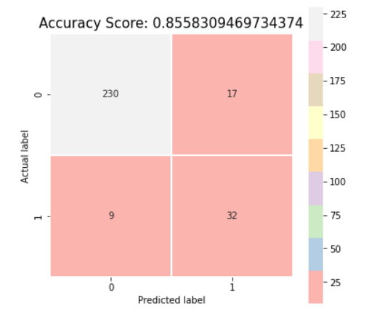

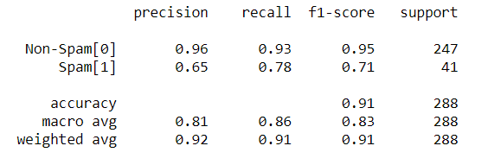

For Heart Disease Prediction:

