Experiment-3

**Aim:** To implement and evaluate a regression problem using Linear Regression. Here, the regression problem considered is Laptop Price Prediction.

**Software used:** Python

**Dataset:** Kaggle

**Theory:**

Linear Regression: Linear regression models the relationship between two variables by fitting a linear equation to observed data. One variable is an explanatory variable, and the other is a dependent variable. A linear regression line has an equation of the form Y = a + bX, where X is the explanatory variable and Y is the dependent variable. The slope of the line is b, and a is the intercept (the value of y when x = 0). For multiple linear regression problems (having multiple features), the equation is like this:

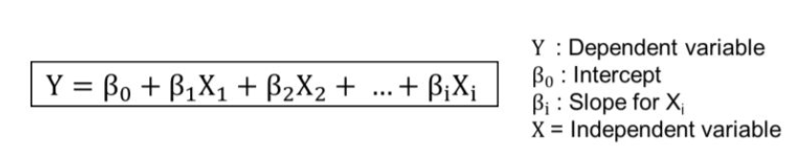

The red line below shows the fitting line. Points in this line denote the best approximation possible:

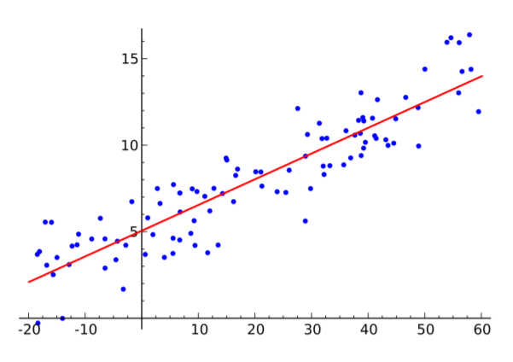

Three major uses for regression analysis are (1) determining the strength of predictors, (2) forecasting an effect, and (3) trend forecasting.

**Program:**

(Notebook is present in the folder.)

**Results:**

