Experiment-4

**Aim:** To implement and evaluate a classification problem using Logistic Regression. Here, the classification problem considered is Amazon Alexa Reviews Analysis.

**Software used:** Python

**Dataset:** Kaggle

**Theory:**

Logistic Regression: It is a “Supervised machine learning” algorithm that can be used to model the probability of a certain class or event. It is used when the data is linearly separable, and the outcome is binary in nature. Graphically, this is how the regression separates the data points into two classes:

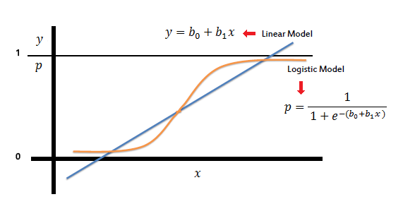

Here, $b_{0}+b_{1}x_{1}+…$ is called the sum of weighted features, $b_{0}$ is the bias and overall, the function is sigmoid.

**Program:**

(Notebook is present in the folder.)

**Results:**

