Experiment-5

**Aim:** To implement XOR gate and encrypt/decrypt an image.

**Software used:** Python

**Theory:**

XOR gate is a digital logic gate that gives a true (1 or HIGH) output when the number of true inputs is odd. Given below is the truth table for it:

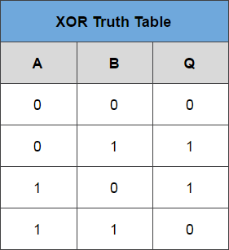

XOR gate has many applications. It is mainly used for encrypting and decrypting data. When used properly, this technique provides strong protection. In fact, it is the basis for the one-time pad, the only provably uncrackable encryption.

**Program:**

(Notebook is present in the folder.)

**Results:**

1. XOR gate implementation:

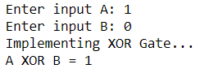

2. Encrypting and Decrypting an Image:

Original Image 1:

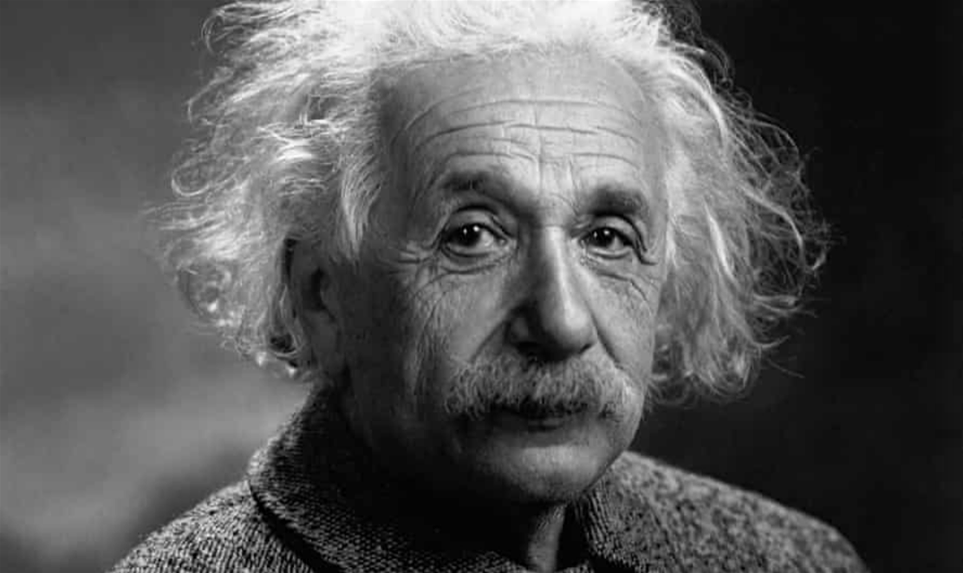

Original Image 2:



Encrypted Image:

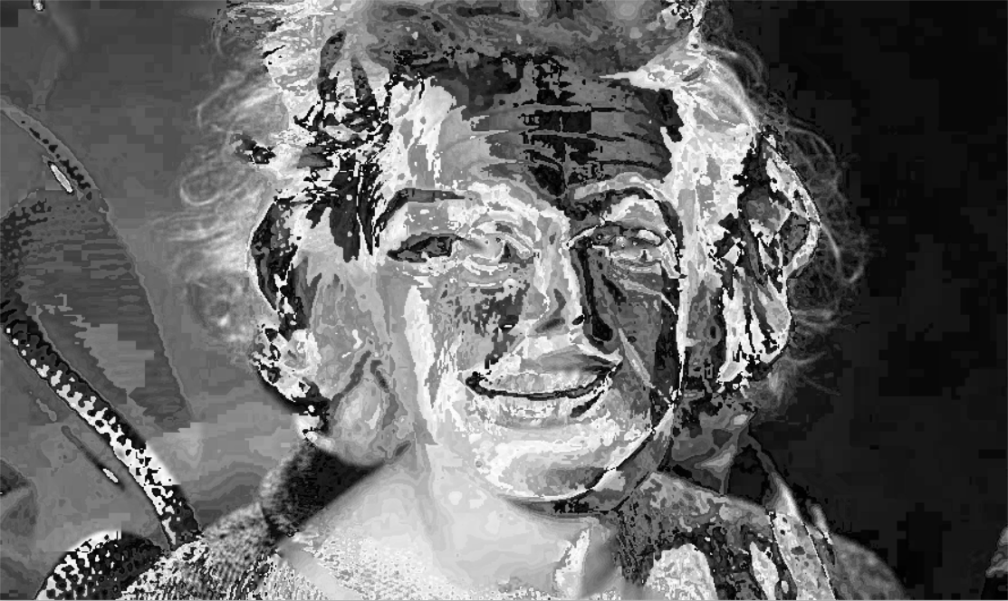

Decrypted Image 1 using Image 2:

