Experiment-6

**Aim:** To perform Dimensionality Reduction using Principal Component Analysis (PCA) and compare the results.

**Software used:** Python

**Dataset:** Kaggle

**Theory:**

PCA: Principal Component Analysis is a statistical procedure that uses an orthogonal transformation that converts a set of correlated variables to a set of uncorrelated variables and also reduces dimensionality of the problem by introducing new principal components.

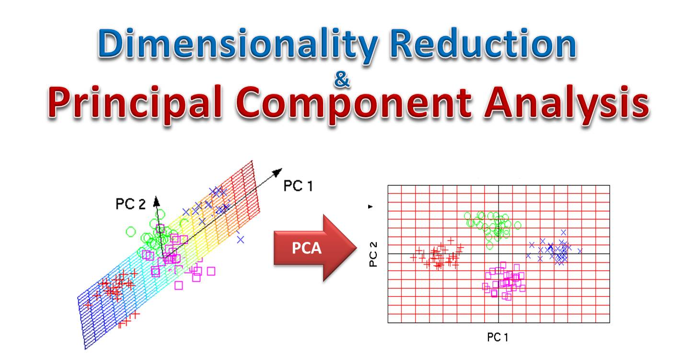

Steps involved in doing PCA:

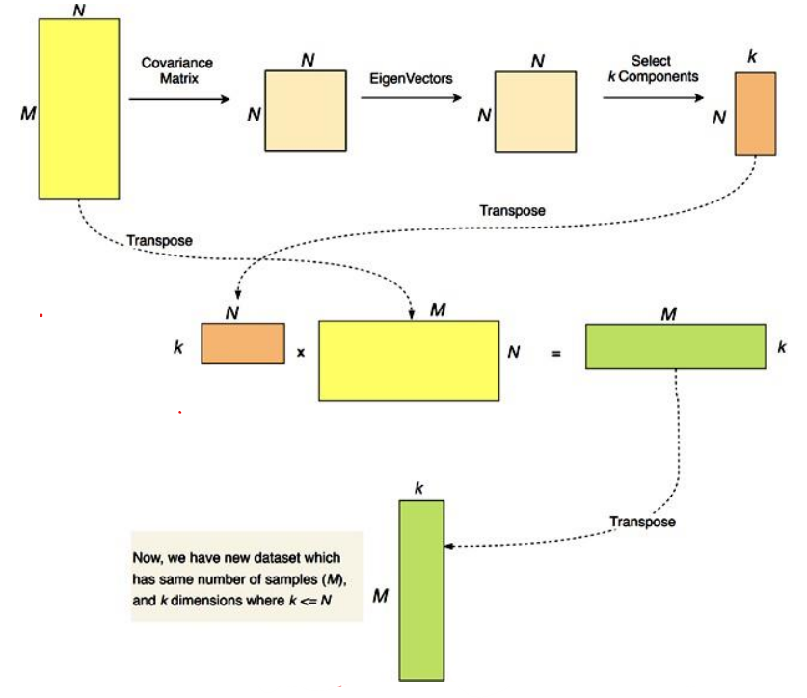

In this experiment, PCA has been performed on a ‘Car Price’ dataset.

**Program:**

(Notebook is present in the folder.)

**Results:**

With PCA:

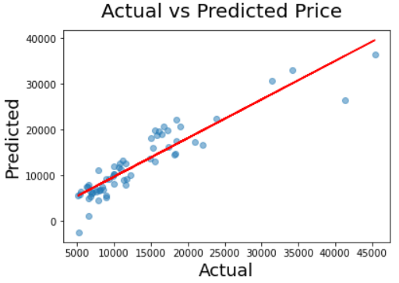

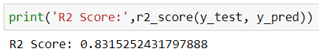

Without PCA:

