Experiment-7

**Aim:** To implement OR gate using backpropagation algorithm for neural networks.

**Software used:** Python

**Dataset:** Kaggle

**Theory:**

Neural Networks: A neural network is a computational model that has a network architecture. This architecture is made up of artificial neurons. This structure has specific parameters through which one can modify it for performing certain tasks. They can approximate a function to any level of accuracy irrespective of its dimension. Neural Networks find extensive applications in areas where traditional computers don’t fare too well. From Siri to Google Maps, neural networks are present in every place where Artificial Intelligence is used. Neural networks take inspiration from the human brain and so their structure is similar to one as well.

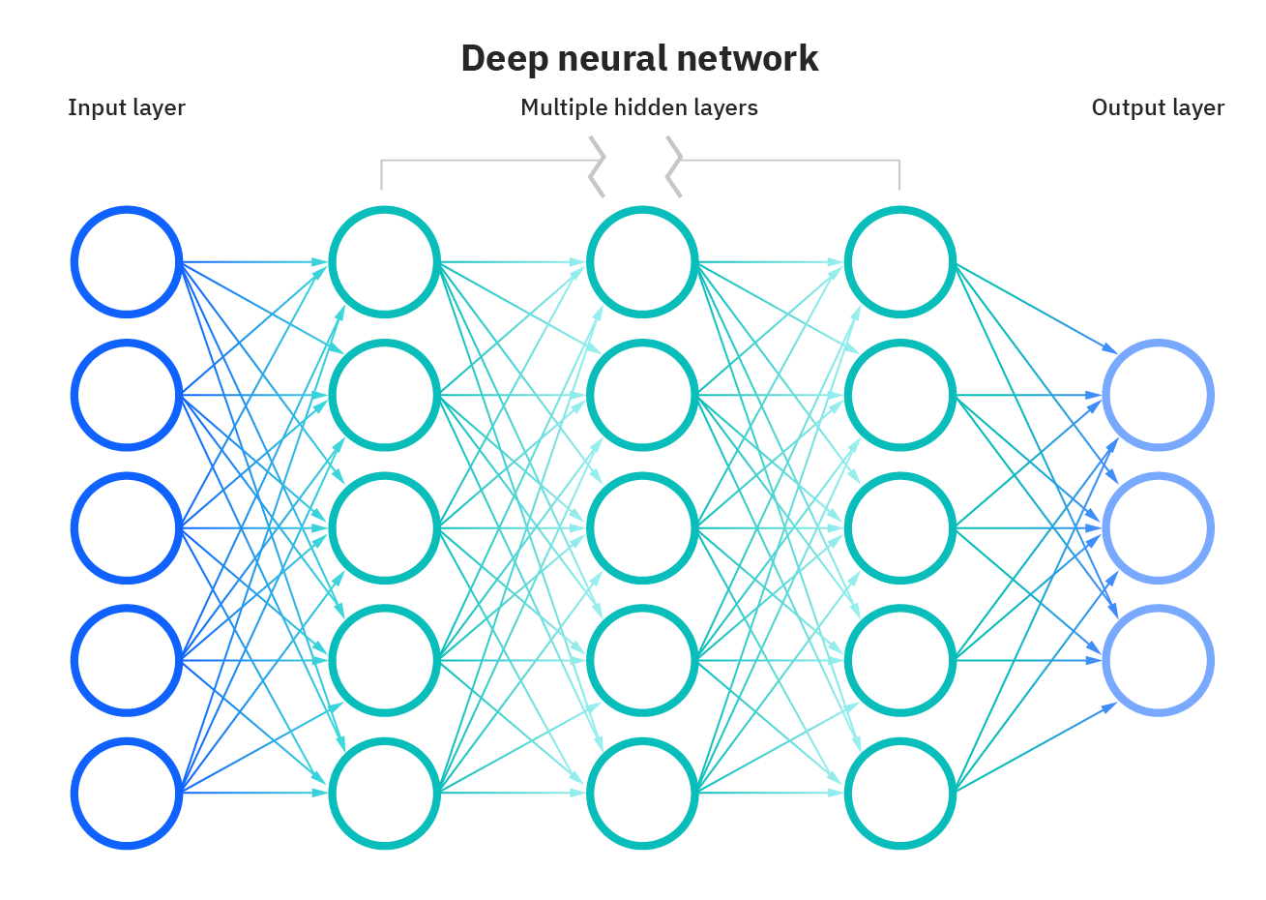

Backpropagation Algorithm: Backpropagation is an algorithm used to calculate derivatives quickly. Artificial neural networks use backpropagation as a learning algorithm to compute a gradient descent with respect to weights. Desired outputs are compared to achieved system outputs, and then the systems are tuned by adjusting connection weights to narrow the difference between the two as much as possible. The algorithm gets its name because the weights are updated backwards, from output towards input.

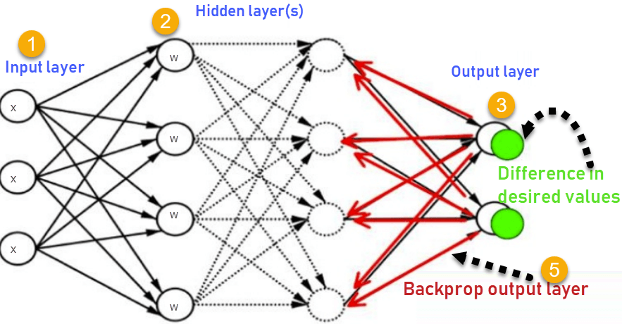

OR Gate:

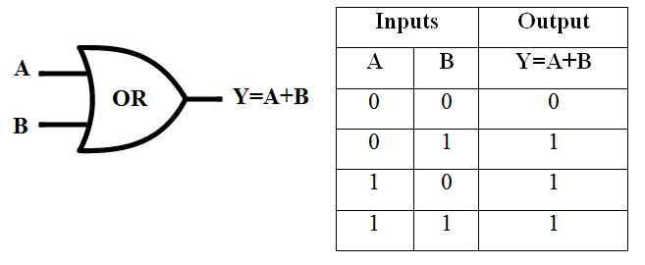

**Program:**

(Notebook is present in the folder.)

**Results:**

