Experiment-8

**Aim:** To implement logic gates using neural networks and to use neural networks on a real-life problem.

**Software used:** Python

**Dataset:** Kaggle

**Theory:**

Neural Networks: A neural network is a computational model that has a network architecture. This architecture is made up of artificial neurons. This structure has specific parameters through which one can modify it for performing certain tasks. They can approximate a function to any level of accuracy irrespective of its dimension.

OR Gate:

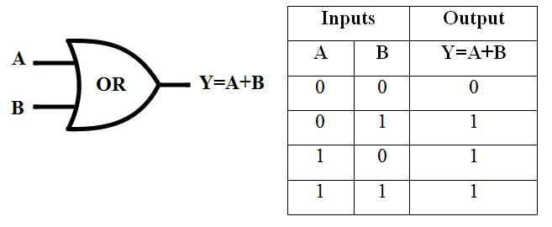

AND Gate:

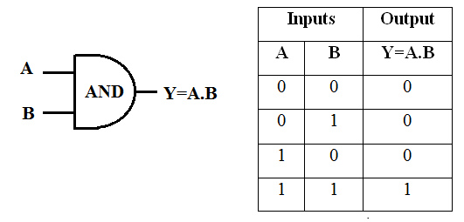

XOR Gate:

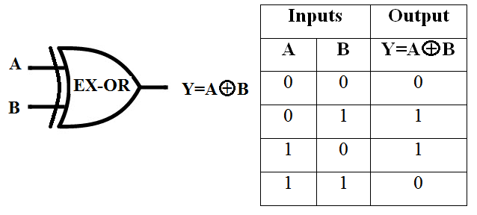

For implementing neural networks on a real-life problem, a ‘Heart Attack Analysis & Prediction’ dataset was taken.

**Program:**

(Notebook is present in the folder.)

**Results:**

For Heart Attack Analysis & Prediction task:





