V

VERSION CONTROL SYSTEM

1. Create a directory ‘project_dir’ & cd to ‘project_dir’.

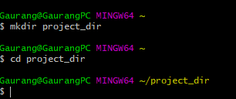

2. Initialize git version database.



3. . Create a new file index.html.

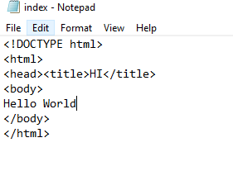

4. Check the git status. You should find index.html as untracked file

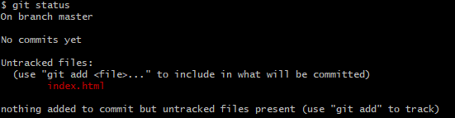

5. Stage the index.html file.

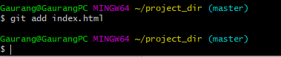

6. Commit index.html

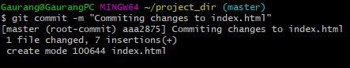

7. Make few changes in index.html & create a new file info.txt file.

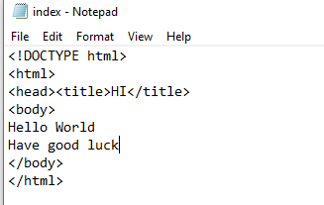

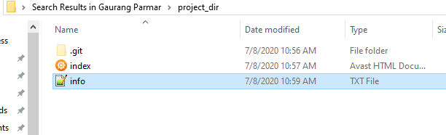

8. Check git status. You should find index.html & info.txt as untracked files

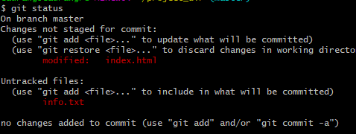

9. Configure GIT to ignore all txt files

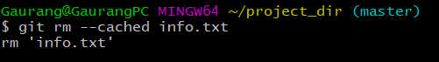

10. Again check the git status. You should find only index.html as untracked file.



11.State & commit index.html

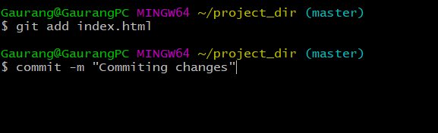

12. Log all your comments so far.

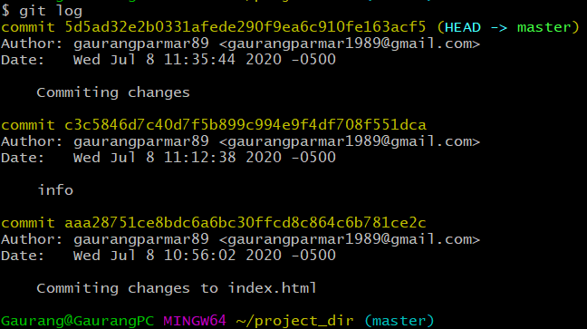

13. Make some changes in index.html.

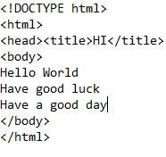

15. Again change index.html.

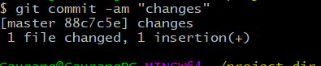

GIT BRANCHING

22. Create an empty directory ‘Assignments’ & cd to ‘Assignments’.

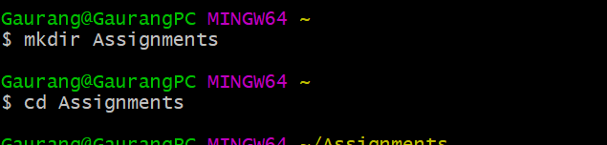

23. Create a file README.txt inside ‘Assignments’ & write few lines about the contents of ‘Assignments’ folder.

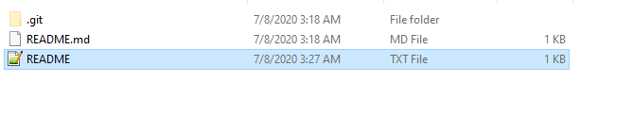



24. Commit README.txt file

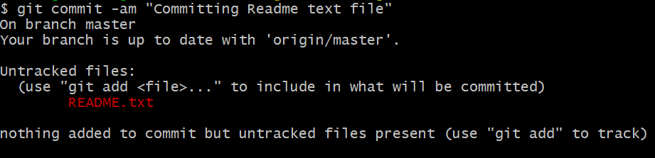

25. Now create a new branch ‘html-assignments’.

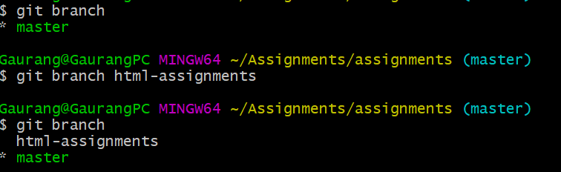

26. Switch to ‘html-assignments’ branch

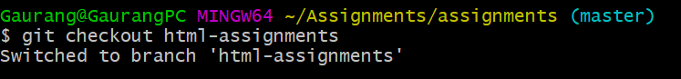

27. Copy all HTML assignments inside ‘Assignments’ folder.

28. Commit HTML assignments into ‘html-assignments’ branch.

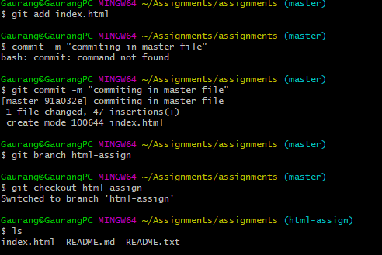

29. Make minor changes into few files belonging to ‘html-assignments’ branch.

Changes in one of file in html-assign branch

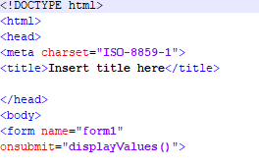

this is original file in master branch

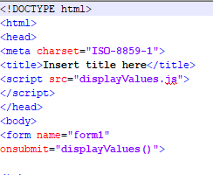

30.Commit those changed files.

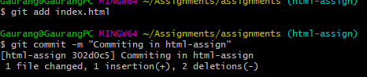

31. Switch to master branch.

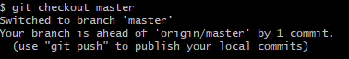

32. Make minor changes into README.txt file & commit those changes into master.

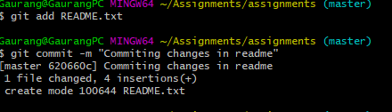



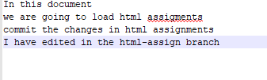

33. Again switch to ‘html-assignments’ branch.



34. Make minor changes into few files belonging to ‘html-assignments’ branch.

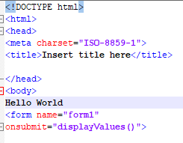

35. Commit those changes.

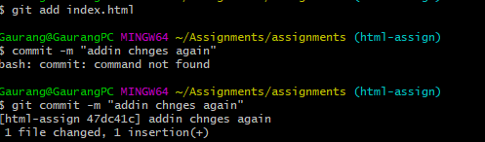

36. Switch to master.

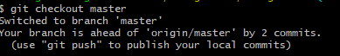

37. Merge ‘html-assignments’ branch into master. Confirm all html assignments are shown in master.

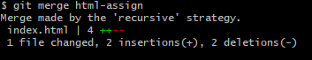

when we do ls command in branch html-assign we have 2 files

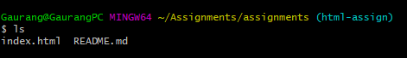

when I merge in master branch I got

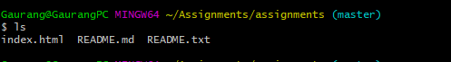

SECTION 2 (CSS ASSIGNMENTS)

1.Create a new branch ‘css-assignments’.



2. Switch to ‘css-assignments’ branch.



3. Copy all CSS assignments inside ‘Assignments’ folder.

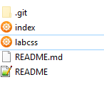

4. Commit CSS assignments into ‘css-assignments’ branch.

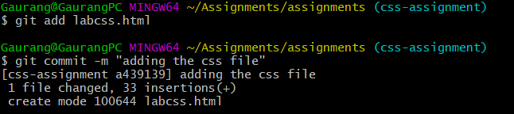

5. Make minor changes into README.txt file on line 1 belonging to ‘css-assignments’ branch.

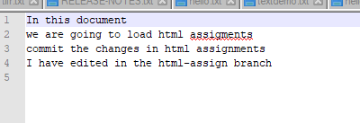

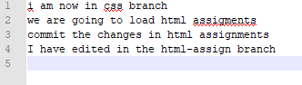

6. Commit those changed files.

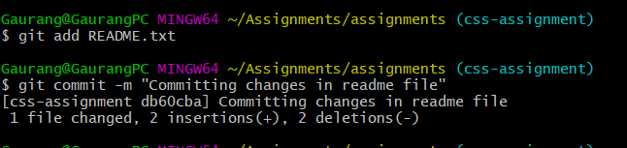

7. Switch to master branch.

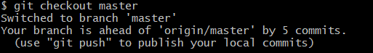

8. Make minor changes into README.txt file on line 3 & commit those changes into master.

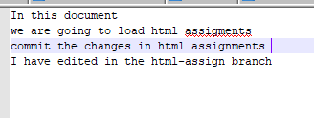

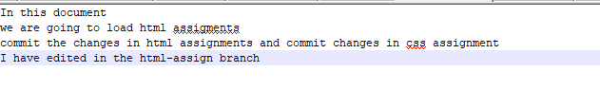

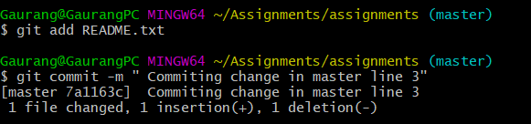

9. Again switch to ‘css-assignments’ branch



10. Make minor changes into few files belonging to ‘css-assignments’ branch.

Original file

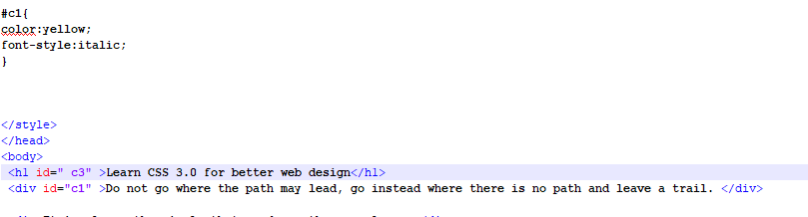

After Changes

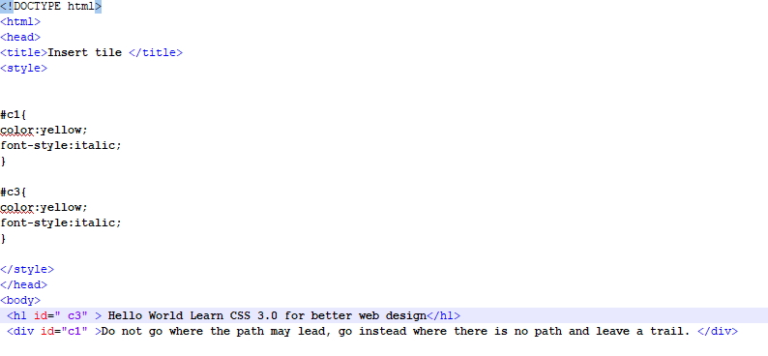

11. Commit those changes

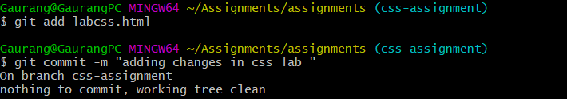

12. Switch to master.

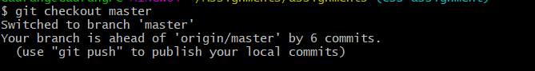

13. Merge ‘css-assignments’ branch into master. Confirm all css assignments are shown in master



JS assignment

1. Create a new branch ‘js-assignments’.



2. Switch to ‘js-assignments’ branch.



3. Copy all JavaScript assignments inside ‘Assignments’ folder.

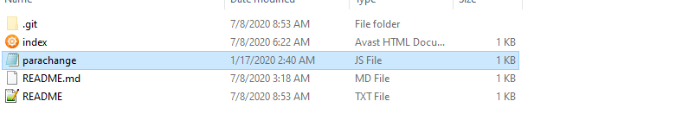

4. Commit JavaScript assignments into ‘js-assignments’ branch.

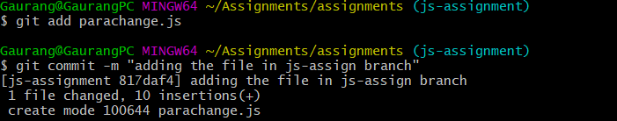

5. Make minor changes into README.txt file on line 1 belonging to ‘js-assignments’ branch.

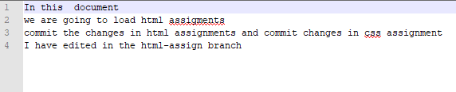

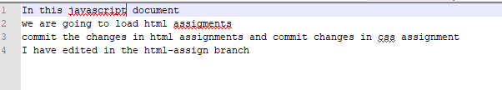

6. Commit those changed files.

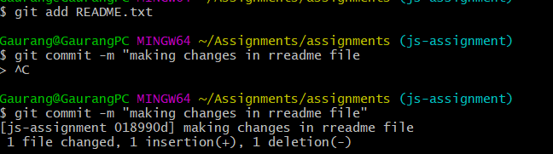

7.Switch to master branch.

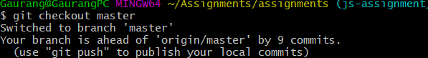

8. Make minor changes into README.txt file on line 1 & commit those changes into master

original file

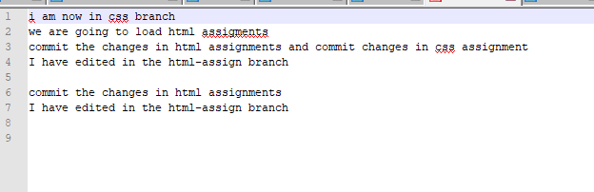

change file

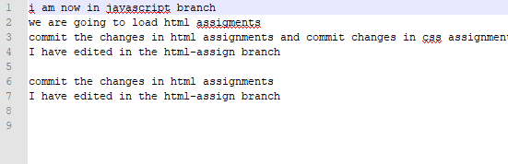

9. Again switch to ‘js-assignments’ branch.

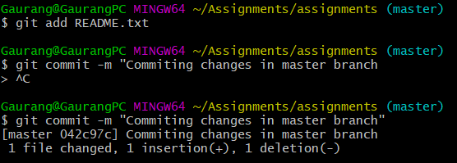



10. Make minor changes into few files belonging to ‘js-assignments’ branch

original file

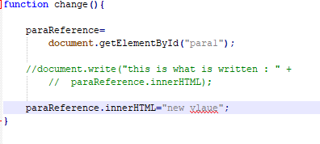

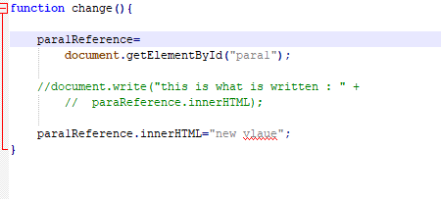

11. Commit those changes.



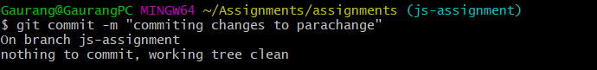

12. Switch to master.

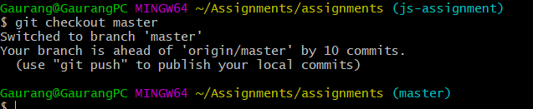

13. Merge ‘js-assignments’ branch into master. Confirm all JavaScript assignments are shown in master



all file from js assignment branch (parachange.js ss)

