Savitribai Phule Pune University

Final Remote Internship Report

on
Multimodal Academic Performance Prediction System using Text, Tabular and Behavioral Data

By
Manasi Narkhede(DS24M11)

Guided by:
Mr. Rithik Raj Vaishya

Table of Contents
Executive Summary 3
1. Background 4
2. Aim 5
3. Technologies 6
4. Hardware Architecture 7
5. Software Architecture 8
6. System Requirements 9
6.1 Functional Requirements 9
6.2 User Requirements 9
6.3 Environmental Requirements 9
7. Design and Architecture 10
8. Implementation 11
9. Testing 12
9.1 Test Plan Objectives 12
9.2 Test Strategy 12
9.3 Test Results Summary 12
10. Graphical User Interface (GUI) Layout 13
11. Snapshots 15
12. Conclusions 17
13. Further Development or Research 18
14. References 19
15. Appendix 20
A. API Endpoint Reference 20
B. Database Schema 20
C. Environment Variables 20

Executive Summary
This report presents the design, implementation, and evaluation of a Multimodal Academic Performance Prediction System — a full-stack machine learning platform that identifies at-risk students by analyzing academic records, behavioral engagement patterns, and free-text submissions simultaneously. The system combines three specialized machine learning models (XGBoost for tabular data, LSTM for behavioral sequences, and a DistilBERT-based classifier for text) through a late fusion ensemble with an XGBoost meta-learner. Predictions are accompanied by SHAP-based feature attributions and natural language explanations, enabling educators to understand not just which students are at risk, but why.
The system is deployed as a containerized web application featuring a React/TypeScript frontend with interactive dashboards and a FastAPI backend with async PostgreSQL persistence. The fusion ensemble achieves superior F1 score compared to any individual unimodal model, demonstrating the value of multimodal integration. The project includes comprehensive testing (17 backend test files, frontend component tests), production deployment scripts for AWS EC2/RDS, and detailed documentation covering API contracts, ethics, monitoring, and model fallback strategies.

1. Background
Educational institutions worldwide face a critical challenge: identifying students at risk of academic failure early enough for effective intervention. Research in Educational Data Mining (Baker & Inventado, 2014; Romero & Ventura, 2010) has demonstrated that machine learning can predict student outcomes using institutional data. However, most existing systems rely on a single data modality — typically grades or attendance — missing important signals from other sources.
Recent advances in multimodal machine learning (Baltrušaitis et al., 2019) have shown that combining heterogeneous data sources can significantly improve prediction accuracy. This project applies these principles to education, building a system that combines tabular academic records, temporal behavioral patterns from learning management systems, and semantic information from student text submissions.

2. Aim
To design and implement a production-ready multimodal machine learning system that:
1. Predicts student academic risk using three complementary data modalities.
2. Provides explainable predictions with SHAP values and natural language summaries.
3. Delivers predictions through an intuitive web interface for educators.
4. Handles missing modalities gracefully through population mean imputation.
5. Follows ethical AI principles including fairness, transparency, and human-in-the-loop design.

3. Technologies
Table 1: Technologies used
Category | Technology | Version / Details
Backend Runtime | Python | 3.11
Web Framework | FastAPI | Latest (async)
ORM | SQLAlchemy + asyncpg | Async sessions
Database | PostgreSQL | 15-alpine
ML (Tabular) | XGBoost | Gradient boosting
ML (Behavioral) | PyTorch (LSTM) | 2-layer LSTM
ML (Text) | HuggingFace Transformers | DistilBERT-base-uncased
Explainability | SHAP | TreeExplainer
Experiment Tracking | MLflow | Metrics + model registry
Frontend Framework | React | 19
Build Tool | Vite | 7
Language | TypeScript | ~5.9
State Management | Zustand | 5
Data Fetching | TanStack React Query | 5
Styling | Tailwind CSS | 3.4
Charts | Recharts | 3
Containerization | Docker + Docker Compose | Multi-stage builds
Reverse Proxy | Nginx | Alpine
Testing (Backend) | pytest + pytest-asyncio | —
Testing (Frontend) | Vitest + Testing Library | —

4. Hardware Architecture
The system is designed to run on commodity hardware with the following minimum requirements:
Development Environment:
• CPU: 4 cores (AMD64 or ARM64)
• RAM: 8 GB (3 GB allocated to backend container)
• Storage: 10 GB for Docker images, data, and model artifacts
Production Environment (AWS EC2):
• Instance type: t3.medium or larger (2 vCPUs, 4 GB RAM)
• RDS: db.t3.micro PostgreSQL 15 instance
• Storage: 20 GB EBS volume
• Network: VPC with public subnet, security groups for ports 80, 443, 8000

5. Software Architecture
The system follows a three-tier architecture: Presentation (React SPA), Application (FastAPI + ML pipeline), and Data (PostgreSQL + file-based model artifacts). The ML pipeline uses a late fusion strategy where three unimodal models produce independent risk probabilities that are combined by an XGBoost meta-learner.
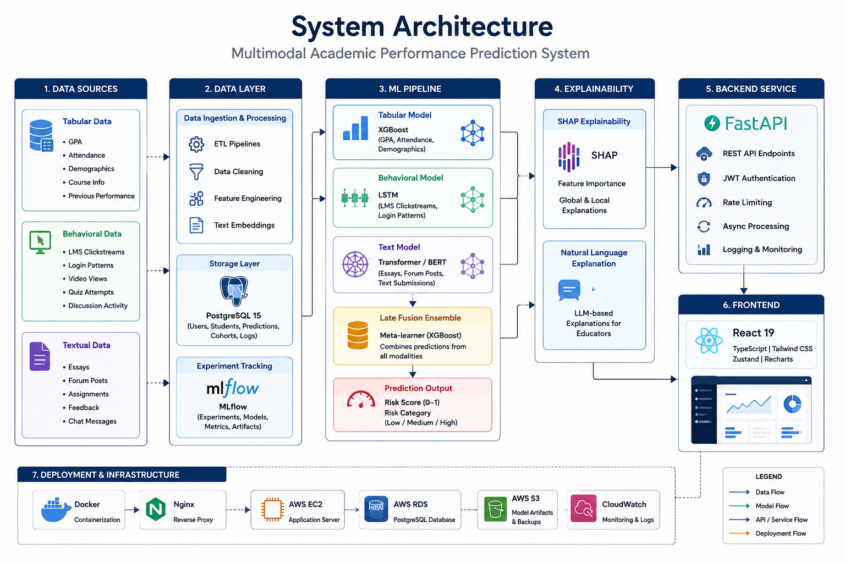
Figure 1: System Architecture Diagram

6. System Requirements

6.1 Functional Requirements
FR-1: The system shall authenticate users via email/password and issue JWT tokens.
FR-2: The system shall accept a student ID and return a risk prediction with probability, risk level (low/medium/high), SHAP values, and a natural language explanation.
FR-3: The system shall display cohort-level dashboards with risk distribution charts.
FR-4: The system shall support sorting and filtering students by risk level.
FR-5: The system shall persist all predictions for audit trails.
FR-6: The system shall handle missing modalities by imputing with population means.
FR-7: The system shall provide model performance metrics and training history.

6.2 User Requirements
UR-1: Educators shall be able to log in and view their cohort dashboards.
UR-2: Educators shall be able to view individual student risk predictions with explanations.
UR-3: Administrators shall be able to view model performance metrics.
UR-4: The interface shall be responsive and work on desktop browsers.
UR-5: Predictions shall be generated within 5 seconds of request.

6.3 Environmental Requirements
• Docker Engine 20+ and Docker Compose v2+
• Python 3.11+ for local backend development
• Node.js 18+ and npm for local frontend development
• PostgreSQL 15 (or Docker-provided instance)
• Minimum 8 GB RAM for development, 4 GB for production
• Internet access for initial dependency installation and DistilBERT model download

7. Design and Architecture
The architecture follows separation-of-concerns principles with clearly defined layers. The frontend communicates with the backend exclusively through RESTful APIs. The backend separates concerns into API routes, authentication, core services (config, cache, errors), ML models, preprocessing, explainability, and database access. Each ML model is encapsulated in a Model class (training) and a Predictor class (inference), following the Strategy pattern for interchangeable model implementations.
The fusion ensemble implements the Template Method pattern: base predictions are loaded, a meta-learner is trained, and results are evaluated — with the specific meta-learner type (XGBoost or Logistic Regression) configurable at instantiation time.

8. Implementation
The implementation proceeded in six phases:
Phase 1 — Data Pipeline: A synthetic data generator (data/generate_synthetic.py) creates realistic student records, behavioral logs, and text submissions with controlled distributions. Three dedicated preprocessors (tabular, behavioral, text) transform raw data into model-ready features stored as NumPy arrays.
Phase 2 — Unimodal Models: Each model was trained independently with MLflow tracking. The tabular XGBoost model uses 13 engineered features with automated class weighting. The behavioral LSTM processes 6-feature temporal sequences. The text classifier operates on pre-computed 768-dimensional DistilBERT embeddings.
Phase 3 — Fusion Ensemble: Predictions from all three models are aligned by student_id and fed to an XGBoost meta-learner. The ensemble handles missing modalities by imputing with population means computed during training.
Phase 4 — Explainability: SHAP TreeExplainer generates feature attributions for the tabular model. The NLG summarizer converts these into human-readable narratives using template-based generation with strength qualifiers (strong/moderate/slight).
Phase 5 — Full-Stack Application: The FastAPI backend exposes prediction, cohort, auth, and health endpoints. The React frontend provides login, cohort dashboard with Recharts visualizations, sortable student risk table, and SHAP explanation modal.
Phase 6 — DevOps: Docker multi-stage builds, Docker Compose orchestration, Nginx reverse proxy with SSL, and AWS deployment scripts.

9. Testing

9.1 Test Plan Objectives
The testing strategy aims to verify correctness of ML models, API endpoints, authentication, error handling, and frontend components through automated testing.

9.2 Test Strategy
Table 2: Test Stratergy
Test Type | Tool | Scope
Unit Tests | pytest | Individual model classes, preprocessors, utilities
Integration Tests | pytest + httpx | API endpoints with test database
Component Tests | Vitest + Testing Library | React components with mocked API
Security Tests | Manual + custom tests | Auth flows, JWT validation, CORS
Performance Tests | Inference timing | Single prediction latency benchmarks

9.3 Test Results Summary
The test suite comprises 17 backend test files covering all major components. Key results:
• All API endpoints return correct HTTP status codes and response shapes.
• ML models produce probabilities in the valid range [0, 1].
• The fusion ensemble handles missing modalities without errors.
• SHAP explainer produces valid feature attributions.
• NLG summarizer generates coherent natural language explanations.
• Authentication correctly rejects invalid credentials and expired tokens.
• Rate limiting enforces the configured request limits.

10. Graphical User Interface (GUI) Layout
The frontend provides three main views, each designed with Tailwind CSS for a clean, responsive layout:
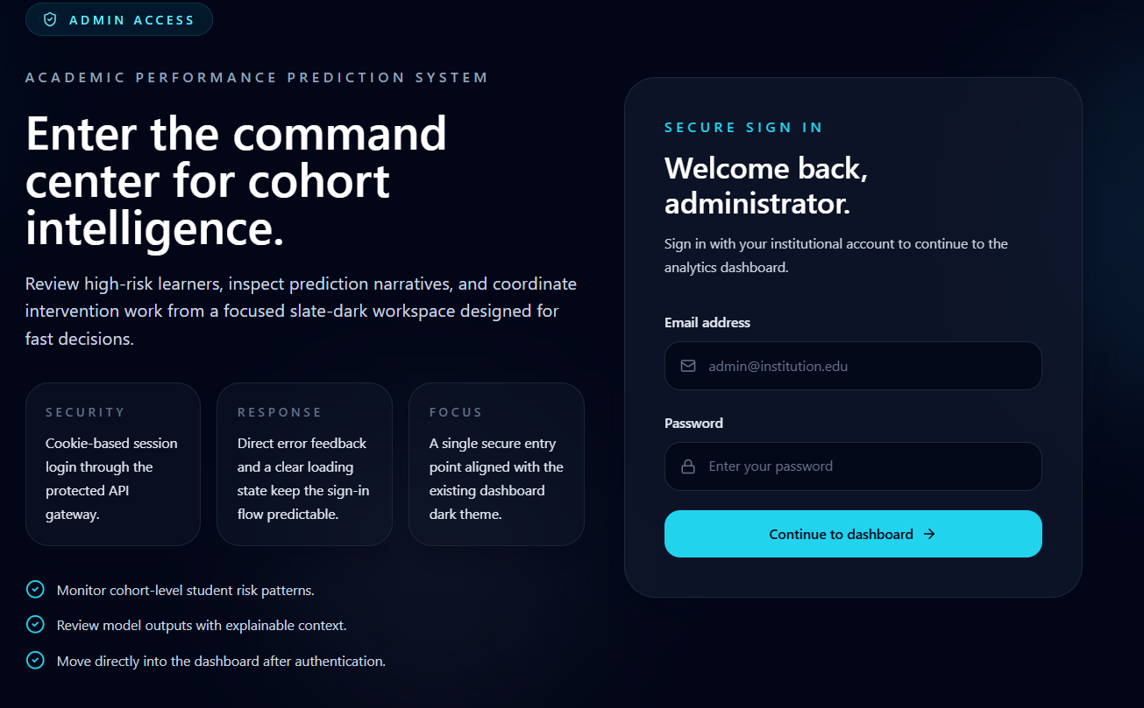
Figure 2: Login Page
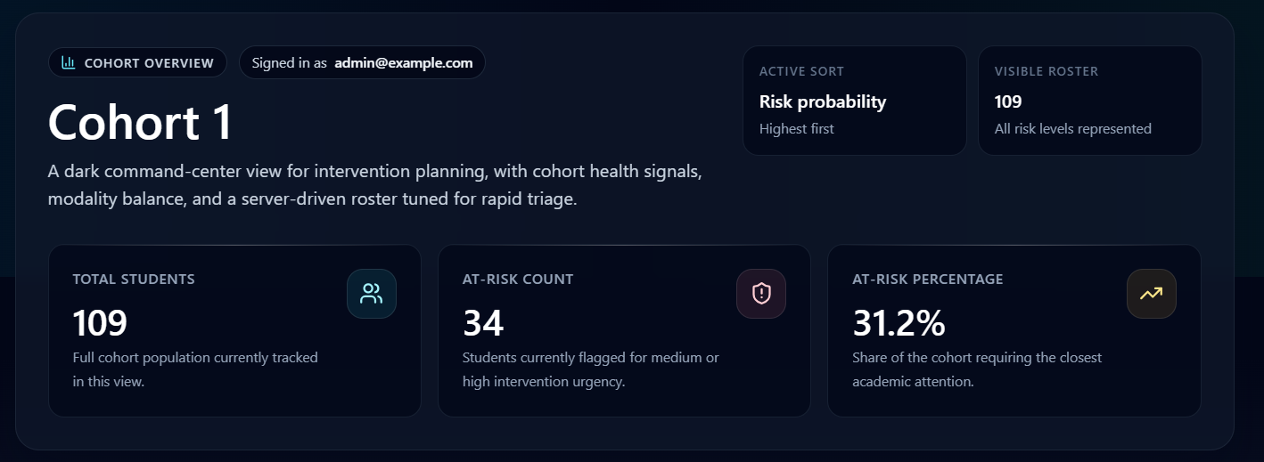
Figure 3: Cohort Dashboard — Risk Overview
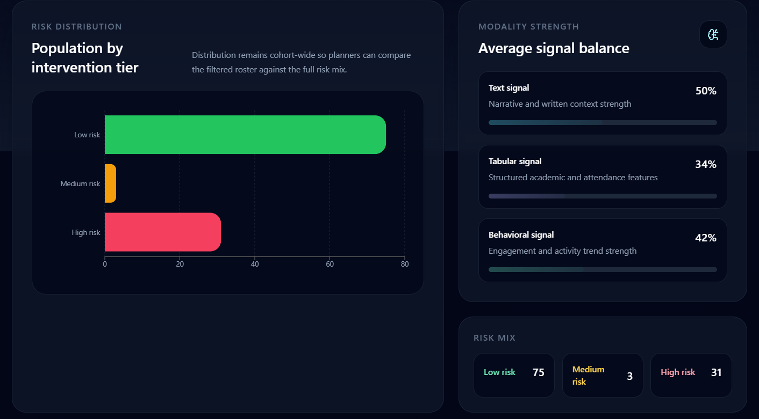
Figure 4: Risk Distribution Chart
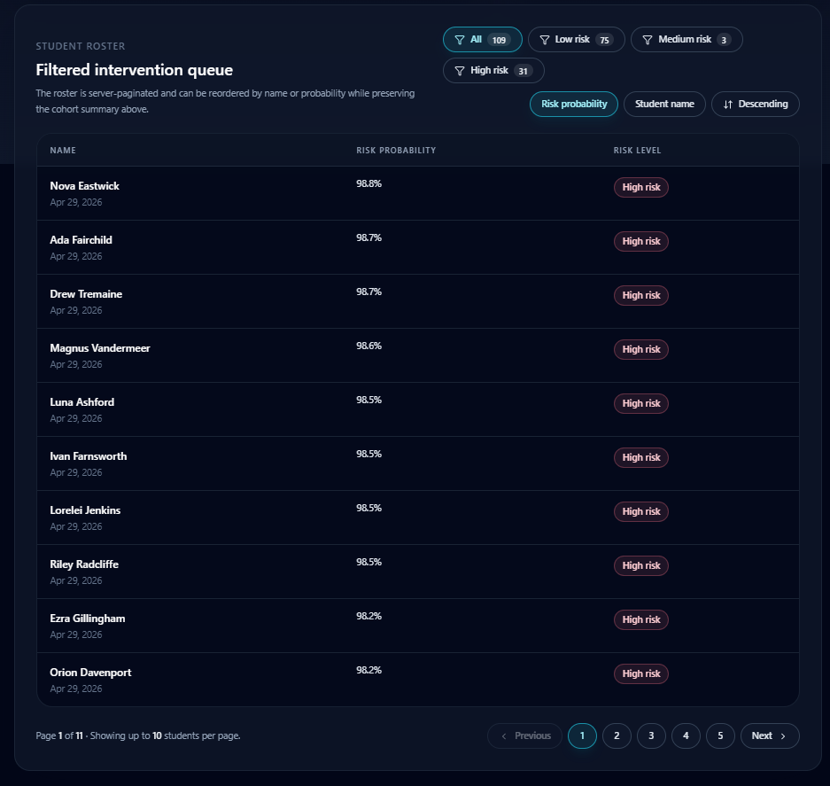
Figure 5: Student Risk Table

11. Snapshots
The following snapshots demonstrate key system features in action:

Snapshot 1: User Authentication Screen

Snapshot 2: Cohort Overview Dashboard

Snapshot 3: Risk Distribution Visualization

Snapshot 4: Student Risk Roster

12. Conclusions
This project successfully demonstrates that multimodal machine learning can provide more accurate and nuanced student risk predictions than any single data source alone. The late fusion ensemble architecture enables graceful degradation when data is incomplete, while SHAP-based explainability ensures predictions are transparent and actionable. The full-stack implementation provides a production-ready platform that educators can use to proactively identify and support at-risk students.
Key achievements include: (1) a working three-modality fusion pipeline, (2) SHAP + NLG explainability, (3) a responsive web application with authentication and dashboards, (4) comprehensive test coverage, and (5) production deployment infrastructure.

13. Further Development or Research
1. Attention-Based Fusion: Replace the meta-learner with a cross-attention mechanism that dynamically weights modalities based on data quality and relevance.
2. Real-Time Behavioral Streaming: Integrate with LMS webhooks for real-time risk updates as student behavior changes.
3. Fairness Auditing: Implement automated bias detection across demographic subgroups with fairness-constrained training.
4. Fine-Tuned Language Models: Fine-tune DistilBERT on educational text corpora for improved text modality performance.
5. Longitudinal Tracking: Add temporal prediction trends to track student risk trajectories over semesters.
6. Mobile Application: Build a companion mobile app for push notifications when student risk levels change significantly.

14. References
[1] Baltrušaitis, T., Ahuja, C., & Morency, L.-P. (2019). Multimodal Machine Learning: A Survey and Taxonomy. Foundations and Trends® in Computer Graphics and Vision.
[2] Zadeh, A., Chen, M., Poria, S., Cambria, E., & Morency, L.-P. (2017). Tensor Fusion Network for Multimodal Sentiment Analysis. ACL Workshop.
[3] Vaswani, A., et al. (2017). Attention Is All You Need. NeurIPS.
[4] Devlin, J., Chang, M.-W., Lee, K., & Toutanova, K. (2019). BERT: Pre-training of Deep Bidirectional Transformers for Language Understanding. NAACL.
[5] Chen, T., & Guestrin, C. (2016). XGBoost: A Scalable Tree Boosting System. KDD.
[6] Lundberg, S. M., & Lee, S.-I. (2017). A Unified Approach to Interpreting Model Predictions (SHAP). NIPS Workshop.
[7] Ribeiro, M. T., Singh, S., & Guestrin, C. (2016). "Why Should I Trust You?" Explaining the Predictions of Any Classifier (LIME). KDD.
[8] Zhou, Z.-H. (2012). Ensemble Methods: Foundations and Algorithms. Chapman & Hall/CRC.
[9] Baker, R. S. J. d., & Inventado, P. S. (2014). Educational Data Mining and Learning Analytics. Springer.
[10] Romero, C., & Ventura, S. (2010). Educational Data Mining: A Review of the State of the Art. IEEE Transactions on SMC.
[11] Kuhn, M., & Johnson, K. (2013). Applied Predictive Modeling. Springer.
[12] Goodfellow, I., Bengio, Y., & Courville, A. (2016). Deep Learning. MIT Press.
[13] Poria, S., Cambria, E., Bajpai, R., & Hussain, A. (2017). A Review of Affective Computing. IEEE Trans. Affective Computing.
[14] Lundberg, S. M., et al. (2020). From Local Explanations to Global Understanding with Explainable AI for Trees. Nature Machine Intelligence.

15. Appendix

A. API Endpoint Reference
Table 3: API Endpoints References
Method | Endpoint | Auth | Description
GET | /health | No | Health check and system status
POST | /auth/login | No | User authentication
POST | /auth/register | No | User registration
POST | /predictions/predict | JWT | Student risk prediction
GET | /cohort/{id} | JWT | Cohort summary
GET | /models | JWT | Model metadata

B. Database Schema
Tables: users, students, cohorts, predictions — see Low Level Design document for complete column specifications.

C. Environment Variables
Table 4: Environment Variables
Variable | Required | Description
DATABASE_URL | Yes | PostgreSQL connection string
JWT_SECRET_KEY | Yes | Minimum 32-character signing key
FRONTEND_URL | Yes | CORS-allowed frontend origin
ENVIRONMENT | No | local or production (default: local)
MLFLOW_TRACKING_URI | No | MLflow server URI

